1)Show Terraform Project Structure
aws-wordpress-terraform-deployment
├── provider.tf
├── variables.tf
├── main.tf
└── outputs.tf

File | Purpose
provider.tf | ---AWS provider configuration
variables.tf | ---instance type and key variables
main.tf | ---EC2, security group, WordPress setup
outputs.tf | ----display public IP
2)Show Terraform Initialization
Open terminal and copy project path : cd [paste project path]
Command to run :
terraform init
Terraform downloads AWS provider plugins and prepares the project.
3 )Show Terraform Plan
terraform plan -var="key_name=wordpress-key"
Terraform checks infrastructure changes and shows resources that will be created.

aws_security_group.wordpress_sg
aws_instance.wordpress_prod
aws_instance.wordpress_dev
aws_cloudwatch_metric_alarm.cpu_alarm
Note : wordpress-key : Go to ec2 left side keypair , create keypair name it wordpress-key

4) Deploy Infrastructure

terraform apply -var="key_name=wordpress-key"
yes
Terraform creates AWS infrastructure automatically.
Terminal when creating EC2
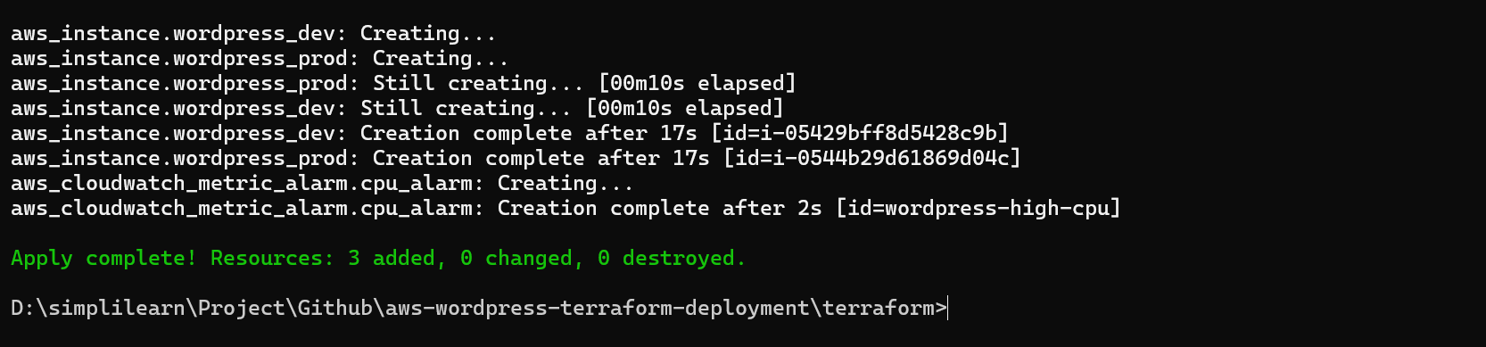

5 )Verify EC2 Instances
EC2 → Instances 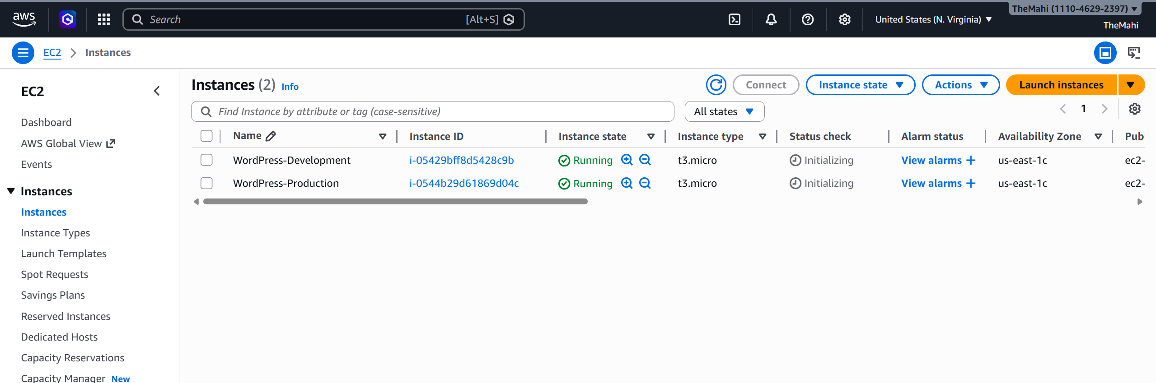
Security Group
EC2 → Security Groups 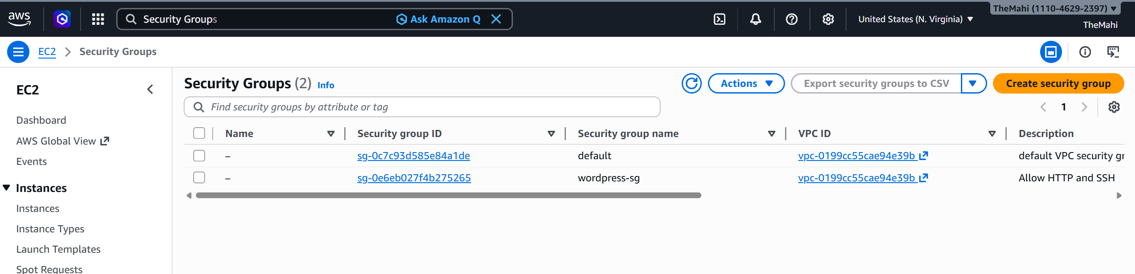
Security Alarm
CloudWatch → Alarms
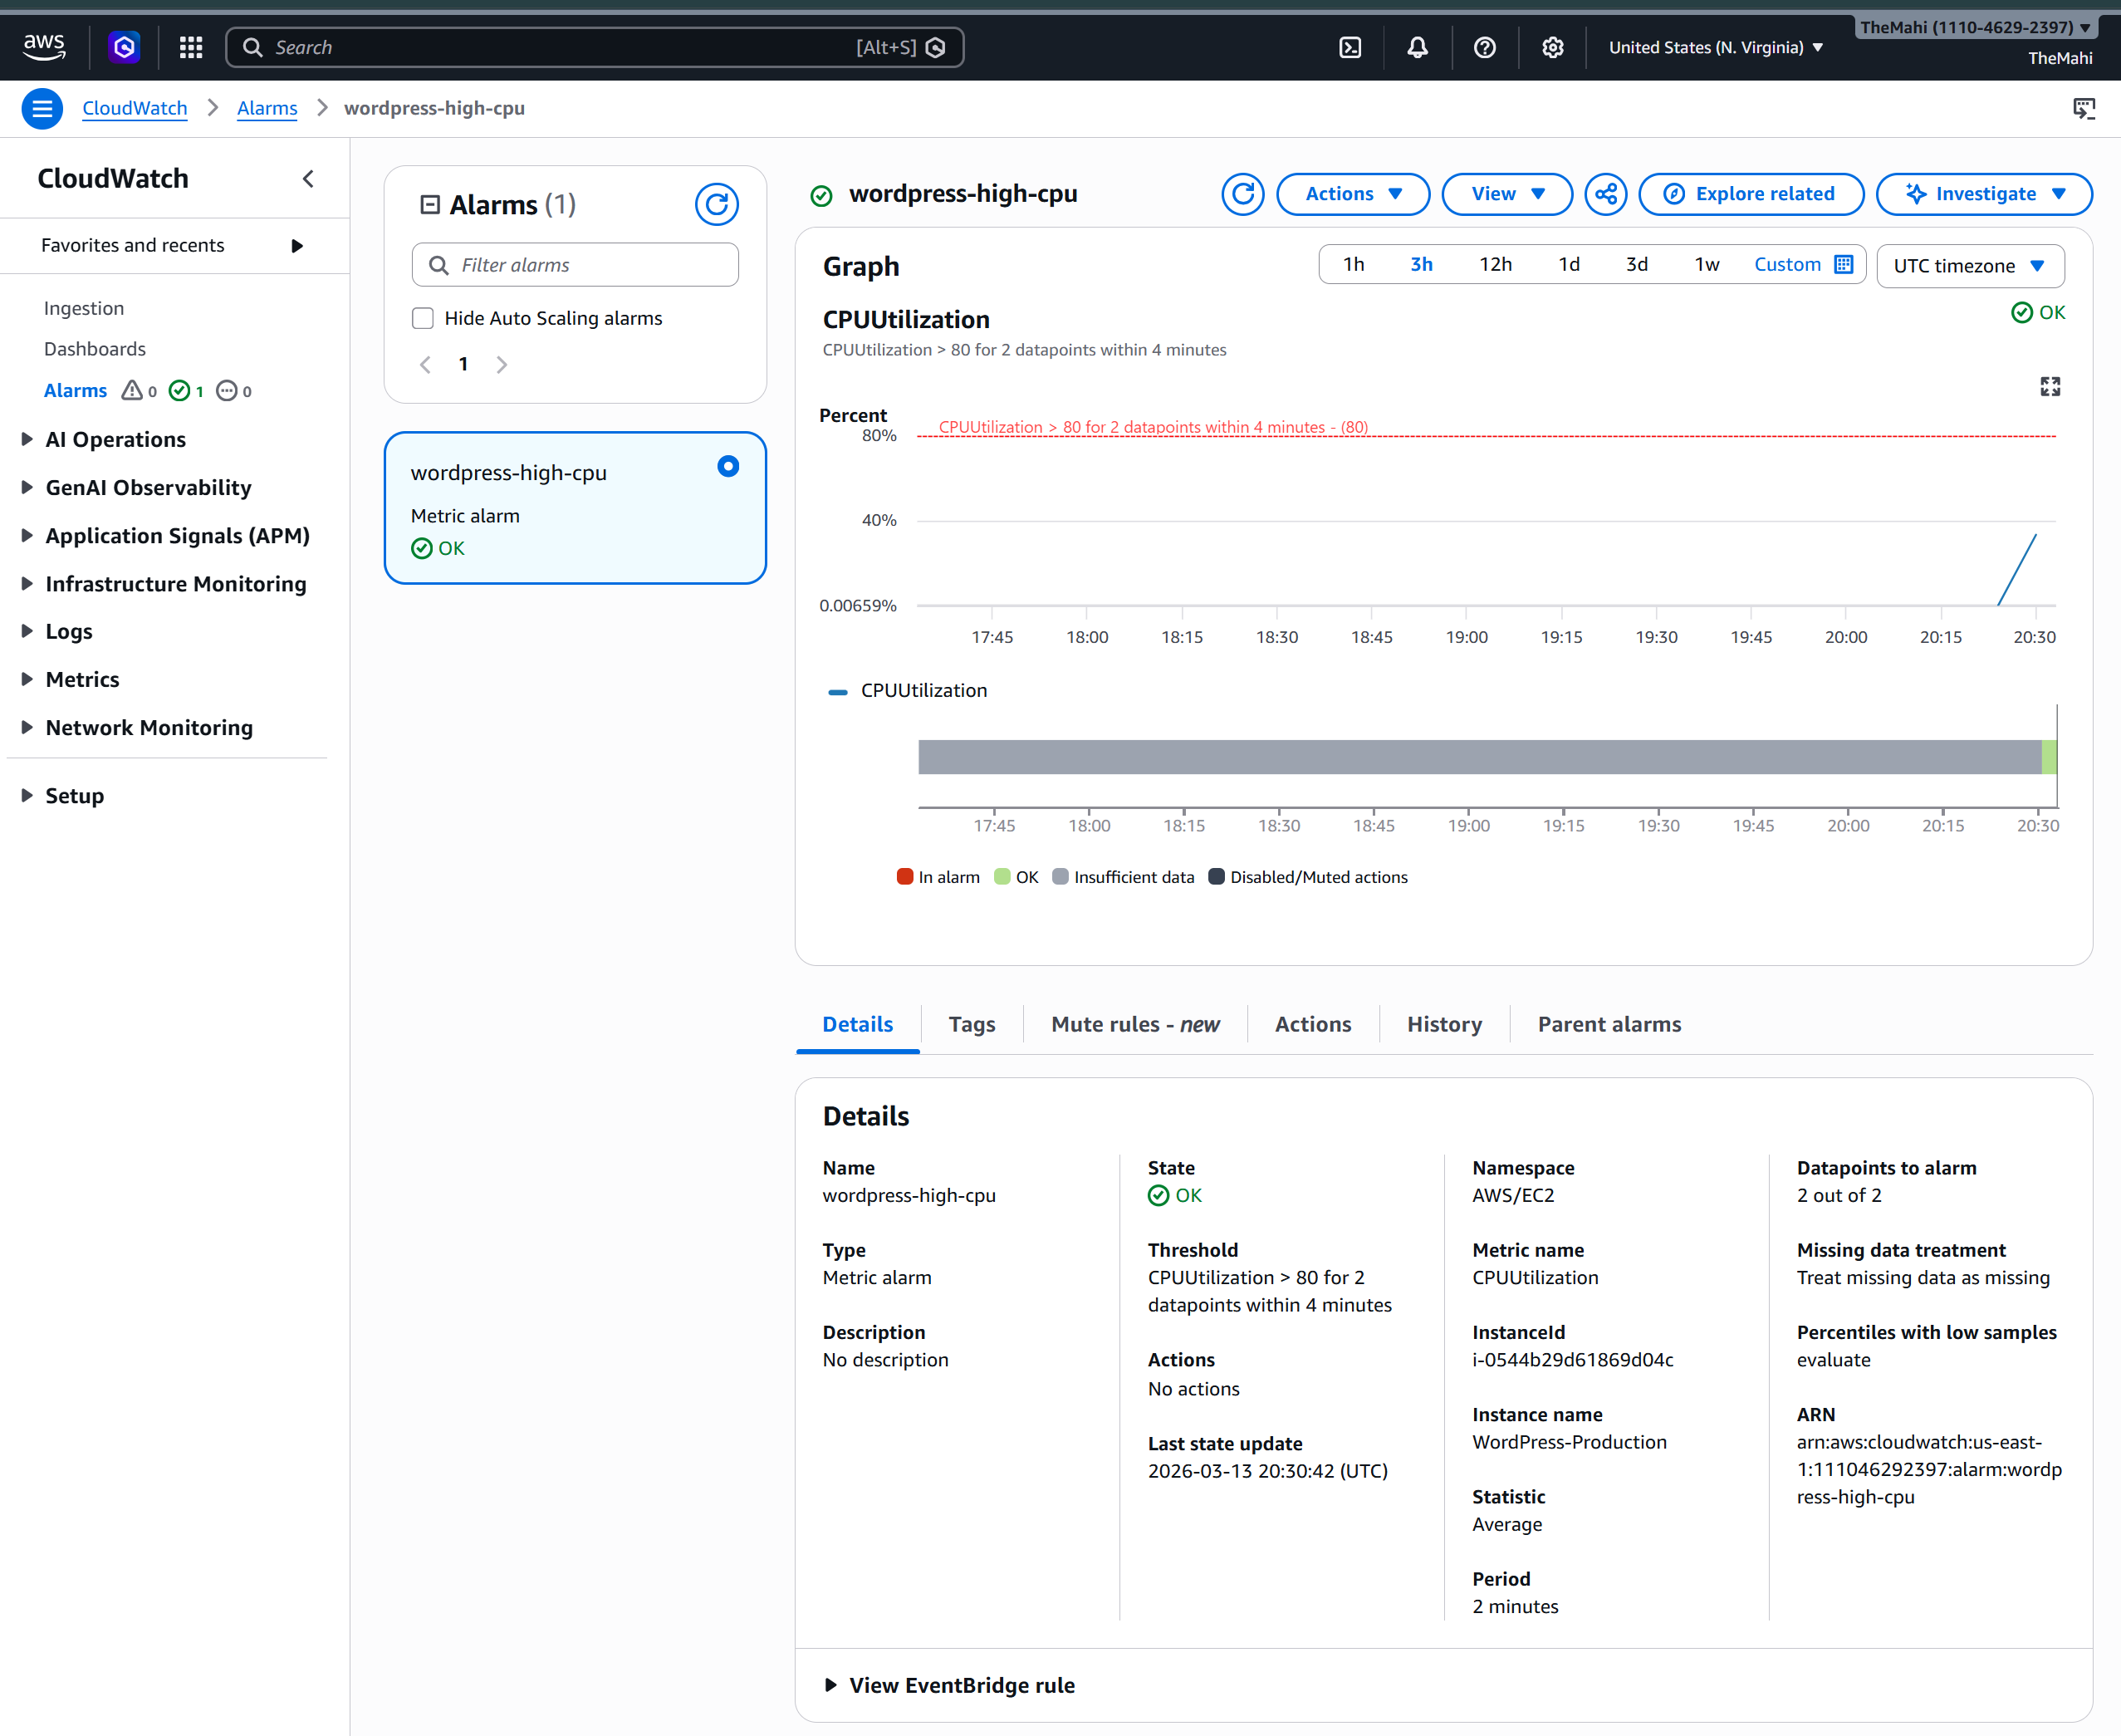

WordPress Running
WordPress-Prod IP : http://18.215.179.49 if you see this 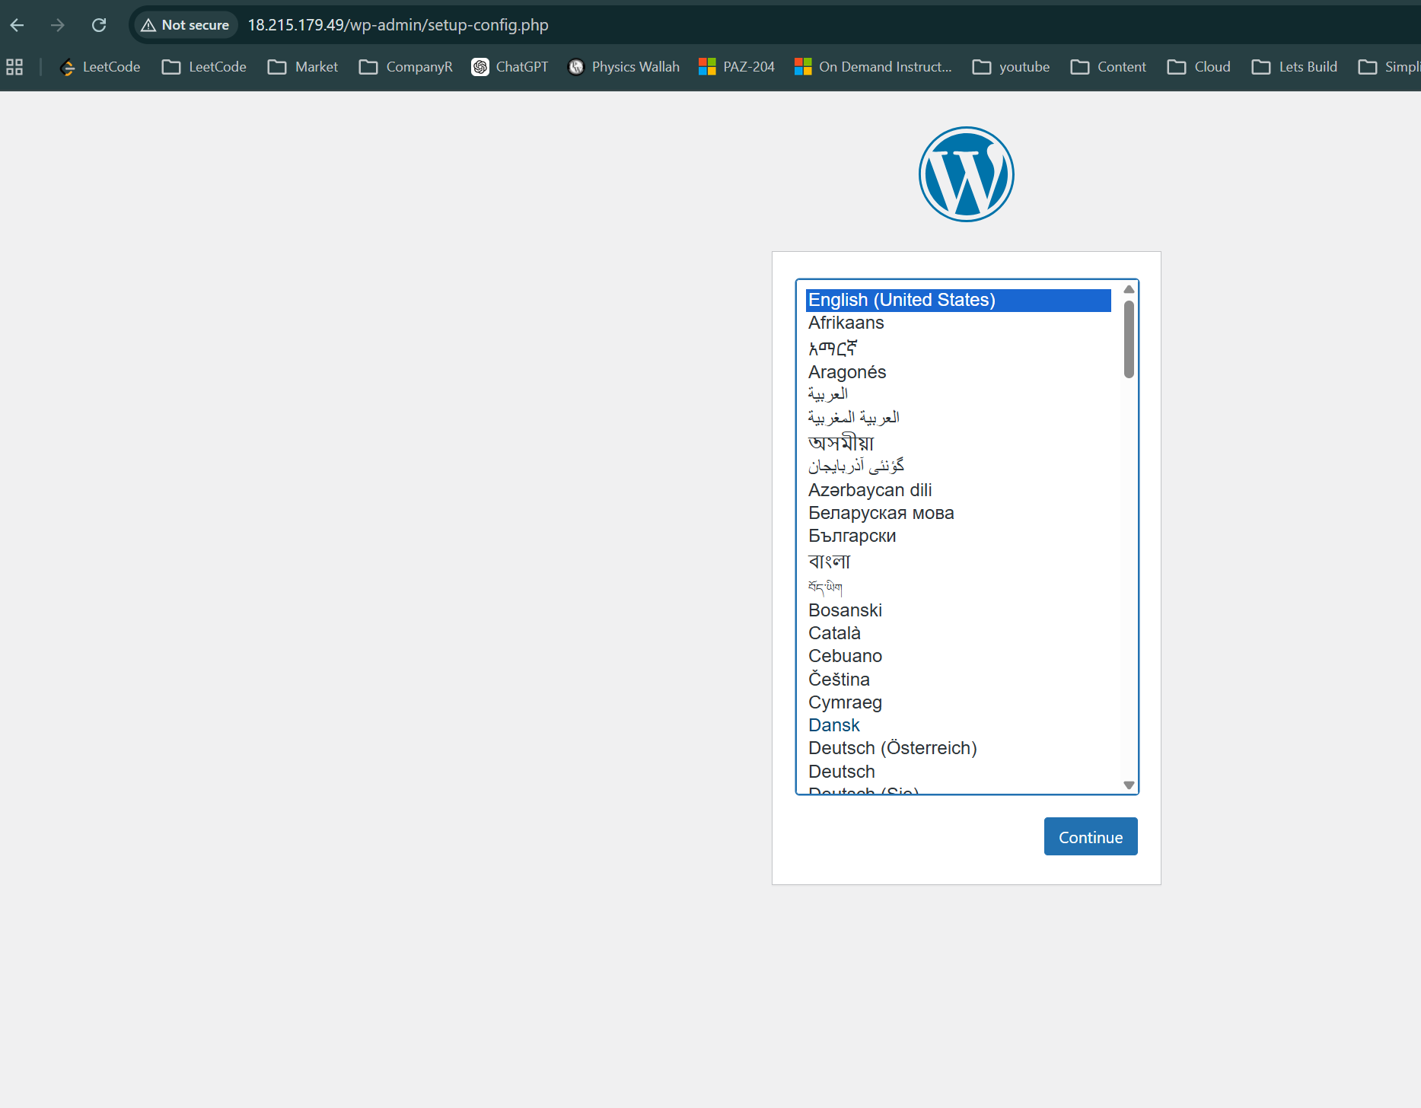
Step 2 : Setup (if you see this screen or above screen )
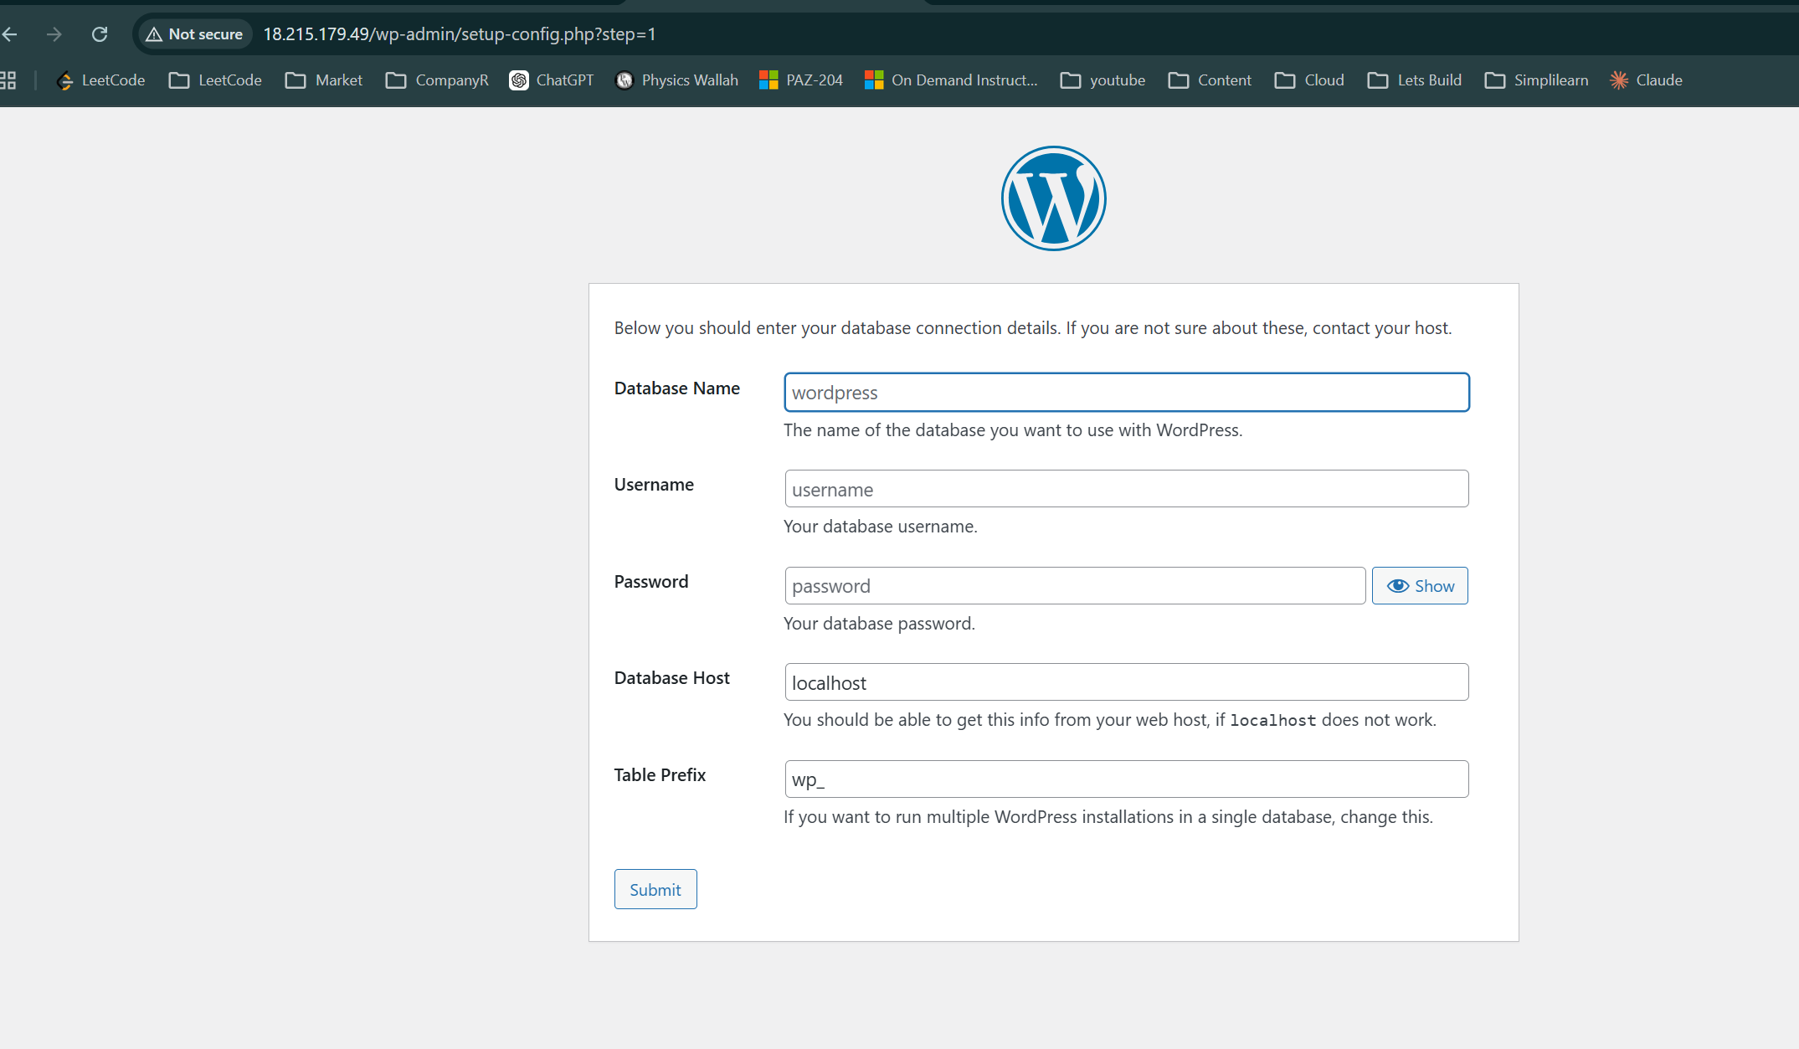
Then Connect to Your EC2 Server : Go to Amazon EC2 → Instances -> WordPress-Production -> Connect -> EC2 Instance Connect -> Connect
In the console :
sudo yum install mariadb-server -y
sudo systemctl start mariadb
sudo systemctl enable mariadb
Step 3 — Create WordPress Database
sudo mysql
Now run these SQL commands:
CREATE DATABASE wordpress;
CREATE USER 'wpuser'@'localhost' IDENTIFIED BY 'password123';
GRANT ALL PRIVILEGES ON wordpress.* TO 'wpuser'@'localhost';
FLUSH PRIVILEGES;
EXIT;
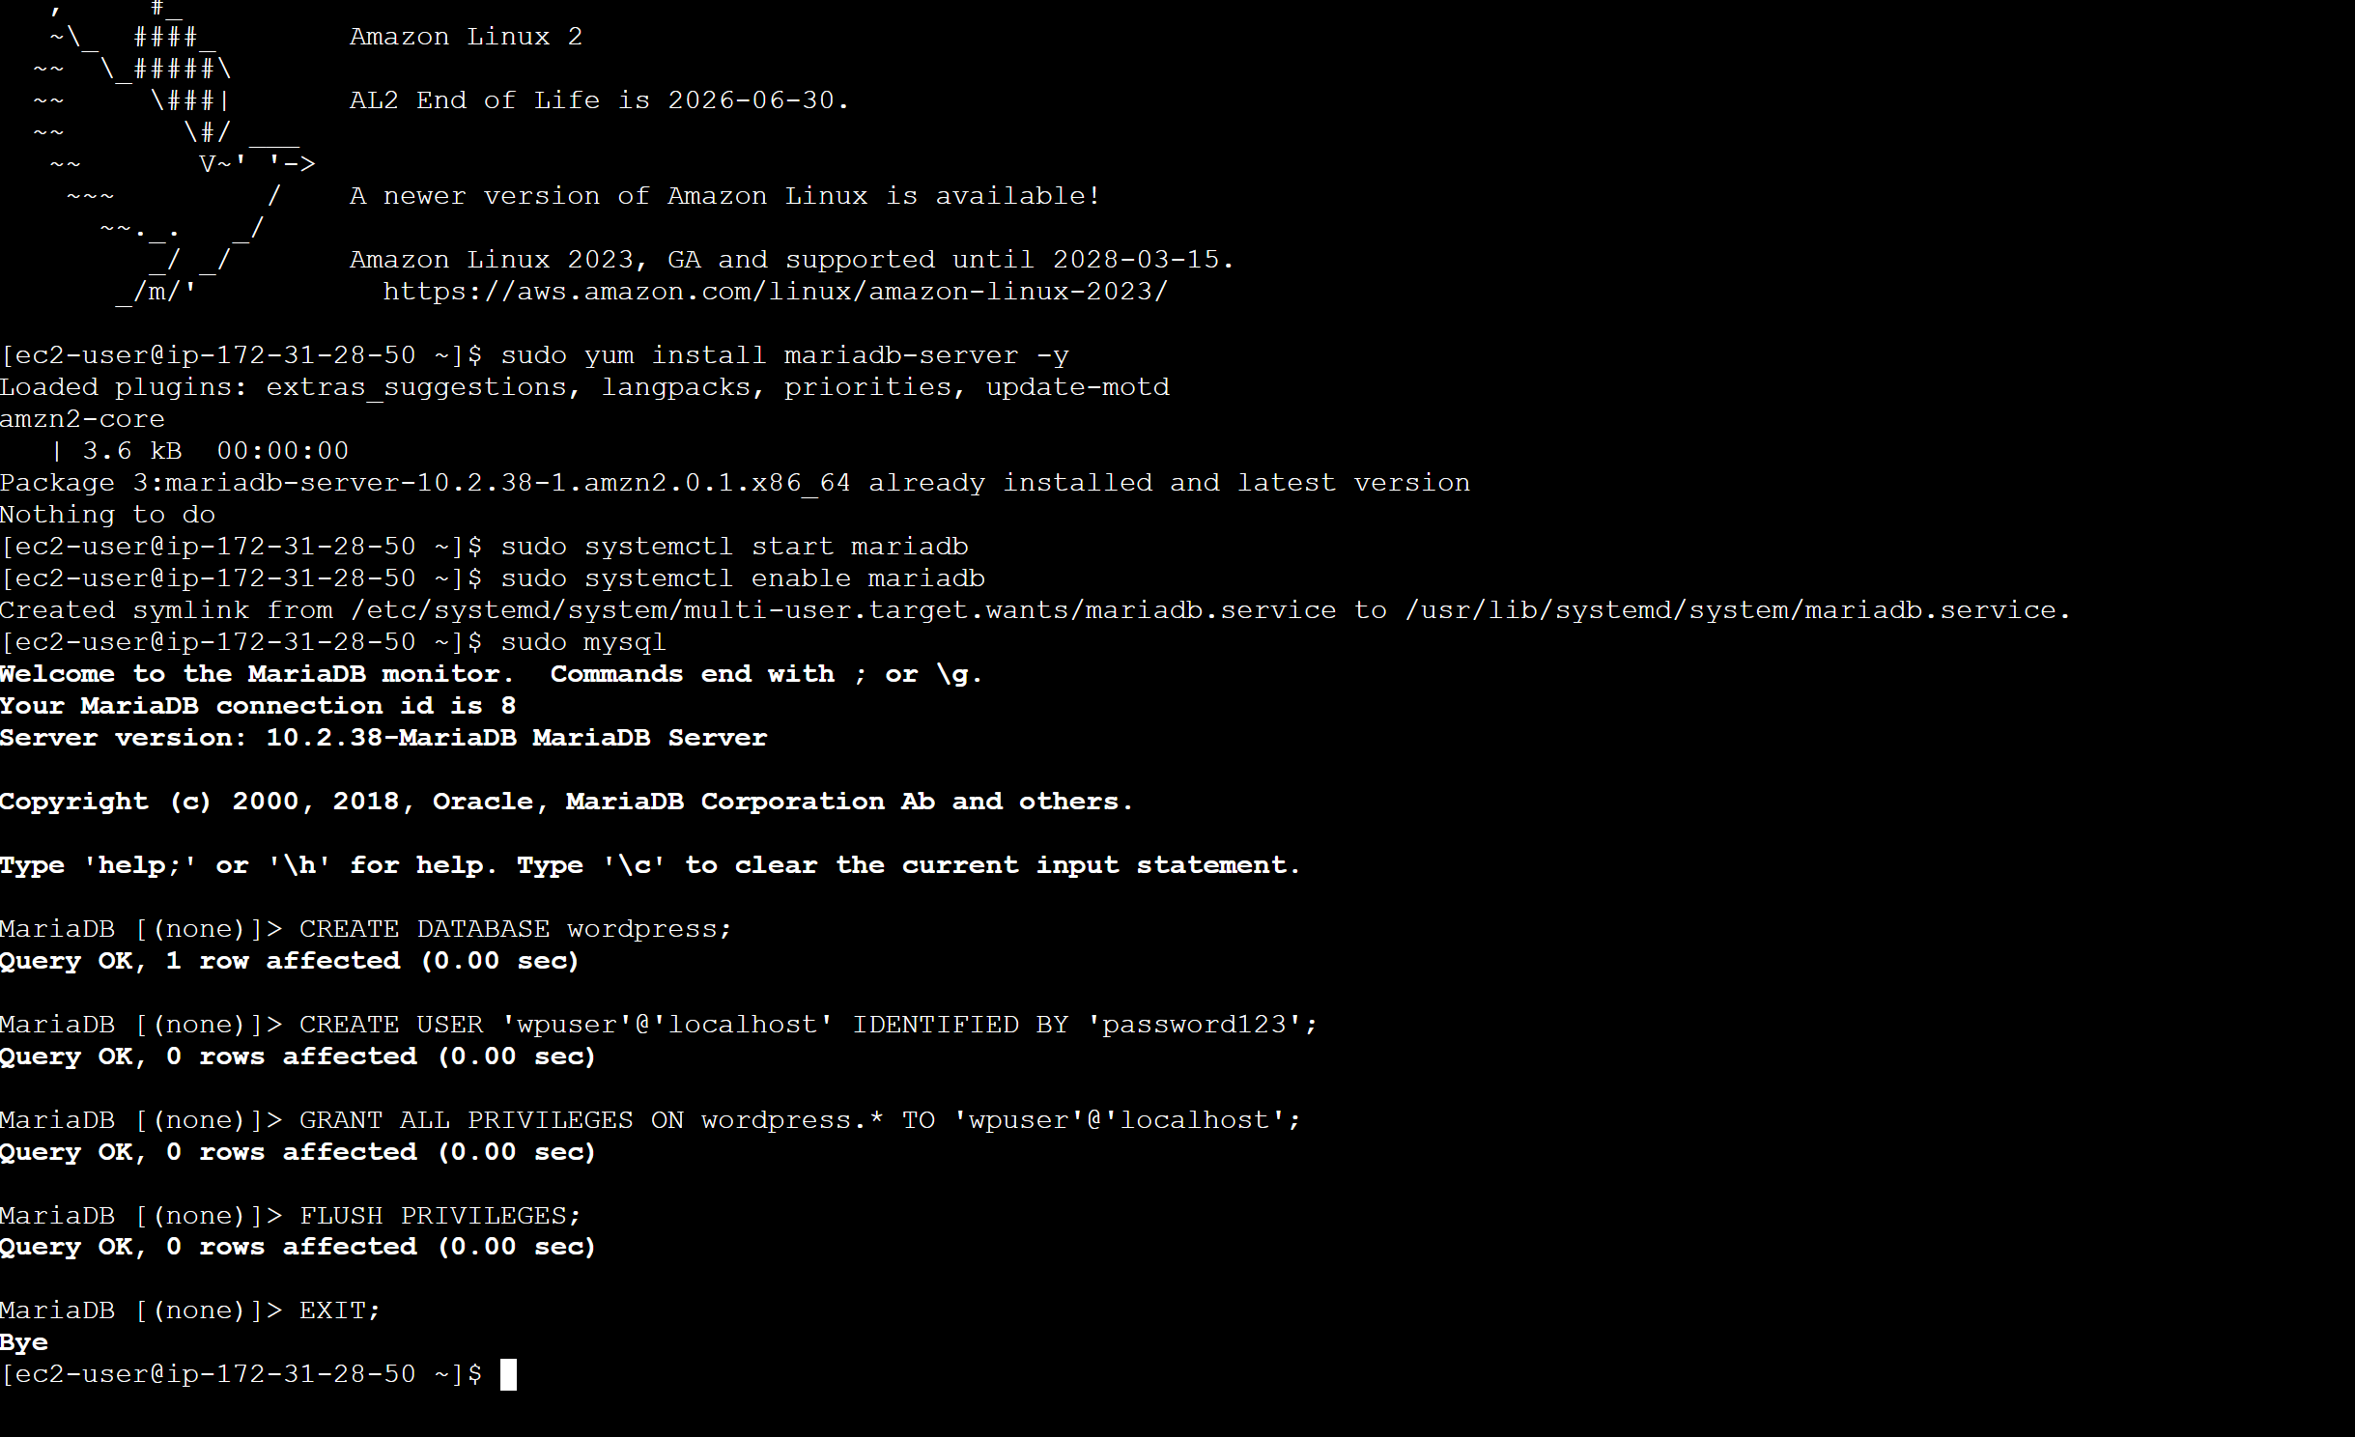

Step5
Fill WordPress Setup Page
Field | Value
Database Name | wordpress
Username | wpuser
Password | password123
Database Host | localhost
Table Prefix | wp_

Then you will see this

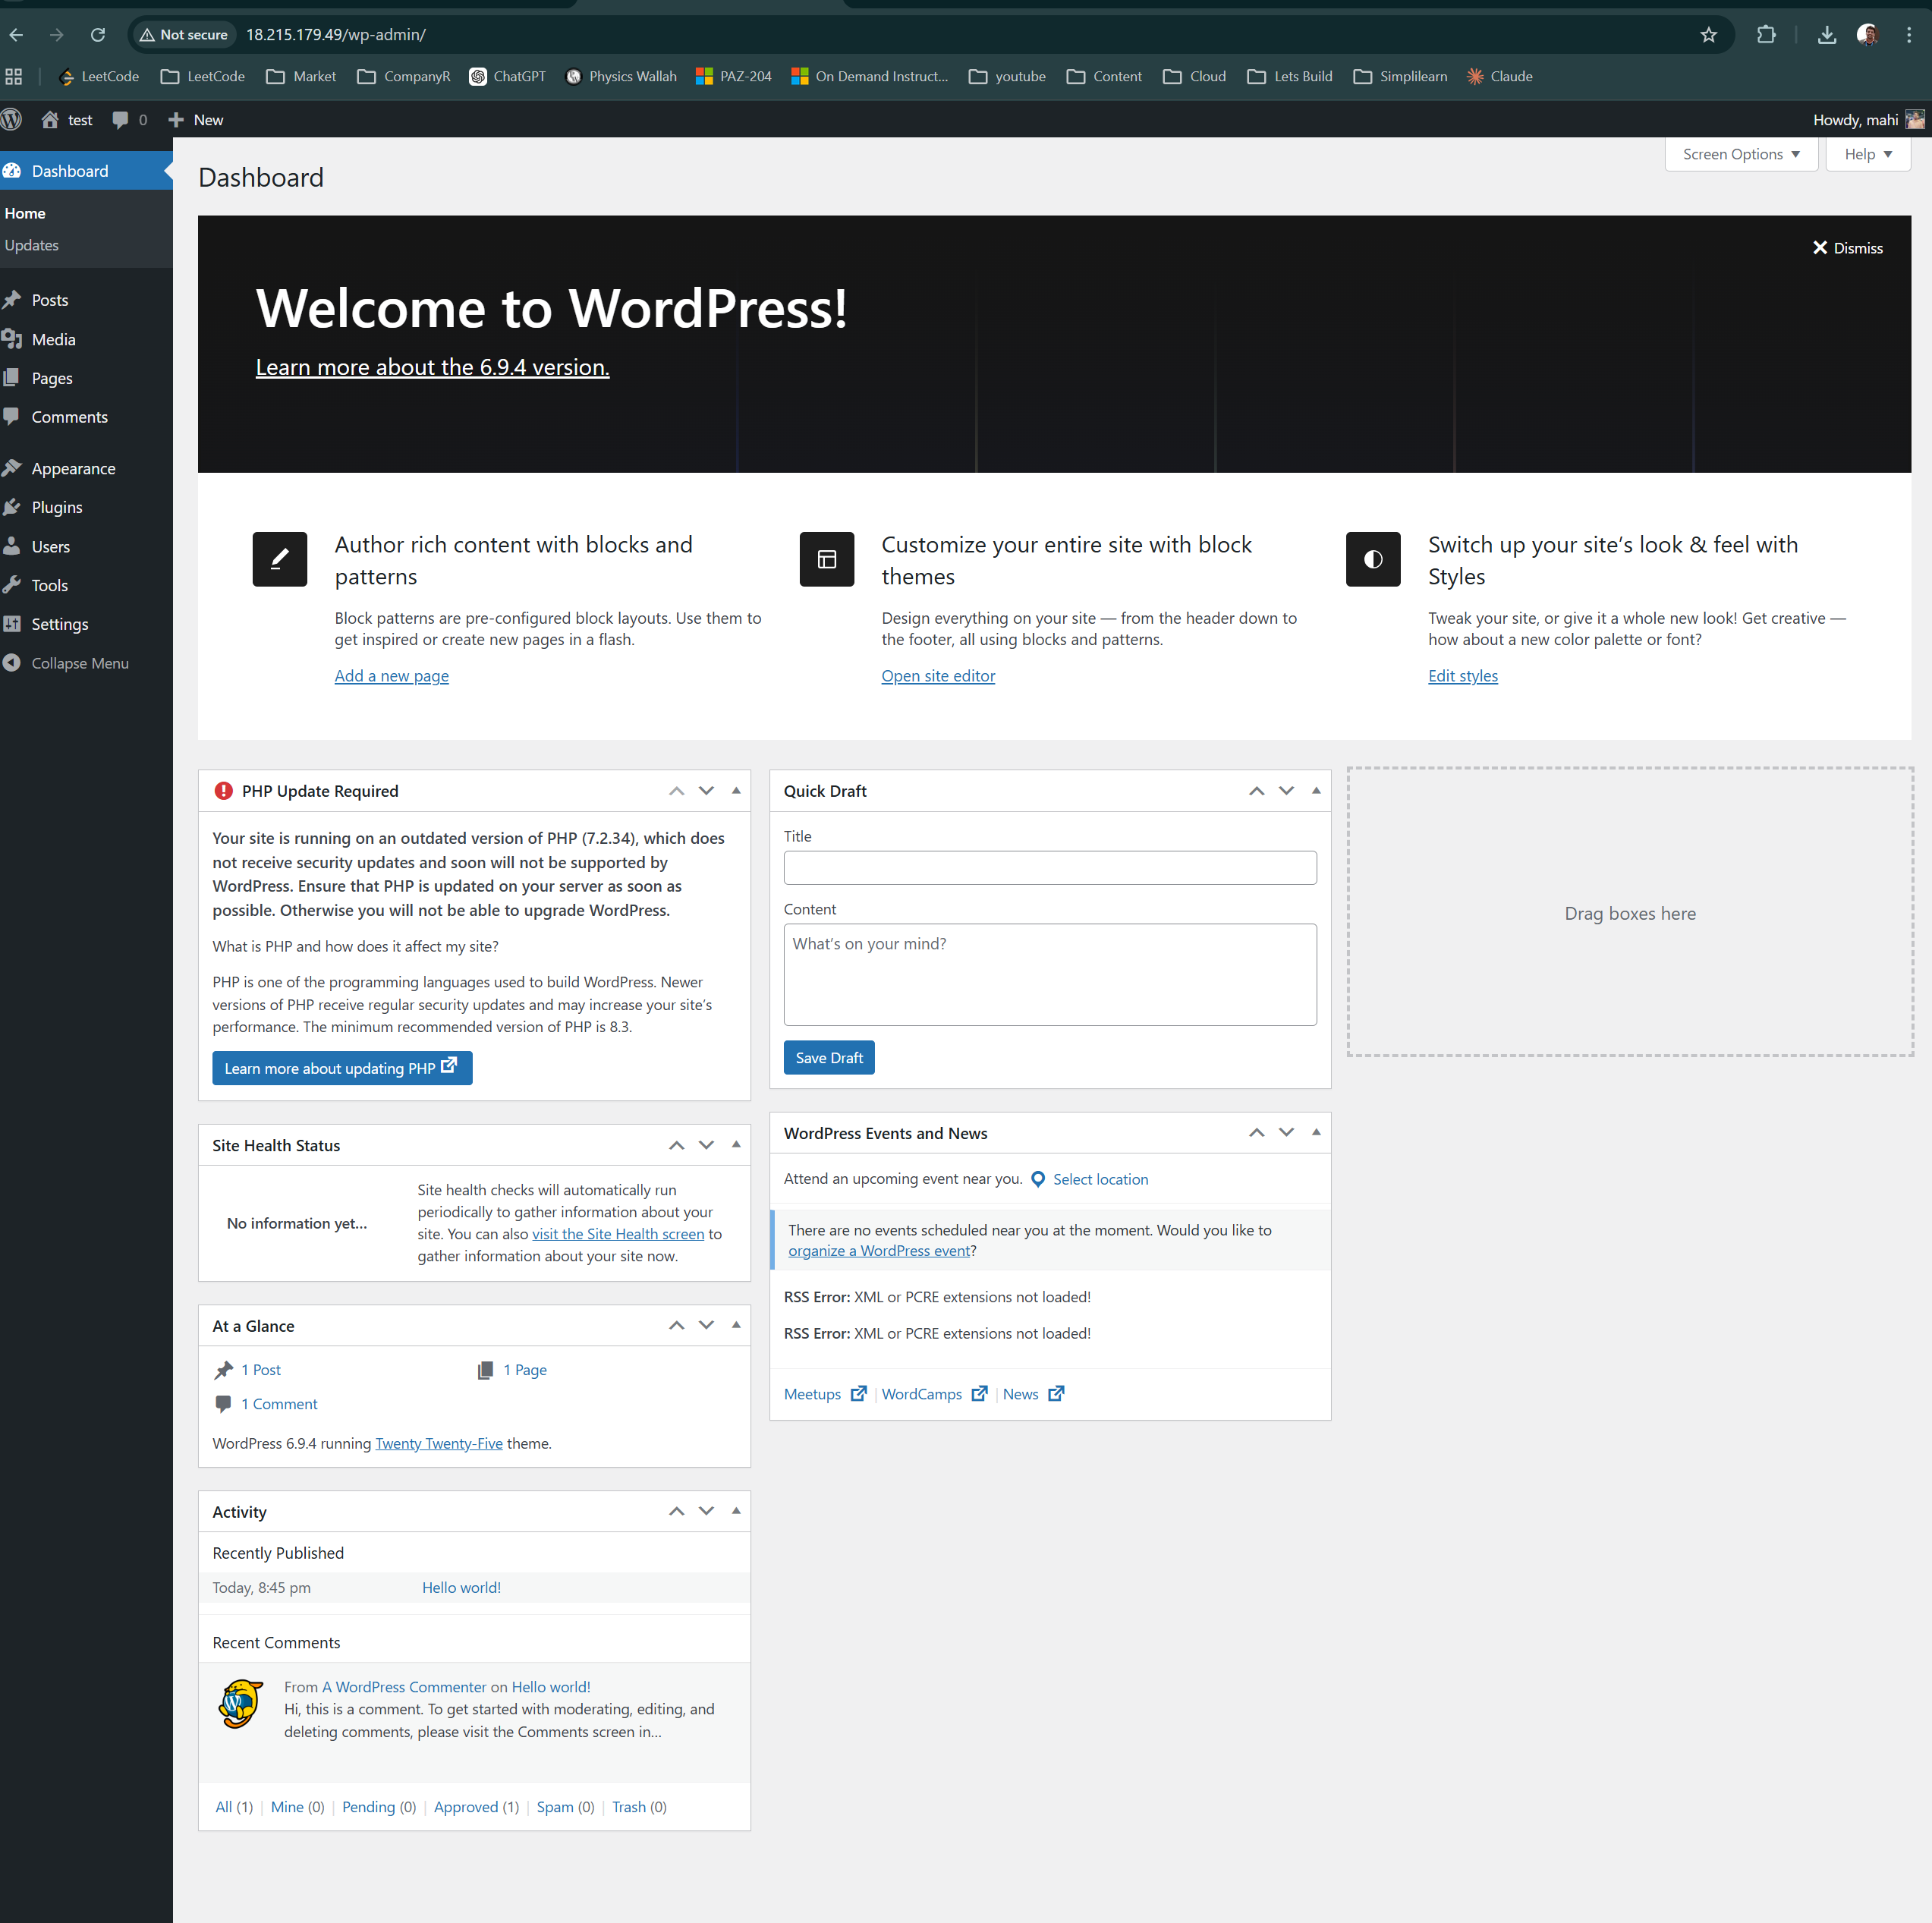

Demo Flow Summary
Project Structure
↓
terraform init
↓
terraform plan
↓
terraform apply
↓
Verify EC2
↓
Open WordPress
↓
Show CloudWatch
↓
terraform destroy
↓
Verify resources deleted

Important Safety Step
terraform destroy

