CSE 450: Quiz # 3 for Realsies

Name: __________________________
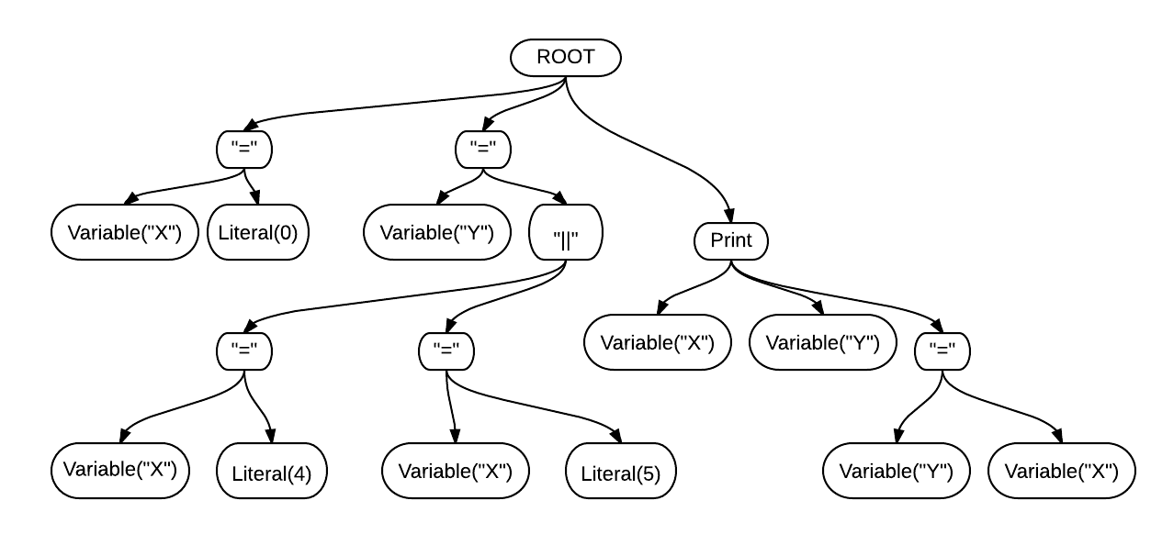
- (3pts) Given the Abstract Syntax Tree above, write source code (tube file) that could have generated it.

- (1 pt) For the same tree, write the output of executing the resulting Tube Intermediate Code through the virtual machine (TubeIC). You can ignore the newline character. Be sure to perform Boolean short-circuiting.

When done, turn over and (optionally) write some haiku's (5-7-5) for your grader's enjoyment.
CSE 450: Quiz # 3 for Realsies

Name: __________________________
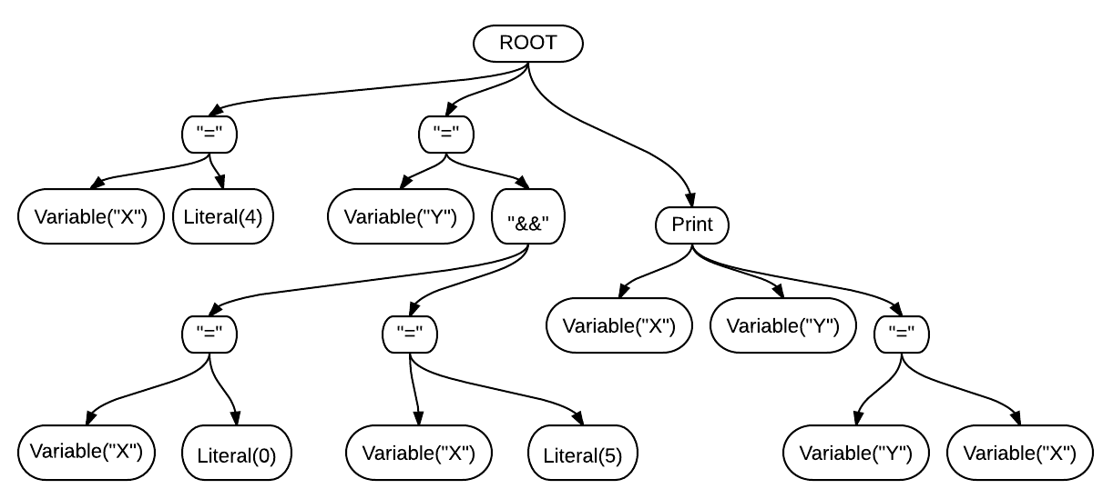

- (3pts) Given the Abstract Syntax Tree above, write source code (tube file) that could have generated it.

- (1 pt) For the same tree, write the output of executing the resulting Tube Intermediate Code through the virtual machine (TubeIC). You can ignore the newline character. Be sure to perform Boolean short-circuiting.

When done, turn over and (optionally) write some haiku's (5-7-5) for your grader's enjoyment.

