

**Tribhuvan University**

**Faculty of Humanities and Social Sciences**

**A PROJECT REPORT**

**On**

**ONLINE VOTING SYSTEM**

**Submitted to**

**Department of Computer Application**

**Ratna Rajya Laxmi Campus**

***In partial fulfillment of the requirements for the Bachelors in Computer Application***

Submitted by

Aman Humagain

Reg no: 6-2-40-3-2019

Manish Ghimire

Reg no:6-2-40-29-2019

August, 2022

Under the Supervision of

**Mr. Bhupendra Ram Luhar**



**Tribhuvan University**

**Faculty of Humanities and Social Sciences**

**Ratna Rajya Laxmi Campus**

**Supervisor’s Recommendation**

I hereby recommend that this project prepared under my supervision by AMAN HUMAGAIN and MANISH GHIMIRE entitled “**ONLINE VOTING SYSTEM”** in partial fulfillment of the requirements for the degree of Bachelor of Computer Application is recommended for the final evaluation.

**SIGNATURE**

Mr. Bhupendra Ram Luhar

**SUPERVISOR**

Department of Computer Application

Pradarshani Marg, Kathmandu



**Tribhuvan University**

**Faculty of Humanities and Social Sciences**

**Ratna Rajya Laxmi Campus**

**LETTER OF APPROVAL**

This is to certify that this project prepared by AMAN HUMAGAIN and MANISH GHIMIRE entitled “**ONLINE VOTING SYSTEM”** in partial fulfillment of the requirements for the degree of Bachelor in Computer Application has been evaluated. In our opinion it is satisfactory in the scope and quality as a project for the required degree.

|  |  |
| --- | --- |
| Mr. Bhupendra Ram Luhar  Department of Computer Application  Pradarshani Marg, Kathmandu | Dr. Buddhi Prasad Sapkota  Department of Computer Application  Pradarshani Marg, Kathmandu |
| **Internal Examiner** | **External Examiner** |

**ACKNOWLEDGEMENT**

The project work presented in this report has been carried out and presented at  
Ratna Rajya Laxmi Campus, Faculty of Humanities and Social Sciences Tribhuvan University of Technology as a part of Bachelors of Arts in Computer Application. Project is a test of not only technical skills but also team work and performance under various constraints. This journey cannot be successfully accomplished without help from experts.

Furthermore, we would like to thank our lecturers of the Department of Computer Application  
for their kindness in sharing their knowledge with us which in different ways has helped us in coming up with this project and being there for us when we needed them, our friends who  
have always been there to support us and our respondents who gave us feedbacks on  
improving our project work.

We will be ever grateful to our supervisor **Mr. Bhupendra Ram Luhar**, Lecturer without whose guidance, this project would not have become successful.

We are also grateful to our department coordinator **Dr. Buddhi Prasad Sapkota**.

Finally, our greatest appreciation and love goes to our families, friends and mentors and for sure this would not have happened without their unconditional love, care and support.

# **ABSTRACT**

Prevalent paper-based voting system has lots of cons as we have seen it being implemented from decades. First, it can be manipulated so easily and mistakes are so likely to occur. Secondly, the vote count might not be accurate enough as it’s done by humans. The ballots could be stolen or destroyed. It also requires lots of manpower and resources. As it is paper based utilizes lots of papers which requires more effort for recycling and cleaning afterwards making it not so environmentally friendly.

So, the objective of this project is to review the existing system and overcome the possible flaws present in the current system by introducing another system Online Voting System. The main aim of this project has been to minimize the use of papers and human resources.

Hence the implementation of the system overcomes some of the major problem faced by paper-based voting system. The problem of accessibility of existing system is eliminated to some extent using the Online Voting System. It can be concluded that this system increases participation in elections.

***Keywords:*** voting system**,** onlinevoting system, paper ballots, e-voting.

**Table of Contents**

**ACKNOWLEDGEMENT** i

**ABSTRACT** ii

**List of Figures** iv

**List of Tables** iv

**List of Abbreviations** iv

**Chapter 1: Introduction** 1

**1.1** **Introduction** 1

**1.2** **Problem Statement** 2

**1.3** **Objectives** 2

**1.4** **Scope and** **Limitation** 3

**1.5** **Report Organization** 3

**Chapter2: Background Study and Literature Review** 4

**2.1** **Background Study** 4

**2.2** **Literature Review** 4

**Chapter 3: System Analysis and Design** 6

**3.1** **System Analysis** 6

**3.1.1** **Requirement Analysis** 6

**3.1.2** **Feasibility Analysis** 7

**3.1.3** **Data Modeling using ER-Diagram** 8

**3.1.4** **Process Modeling using DFD** 8

**3.2** **System Design** 10

**3.2.1** **Architectural Design** 10

**3.2.2** **Database Schema Design** 11

**3.2.3** **Interface Design (UI Interface / Interface Structure Diagrams)** 11

**3.2.4** **Physical DFD** 13

**Chapter 4: Implementation and Testing** 14

**4.1** **Implementation** 14

**4.1.1** **Tools Used (CASE tools, Programming languages, Database platforms)** 14

**4.1.2** **Implementation Details of Modules** 14

**4.2** **Testing** 15

**4.2.1** **Test Cases for Unit Testing** 15

**4.2.2** **Test Cases for System Testing** 19

**Chapter 5: Conclusion and Future Recommendations** 21

**5.1** **Lesson Learnt / Outcome** 21

**5.2** **Conclusion** 21

**5.3** **Future Recommendations** 21

**References** 22

**Appendices** 23

# **List of Figures**

Figure 3.1 Use Case Diagram of Online Voting System 6

Figure 3.2 Gantt Chart of Online Voting System 8

Figure 3.3 Online Voting System ER Diagram 8

Figure 3.4 Context Level Diagram of Online Voting System 9

Figure 3.5 Level 1 DFD of Online Voting System 9

Figure 3.6 Architectural Design of Online Voting System 10

Figure 3.7 Database design of Online Voting System 11

Figure 3. 8 Registration Page 11

Figure 3.9 Login Page 12

Figure 3. 10 Admin Panel 12

Figure 3. 11 Physical DFD of Online Voting System 13

# **List of Tables**

Table 4.1 Testing Registration Form 15

Table 4.2 Testing Login Form 16

Table 4.3: Testing Admin Dashboard 17

Table 4.4: Testing Voter/Candidate Dashboard 18

Table 4.5 Testing Whole System 19

# **List of Abbreviations**

**OVS**: Online Voting System

**ID**: Identity

**PIN**: Personal Identification Number

**HTML**: HyperText Markup Language

**CSS**: Cascading Style Sheets

**PHP**: HyperText Preprocessor

**DFD**: Data Flow Diagram

**ER**: Entity-Relationship

**UI**: User Interface

**CASE:** Computer Aided Software Engineering

# **Chapter 1: Introduction**

## **Introduction**

Democracy grants every citizen the right to vote for choosing head of the states. That means election should be fairly conducted. Elections are must under democratic system which happens in business environment, educational environment, social organizations and in state’s governance. Paper-based voting system in which everything was done with hands from casting to counting of votes, were in implementation in many states and organizations for conducting elections. Paper ballots are subject to be corrupted, malicious, manipulative and very high chance of occurrence of physical hazards. After that electronic tabulation was introduced in which voters cast votes manually but counted electronically and it is still in implementation. All these traditional systems require more manpower for almost all the work such as for securely transporting paper ballots, counting votes, etc. so it is labor intensive and costly. Also, it might require training workshops on how to conduct fair elections or on how to cast votes in a proper way.

Online voting system allows voters to cast their votes without their physical presence rather from where they are with their devices connected to internet. It is also referred as I-voting, online election system or online e-voting. It is one of the levels to e-voting system. Online voting is nothing but a secure voting tool that allows voters to cast vote and view results. Online voting system just integrates the voting system with this era of information and technology. Everything done in past elections manually by hands could be digitalized with the help of online voting system. So, to overcome this and for paperless system Online Voting System can be implemented. Online Voting requires nothing but a digital platform so it saves lots of resources and it is environment-friendly. Also, it is precise and consumes less time. It is secure and also provides security to the voters as one can cast votes from anywhere when connected to the system. It is safe and secure collection of votes. As it is online, the need to gather in-person, cast votes using paper, etc. are overcome. Online voting can be implemented for electing organizational leaders, staffs, for choosing company’s policy, for selections, etc. It is done through web which means it guarantees more numbers of voter than in past elections conducted in paper-ballot system so it increases voter-turnout [1]. Mainly, it increases involvement of youth of the country in elections i.e., vital for country’s future.

Therefore, there is need of Online voting system where people can vote freely feeling secure with very less chance of physical hazards. This project is mainly aimed to provide convenient environment for the voters and to minimize the use of papers in elections by conducting it digitally. It is a web-based voting system with secure interface to cast votes. In this project, a feasible online voting system is designed and implemented. Traditional electoral methods are simplified and digitalized with information technology by saving human resources and time. In this system, citizens must be 18 years of age or above to be registered for being able to cast votes to be a voter. In this system, voters regardless of any race, gender, religion can cast vote online without physical presence [2]. Registration of the candidates are manually done by the system administrator whereas voters themselves fill the forms with their personal details and submit to the system. After the registration, voters are assigned username and password to sign in to the system for casting votes. Invalid log in details redirects users to the same login page where there is an option to register as a voter. In the system’s database names of all the voters are stored including their essential information.

## **Problem Statement**

There are lots of drawbacks of that is both previous and present voting system requires lots of human resource, time and money. And mainly it requires lots of paper and paperwork for registration, identification, authentication, etc. Also, there are malpractices in the elections which results in chaos and violence. Hence, there is need of replacement of current voting system with online voting system which could overcome cons of previous system.

## **Objectives**

The objectives of project are:

* To let users, select roles.
* To let all the user cast votes.
* To view vote counts.

## **Scope and** **Limitation**

This document describes the requirement analysis and designing of the system. The scope of the project has been to successfully develop a paperless online voting system which is environment friendly. The system can be used anytime from anywhere. Multiple votes from the same users can’t be casted. It is easier to use with friendly interface.

The authentication part of the system is not so professional. Function for specifying voting time is not present in the system.

## **Report Organization**

The report can be organized into 5 chapters which are given below:

**Chapter 1** includes introduction includes the brief introduction of the system, statement of problem, objectives, scope and limitation.

**Chapter 2** includes background study and literature review includes the previous work related to the systems and similar works were studied and are summarized.

**Chapter 3** includes system analysis and design includes different feasibility analysis and designed system architecture, system flow diagram, dataflow diagram.

**Chapter 4** includes implementation and testing includes various implementation method and tools and also contains description of testing.

**Chapter 5** includes conclusion and future recommendations includes outcomes of the system, conclusion to the system and description about what features can be added in the future.

# **Chapter2: Background Study and Literature Review**



## **Background Study**

Democracy is a system of governance in which people have the authority to deliberate and decide legislation or to choose governing officials to make laws. In democracy the supreme power lies in the people. People choose their representatives in democracy through elections. Election is a major part of democracy of which voting is the core component. Election is a formal decision-making process by which a mass chooses individuals as their representation to hold the authority to govern and make legislature.

Paper-based voting system is a voting system in which ballots are used to cast votes. Ballots are papers or small balls used in secret voting [2]. Online voting system is the modern way of voting using digital technologies like internet and computers.

## **Literature Review**

The existing system of election is running manually i.e., paper-ballot system. The Voter has to visit to booths to vote a candidate so there is wastage of time [3]. The voter has to manually register into the voter list. Vote counting has to be done manually. All the information of the voter or Candidate is to be filling in manually. Voter must be present physically to cast votes [4].

Implementation of voting via internet was tried but was not quite successful on designing a secure and efficient designing of voting system. Electronic voting was also used in elections in Estonia where the system included the use of smart card and electronic signatures. There was internet voting system that offered voting through different identification like ID card and PIN codes, Digital ID, Mobile numbers, etc. [5].

Previously, many efforts have been carried out for developing an efficient online voting system for election purpose. There are various implementations of electronic voting system around the world but it differs slightly from online voting system as an electronic voting system may require human clerks tallying the votes upon termination of the election process as it uses biometrics and coded voter cards [6].

Paper ballots are the traditional tool used for voting. Paper ballots are usually punched or marked by a human and then tallied by machine. Paper ballots come at a much cheaper cost than electronic systems. They also reduce the attack surface on an election by removing the possibility of a soft-ware/hardware attack. Paper ballots rely on physical security and trust in the polling stations to not manipulate them and to properly handle them. [7]

When it comes time to cast a vote, the voter once again launches the application and logs  
in to the previously registered account. The application requests a ballot from the Ballot  
Regulator (via the application server). The Ballot Regulator checks Blockchain A for the  
requesting voter’s address, and ensures it is signed by the Verifier. If the address does exist on Blockchain A, then the Ballot Regulator sends the voter the appropriate regional ballot. The voter marks their responses. Before submitting the ballot, the voting application encrypts the vote using the Ballot Regulator’s Public Voting key.[8]

It is helpful to know if those that vote by paper are committed to that voting method, or  
if they would be willing to vote online in a future election, Figure 23. To get a sense of this willingness respondents were asked whether they would be inclined to vote online under particular circumstances. Forty-seven percent said they would use Internet voting in a future election under special circumstances such as in cases of illness, inclement weather, mobility issues, or because they were traveling. This speaks to both the convenience and accessibility of Internet voting as a remote voting method, which can make casting a ballot easier institution where an elector is not able to make it to the polls. About one-third (30 percent) of respondents said they would use Internet voting in future ‘no matter what’ and 16 percent commented they would not use it at all. While some paper voters are inclined to vote by Internet in a future election then, the majority of this group would elect to make use of the voting method under particular situations where they could not physically make it to a poll location.[9]

Hence, there are many efforts applied in the field of voting system and many organizations & countries has adopted it but most of them are not web-based online voting system.

# **Chapter 3: System Analysis and Design**



## **System Analysis**

Requirement collection provides detailed analysis of user requirements, functional & non-functional requirement and system requirement. The front-end is done using HTML&CSS whereas in back-end JavaScript is used for Client side and PHP for Server side. MySQL is used for Database programming.

### **Requirement Analysis**

1. **Functional Requirement:**

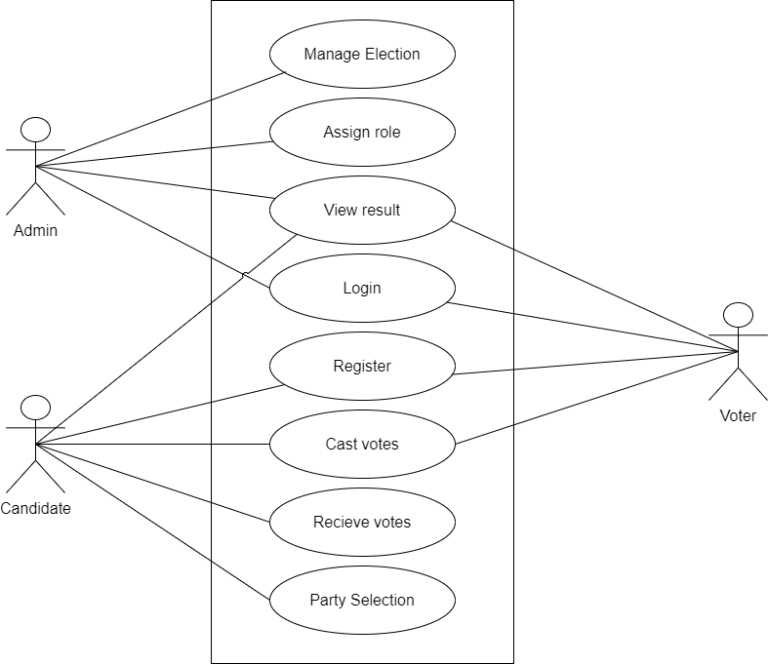

Figure 3.1 Use Case Diagram of Online Voting System

The use case diagram represents the requirement of the system comprising use cases, voters, admin and their relationships. This use case diagram shows functional requirement of the system between admin and the user when registered as a voter. When registered as a voter, he/she can login to cast vote to the candidate. Candidate can receive vote and select party. Admin looks after the overall management of the system.

To cast vote, one must register, unregistered user can’t cast vote. User logins to the system by entering valid user id and password. User can cast vote only once after they login and same credentials can’t be used to cast vote. User logs out of the system after casting the vote.

1. **Non-functional Requirement:**

The system has form-based interface for data entry and stores reports in formatted in a table and for user friendliness. The system is expected to have reasonable short time response.

### **Feasibility Analysis**

1. **Technical Feasibility**

Since the project is design with PHP as code behind and MySQL as backend it is easy to install in the systems whenever needed. It is more efficient, easy and user friendly to understand by almost everyone. Huge amount of data can be handled efficiently using MySQL as backend. Hence this project has good technical feasibility.

1. **Operational Feasibility**

The system is operationally feasible as it provides enough response and throughput time. Also, manpower to operate this system are easily available.

1. **Economic Feasibility**

Economic feasibility is mainly concern with the cost incurred during their implementation of the software. Since the project is developed using PHP and MySQL which is more commonly available and free. Similarly, it is to recruit persons for operating the software. Since almost all the people are aware of PHP and MySQL. Even if we want to train the person in these areas, the cost involved in training is also very less. Hence this project has good economic feasibility.

1. **Schedule Feasibility**

The time required to complete the project is calculated and classified using the following Gantt Chart:

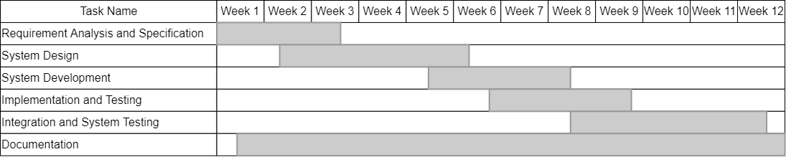

Figure 3.2 Gantt Chart of Online Voting System

### **Data Modeling using ER-Diagram**

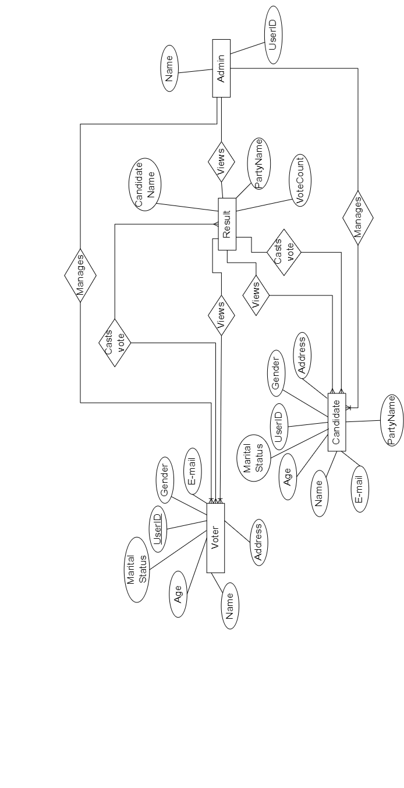

Figure 3.3 Online Voting System ER Diagram

This model shows entities, relationships between entities, mapping and the entity relationship models. User provides all the required information and gets a role. When assigned voter, he/she can cast vote. When assigned candidate he/she is assigned party. Vote count gets number of casted votes along with party name, voter info and provides it to result which can be viewed by everyone.

### **Process Modeling using DFD**

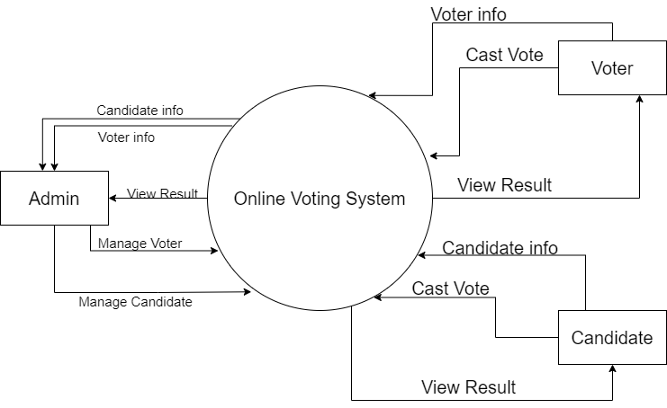

Figure 3.4 Context Level Diagram of Online Voting System

User needs to register in the system and should provide their information to get role. Candidate and Voters both can cast vote. Admin manages all users and everyone can view result.

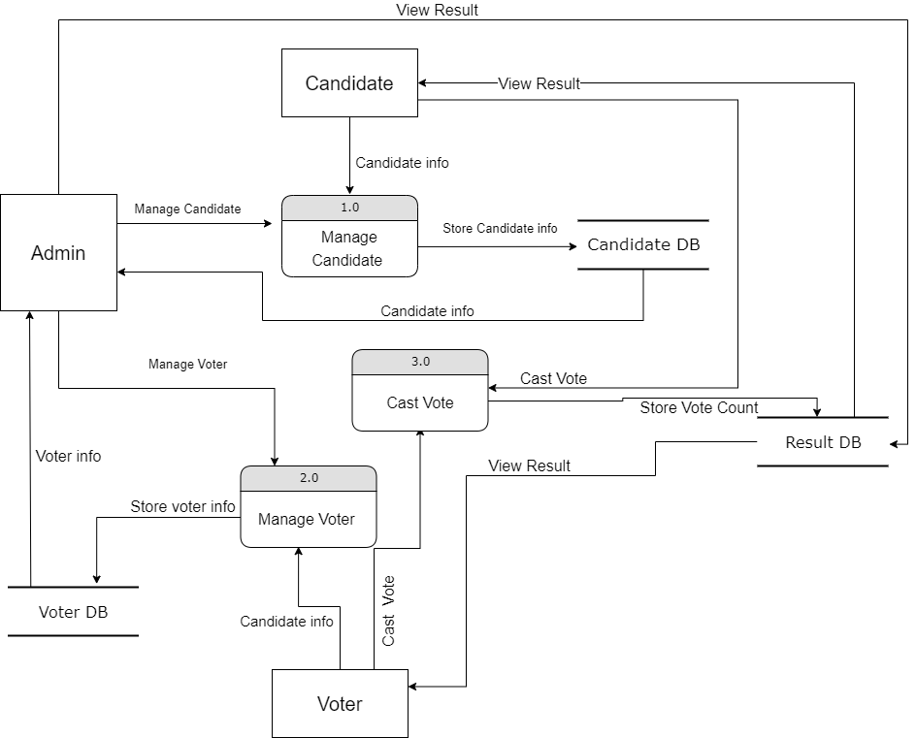

Figure 3.5 Level 1 DFD of Online Voting System

DFD is an abstract description of the system. DFDs are in levels which represent increasing information flow and functional detail. User chooses a role either as a voter or a candidate. All the registration vote and voting details are stored in the database. As admin manages election, he/she manages voters and candidate information too. System generates result which can be viewed by all actors.

## **System Design**

### **Architectural Design**

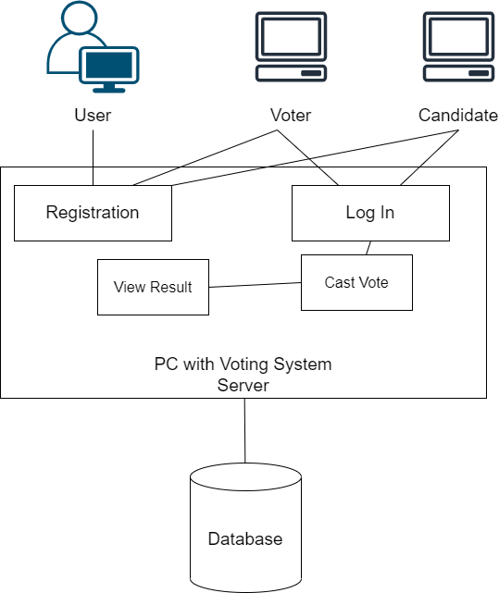

Figure 3.6 Architectural Design of Online Voting System

User takes role as either voter or candidate during registration who then login into the system to cast the vote and view result which are stored in the database.

### **Database Schema Design**

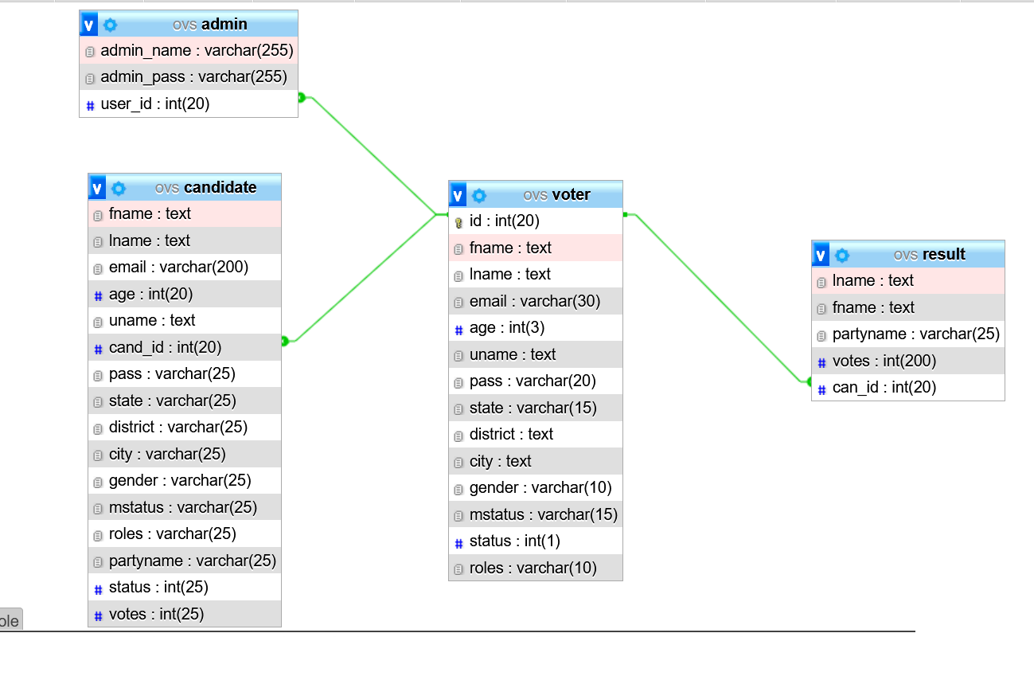

Figure 3.7 Database design of Online Voting System

The database of Online Voting System is maintained with 4 tables as per the ER diagram. As every candidate is a voter, id of voter is assigned as primary key whereas other id in other tables is reference to it.

### **Interface Design (UI Interface / Interface Structure Diagrams)**

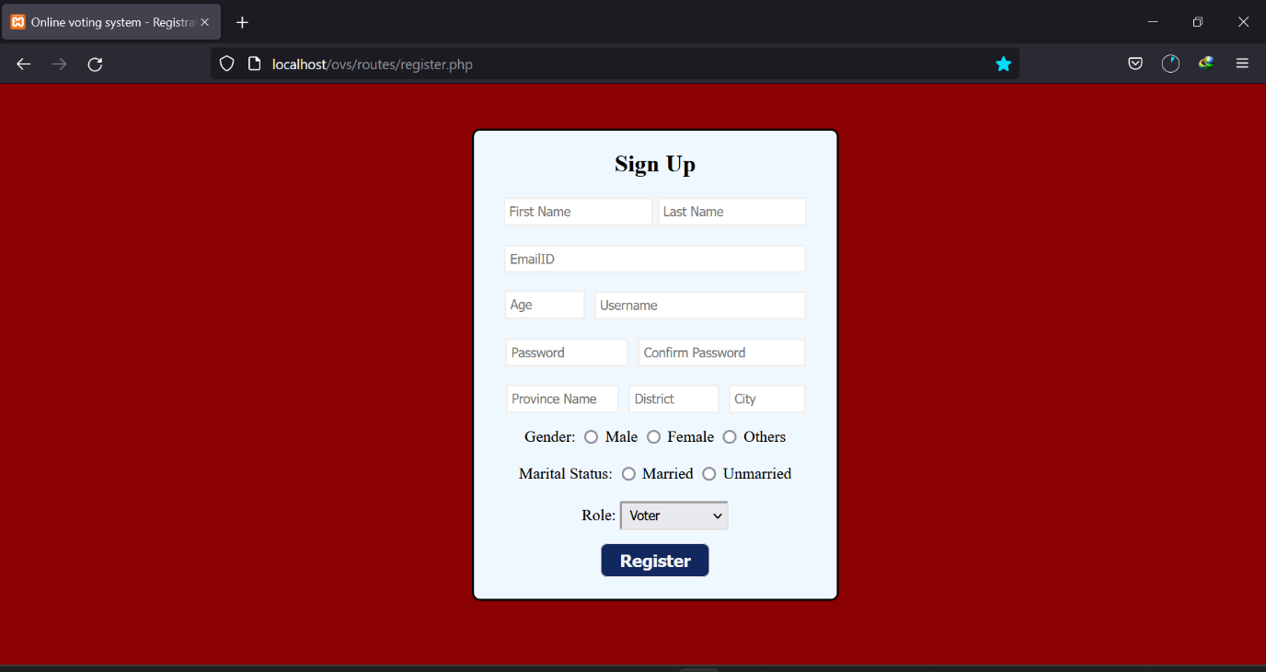

Figure 3. 8 Registration Page

Here is the interface design of the registration page. Text Box, Radio Button- and Drop-Down lists are used in registration form.

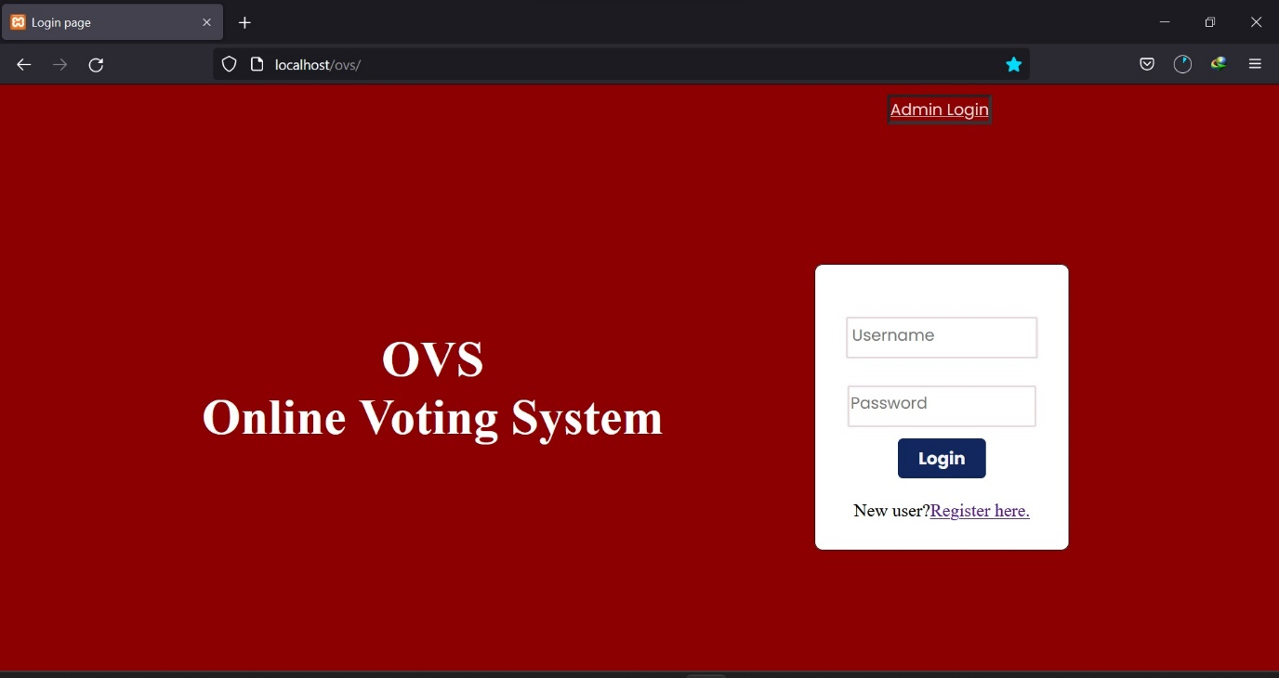

Figure 3.9 Login Page

This is the main page of the system from which the user logs in or goes to registration page. It contains Text Box, Button,etc.

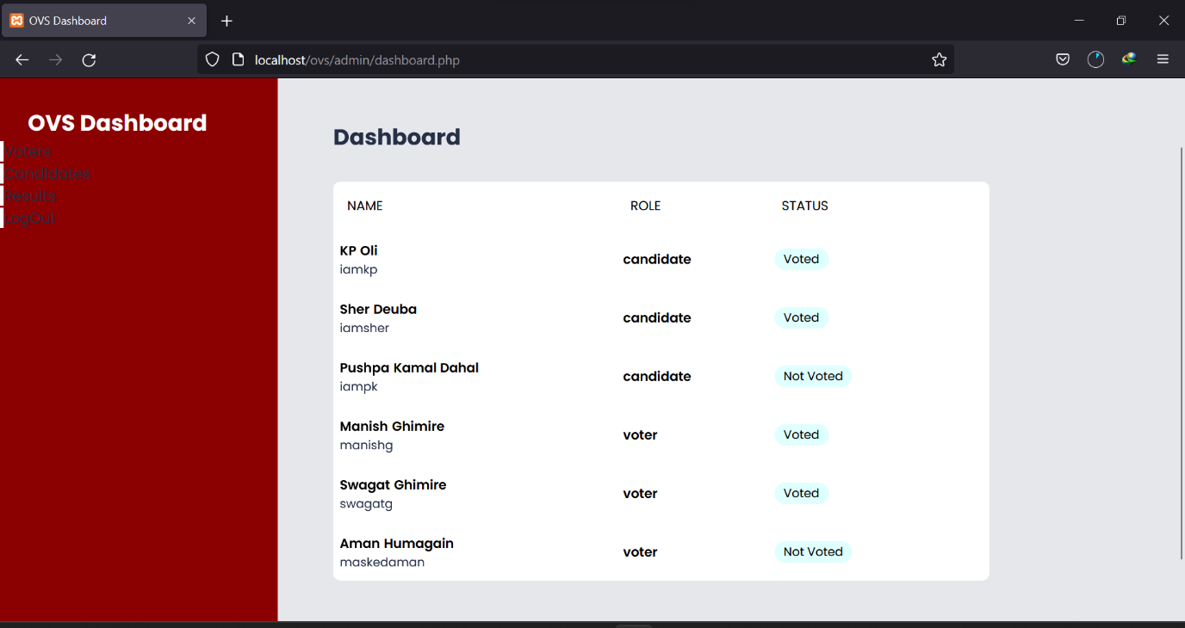

Figure 3. 10 Admin Panel

This is the Admin’s dashboard of the system from which the manages voters and candidates and also views result from the list of menu in the left side of the page.

### **Physical DFD**

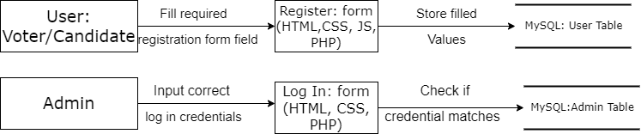

Figure 3. 11 Physical DFD of Online Voting System

The registration is implemented by making a register form in PHP designed using HTML and CSS which accepts user’s information and stores it to respective database table. If the user doesn’t fill all the required fields then the registration is not submitted. Admin fills the log in form with their login credentials,if matches with credentials stored in admin’s database then access is granted.

# **Chapter 4: Implementation and Testing**



## **Implementation**

The implementation phase involves the application of the design specifications done before. The implementation involves coding of the system designs if this project, systems testing and live running.

### **Tools Used (CASE tools, Programming languages, Database platforms)**

Diagramming tools such as draw.io, lucid chart and dia were used for graphical representation of the data and systems. These were used to make flowcharts, DFD, ER diagrams, Gantt Charts, etc. MSWord was used for the documentation. Visual Studio Code was used to write, edit and compile the codes. PHP, JavaScript, CSS, HTML was used to build the webapp. XAMPP was used to host the webapp. MySQL was used to design the database for data storage.

### **Implementation Details of Modules**

**User Registration**: Users have to register into the system before they can cast votes. User is required to fill the registration form with text boxes, radio buttons for user information, dropdown list for role and party selection. User can choose two roles while registering:

1. As a Voter: When selects Voter form the dropdown menu in role, he/she is assigned the role of voter.
2. As a Candidate: When user selects Candidate from the dropdown menu in role, he/she is allowed to choose the party. After selecting the party name, they can proceed to get the role of candidate.

To be able to register into the system one must be at least 18 years old.

**User login**: Users are required to login to the system after only complete registration. Users are only able to login in the system with the username and password they registered their account with.

**Cast Vote**: Any user either voter or candidate logged in into the system is able to cast their vote to their favorite candidate. They can cast vote as soon as they login to the system through voting dashboard.

**Admin Dashboard Panel**: Admin after logging in can edit or delete user’s details or the users themselves through admin dashboard.

**View Result**: Any user logged in into the system can see the vote count of every candidate from the dashboard.

**User logout**: User is automatically signed out of the system after casting their vote. So, the same user can’t cast multiple votes.

## **Testing**

### **Test Cases for Unit Testing**

The system comprises of registration form, login form, admin dashboard, voter/candidate dashboard and for each case unit testing is done.

**Table 4.1 Testing Registration Form**

|  |  |  |  |  |  |  |  |
| --- | --- | --- | --- | --- | --- | --- | --- |
| S N | Test Case ID | Test Case  Name | Test Case Description | Step | Expected Result | Actual Result | Test  Case Status  Pass/  Fail |
| 01 | TC 01 | Registration  Form  Password validation | Input unmatched password | Input unmatched password | Display message “Password and Re-enter password must match.” | Display message “Password and Re-enter password must match.” | Pass |
| 02 | TC 02 | Registration Form email  validation | Email validation | Input email | If same email alert display message “Email already exists.” | Message displayed “Email already exists.” | Pass |
| 03 | TC 03 | Registration  Form  validation | Provide valid username password email | Provide valid username password email | Display alert message “Registered  Successfully” | Display alert  message “Registered  Successfully” | Pass |

**Table 4.2 Testing Login Form**

|  |  |  |  |  |  |  |  |  |
| --- | --- | --- | --- | --- | --- | --- | --- | --- |
| SN | Test  Case id | Test  Case  Name | Test  Case  User | Test Case Description | Step | Expected Result | Actual Result | Test Case status  Pass/  Fail |
| 1. | TC 04 | Validate  Login | Admin | Enter valid username,  email and password | Choose user type  Admin  Enter username, email and password | Login Successful or an error message “Invalid credentials” must be displayed. | Successful  Login Directed to Admin dashboard. | Pass |
| 2. | TC 05 | Validate  Login | Voter/Candidate | Enter valid email and password | Enter email and password | Login Successful or an error message “Invalid credentials” must be displayed. | Successful  Login Directed to  Voting Dashboard. | Pass |
| 3. | TC  06 | PREVIEW |  | To check  if the  admin, candidate and voter will be able to visit their respective  dashboard | Enter valid username email and password | Successfully Visit their own dashboard | Successfully Visit their own dashboard | Pass |

**Table 4.3: Testing Admin Dashboard**

|  |  |  |  |  |  |  |  |
| --- | --- | --- | --- | --- | --- | --- | --- |
| SN | Test  Case  ID | Test  Case  Name | Test Case Description | Step | Expected Result | Actual Result | Test  Case  Status  Pass/Fail |
| 1. | TC 07 | Edit Voter | Edit selected Voter data | Click on manage Voter and then click edit to edit selected Voter | Display form to edit Voter details and then Updated successfully message should be displayed | Updated successfully | Pass |
| 2. | TC 08 | Delete Voter | Delete selected Voter data | Click on manage Voter and then click delete to delete selected voter | Delete selected Voter  details | Deleted successfully | Pass |
| 3. | TC 09 | Edit Candidate | Edit selected candidate data | Click on manage candidate and then click edit to edit selected candidate | Display form to edit candidate details and then Updated successfully message should be displayed | Updated successfully | Pass |
| 4. | TC 10 | Delete Candidate | Delete selected candidate data | Click on manage candidate and then click delete to delete selected candidate | Delete selected candidate details | Deleted successfully | Pass |
| 5. | TC 11 | Logout | To exit from the dashboard | Click on  logout | Direct to index page | Directed to index page | Pass |

**Table 4.4: Testing Voter/Candidate Dashboard**

|  |  |  |  |  |  |  |  |
| --- | --- | --- | --- | --- | --- | --- | --- |
| SN | Test  Case  ID | Test Case  Name | Test Case Description | Step | Expected Result | Actual Result | Test  Case Stat us Pass  /Fail |
| 01 | TC 12 | View Candidates | View candidates in election | Log in | Display candidates | Displayed candidates | Pass |
| 02 | TC 13 | Cast Votes | Cast vote to candidate | Click on vote | Increase vote count | Increase vote count | Pass |
| 03 | TC 14 | View votes | View vote counts | Select candidate | Display total votes received | Display total votes received | Pass |
| 04 | TC 15 | Logout | To exit from the dashboard | Click on  logout | Direct to index page | Directed to index page | Pass |

### **Test Cases for System Testing**

After unit testing, the whole integrated system is tested for security, usability, regression, recovery and migration.

**Table 4.5 Testing Whole System**

|  |  |  |  |  |  |  |  |
| --- | --- | --- | --- | --- | --- | --- | --- |
| SN | Test  Case id | Test  Case  Name | Test  Case Descript ion | Step | Expected Result | Actual Result | Test Case status Pass/ Fail |
| 01. | TC 16 | Security  Testing | Checking Security to access system | Login with your registered username and password | Successful  Login  Directed to User dashboard. | Successful  Login  Directed to User dashboard. | Pass |
| 02. | TC 17 | Security  Testing | Checking Security to access system | Try Login with unauthorized email and password | An error message “Invalid credentials” must be displayed. | An error message “Invalid credentials” displayed. | Pass |
| 03. | TC 18 | Usability Testing | Eliminate  Duplicate email data on registration | User Registration with already  available email | Message displayed “Email already exists.” | Message displayed “Email already exists.” | Pass |
| 04. | TC 19 | Usability Testing | User casting vote | User casting vote | Vote casted | Vote casted | Pass |
| 05. | TC 20 | Usability Testing | Cast multiple vote | Try casting vote twice form the same username | Error message displayed. | Error message displayed. | Pass |
| 06. | TC 21 | Usability Testing | Admin managing user detail. | Admin managing user detail. | Admin managing user detail. | Admin managing user detail. | Pass |
| 08. | TC 22 | Load Testing | Testing Load of system | For demo test we have added 5 voters and 4 candidates | System performs well | System performs well | Pass |
| 09. | TC 23 | Regression Testing | Testing new bugs during the development and  changes | Development and changes on code. | Bugs found and solved | Bugs found and solved | Pass |
| 10. | TC 24 | Recovery testing | Input Recovery testing | Updating user detail | User detail  Updated | User detail  Updated | Pass |
| 11. | TC 25 | Migration testing | Migrating System to another  PC | Migrating System to  another  PC | System works successfully | System works successfully | Pass |

# **Chapter 5: Conclusion and Future Recommendations**



## **Lesson Learnt / Outcome**

The expected outcome of the project is an online voting system with user-friendly interface which is secure and paperless system superior to the previous voting system.

## **Conclusion**

This voting system is easily accessible to more people. So, the participation in the election increases. The vote count is shown to every user in the system which maintains transparency too. Hence, many flaws of existing system are eliminated to some extent which makes the Online Voting System more efficient than the existing one.

## **Future Recommendations**

The system implemented was to showcase better alternative way to conduct elections mainly focusing on reducing paper wastage which was the major problem of the paper-based voting system and the work was limited to this extent but there are other plenty issues to be solved.

There are lots of other flaws in the voting system which are needed to be solved. Security of the system can be implemented in better way. Transparency control can be maintained in the system letting different users view different perspective. Event control which lets to schedule the specific time of election could be added in the future

.

# **References**

[1] eBallot, *What is an Online Voting System?* [Online]. Available: https://www.eballot.com/votes-and-elections/what-is-an-online-voting-system

[2] Nitin Bhasin, “Online Voting System Project”, Slideshare [Online]. Available: <https://www.slideshare.net/nitinbhasin3/online-voting-system-project-file>.

[3] Simon Kiiru Kauguru, “University Voting System”, Academia [Online]. Available: <https://www.academia.edu/38396256/Design_and_Implementation_of_a_Web_based_University_Voting_System_UVS_>

[4] Kamlakar Singh, “Online Voting System”, Academia [Online]. Available: <https://www.academia.edu/9483312/Online_Voting_System>

[5] Maryblessing Umah, “Design and Implementation of an E-Voting System”, ResearchGate [Online]. Available: <https://www.researchgate.net/publication/340234262_DESIGN_AND_IMPLEMENTATION_OF_AN_E-VOTING_SYSTEM>

[6] MD Jahirul Islam, “Online Voting System”, Slideshare [Online]. Available: <https://www.slideshare.net/khanjahir/online-voting-system-full-thesis-project-by-jahir>

[7] Willem Wyndham, Spencer Chen, Saurav Das, “Proposal For Secure Electronic Voting”, Economist [Online]. Available: <https://www.economist.com/sites/default/files/maryland_cyber_ctr.pdf>

[8] Christopher Dougherty, Hammad Khan, Jason Occidental, “Vote Chain: Secure Democratic Voting”, Economist [Online], Available: <https://www.economist.com/sites/default/files/rutgers.pdf>

[9] Nicole Goodman, “Internet Voting Project Report”,Centrefordemocracy [Online]. Available: <http://www.centreforedemocracy.com/wp-content/uploads/2016/08/IVP_Report.pdf>

# **Appendices**

