**Routers**

As I explained earlier, a router’s job is to move packets of data from one network to another. This definition might seem strange in the context of a PC that’s connected to a broadband Internet connection. If you stop and think about it, the Internet is a network (actually it’s a collection of networks, but that’s beside the point).

So if a router’s job is to move traffic between two networks, and the Internet is one of those networks, where is the other one? In this particular case, the PC that is connected to the router is actually configured as a very simple network.

To get a better idea of what I am talking about, take a look at the pictures shown in Figures A and B. Figure A shows the front of a 3COM broadband router, while Figure B shows the back view of the same router.

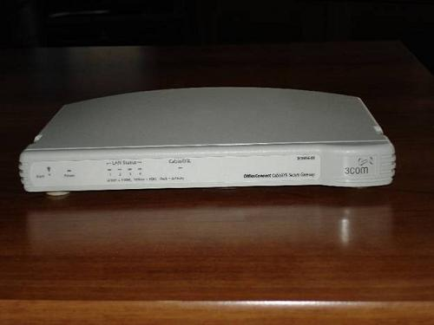  
**Figure A:**This is the front view of a 3COM broadband router

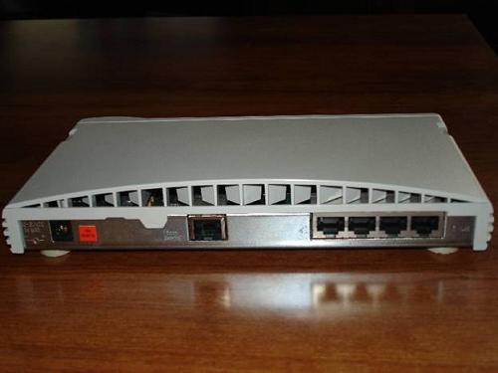  
**Figure B:**A broadband Internet router contains a set of RJ-45 ports just like a hub or switch

As you can see in the figures, there is nothing especially remarkable about the front view of the router. I wanted to include this view anyway though, so that those of you who are unfamiliar with routers can see what a router looks like. Figure B is much more interesting.

If you look at Figure B, you’ll see that there are three sets of ports on the back of the router. The port on the far left is where the power supply connects to the router. The middle port is an RJ-45 port used to connect to the remote network. In this particular case, this router is intended to provide Internet connectivity. As such, this middle port would typically be used to connect the router to a cable modem or to a DSL modem. The modem in turn would provide the actual connectivity to the Internet.

If you look at the set of ports on the far right, you’ll see that there are four RJ-45 ports. If you think back to the first part of this article series, you’ll recall that hubs and switches also contained large groups of RJ-45 ports. In the case of a hub or switch, the RJ-45 ports are used to provide connectivity to the computers on the network.

These ports work the exact same way on this router. This particular router has a four port switch built in. Remember earlier when I said that a router’s job was to move packets between one network and another? I explained that in the case of a broadband router, the Internet represents one network, and the PC represents the second network. The reason why a single computer can represent an entire network is because the router does not treat the PC as a standalone device. Routers treat the PC as a node on a network. As you can see from the photo in Figure B, this particular router could actually accommodate a network of four PCs. It’s just that most home users who use this type of configuration only plug one PC into the router. Therefore a more precise explanation would be that this type of network routes packets of data between a small network (even if that network only consists of a single computer) to the Internet (which it treats as a second network).

The Routing Process

Now that I’ve talked a little bit about what a router is and what it does, I want to talk about the routing process. In order to understand how routing works, you have to understand a little bit about how the TCP/IP protocol works.

Every device connected to a TCP/IP network has a unique IP address bound to its network interface. The IP address consists of a series of four numbers separated by periods. For example, a typical IP address looks something like this: 192.168.0.1

The best analogy I can think of to describe an IP address is to compare it to a street address. A street address consists of a number and a street name. The number identifies the specific building on the street. An IP address works kind of the same way. The address is broken into the network number and a device number. If you were to compare an IP address to a Street address, then think of the network number as being like a street name, and at the device number as being like a house number. The network number identifies which network the device is on, and the device number gives the device an identity on that network.

So how do you know where the network number ends and the device number begins? This is the job of the subnet mask. A subnet mask tells the computer where the network number portion of an IP address stops, and where the device number starts. Subnetting can be complicated, and I will cover in detail in a separate article. For now, let’s keep it simple and look at a very basic subnet mask.

A subnet mask looks a lot like an IP address in that it follows the format of having four numbers separated by periods. A typical subnet mask looks like this: 255.255.255.0

In this particular example, the first three numbers (called octets) are each 255, and the last number 0. The number 255 indicates that all of the bits in the corresponding position in the IP address are a part of the network number. The number zero indicates that none of the bits in the corresponding position in the IP address are a part of the network number, and therefore they all belong to the device number.

I know this probably sounds a little bit confusing, so consider this example. Imagine that you had a PC with an IP address of 192.168.1.1 and a subnet mask of 255.255.255.0. In this particular case, the first three octets of the subnet mask are all 255. This means that the first three octets of the IP address all belong to the network number. Therefore, the network number portion of this IP address is 192.168.1.x.

The reason why this is important to know is because a router’s job is to move packets of data from one network to another. All of the devices on a network (or on a network segment to be more precise) share a common network number. For example, if 192.168.1.x was the network number associated with computers attached to the router shown in Figure B, then the IP addresses for four individual computers might be:

* 192.168.1.1
* 192.168.1.2
* 192.168.1.3
* 192.168.1.4

As you can see, each computer on the local network shares the same network number, but has a different device number. As you may know, whenever a computer needs to communicate with another computer on a network, it does so by referring to the other computer’s IP address. For example, in this particular case the computer with the address of 192.168.1.1 could easily send a packet of data to the computer with the address of 192.168.1.3, because both computers are a part of the same physical network.

Things work a bit differently if a computer needs to access a computer on another network. Since I am focusing this particular discussion on small broadband routers that are designed to provide Internet connectivity, let’s pretend that one of the users on the local network wanted to visit the [www.brienposey.com](http://www.brienposey.com/) Web site. A Web site is hosted by a server. Like any other computer, a Web server has a unique IP address. The IP address for this particular Web site is 24.235.10.4.

You can easily look at this IP address and tell that it does not belong to the 192.168.1.x network. That being the case, the computer that’s trying to reach the Web site can’t just send the packet out along the local network, because the Web server isn’t a part of the local network. Instead, the computer that needs to send the packet looks at its default gateway address.

The default gateway is a part of a computer’s TCP/IP configuration. It is basically a way of telling a computer that if it does not know where to send a packet, then send it to the specified default gateway address. The default gateway’s address would be the router’s IP address. In this case, the router’s IP address would probably be 192.168.1.0.

Notice that the router’s IP address shares the same network number as the other computers on the local network. It has to so that it can be accessible to those computers. Actually, a router has at least two IP addresses. One of those addresses uses the same network number as your local network. The router’s other IP address is assigned by your ISP. This IP address uses the same network number as the ISPs network. The router’s job is therefore to move packets from your local network onto the ISPs network. Your ISP has routers of its own that work in exactly the same way, but that route packets to other parts of the Internet.