### PM Firmware Driver Installation Instructions

1. Power on the Power Monitor in Output Enable mode by depressing the Output Enable button and the Power button simultaneously – Amber LED should be on.

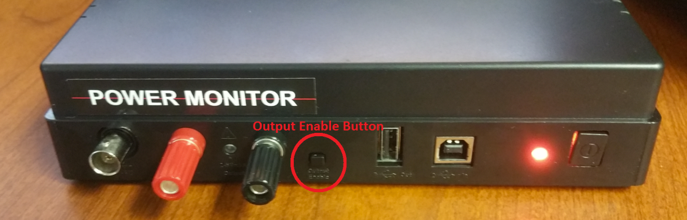

2. Open the Device Manager (find it by windows search, or by navigating there as shown from ‘This PC’) and look for the “Unknown device”:

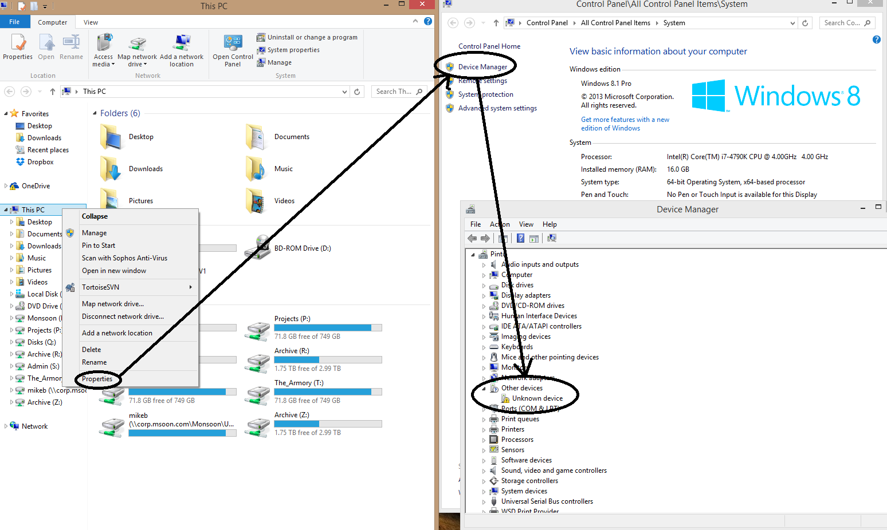

1. Right-click unknown device select ‘update Driver Software.’ When the prompt comes up, select ‘Browse my computer for driver software’

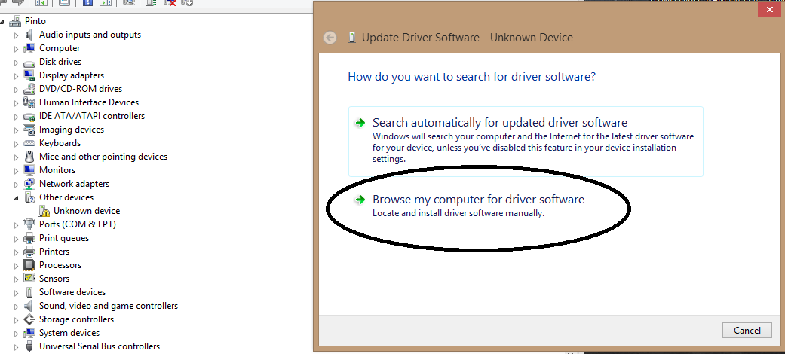

1. Browse to Drivers/LVPM/Reflash
2. Click Okay. Windows should take over from there, and successfully install drivers for “Microchip Custom USB Device.”

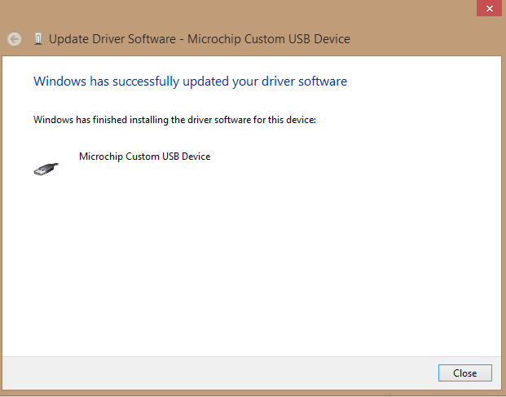

### PC Driver Installation Instructions:

After the PowerTool application has been installed and this is the first time the workstation will be running the PowerTool application you will need to install two drivers, the Power Monitor driver and the Firmware driver. Instructions are as follows:

1. Power on Power Monitor in normal mode – Green led should be on.
2. Under Device Manager, find Mobile Device Power Monitor – will have a yellow exclamation mark.
3. Right click and select Update Driver Software…
4. Select Browse my computer for driver software
5. Browse to Drivers\Beta Drivers for the new protocol, Drivers\LVPM\PC for the old protocol.
6. Click on Close once the driver has finished installing.
7. Under Device Manager – Universal Serial Bus devices, ensure that the Mobile Device Power Monitor has enumerated properly.