**EXECUTIVE SUMMARY**

**Problem Statement**

Cardinal Health is a global, integrated healthcare services and products company, providing customized solutions for hospitals, health systems, pharmacies. The company has many dealerships with pharmaceutical companies from which the medications are purchased directly. Then the company will supply the medications to local pharmacies per order request. For the past few months they are facing difficulties in the current system for tracking down the details of the medication transactions due to increased consumption of the medicines. Therefore, they are looking for a solution to resolve difficulties in keeping tracking and maintaining the records of medication transactions. They are also looking for an efficient way to manage employees.

**The main purposes of proposed system :**

* Management of buying and selling medications.
* Management of Stock.
* Management of employees.

**System’s Objects:**

* Employees/Administrator
* Customers

**Solution**

The solution is the creation of a desktop application and multiple database tables include the relationships between those tables. The tables consist of the following: **Medication**, **Customer**, **Customer_Order**, **Manufacturer**, **Manufacturer_Order**, and **Employee**. These tables represent the main entities of the application and define relationships between entities. We can create queries and reports that will provide the necessary information. The database will be implemented using Oracle 11g.

**Benefits to Users**

* Users will be able to order bulk medication from manufacturers.
* Users will be able to manage orders from customers such as CVS Pharmacy, Kroger, Walgreens, etc.
* Users will be able to manage the company’s employees and have access to their information.
* Finding and management of information about medication, manufacturers, customers, employees, and orders correctly and quickly. For customers living in another locations, information will be updated regularly through the website, so customers can find information of medication suitable and fast.

**Hardware/Software Requirements:**

* Hardware**:**
* Intel i5 processor
* 4 GB of RAM or greater
* Windows 7 or later
* Java Virtual Machine
* Software: Either or combination of the following
* JDK 8 or later/.NET/J2EE
* IDE
* Oracle SQL Developer/MySQL/Microsoft SQL Server

**Project Outline**

The project will contain the following major components:

* Schema design
* Entity-Relationship Diagram
* Table implementation
* Queries
* Reports

**Part II. Schema Design**

**Medication** (NDC, Medication_Name, Manu_ID, Made_In_Country, Unit)

FK Manu_ID 🡪 Manufacturer

**Customer** (Customer_ID,Last_Name,First_Name,Street,City,State,Zip,Fax,Phone_Number,Tax_ID,Web_Site,Rate)

**Order** (Customer_ID,NDC,Quantity,Total_Price,Order_Date,Delivery_Date,Expiration_Date,Paid,Emp_Ordered)

FK Customer_ID 🡪 Customer  
 FK NDC 🡪 Medication  
 FK Emp_Ordered 🡪 Employee

**Manufacturer** (Manu_ID,Manu_Name,Street,City,State,Zip,Fax,Phone_Number,Email,Tax_ID,Web_Site, International_or_Domestic)

**Employee** (Emp_ID,Last_Name,First_Name,Email,Phone_Number,Hire_Date,Salary,Role,Supervisor_ID)

FK Supervisor_ID 🡪 Employee

**Entity-Relationship Diagram**

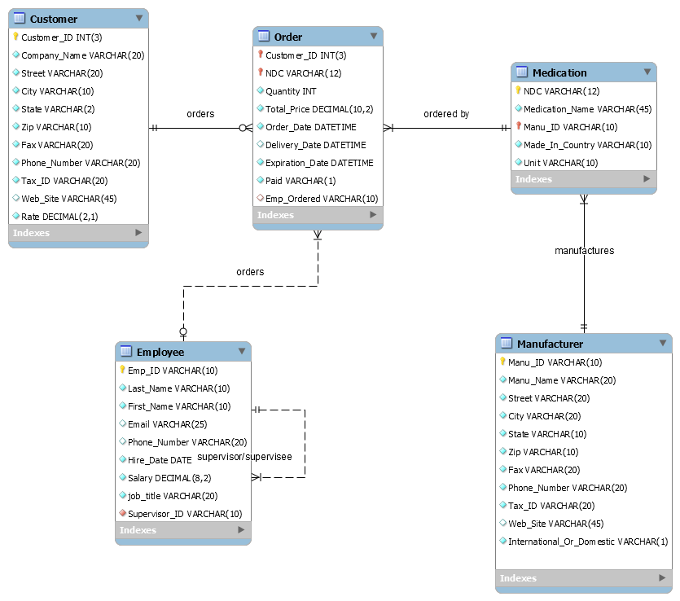

--Dropping TABLES for multiple runs

DROP TABLE cardinal_orders CASCADE CONSTRAINTS;

DROP TABLE cardinal_medication CASCADE CONSTRAINTS;

DROP TABLE cardinal_manufacturers CASCADE CONSTRAINTS;

DROP TABLE cardinal_employees CASCADE CONSTRAINTS;

DROP TABLE cardinal_customers CASCADE CONSTRAINTS;

DROP SEQUENCE cardinal_customers_seq;

--Creating CARDINAL_CUSTOMERS table

CREATE TABLE cardinal_customers

( customer_id number(3),

company_name varchar2(20) NOT NULL,

street varchar2(20) NOT NULL,

city varchar2(10) NOT NULL,

state varchar2(2) NOT NULL,

zip varchar2(10) NOT NULL,

fax varchar2(20) NOT NULL,

phone_number varchar2(20) NOT NULL,

tax_id varchar2(20) NOT NULL,

web_site varchar2(45),

rate number(2,1) NOT NULL,

CONSTRAINT pk_customer_id PRIMARY KEY (customer_id)

);

--Creating the Primary Key sequence for CARDINAL_CUSTOMERS

CREATE SEQUENCE cardinal_customers_seq

START WITH 1

INCREMENT BY 1;

--Creating CARDINAL_MANUFACTURERS table

CREATE TABLE cardinal_manufacturers

( manu_id varchar2(10),

manu_name varchar2(20) NOT NULL,

street varchar2(20) NOT NULL,

city varchar2(20) NOT NULL,

state varchar2(10) NOT NULL,

zip varchar2(10) NOT NULL,

fax varchar2(20) NOT NULL,

phone_number varchar2(20) NOT NULL,

tax_id varchar2(20) NOT NULL,

web_site varchar2(30),

international_or_domestic varchar2(1) NOT NULL,

CONSTRAINT pk_manu_id PRIMARY KEY (manu_id),

CONSTRAINT int_dom_check CHECK (international_or_domestic IN ('I','D'))

);

--Creating CARDINAL_EMPLOYEES table

CREATE TABLE cardinal_employees

( emp_id varchar2(10),

first_name varchar2(10) NOT NULL,

last_name varchar2(10) NOT NULL,

email varchar2(25),

phone_number varchar2(20),

hire_date DATE NOT NULL,

salary number(8,2) NOT NULL,

job_title varchar2(20) NOT NULL,

supervisor_id varchar2(10),

CONSTRAINT pk_employee_id PRIMARY KEY (emp_id),

CONSTRAINT fk_supervisor_id

FOREIGN KEY (emp_id)

REFERENCES cardinal_employees(emp_id)

);

--Creating CARDINAL_MEDICATION table

CREATE TABLE cardinal_medication

( ndc varchar2(12),

medication_name varchar2(45) NOT NULL,

manu_id varchar2(10),

made_in_country varchar2(10) NOT NULL,

unit varchar2(10) NOT NULL,

CONSTRAINT pk_medication PRIMARY KEY (ndc),

CONSTRAINT fk_medication_manu

FOREIGN KEY (manu_id)

REFERENCES cardinal_manufacturers(manu_id)

);

--Creating CARDINAL_ORDERS table

CREATE TABLE cardinal_orders

( customer_id number(3),

ndc varchar2(12),

quantity number NOT NULL,

total_price number(10,2) NOT NULL,

order_date DATE NOT NULL,

delivery_date DATE,

expiration_date DATE NOT NULL,

paid varchar2(1) NOT NULL,

emp_ordered varchar2(10),

CONSTRAINT pk_order PRIMARY KEY (customer_id,ndc),

CONSTRAINT fk_order_customers

FOREIGN KEY (customer_id)

REFERENCES cardinal_customers(customer_id),

CONSTRAINT fk_order_medication

FOREIGN KEY (ndc)

REFERENCES cardinal_medication(ndc),

CONSTRAINT fk_order_employees

FOREIGN KEY (emp_ordered)

REFERENCES cardinal_employees(emp_id),

CONSTRAINT paid_check CHECK (paid IN ('y','n','Y','N')),

CONSTRAINT delivery_date_check CHECK (delivery_date > order_date),

CONSTRAINT expiration_date_check CHECK (expiration_date > order_date)

);

COMMIT;

**RUN OF SCRIPT:**

Table CARDINAL_ORDERS dropped.

Table CARDINAL_MEDICATION dropped.

Table CARDINAL_MANUFACTURERS dropped.

Table CARDINAL_EMPLOYEES dropped.

Table CARDINAL_CUSTOMERS dropped.

Sequence cardinal_customers_seq dropped.

Table CARDINAL_CUSTOMERS created.

Sequence cardinal_customers_seq created.

Table CARDINAL_MANUFACTURERS created.

Table CARDINAL_EMPLOYEES created.

Table CARDINAL_MEDICATION created.

Table CARDINAL_ORDERS created.

Commit complete.

--Part 4 Q1: UNION with JOIN query

--This query returns medication's NDC, medication's name, and manufacturer's name

--that have been ordered by customers.

SELECT m.ndc AS "NDC",

m.medication_name AS "Medication",

ma.manu_name AS "Manufacturer"

FROM cardinal_medication m, cardinal_manufacturers ma

WHERE m.manu_id = ma.manu_id

UNION

SELECT ndc,

to_char(NULL),

to_char(NULL)

FROM cardinal_orders

ORDER BY 1;

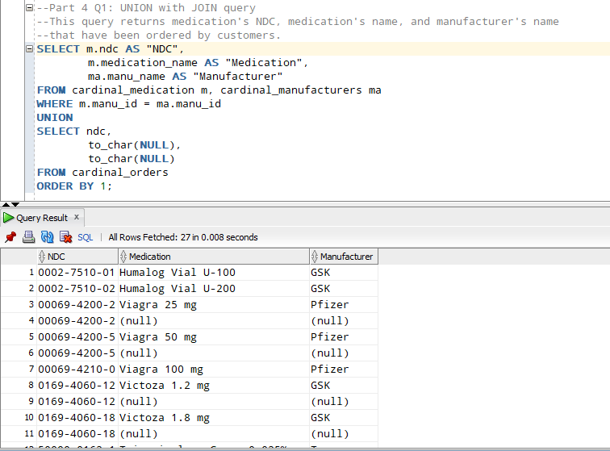

--Part 4 Q2: INTERSECT

--This query returns the list of IDs of customers who have ordered medication.

SELECT customer_id AS "Customer ID"

FROM cardinal_customers

INTERSECT

SELECT customer_id

FROM cardinal_orders

ORDER BY 1;

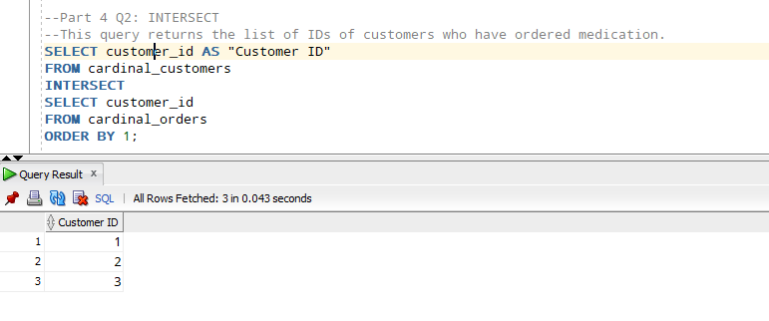

--Part 4 Q3: MINUS

--This query returns the manufacturer that does not have any medication available to purchase through Cardinal.

SELECT manu_id AS "Manufacturer ID"

FROM cardinal_manufacturers

MINUS

SELECT manu_id

FROM cardinal_medication;

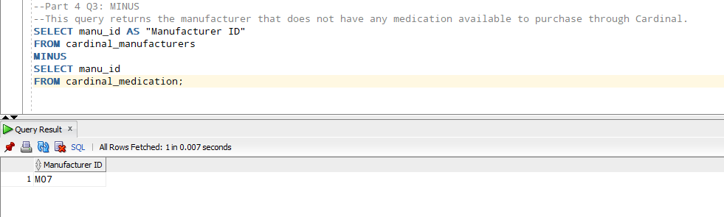

--Query 1:

/*This query returns employee id, first name, last name, and hire date

for all employees hired before 01/01/2016 and have salary less than 6000. Sort in the order of employee ID*/

SELECT emp_id as "Employee ID",

first_name as "First Name",

last_name as "Last Name",

hire_date as "Hired Date"

FROM cardinal_employees

WHERE hire_date < '01-JAN-16' AND salary < 6000

ORDER BY 1;

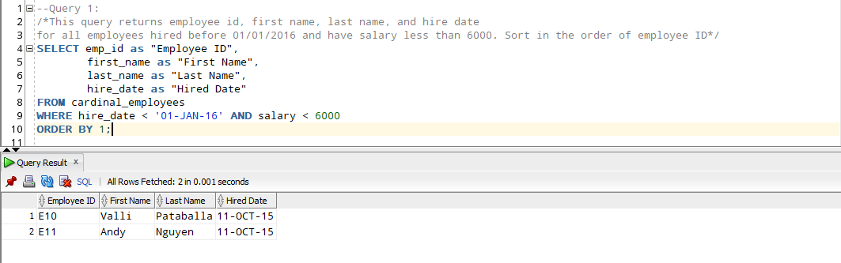

--Query 2:

/*This query returns manufacturer name, address, and check if the manufacturer is domestic or international.

Sort in the order of manufacturer name*/

SELECT manu_name AS "Manufacturer Name",

street || ', ' || city || ', ' || state || ' ' || zip AS "Address",

DECODE(international_or_domestic, 'D', 'Domestic',

'I', 'International',

'N/A') AS "Origin"

FROM cardinal_manufacturers

ORDER BY 1;

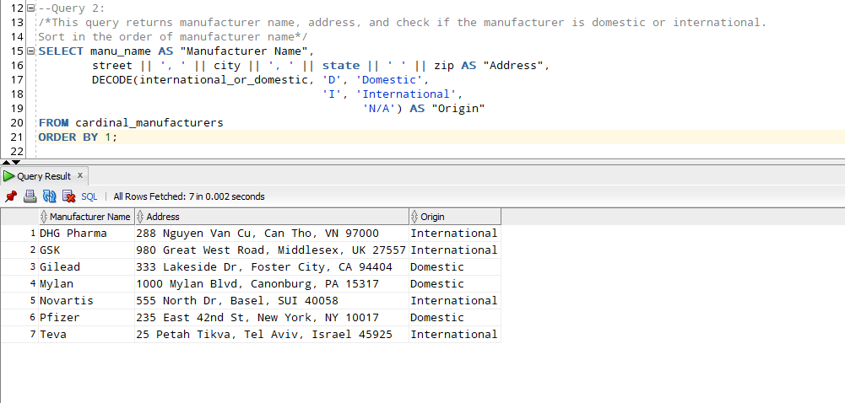

--Query 3:

/*This query returns the average order amount for each customer.

Sort in the order of order amount.*/

SELECT customer_id AS "Customer ID",

to_char(AVG(total_price),'$99999.99') AS "Average Order Price"

FROM cardinal_orders

GROUP BY customer_id

ORDER BY 2;

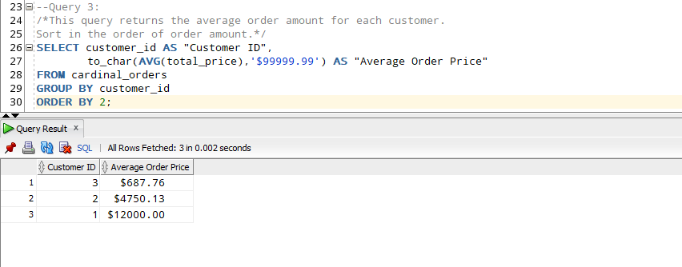

--Query 4:

/*This query returns ndc, medication name, manufacturer name, and unit of all medication in database.

Sort in order of medication name*/

SELECT m.ndc AS "NDC",

m.medication_name AS "Medication Name",

ma.manu_name AS "Manufacturer Name",

m.unit AS "Unit"

FROM cardinal_medication m JOIN cardinal_manufacturers ma ON m.manu_id = ma.manu_id

ORDER BY 2;

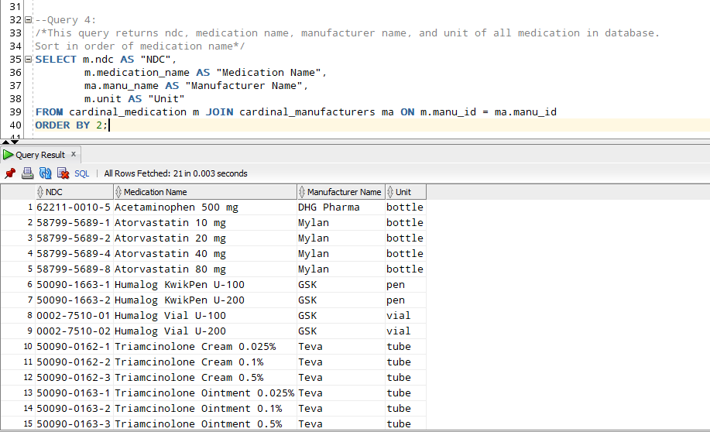

--Query 5:

/*This query returns employee id, first name, last name, and salary of all employees that have a salary greater than

the average salary of the company. Sort in order of salary*/

SELECT emp_id AS "Employee ID",

first_name AS "First Name",

last_name AS "Last Name",

to_char(salary,'$99,999.99') AS "Salary"

FROM cardinal_employees

WHERE salary > (SELECT AVG(salary) FROM cardinal_employees)

ORDER BY 4 DESC;

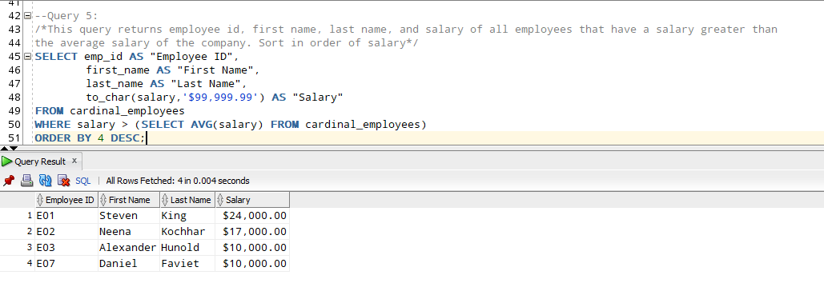

--Query 6:

/*This query returns employee id, first name, last name, job title, and salary

of the lowest paid employee for that supervisor. Exclude whose supervisor is not known.

Exclude groups where salary is less than 6000. Sort in order of salary.*/

SELECT emp_id AS "Supervisor ID",

first_name || ' ' || last_name AS "Name",

job_title AS "Job Title",

MIN(salary) AS "Smallest Salary in Group"

FROM cardinal_employees

WHERE supervisor_id IS NOT NULL

GROUP BY emp_id, first_name || ' ' || last_name, job_title

HAVING MIN(salary) >= 6000

ORDER BY "Smallest Salary in Group";

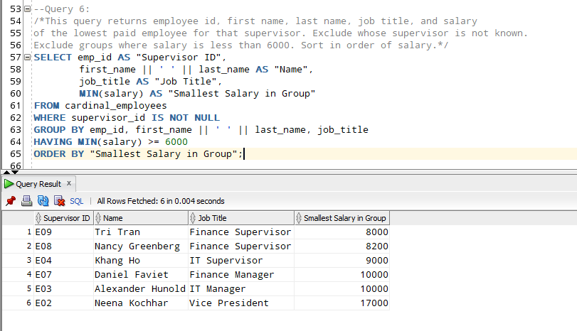

--Query 7:

/*This query returns customer id, NDC, quantity, oder date, and calculates the expected delivery date.

The delivery date would be the first Monday following the order date. Sort in the ascending order of order date*/

SELECT customer_id AS "Customer ID",

ndc AS "NDC",

quantity AS "Quantity",

order_date AS "Order Date",

NEXT_DAY(order_date,'MONDAY') AS "Expected Delivery Date"

FROM cardinal_orders

ORDER BY order_date;

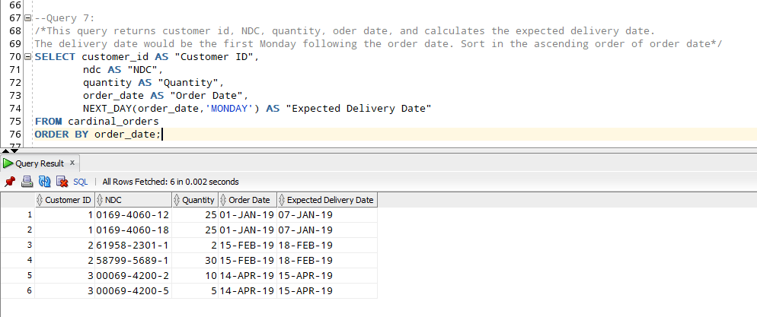

--Query 8:

/*This query returns first name, last name, and hire date of all employees.

Format the hire date in Month, day, yyyy (ex: January 1st, 2019). Sort in order of hire date*/

SELECT first_name AS "First Name",

last_name AS "Last Name",

trim(to_char(hire_date,'Month')) || ' ' || to_char(hire_date,'dth, YYYY') AS "Hire Date"

FROM cardinal_employees

ORDER BY 3;

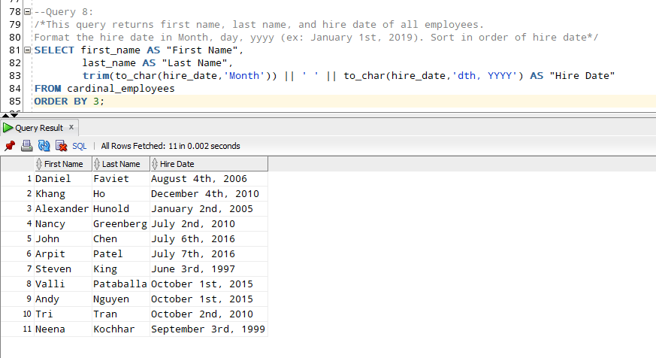

--Query 9:

/*This query returns employee id, first name, last name, and salary

of all employees who have salary equal to average salary of their department (job title).

Sort in order of salary*/

SELECT emp_id AS "Employee ID",

first_name AS "First Name",

last_name AS "Last Name",

to_char(salary,'$99,999') AS "Salary"

FROM cardinal_employees main

WHERE salary IN (SELECT AVG(salary)

FROM cardinal_employees sub

WHERE main.job_title = sub.job_title)

ORDER BY salary;

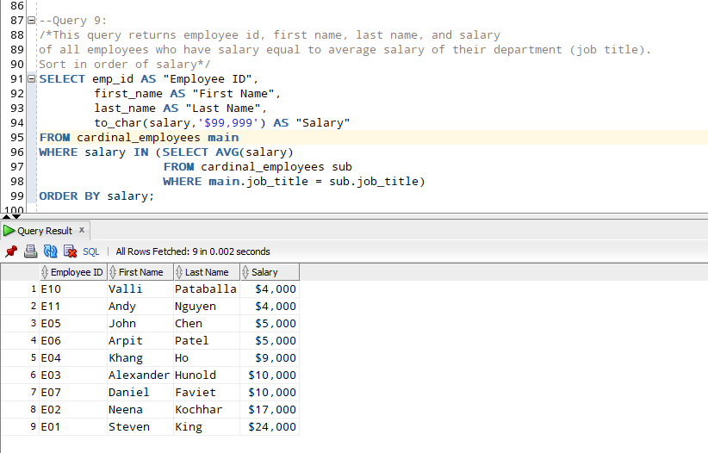

--Query 10:

/*This query returns customer ID and customer name of all customers who have not ordered medication from Cardinal.

Sort in the order of customer ID.*/

SELECT c.customer_id AS "Customer ID",

c.company_name AS "Customer Name"

FROM cardinal_customers c LEFT OUTER JOIN cardinal_orders o

ON c.customer_id = o.customer_id WHERE o.customer_id IS NULL

ORDER BY 1;

