INVENTORY MANAGEMENT SYSTEM

USER GUIDE

Installation Guide:

I. System Requirement:

a. Hardware: Pentium 200 or higher with 200MB of RAM

b. Software: Java SE 5, MS SQL Server 2005 or higher

II. Launch:

1. Open SQL Server 2005 and create a database. Then import mdf and ldf database files.

2. Execute InstallSoftware.jar

3. Enter server name, port number, database name, owner, password. Choose install with examples data or not. And then click Install.

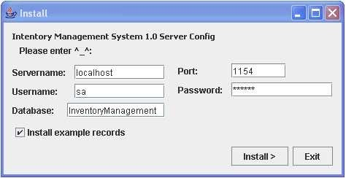

4. Please a moment until installation complete.

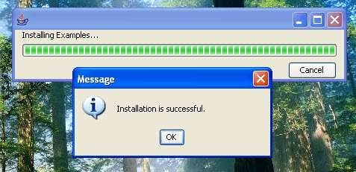

User Manual:

1. Launch:

Execute InventoryManagement2.jar

A window will show with a form for Sales, Sales Manager, Inventory Manager or Administrator log in system to manage.

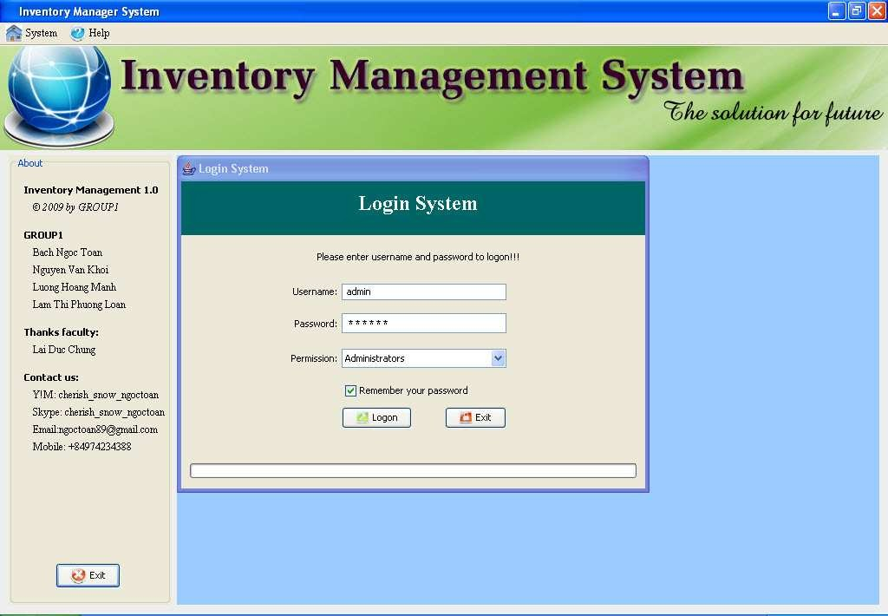

2. Home

This is main windows of application after administrator’s login.

If you login by an administrator user, you would have entire permission access to functional.

And if you login by a user sales, sales manager or inventory manager, system would display permission corresponding

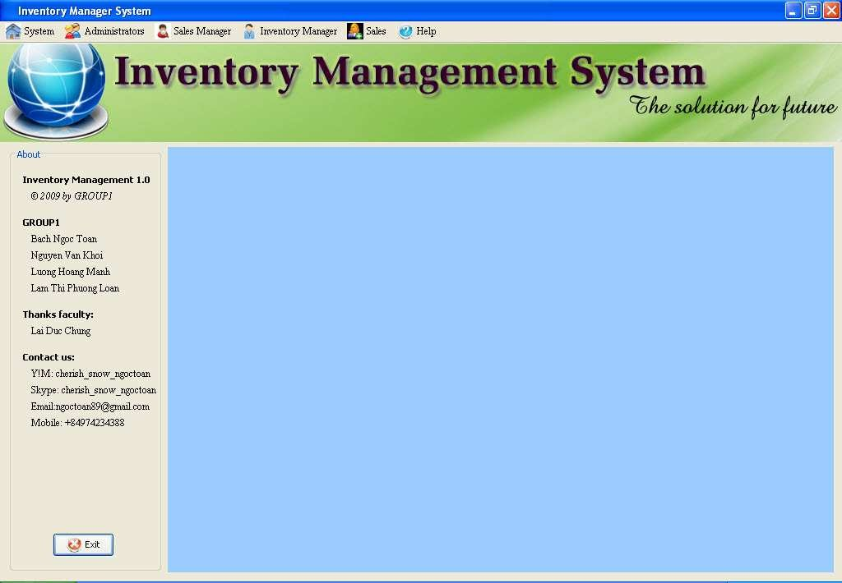

3. Sale Bill

This tab has 2 sub tabs: Bills and Bill Details.

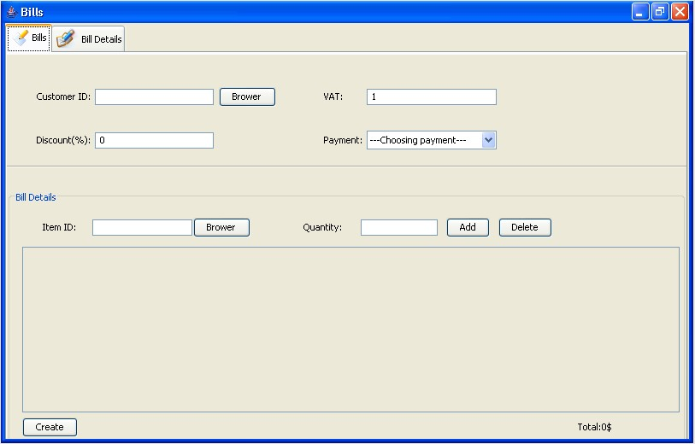

a. Bill

User can make sale bill at here. Enter customer code, discount, VAT. You can easier to select customer by click Browse and choose a customer and then click Select.

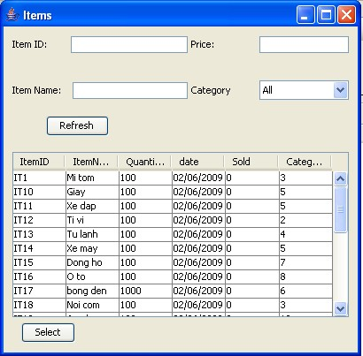

To add bill details, enter product code, quantity wants to sell and click

Add. You also can easier choose Product by click Browse and select one.

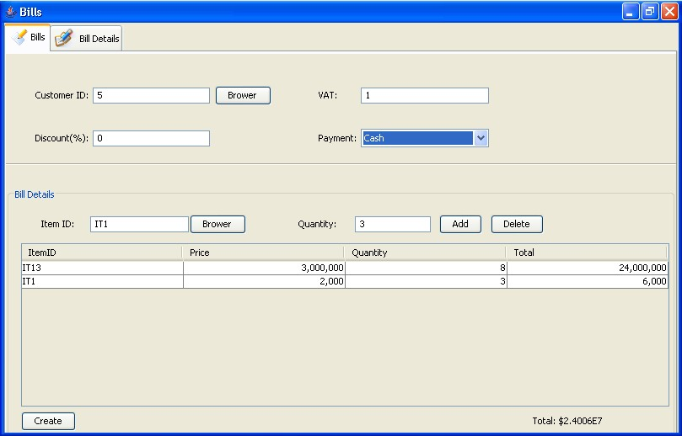

To delete a detail of bill, select it in the below table and click Delete. After all, click Create to make a bill.

b. Bill details

You can Bill details bills created by go to tab Bill details. Select a row in Bills table and the Bill Detail table will show you all details of this selected bill.

If number of bills is too much and you can also find it quickly by use Search. You can search by Date or Customer or both.

4. Purchase Bill

Like sale bill tab, but this tab help you make purchase bills.

5. Product

At this tab, you can search, add and edit products. a.

To search, you can enter one or more of details like code, name, price from, to.etc..

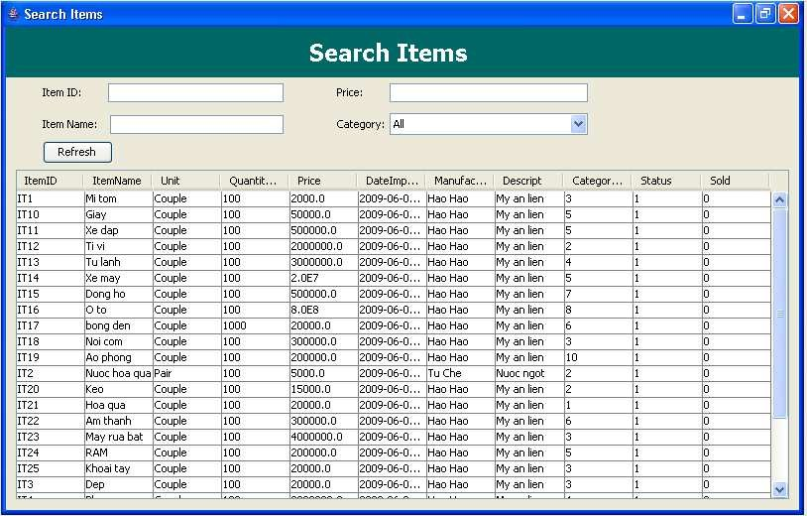

b. Add

To add a product, you change to add tab and enter all details about this product. Finally click Add to submit. If you want to clean all box, click Reset Form.

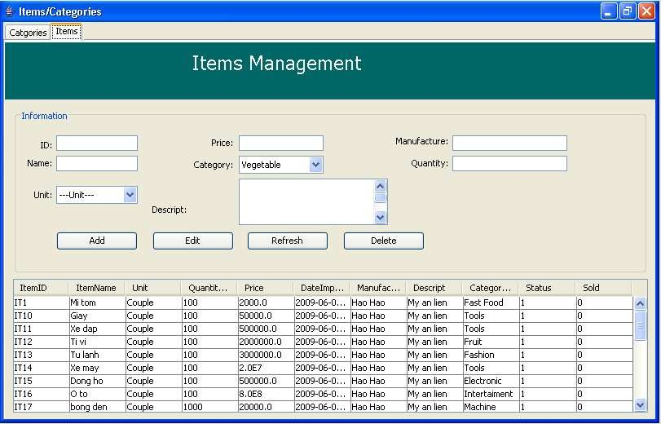

6. Customer

Like to product tab, you can search, add and edit customers in this tab.

