“Resilient Dwellings”
Building Flood Resistant Homes for Vulnerable Communities in India

Executive Summary

This social venture proposal addresses the urgent need for climate-adaptive housing solutions in India’s most flood-prone states—Kerala, Bihar, and Assam. Recognizing the annual devastation caused by flooding, this initiative aims to construct cost-effective, flood-resistant homes that prioritize community resilience and align with key Sustainable Development Goals (SDGs), including SDG 1 (No Poverty), SDG 11 (Sustainable Cities and Communities), and SDG 13 (Climate Action). The project will leverage locally available, sustainable building materials and modular construction techniques to ensure scalability and environmental sustainability. By integrating these flood-resistant designs, the initiative seeks to reduce displacement, safeguard livelihoods, and foster long-term socio-economic stability in vulnerable communities.

Problem Statement

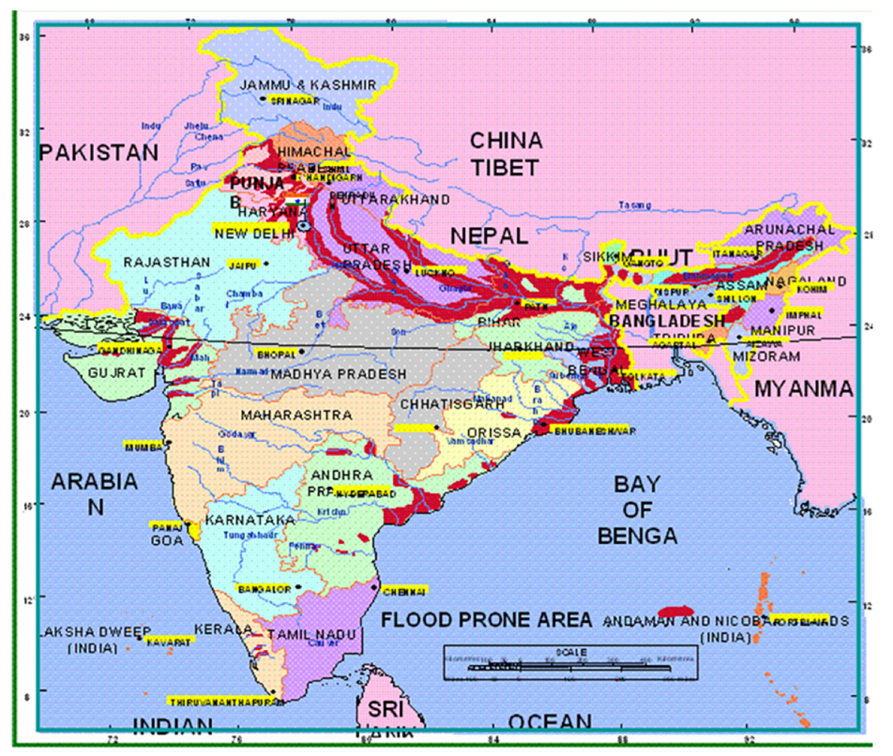
India faces a persistent and severe threat from seasonal flooding, with approximately 40 million hectares of land classified as flood-prone. Historical data from 1953 to 2010 reveals that the maximum flood-affected area in a single year reached 49.815 million hectares. The states of Kerala, Bihar, and Assam are particularly susceptible to recurring flood events due to a combination of topographical, climatic, and anthropogenic factors.

Kerala’s vulnerability arises from high rainfall patterns, rapid deforestation in the Western Ghats, and resulting flash floods. Bihar faces annual flooding from the Ganges and Kosi rivers, exacerbated by inadequate drainage infrastructure and the failure of embankments. Assam’s exposure is driven by the Brahmaputra River’s overflow, riverbank erosion, and sedimentation processes, all intensified by deforestation and land-use changes.
Figure 1: Map of Flood-Prone Areas in India

The socio-economic consequences of these flood events are profound. Annually, floods in India result in an average of 1,654 human fatalities and the loss of approximately 618,000 livestock, inflicting significant economic and social disruptions. Moreover, an estimated 1.2 million homes are damaged or destroyed each year, compounding displacement and undermining the livelihoods of affected communities. Agricultural productivity also suffers substantial setbacks, as floods annually impact 7.17 million hectares of land, including 3.94 million hectares of fertile farmland.

These recurring floods impose average economic losses of ₹5,649 crores (USD 750 million) annually, straining both state and national resources and perpetuating cycles of poverty and vulnerability in affected regions. The cumulative human, social, and economic costs highlight the urgent need for comprehensive flood risk reduction strategies and the development of resilient housing solutions tailored to the needs of vulnerable populations in these flood-prone areas.

Objectives

1. To design and construct cost-effective, eco-friendly, flood-resistant homes for vulnerable communities.

2. To enhance community resilience through climate-adaptive infrastructure.
3. To reduce displacement, economic disruption, and loss of life in flood-prone regions.
4. To contribute to global sustainability efforts through localized climate action.

Project Scope and Strategy

The project prioritizes interventions in the most flood-prone regions of India, namely the hilly districts of Kerala, the low-lying plains of Bihar, and the riverbank settlements of Assam. These regions are highly susceptible to annual flooding due to their unique topographical and hydrological characteristics. The selection of these areas is informed by comprehensive vulnerability assessments and historical data on flood intensity and impact, ensuring the relevance and effectiveness of the intervention.

To address the acute challenges posed by flooding, the project integrates multiple design features that collectively enhance the resilience and sustainability of housing in these regions.

Raised Plinths or Stilts

Elevating homes on raised plinths or stilts forms the foundation of flood resilience. This technique minimizes water ingress by ensuring that the building’s main structure and critical living spaces remain above anticipated flood levels, thereby preventing damage during inundation events.

Sloped, Waterproof Roofing

The incorporation of sloped, waterproof roofing ensures rapid drainage of rainwater, reducing the risk of structural compromise due to water accumulation. Treated metal sheets and waterproof tiles further enhance the roof’s durability and watertight performance, extending the building’s lifespan.

Use of Locally Sourced, Sustainable Materials

The project prioritizes materials such as bamboo and fly ash bricks, which are locally sourced and environmentally sustainable. Bamboo’s flexibility and strength make it ideal for dynamic loading conditions, while fly ash bricks utilize industrial byproducts, reducing waste and providing water-resistant properties.

Permeable Pavements and Rainwater Harvesting Systems

Integrating permeable pavements constructed from porous materials supports groundwater recharge and minimizes surface runoff. Rainwater harvesting systems capture and store rooftop rainwater, promoting water conservation and reducing flood-induced runoff, thereby contributing to both climate adaptation and community water security.

Elevated Sanitation and Electrical Fixtures

To reduce health and safety risks during floods, sanitation facilities and electrical systems are strategically positioned above expected flood levels. This design approach mitigates water contamination and electrical hazards, safeguarding both public health and infrastructure integrity.

Modular Design for Rapid Construction and Scalability

The modular construction approach involves prefabricated components that allow rapid assembly on-site. This technique supports quick deployment in post-disaster settings and enables easy expansion or modification in response to evolving community needs, offering flexibility and long-term sustainability.

The implementation of the project is structured into four key phases:

Research and Community Assessment

This initial phase involves detailed assessments of site-specific risks, community needs, and cultural contexts to inform the design process and ensure relevance and acceptability.

Pilot Construction of 50 Homes per State

The second phase focuses on the pilot construction of 50 flood-resistant homes in each targeted state, providing immediate protection to vulnerable households and demonstrating the project’s practical viability.

Impact Monitoring and Evaluation

This phase involves rigorous evaluation of the pilot homes’ performance during flood events, combined with community feedback to refine and optimize the housing designs for broader implementation.

Scale-Up via Public-Private Partnerships (PPP)

The final phase seeks to expand the project’s reach through collaborative partnerships with government agencies, NGOs, and private sector actors. These partnerships aim to mobilize resources, streamline implementation, and scale up the construction of flood-resistant housing solutions across other high-risk regions in India.

This comprehensive and adaptive approach ensures that the project’s scope and strategy effectively address the multifaceted challenges of flooding in vulnerable communities.

Alignment with Sustainable Development Goals (SDGs)

The project aligns with the following Sustainable Development Goals:

SDG 1 – No Poverty

Prevents asset loss, reduces dependency on relief aid, and enables faster recovery.

SDG 11 – Sustainable Cities and Communities

Promotes resilient housing and sustainable urban planning.

SDG 13 – Climate Action

Adapts infrastructure to withstand extreme weather and integrates nature-based solutions like wetland restoration.
SDG 11: Sustainable Cities and Communities

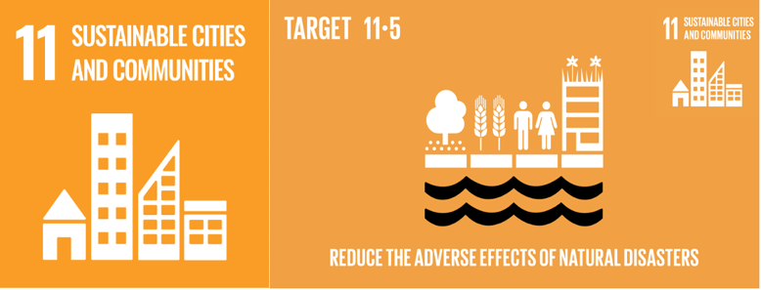
The project aligns with Sustainable Development Goal 11, which seeks to make cities and human settlements inclusive, safe, resilient, and sustainable. By constructing flood-resistant housing, the initiative directly contributes to enhancing the safety and resilience of communities residing in flood-prone regions. Elevated structures and modular construction mitigate the risk of property damage and loss of life during flooding events, fostering more secure living environments. Moreover, the integration of permeable pavements and rainwater harvesting systems promotes sustainable urban infrastructure that supports groundwater recharge and reduces surface runoff, addressing long-term flood management needs. Beyond the physical structures, the project encourages participatory planning processes involving local communities, aligning with the SDG 11 target of promoting inclusive decision-making. This participatory approach ensures that the housing solutions are culturally appropriate and responsive to local needs, enhancing community ownership and social cohesion. Ultimately, this comprehensive strategy strengthens urban and rural settlements' capacity to withstand environmental shocks, advancing SDG 11's vision of creating sustainable and resilient communities in vulnerable flood-prone areas.
Figure 2: Target 5 of SDG 11

SDG 13: Climate Action

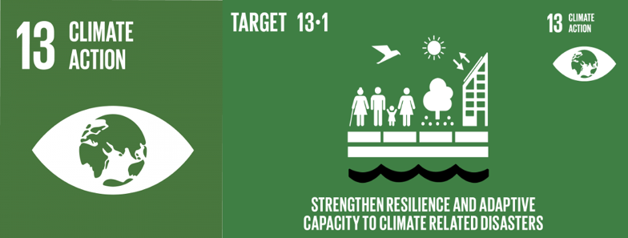
This project is closely aligned with Sustainable Development Goal 13, which calls for urgent action to combat climate change and its impacts. Flooding events in India have become more severe and frequent due to climate change-induced variations in rainfall patterns, glacial melt, and rising temperatures. By developing climate-resilient housing solutions tailored to these changing environmental conditions, the project embodies climate adaptation principles outlined in SDG 13. Elevated structures, water-resistant building materials, and modular construction techniques are critical adaptations that enable communities to withstand intensified flooding linked to climate change. Additionally, incorporating rainwater harvesting systems contributes to climate mitigation by reducing reliance on external water sources and supporting local water security. The project also promotes ecosystem-based approaches, such as green infrastructure and permeable pavements, which help manage excess water while preserving natural hydrological cycles. In this way, the project exemplifies a proactive response to climate risks, strengthening the adaptive capacity of vulnerable populations and advancing India's broader climate action commitments under SDG 13.
Figure 3: Target 1 of SDG 13

SDG 1: No Poverty

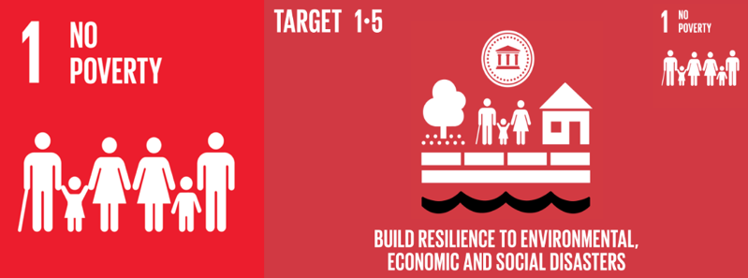
The project also advances Sustainable Development Goal 1, which aims to end poverty in all its forms everywhere. Floods disproportionately affect marginalized communities, destroying homes, livelihoods, and critical infrastructure, thereby pushing families deeper into cycles of poverty and social exclusion. By providing cost-effective and durable housing solutions, this initiative helps protect vulnerable populations from the devastating economic impacts of recurring floods. Elevated housing prevents displacement and safeguards assets, reducing the financial burden on low-income households who typically lack the resources to rebuild after disasters. Additionally, by utilizing local labor and sustainable materials, the project generates employment opportunities and supports the local economy, fostering long-term economic resilience. These efforts align with SDG 1’s target of building resilience for people living in vulnerable situations, reducing exposure to climate-related extreme events. By preventing the erosion of assets and livelihoods, the project enables vulnerable communities to maintain economic stability and gradually build financial security, thus directly addressing the multidimensional nature of poverty in flood-prone areas.
Figure 4: Target 5 of SDG 1

Social Impact

India's vulnerability to floods is a pressing concern, with large portions of its land prone to inundation due to the country's diverse geographical and climatic conditions. According to the Rashtriya Barh Ayog (RBA), approximately 40 million hectares (Mha) of land across India are susceptible to flooding annually. The dynamic interplay of monsoon intensity, changes in river flow patterns, deforestation, and unplanned urban expansion exacerbates this vulnerability, leading to complex challenges in flood management and disaster mitigation. A detailed analysis by the Working Group on Flood Management and Region-Specific Issues for the XII Plan (2012-2017) revealed that between 1953 and 2010, the maximum area affected by floods in a single year reached nearly 49.8 Mha. This underscores the expanding threat of floods and the urgent need for sustainable and community-centered interventions.
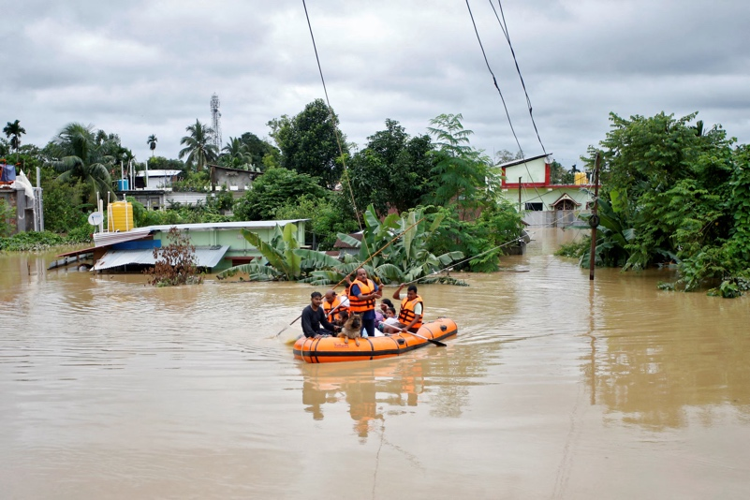
Figure 5: Flood Displacement and Rescue in India
Flood events in India extend beyond immediate physical devastation, causing profound social disruptions. On average, floods claim 1,654 human lives and result in the loss of approximately 618,248 livestock annually. Livestock play a crucial role in sustaining rural livelihoods, providing dairy products, labor support, and acting as financial security in times of hardship. The loss of livestock not only compounds economic burdens but also undermines the social safety nets within rural communities. Additionally, the psychological trauma of losing family members and livestock erodes social cohesion and contributes to long-term social distress.

Floods also displace thousands of families, destroying social networks and disrupting the continuity of everyday life. On average, over 1.2 million houses are damaged or completely destroyed each year, forcing families into temporary shelters or substandard living conditions. This displacement fragments communities, breaks cultural ties, and jeopardizes access to essential social services such as education and healthcare. Children, particularly girls, often bear the brunt of disrupted schooling, leading to long-term consequences for their educational attainment and future opportunities.

Furthermore, the destruction of local infrastructure—including roads, bridges, and community facilities—complicates relief efforts and exacerbates social vulnerabilities. Rebuilding these structures requires significant public and private resources, diverting funds from other critical social development initiatives. For marginalized communities, which often lack formal land titles or financial savings, the cycle of displacement and rebuilding can trap them in chronic poverty and social exclusion.
The participatory approach of the flood-resistant housing project addresses these vulnerabilities holistically. By elevating sanitation and electrical fixtures and integrating modular, locally appropriate designs, the project safeguards critical social infrastructure even during extreme flood events. Moreover, the inclusion of local labor and materials in construction strengthens community identity and agency. Such approaches foster social cohesion, reduce dependency on external aid, and empower communities to adapt to future challenges proactively.

In the long term, providing stable and secure housing solutions for flood-prone areas not only mitigates the immediate social consequences of floods but also fosters a culture of resilience and preparedness. This, in turn, supports the development of robust social systems that can withstand environmental shocks, enhancing overall community well-being and advancing broader social development goals.

Economic Impact

Flooding in India has significant economic ramifications, particularly in regions where the economy is predominantly agrarian. While approximately 21 million hectares (Mha) of flood-prone land benefit from protective infrastructure such as embankments and drainage systems, vast areas remain unprotected and susceptible to repeated damage. Annually, an estimated 7.17 Mha of land is affected by floods, with 3.94 Mha comprising agricultural land. Given that agriculture contributes nearly 17-18% to India’s GDP and provides employment for more than half of the population, these losses have far-reaching consequences on both household and national economic stability.

Recurrent flooding results in direct damage to agricultural crops, livestock, and associated supply chains. The disruption of planting and harvesting cycles impacts food security and reduces farmers’ incomes, exacerbating rural poverty. In addition, the destruction of stored seeds, fertilizers, and farming equipment creates a compounding effect that can take years to recover from, reducing long-term agricultural productivity. Livestock losses further weaken rural economies, as they represent critical assets and sources of collateral for smallholder farmers.

The average annual economic loss due to floods in India is estimated at ₹5,649 crores (USD 750 million), a figure that reflects both direct property damage and indirect economic disruptions. Floods also cause extensive damage to public infrastructure, including roads, bridges, power lines, and communication networks. These damages interrupt trade, limit mobility, and reduce access to markets, hindering economic growth in affected regions. Moreover, the repeated need to allocate substantial resources for flood relief and rehabilitation diverts funds from critical development projects in education, health, and social protection, stalling progress in broader economic development objectives.

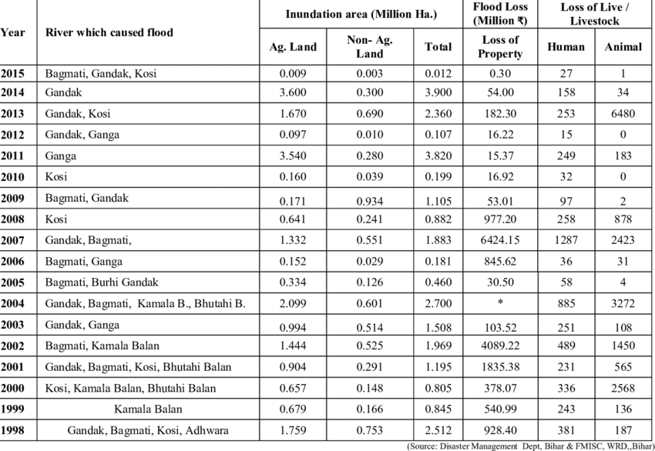
The flood-resistant housing project directly addresses these economic vulnerabilities by investing in durable, adaptable, and locally sourced housing solutions. Elevated homes on stilts or raised plinths reduce exposure to floodwaters, minimizing reconstruction costs and safeguarding household assets. The use of locally available materials such as bamboo and fly ash bricks not only reduces construction costs but also stimulates local economies and creates employment opportunities. By leveraging modular construction techniques, the project promotes rapid scalability and cost-effective deployment in post-disaster scenarios.
Figure 6: Annual Flood Inundation and Human-Animal Loss in Bihar (1998-2015)

Rainwater harvesting systems integrated into these housing designs also contribute to long-term economic sustainability by reducing reliance on external water sources and lowering utility costs. In addition, minimizing the risk of flood-induced displacement preserves livelihoods and enables families to invest in health, education, and productive assets, fostering upward economic mobility.

In the broader economic context, flood-resilient housing reduces the financial burden on governments and relief agencies, allowing resources to be redirected to strategic development initiatives. These interventions collectively enhance local economic resilience and contribute to a more robust, inclusive economy capable of withstanding the recurrent challenges posed by climate variability and flooding in India.

Funding and Partnerships

To ensure the successful implementation and sustainability of the flood-resistant housing project, a multifaceted funding strategy will be pursued. This will involve leveraging governmental disaster relief programs that prioritize climate adaptation and disaster risk reduction. In parallel, corporate social responsibility (CSR) contributions from private sector entities will be sought to bolster financial resources and demonstrate collaborative engagement in addressing climate resilience. Additionally, applications for international climate resilience grants will be submitted to secure financial support from global environmental and humanitarian agencies. Microfinance initiatives will be integrated within the funding model to empower low-income households to participate in the project while maintaining financial inclusivity. Strategic partnerships will be established with local non-governmental organizations (NGOs), engineering institutions, and state urban development departments. Local NGOs will provide community-level insights and engagement, ensuring culturally and contextually appropriate interventions. Engineering institutions will contribute technical expertise, promoting the adoption of innovative, locally suitable construction practices. Collaboration with state urban development departments will facilitate regulatory compliance and the incorporation of the project within broader urban planning and disaster management frameworks. This integrative funding and partnership strategy is designed to ensure fiscal sustainability, enhance community ownership, and enable the long-term viability of climate-resilient housing solutions.

Monitoring and Evaluation

A comprehensive monitoring and evaluation (M&E) framework will be established to rigorously assess the efficacy, social acceptability, and long-term impact of the flood-resistant housing project. Key Performance Indicators (KPIs) will include the number of homes constructed and occupied, which will provide quantitative evidence of the project’s immediate outputs. The reduction in annual displacement reports will serve as a critical indicator of the project’s capacity to mitigate the socio-economic disruptions associated with recurring flooding events. Community satisfaction scores will be systematically gathered through structured interviews and surveys, enabling qualitative assessment of residents’ perceptions and the degree of social acceptability of the interventions. Furthermore, a cost-benefit analysis will be conducted following flooding events to ascertain the project’s economic efficiency and its capacity to deliver long-term financial savings for households and local governments. The M&E framework will also incorporate periodic site inspections, third-party independent audits, and iterative feedback mechanisms to facilitate adaptive learning and continual refinement of the project’s strategies. This rigorous, evidence-based evaluation process will ensure accountability to stakeholders, inform future scaling initiatives, and contribute to the broader academic and policy discourse on climate adaptation and disaster risk reduction in flood-prone regions.

Conclusion

This social venture project proposal envisions a transformative future in which Indian communities vulnerable to recurrent flooding can live in safety, dignity, and stability. By integrating innovative, affordable, and climate-adaptive housing solutions, the project directly addresses the persistent cycle of disaster vulnerability that has historically undermined social and economic development in flood-prone regions. Through raised plinths and stilts, the use of sustainable local materials, modular construction techniques, and inclusive community engagement, these flood-resistant homes are more than just physical structures—they are catalysts for long-term resilience and empowerment.

This initiative aligns seamlessly with India’s broader climate adaptation and poverty alleviation goals, reflecting a clear commitment to the Sustainable Development Goals. By reducing displacement, safeguarding livelihoods, and fostering economic stability, the project not only mitigates immediate flood risks but also strengthens social cohesion and enhances the adaptive capacity of entire communities. Furthermore, the project’s emphasis on inclusive decision-making and local labor markets ensures that communities themselves are active agents in the process of building back better, reinforcing a sense of ownership and agency.

Ultimately, this social venture sets a replicable model for climate-resilient housing in flood-prone areas, demonstrating that proactive, community-centred, and environmentally sustainable interventions can drive systemic change. It offers a pragmatic and hopeful vision of the future—one in which no family must live in fear of losing their home to the floods. In doing so, it contributes to building a more equitable, sustainable, and climate-resilient India—one resilient home at a time.

References

https://www.unep.org/news-and-stories/story/india-builds-flood-resilient-homes-climate-adaptation
https://www.nationalgeographic.com/environment/article/india-floods-climate-change-housing
https://www.worldbank.org/en/news/feature/2022/08/15/building-resilience-to-floods-in-india
https://www.preventionweb.net/news/india-building-flood-resilient-homes-vulnerable-communities
https://www.hindustantimes.com/india-news/how-assam-s-villages-are-building-flood-resilient-homes-101655804443673.html
https://www.downtoearth.org.in/news/climate-change/how-to-build-flood-resilient-homes-in-assam-83757
https://www.nrdc.org/bio/anjali-jaiswal/flood-resilient-housing-india
https://www.unicef.org/india/stories/building-resilient-communities-flood-prone-areas
https://www.undp.org/india/news/india-building-resilience-floods
https://www.oxfamindia.org/featuredstories/building-flood-resilient-homes-kerala
https://www.sciencedirect.com/science/article/pii/S2212420922000930
https://www.mdpi.com/2071-1050/13/2/898
https://www.researchgate.net/publication/343079857_Flood_Resilient_Housing_for_Flood-Prone_Areas_of_India
https://www.cseindia.org/floods-and-urban-india-10862
https://www.niti.gov.in/sites/default/files/2021-07/SDG_India_Index_2020-21.pdf
https://sdgs.un.org/goals
https://www.indiawaterportal.org/articles/keralas-flood-resilient-housing-initiative
https://www.ijert.org/research/design-and-construction-of-flood-resistant-houses-IJERTV10IS080184.pdf
https://www.tandfonline.com/doi/full/10.1080/19475705.2022.2050733
https://www.preventionweb.net/publication/flood-risk-management-india
https://www.adb.org/sites/default/files/publication/672796/sdgs-climate-resilient-infrastructure-india.pdf
https://www.thehindu.com/news/national/kerala/kerala-to-promote-flood-resilient-houses/article29441896.ece
https://www.brookings.edu/articles/urban-flooding-in-india/
https://www.indiatoday.in/india/story/floods-in-india-causes-impact-solutions-1590227-2019-08-23
https://www.habitat.org/asiapacific/stories/building-flood-resilient-homes-india
https://www.sciencedirect.com/science/article/pii/S2210670721001788
https://www.ijser.org/researchpaper/Flood-Resistant-Housing-for-Flood-Prone-Areas.pdf
https://www.drishtiias.com/daily-updates/daily-news-editorials/flood-management-in-india
https://www.worldbank.org/en/news/feature/2021/07/15/india-floods-resilience
https://www.indiaspend.com/cover-story/why-indias-flood-management-needs-an-urgent-overhaul-788172
https://www.teriin.org/article/building-flood-resilient-infrastructure-india

