**FINAL Exam: DATABASE**

**WEP 2024**

**{3h 00}**

25 JAN 2023

**RULES:**

* Chatting and talking to other students is forbidden
* You are allowed to use PhpMyAdmin or VSCode or any other software. But it is not required
* Write (copy/paste) your answer below the question. Do not screenshot.

**HOW DO I SUBMIT THE EXAM?**

* Save this document as a yourfullname.PDF file
* In Google Classroom, attach this file to submit.

|  |  |
| --- | --- |
| **EXERCISES** | **POINTS** |
| THOERYS | 20 |
| EXERCISE 1 | 20 |
| EXERCISE 2 | 20 |
| EXERCISE 3 | 20 |
| EXERCISE 4 | 20 |
| EXERCISE 5 | 20 |
| **TOTAL** | **100** |

# Exercise 03 (20 points) Basic SQL Query

Write SQL query to create tables that have in Entity Relational Diagram (ERD) below:

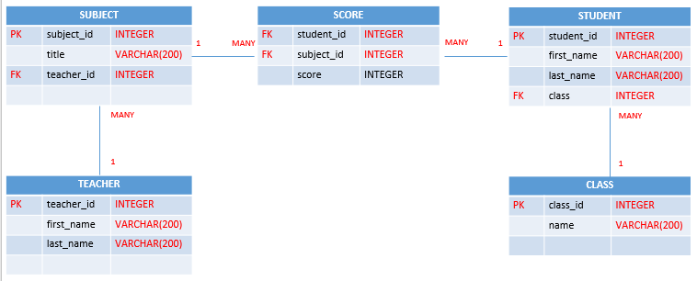

**Your Query:**

|  |
| --- |
| 1. Create teachers table:   **CREATE TABLE teachers ( teacher_id INT AUTO_INCREMENT PRIMARY KEY , first_name VARCHAR(200) , last_name VARCHAR(200));**   1. Create classes table:   **CREATE TABLE classes ( class_id INT AUTO_INCREMENT PRIMARY KEY , name VARCHAR(200));**   1. Create subjects table:   **CREATE TABLE subjects ( subject_id INT AUTO_INCREMENT , title VARCHAR(200) , teacher_id INT , PRIMARY KEY(subj**  **ect_id) , FOREIGN KEY (teacher_id) REFERENCES teachers(teacher_id));**   1. Create students table:   **CREATE TABLE students ( student_id INT AUTO_INCREMENT , first_name VARCHAR(200) , last_name VARCHAR(200) , class INT , PRIMARY KEY (student_id) , FOREIGN KEY (class) REFERENCES classes(class_id));**   1. Create score table:   **CREATE TABLE score ( student_id INT , subject_id INT , score INT , FOREIGN KEY ( student_id ) REFERENCES stude**  **nts(student_id) , FOREIGN KEY( subject_id ) REFERENCES subjects(subject_id));** |
|  |

# Exercise 04 (20 points) SQL Query Select

***Important****: Import database name “database_final_exam.sql” into your databasae.*

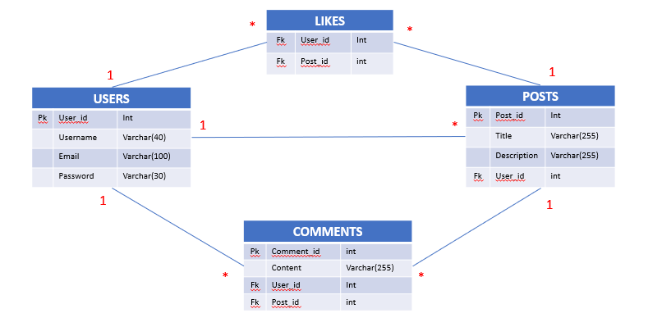

**Q1 – (10 POINTS):** Write a SQL statement to display all POSTS for the user named “**Rady Y**”

**Expected result:**

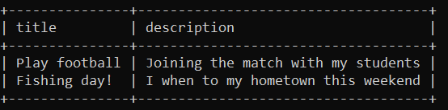

**Your Query:**

|  |
| --- |
| **SELECT posts.title , posts.description FROM (posts INNER JOIN users ON posts.user_id = users.user_id ) WHERE username = "Rady Y";** |

**Q2 – (10 POINTS):** Write a SQL statement to display the username of who likes on many posts.

**Expected result:**

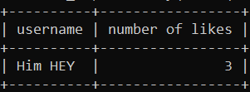

**Your Query:**

|  |
| --- |
| **SELECT users.username , COUNT(likes.user_id) AS number_of_like FROM (users INNER JOIN likes ON users.user_id = likes.user_id ) GROUP BY likes.user_id ORDER BY COUNT(likes.user_id) DESC LIMIT 1;** |