Name: Hay SEV

Class: WepA

HOMEWORK

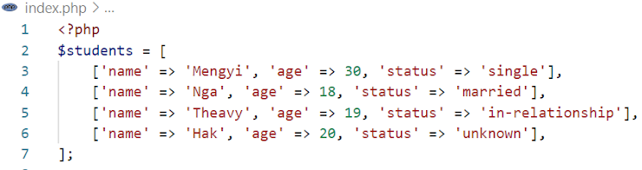

Q1. Write code to display the number of SINGLE students

    $studentstatus = $students[0]['status'];

    $studentName = $students[0]['name'];

    foreach ($students as $student) {

        if ($student['status'] === "single") {

            $studentName = $student['name'];

        }

    }

    echo "The youngest student is: ".$studentName;

Q2. Write code to display the name of the youngest student

$studentAge = $students[0]['age'];

$studentName = $students[0]['name'];

foreach ($students as $student) {

    if ($student['age'] < $studentAge) {

        $studentAge = $student['age'];

        $studentName = $student['name'];

    }

}

echo "The youngest student is: ".$studentName;

Q3. Write code to display the names of students who are single and between 25 and 30 years old.

    $studentstatus = $students[0]['status'];

    $studentAge = $students[0]['age'];

    $studentName = $students[0]['name'];

    foreach ($students as $student) {

        if ($student['status'] === "single" && $studentAge >25 && $studentAge < 30) {

            $studentName = $student['name'];

        }

    }

    echo "The youngest student is: ".$studentName;