**HOW TO FIND YOUR LOCAL IP ADDRESS ?**

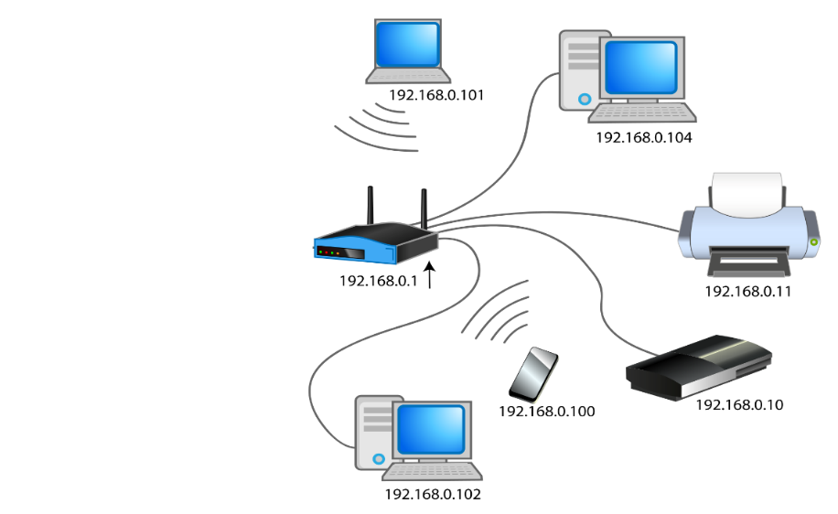

Terminal command

* Windows: *> ipconfig*
* Linux: *$ ip a*

Local IP address format is 192.168.XXX.XXX

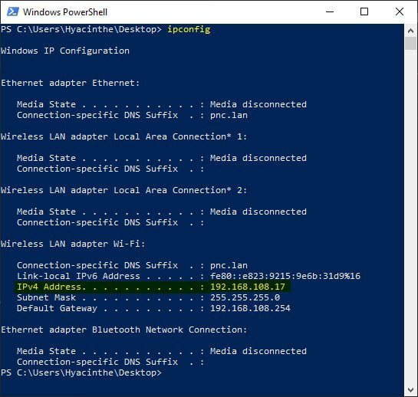

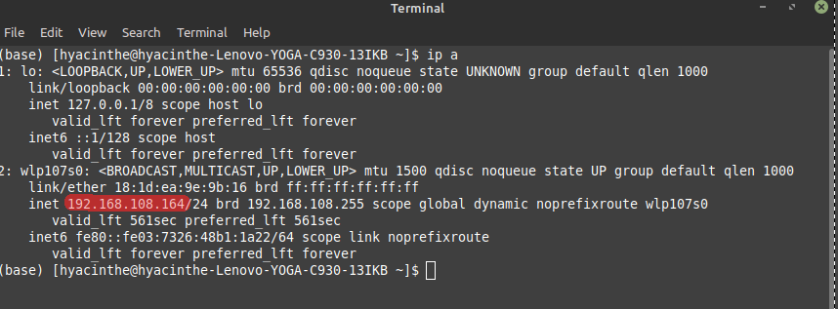

**HOW TO START PHP BUILT-IN WEB SERVER ?**

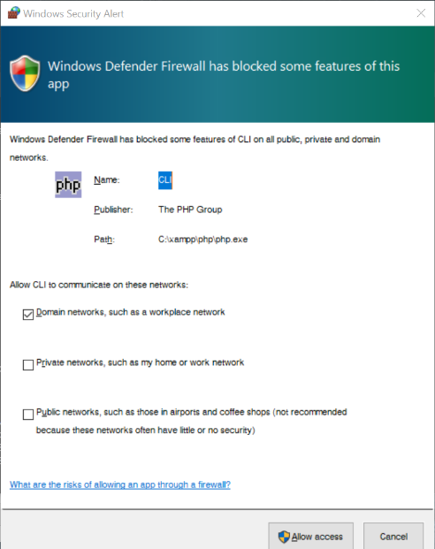

**If you get a Security Alert from the firewall, click on “Allow Access” and ask to the teacher the admin access for PNC computer.**

**If you clicked on Cancel, ask the teacher to configure the firewall**

1. Go to the directory of the activity (use the command *> cd* (“change directory”))
2. Use terminal command > php -S <ip>:<port> (Capital ‘S’ !)  
   <ip> = Your IP address  
   <port> = use any number between 1024 and 9999, for example 8080

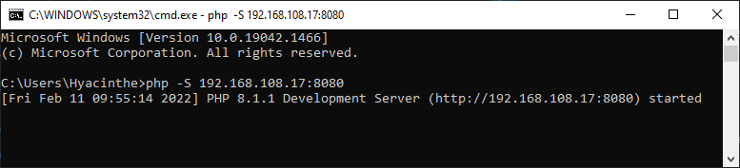

LOCALHOST

The same computer can be at the same time server and client!

As a server, how can you access the site you are hosting?

# 3 solutions:

1. http://<local_network_ip>:<port>  
   → Like the other clients!
2. http://127.0.0.1:<port>  
   → 127.0.0.1 is special IP address redirecting to your own computer
3. http://localhost:<port>  
   → localhost resolves to 127.0.0.1

For web development: No need 2 computers, and no need to know your IP

APACHE

PHP built-in server is fine for development only

Start Apache then visit <http://localhost> (on default port 80!)

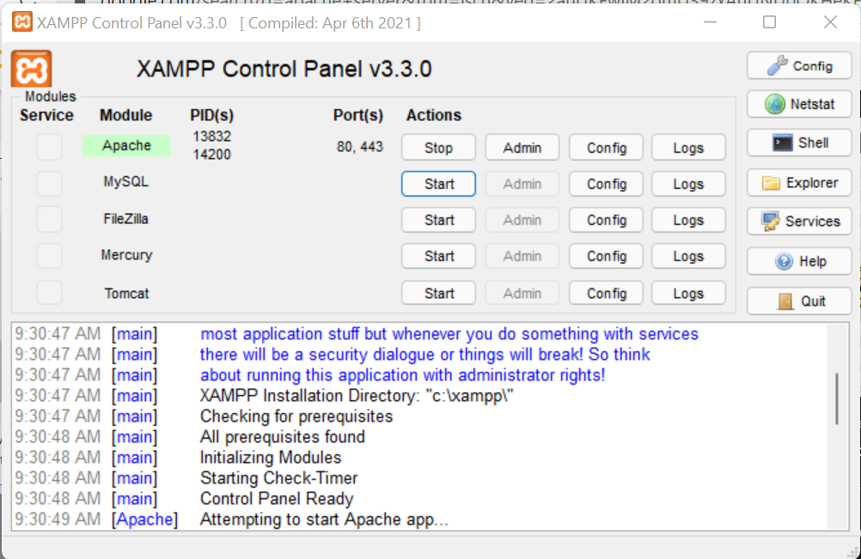

You can change the content of the folder xampp/htdocs to change the default content to your website!

