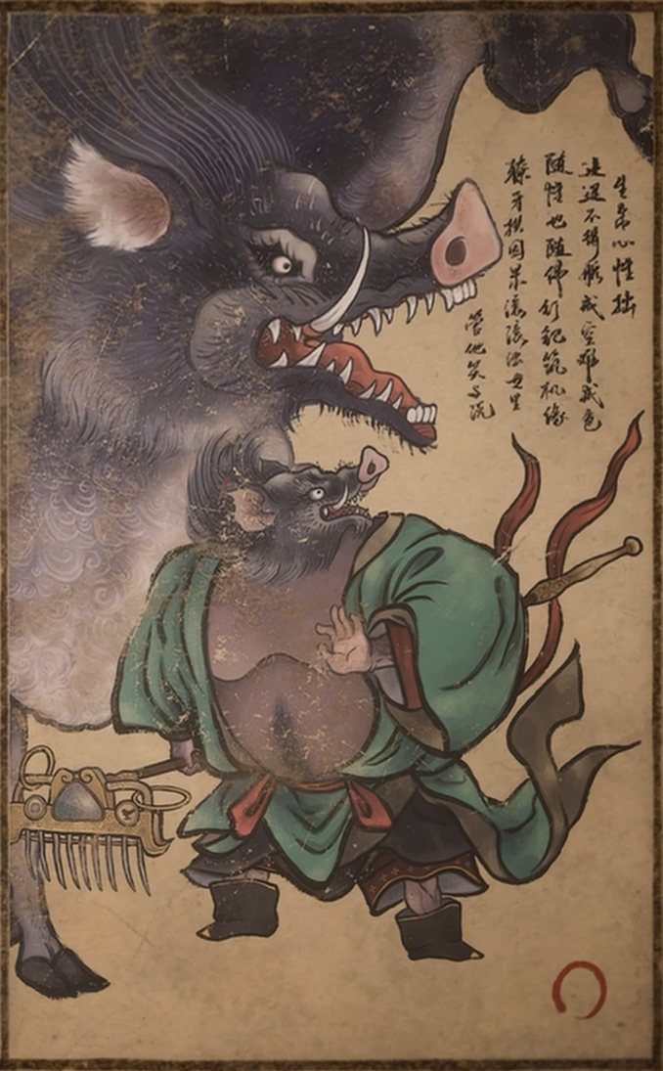
Zhu Bajie

Born blunt of heart, caught between advance and retreat;
he may renounce emptiness, yet never desire.
His rake turns fate, his tusks shoulder karma;
in this muddied world, let them laugh, let them talk.

High in Daluo Heaven, above the Jade Pool, celestial maidens moved to and fro. The Queen Mother had opened her pavilion that day for a banquet to view the lotus blooms.
As Tianpeng entered the palace gate, he saw a burly man held at the threshold by the maidens on watch. One maiden said, with neither warmth nor haste, “General Juanlian, without an invitation written by the Queen Mother herself, you cannot enter the seats by the pool. There are seats left in the side hall. If you do not mind them, you may take a cup there.” The man gave a word of assent, yet his eyes kept straying inward.
Tianpeng shook his head with a faint smile, showed his invitation to another maiden, and strode in, chin lifted.
The banquet was already in full swing; cups passed among the celestial officials, and the toasts did not cease. Tianpeng commanded the water troops of the Heavenly River and seldom came to such revels. Still, he greeted everyone as though they were old acquaintances, while taking care not to drink too deeply.
The God of Longevity stood beside the Queen Mother, stroking his beard as he smiled. “If today’s banquet is held with such ceremony, what grandeur will be left for the Peach Banquet?”
A nearby star lord laughed, “You worry too much, Immortal Elder. With the nine-thousand-year peaches to uphold the occasion, even a few tables outside the Southern Heavenly Gate would draw the great and lesser gods of the Three Realms crawling in for a taste.”
Another red-faced immortal gave a cold laugh. “It is hardly the peaches they come for. Most only wish to pay respects to the Jade Emperor and the Three Pure Ones, or to behold the Buddhas of the West. Such a pretext to ascend and make themselves seen is rare enough.”
The Queen Mother’s face grew solemn. “The Peach Banquet is no small matter. Today’s banquet is a rehearsal; every rite that must be observed shall be observed properly.”
With that, she cast a glance at Lord of the Moon. He clapped once, and a line of Chang’e maidens in white silk entered from behind the hall.
The maidens took their places by the Jade Pool: some played, some sang, and some danced. Among them, the leading dancer stood out: white-robed and white-haired, graceful in every turn, with a beauty that surpassed the rest. Never had Tianpeng watched the Chang’e maidens dance so close at hand. Before he knew it, he was staring, spellbound.
A maiden in purple gauze robes came before Tianpeng with a wine cup in hand and softly called, “Marshal.”
Tianpeng raised the cup without thinking, his eyes never leaving that white arc upon the stage.
When the Chang’e maidens had finished their dance, Tianpeng came back to himself and made ready to offer the Queen Mother a toast. The line was so long that, following it to its end, he found himself beyond the palace gate.
Just then, a shout rang out: “Shoes! Shoes!”
He looked toward the sound and saw two celestial attendants hurry past, propping up a monkey gone crooked with drink.
Tianpeng thought: When will I ever be allowed to be that drunk?

