PART A: SITE ACCEPTANCE REPORT AND INSTALLATION CHECKLIST

1.0 SITE INFORMATION

MHS No | {siteName} | System Size Installed | {systemSize}
Installation  Start Date | {startDate} | Installation End Date | {endDate}
System Installer | Ai Solar Sdn Bhd
PIC Onsite | {picName}
Premise Address | {address}
Note:
Please ensure that the information filled out is correct.

2.0 SYSTEM COMPONENTS INSTALLED

Item | Description | Quantity/Length
PV Solar Panels | Trina Solar TSM NEG19.20 620W  - {serialNumbers} | {panelQty} Nos
Inverter | (Huawei sun2000-{inverter_rating}K-MAP0)  1. {inverterSn} | 1 Nos
Mounting Structure | Aluminium Solar Mounting structure and accessories | 1 Set
DC cabling | Helukable 1500v 4sq.mm | 1 Roll
AC Cabling | DNF PVC insulated Cable 450/750v 6sq.mm | 1 Roll
Solar combiner box | IP65 14 Ways Combiner Box | 1 Nos
AC breakers | 4P C25 TAXNELE MCB | 1 Nos
AC SPD | 3 PHASE 40kA TYPE 2 SPD | 1 Nos
Wifi Dongle | SDongleA-05 SN: {dongleSn} | 1 Nos
Smart Meter | Acrel ADL 400 | 1 Nos

3.0 DRAWINGS
- Single Line Diagram – (Kindly attach as per sample below)
{%img_sld}

- PV Layout submission to SEDA – (Kindly attach as per sample below)
{%img_pvlayout}

4.0 INSTALLATION PHOTOGRAPHS

Notes:
*Photos to be captured with GPS (latitude / longitude) information, time and date; shown on photo
*Please attach maximum 3 photographs per page, please ensure that photographs are of great viewing quality.
*Ideally please utilize full page per item.
* All photos must be labelled

- Solar Panel Array Layout
{%img_array}

- AC and DC Cable Route
- DC Route
{%img_dc_route}

- AC Route
{%img_ac_route}

- Inverter or Microinverter
{%img_inverter}

- Combiner Box
{%img_combiner}

- Interconnection Point at the Customer’s Distribution Board (DB)
{%img_interconnection}

- Housekeeping at customer premise after installation completed.
{%img_housekeeping}

5.0 TESTING & COMISSIONING RESULTS

  - Cable Insulation Test (For String Inverter System)

Cable Insulation Test
Test Point |  | All cables
Use appropriate tools to measure and record
Testing is conducted on new cable installations to determine if the insulation has been damaged.  Notes:  Mandatory for all test on-site photographs to be attached and labelled accordingly. |  |  |  | Instructions: SWITCH OFF / DISCONNECT the following: - PV AC MCB  Isolate all cables except for inter-module connection and earthing cables.
No. | Cable from  (Originating) | Cable to  (Terminating) | Insulation Resistance  Value (M Ohms) |  | Pass | Fail
 |  |  |  |  | (Please tick the relevant box)
For String Inverter System
1 | PV String 1 (+) | MPPT Inverter | >200 |  | /
2 | PV String 1 (-) | MPPT Inverter | >200 |  | /
3 | PV String 2 (+) | MPPT Inverter | >200 |  | /
4 | PV String 2 (-) | MPPT Inverter | >200 |  | /
5 | Inverter | AC MCB | >200 |  | /
6 | AC MCB | PV Meter | >200 |  | /
7 | AC MCB | AC SPD | >200 |  | /
8 | PV Meter | Load Main Breaker | >200 |  | /
For Micro Inverter System
1 | PV Panels | Microinverter 1
2 | PV Panels | Microinverter 2
3 | PV Panels | Microinverter 3
4 | PV Panels | Microinverter 4
5 | PV Panels | Microinverter 5
6 | PV Panels | Microinverter 6
7 | PV Panels | Microinverter 7
8 | Junction Box | AC MCB
9 | AC MCB | ELCB
10 | ELCB | PV Meter
11 | AC MCB | AC SPD
12k | PV Meter | Load Main Breaker
Photographs:

  - String Open Circuit Voltage Test

String Open Circuit Voltage Test
Test Point |  | Solar Combiner Box
Use appropriate tools to measure and record
Test the continuity of each string |  |  |  |  |  | OK: |  | Not OK:
Determine the following:  1. Measured Open Circuit Voltage (Voc_mea) of each  string.  2. Expected Open Circuit Voltage (Voc_exp) of each string.  3. % Difference between measured and expected Voc.  ACCEPT if  - % difference of Voc (between measured Voc and expected Voc) with respect to expected Voc is within +/- 5%  - Voc measured of each string is less than the maximum input voltage of the inverter  - Polarity of all DC cables (string and array) is correct  Notes:  Mandatory for all test on-site photographs to be attached and labelled accordingly. |  |  |  |  |  | Solar irradiance should be at least 350  Wm-2 when performing this test.  Instructions:  SWITCH OFF / DISCONNECT the  following:  - PV AC MCB
String No. | Voc of string at STC (V) |  | Voc measured (V) | Voc expected (V) | Measured module temp (ºC) | Measured Irradiance (Wm-2) | % difference of Voc |  | Accept (A)  or  Reject (R)
1 | {voc_str1} |  | {dc_str1} | {vocex_str1} | {module_temp1} | {module_irr1} | {percent1} |  | A
2 | {voc_str2} |  | {dc_str2} | {vocex_str2} | {module_temp2} | {module_irr2} | {percent2} |  | A
3
4
5
Photographs:

String 1: {%image_dc_str1} String 2: {%image_dc_str2}

DC Short Circuit Current Test

DC Short Circuit Current Test
Test Point | Solar Combiner Box
Use appropriate tools to measure and record
Using appropriate method, determine the following:  1. Measured short circuit current (Isc_mea) of each string  2. Expected short circuit current (Isc_exp) of each string  3. % Difference between measured and expected Isc.  ACCEPT if  % difference of Isc (between measured Isc_mea and expected Isc_exp) with respect to Isc_exp is within +/- 5%  Notes:  Mandatory for all test on-site photographs to be attached and labelled accordingly. |  |  |  |  | Solar irradiance should be at least 350 Wm⁻² when performing this test.  Instructions:  SWITCH OFF / DISCONNECT the following:  - PV AC MCB
No.  String No. | Solar irradiance  (Wm⁻²⁾ | Measured module temp (ºC) | Measured Isc of string  (A) | Expected Isc of String (A) |  | % difference of Isc | Accept (A) or Reject (R)
1 | {module_irr1} | {module_temp1} | {current1} | {exp_current1} |  | {perdif1} | A
2 | {module_irr2} | {module_temp2} | {current2} | {exp_current2} |  | {perdif2} | A
Photographs:

  - Isolation Device Functional Test

Isolation Device Functional Test
Test Point |  | All breakers and switches
Use appropriate tools to measure and record
Please tick in the appropriate box  Notes:  Mandatory for all test on-site photographs to be attached and labelled accordingly |  | Solar irradiance should be at least 350 Wm⁻² when performing this test.  Instructions:  SWITCH OFF / DISCONNECT the following:  - PV AC MCB
No. | Description |  | Accept | Reject | Note
1 | Confirm voltage is NOT present at the outgoing terminal of PV AC MCB when the switch is in OFF position |  | ✓
2 | Confirm voltage is present at the outgoing terminal of PV AC MCB when the switch is in ON position |  | ✓
Photographs:

  - Inverter Functional Test and Incoming power supply measurement.

Inverter Functional Test
Test Point |  |  |  | Inverter
Use appropriate tools to measure and record
Notes:  Mandatory for all test on-site photographs to be attached and labelled accordingly |  |  | Please tick in the appropriate box  Solar irradiance should be at least 350 Wm-2 when performing this test.  Instructions: SWITCH ON the system and ensure that the inverter is operating.  CAUTION: Before switching on the inverter, make sure Voc measured at the inverter input terminal must be LESS THAN the maximum allowable input DC voltage of the inverter
No. | Description |  |  |  | Value | Accept | Reject | Reasons
1 | Check whether the measured DC voltage falls within the allowable MPPT voltage range of the inverter.
2 | Check whether the measured Grid Phase Voltage are within the acceptable limit.  (Single Phase - 253V max / 216V min)  (Three Phase – 440V max / 376V min)
 | L1 to N |  |  |  | {3p_l1tn} | ✓
 | L2 to N |  |  |  | {3p_l2tn} | ✓
 | L3 to N |  |  |  | {3p_l3tn} | ✓
3 | Check whether the measured Grid Line Voltage are within the acceptable limit.  (Single Phase - 243V max / 216V min)  (Three Phase – 440V max / 376V min)
 | L1 to L2 |  |  |  | {3p_l1tl2} | ✓
 | L2 to L3 |  |  |  | {3p_l2tl3} | ✓
 | L1 to L3 |  |  |  | {3p_l1tl3} | ✓
4 | Check whether the voltage of Phase to Earth are within the acceptable limit.  (Single Phase - 216V to 253V)  (Three Phase – 216V to 253V per phase)
 | L1 to E |  |  |  | {3p_l1te} | ✓
 | L2 to E |  |  |  | {3p_l1te} | ✓
 | L3 to E |  |  |  | {3p_l1te} | ✓
5 | Check whether the voltage of Neutral to Earth are within the acceptable limit. |  |  |  | {3p_nte} | ✓
 | Condition | Acceptable NEV
 | Normal Operation | < 3V
 | Best Practice range | 0.5V to 2V
 | Warning Threshold | > 3V - investigate
 | Critical concern | > 5V – unsafe, must be rectified
Photographs:
R-N
{%image_3p_l1tn}
Y-N
{%image_3p_l2tn}
B-N
{%image_3p_l3tn}

R-Y
{%image_3p_l1tl2}
R-B
{%image_3p_l1tl3}

Y-B
{%image_3p_l2tl3}

R-E
{%image_3p_l1te}

Y-E
{%image_3p_l2te}
B-E
{%image_3p_l3te}

N-E
{%image_3p_nte}

PART B: HSSE MAXIS SITE PACK
GENERAL INFO

Applicant Name (System Installer): {customer_name}

Supervisor/PIC Name (at site): {pic_name}  IC/Passport No.: {pic_ic} | Mobile No.: {pic_number}
Company Name (Main Vendor/Contractor): Ai Solar Sdn Bhd | Sub-Contractor/Vendor name: (if applicable)
Project: Residential GCPV system installation | Work description: Solar Installation
LRD/Address: {address} | Work Area/Room:  Rooftop :  Front porch :  DB room :
Permit duration: Start date: End date:
Request by (Maxis): | Mobile No:

Emergency Contact Number:

No | Description | Phone No. | Remark
1 | Hospital: {hospitalName} | {hospitalPhone}
2 | Nearest Clinic: {clinicName} | {clinicPhone}
3 | Nearest BOMBA: {bombaName} | {bombaPhone}
4 | Nearest Polis station: {policeName} | {policePhone}
5 | HSE/Safety Officer/Site Safety Supervisor
6 | Main Office No.

Worker name list.

No | Name | Toolbox  day 1 | Toolbox  day 2 (if installation extended beyond 1 day)
1 | MOHD HAYEE | / | /
2 | OSMAIZA BIN OMAR | / | /
3 | MUHAMMAD AN NUBLI BIN MOHD ROZI | / | /
4 | MOHD DANIAL FAHMI BIN MOHD RASHIB | / | /
5 | AFIK AFIAT BIN BUSRA | / | /
Note:
1. Attached another name list if required
2. Valid CIDB, WAH, NTMSP or other relevant card/cert refer to next page
3. All incident (Accident & Near miss) to be report immediately at Maxis

Workers card photo: (CIDB, WAH, NTMSP)

No | Name | CIDB | WAH | NTMSP | Valid Work Permit (foreign workers)
1. | MOHD HAYEE | Ref:w91060120140024  Expiry date:10/26  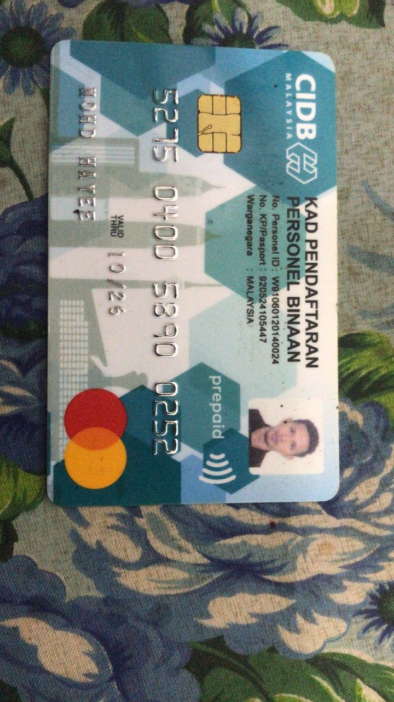 | Ref:  Expiry date  Photo | Ref:  Expiry date  Photo
2. | MUHAMMAD IZZAT HILMI BIN SAIMAN | Ref:001102140173  Expiry date: 21/11/2027  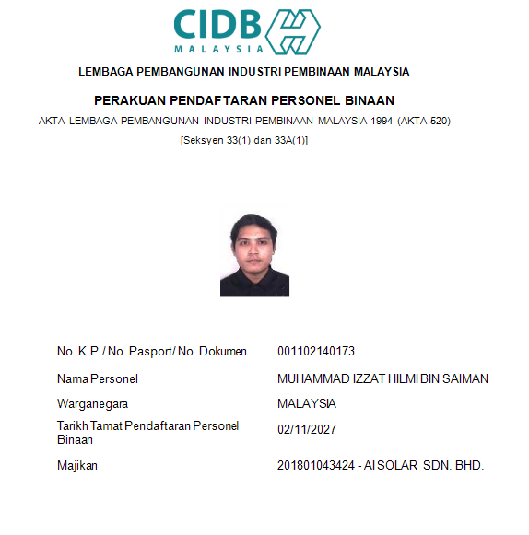 | Ref: 001102140173  Expiry date: | Ref:  Expiry date  Photo
3. | OSMAIZA BIN OMAR | Ref:  Expiry date:  Photo  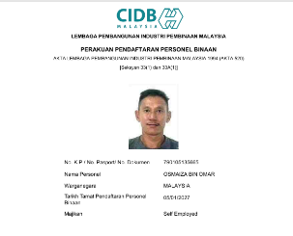 | Ref:  Expiry date  Photo | Ref:  Expiry date  Photo
4. | MUHAMMAD AN NUBLI BIN MOHD ROZI | Ref:  Expiry date:  Photo  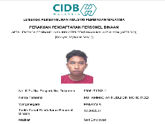 | Ref:  Expiry date  Photo | Ref:  Expiry date  Photo
5. | MOHD DANIAL FAHMI BIN MOHD RASHIB | Ref:  Expiry date:  Photo  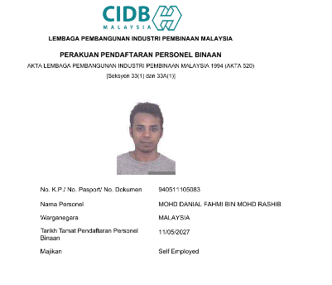 | Ref:  Expiry date  Photo | Ref:  Expiry date  Photo
7. | AFIK AFIAT BIN BUSRA | Ref: 920603146159  Expiry date: 03/06/2027  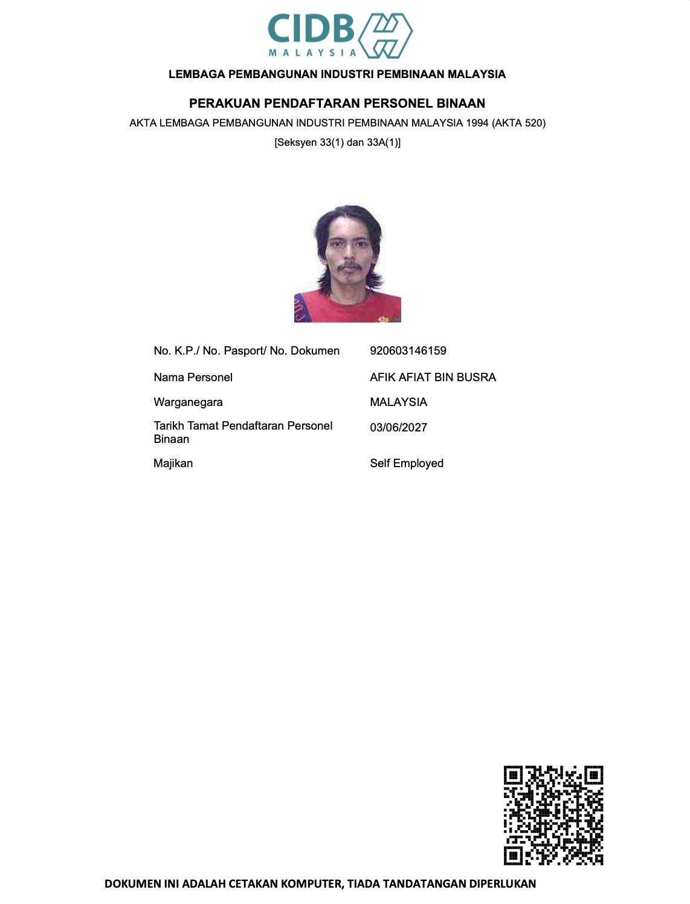 | Ref:  Expiry date  Photo | Ref:  Expiry date  Photo

Maxis Site Pack Photographs

- Site Toolbox
{%img_toolbox}

- Safety Briefing & Toolbox Meeting (capturing tools, safety gear, and PPE compliance)
{%img_safety}

- Equipment Inspection
{%img_inspection}

- Sky lift Photos
{%img_skylift}

Note:
1. Reflective vests to be used at ground level works, night work. Reflective vest cannot be used during climbing/working at height
2. Key collection will use NCR
3. Physical site pack required, If online document not available
Lifting Operation and Lifting Equipment
(For manual operation or using Crane)

Person in charge name: Lee Skylift Sdn Bhd | Mobile No.:
Lifting method:
(refer to lifting procedure)
Lifting material description: Install | Estimated weight: LESS THAN 200KG
Height:

No | Description (Lifting equipment) | Yes | No | Remark
 | Pulley |  | /
 | Sling |  | /
 | Connector/Shackle |  | /
 | Hook |  | / | Safety ledge available/function
 | Rope/Cable |  | /
 | Hoist assistance (Descender/etc) | /
N/A – not applicable

Crane/Skylift Inspection

Height:

No | Description | Yes | No | Remark
 | PMA No & validity | / |  | PMA No: PMA-NS/A25-85583  Reg No: NS-PMA-114552  Expiry date:19/8/2026
 | Out rigger | /
 | Out rigger plate/ground stability | /
 | Hydraulic system | /
 | Work area protection | / |  | Cone, signage, light, blinker
 | Operator PPE’s | /
 | Skylift bucket | / |  | For skylift
1. Detail inspection to be conducted by Crane/Skylift operator
2. Workers that require to exit the skylift bucket to another level and expose to fall more than 2 meter require to have valid working at height competency from approved training vendor)

Electrical
No | Description | Yes | No | Remark
1. | ELCB/Circuit breaker | /
2. | Competence person | / |  | Wireman/Chargeman
3. | PPE | / |  | Electrical glove
4. | LOTO

Hotwork
No | Description | Yes | No | Remark
1. | Fire blanket (if applicable) |  | /
2. | Observer (fire watcher)
Note: Portable fire extinguisher is mandatory at site

Confined Space
SECTION 1: Application (To be completed by Applicant)
Applicant Name |  | Company |  | Date
IC/Passport No. |  | Location |  | Start Time
Equipment No. |  | Work Order No |  | End Time
Work Description

SECTION 2: ISOLATION
 | Piping/Ducting |  | Barricade |  | Other engulfment material
 | Mechanical/Electrical Room |  | Material/Sand/Soil |  | Others
The items ticked have been isolated or made safe.
Verify by Entry Supervisor
Name: Sign Date

SECTION 3: ATMOSPHERIC MONITORING (To be filled by Authorised Gas Tester: AGT)
Type of Gas | Acceptable Range | Test 1 | Test 2 | Test 3 | Test 4 | The conditions are safe for entry under the conditions ticked below
O2 | 19.5 – 23.5%
Flammable | <10% LEL
CH4 | < 25 ppm |  |  |  |  | With a supplied air respirator
H2S | < 10 ppm |  |  |  |  | With an air purifying respirator
 |  |  |  |  |  | Without a respiratory protective device
AGT Signature
AGT Name |  |  |  |  |  | Remarks:
Time
Instrument Serial No
Instrument Calibration Date

SECTION 4: STAND-BY PERSONNEL AND RESCUE ARRANGEMENTS (To be filled by Person Applicant)
Stand-by personnel Name | 1. | Rescue facilities, equipment and communication with Entry Supervisor & Rescue Personnel
 | 2.
 | 3.
 | 4.
Verify by Entry Supervisor Name: Sign:

SECTION 5: PERMIT AUTHORIZATION (To be filled by Permit Issuance)
Base on my evaluation, the confined space described above is in a safe condition for work to be done, provided that the precautions above are fully observed.
Entry date: Entry Time: to

Permit issuer Name: Signature

SECTION 6: PERMIT ACCEPTANCE (To be filled by Entry Supervisor)
I understand the procedures required for entry and work in the confined space and the protective measures and equipment to be used

Entry Supervisor Name: Signature: Date:

SECTION 7: SIGNING OUT (to be filled by Entry Supervisor and Permit Issuer)
All persons & Equipment have been withdrawn and the work has been completed. Any further entry requires a new confined space permit to be applied
Entry Supervisor Name Signature Date

Permit Issuer Name Signature Date

SECTION 8: DEBRIEFING (to be conducted by Permit Applicant and Entry Supervisor with Work Party)
Debriefing note:

Inspection

No | Description | Yes | No | Remark
1. | Portable fire extinguisher | /
2. | First Aid box | /
3. | Safety Signage |  | /
4. | Barricade tape (if applicable) | /
5. | Safety Cone/Safety Signboard | /
6. | Ear Protection |  | /
7. | Eye protection |  | /
8. | Hand protection | /
9. | Other machinery |  | /
10.

Toolbox

PIC/Trainer name:

 | Toolbox content |  | Toolbox content
 | Electrical Safety |  | Lifting operation
 | Working at Height |  | Housekeeping
 | Manual handling
 | Fire Safety |  | Hazard
 | PPE usage |  | Emergency Response
 | Hand tools | 
 | Power tools | 
 | Chemical | 
 |  | 
 |  | 
Note: Signed at Workers Name list after toolbox briefing

Job Hazard Analysis (JHA)
(HIRARC refer to Safety Manual)

Required PPE
Sequence of Basic Job Steps | Potential Hazards | Recommended Action or Procedure
Lifting Materials | Falling Object | Barricade area and signal man
Cable Termination to House DB | Electric shock | Insulation Rubber Glove and Shutdown power supply
Cutting Materials | Equipment Malfuction and impact on workers | Regular inspection, Proper PPE and follow SOP.

