Title: ***Cost-effective Computing using Serverless Architecture***

In this paper, we present a comparison of costs for normal cloud computing and serverless computing and the cost of serverless computing from different Cloud Service Providers. We emphasize the reduction of the cost of serverless computing by providing a clear-cut comparison of costs instilled by various service providers.

Research Paper includes:

* Basic Concepts
* Service Providers
* Cost of services
* Cost Comparison

**Introductory Concepts which were covered on the survey paper**

Cloud Computing -- Cloud computing is an on-demand delivery of IT resources such as computing, storage, databases and other mandatory services that follow the concept of the pay-as-you-go model pricing

Serverless Computing -- In contrast to standard cloud computing principles, serverless computing masks the infrastructure and platforms on which the services are delivered to customers.

The Paper also covered -- How serverless architecture works, its flow and detailed comparison.

**Different Cloud Service Providers which Offer Serverless Services**

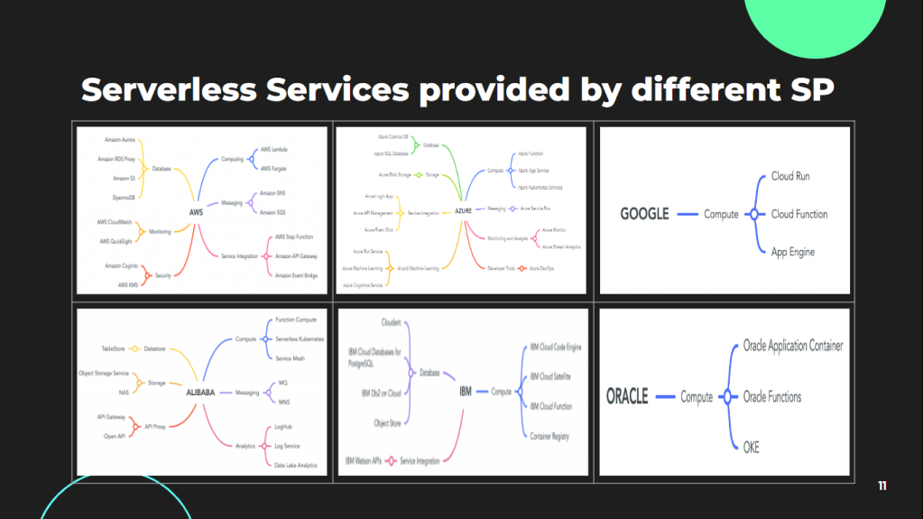

**Compute Serverless Services pricing among different Cloud Service Providers**

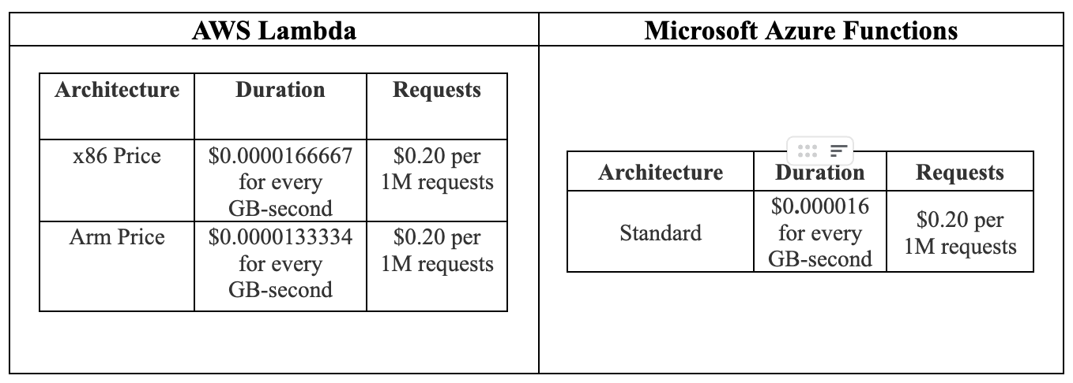

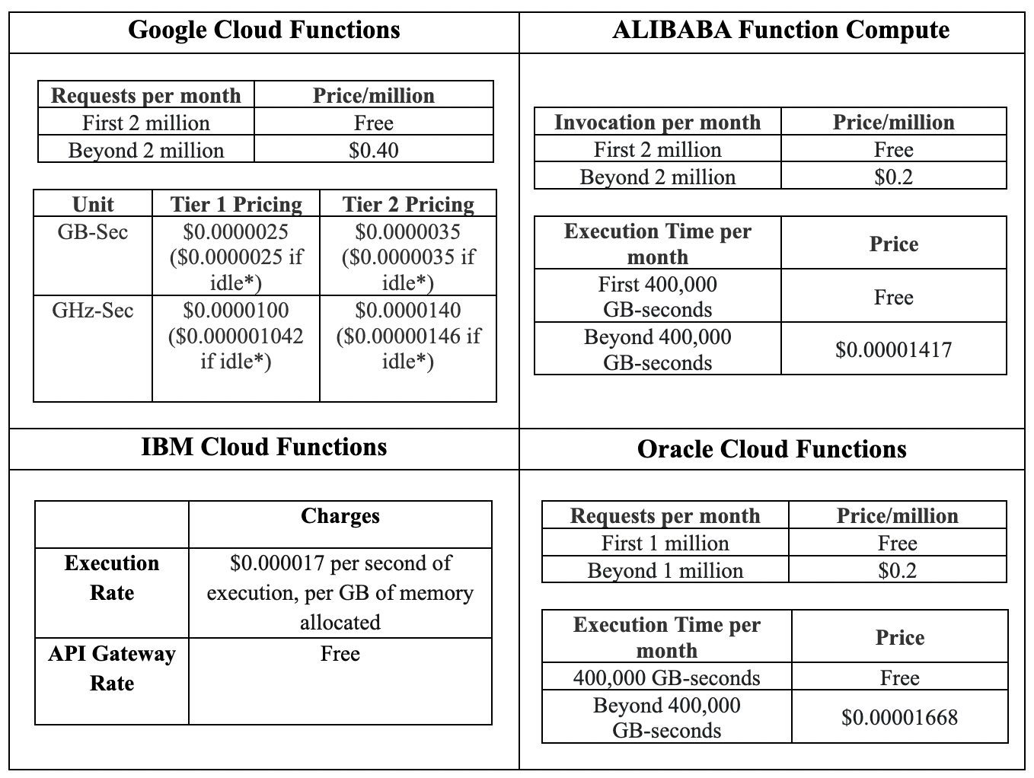

**Cost Comparison of Normal and Serverless Architecture**

Comparison is performed using the pricing calculator offered by the Cloud Service Provider. The architecture contains all the minimum necessary services for completing the scenario.

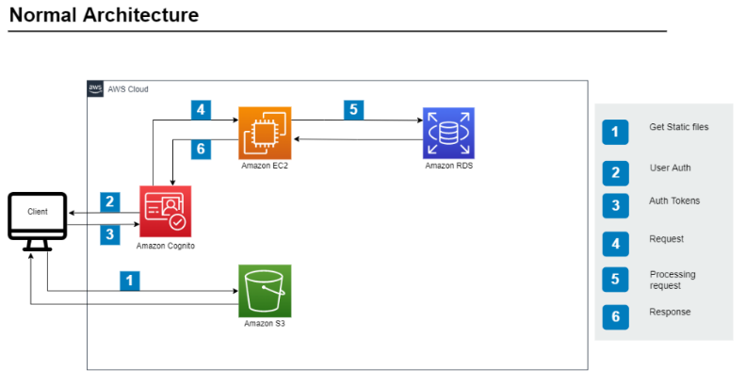

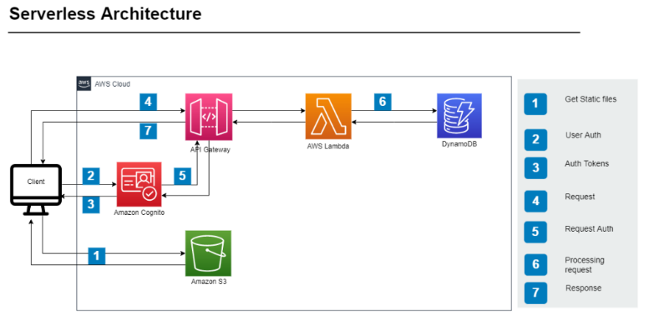

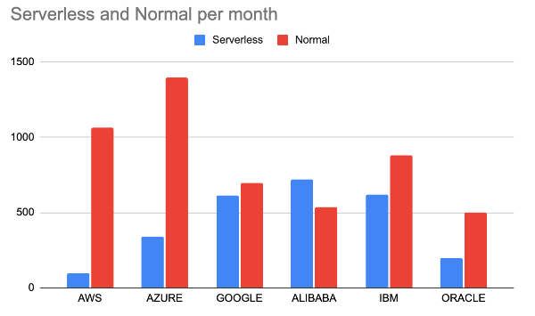

Author:

* Mayur Bhatti - 19it010@charusat.edu.in
* Khushi Carpenter - 19it020@charusat.edu.in
* Mentor - Dr. Bimal Patel