Data Science Project Plan & Strategy
Customer Churn Prediction for a Telecom Company
Virtual Data Science Explorer Intern — Week 1 Task
Prepared by: Md Asgar Ansari

1. Introduction & Background
Customer retention is one of the most critical challenges faced by subscription-based businesses such as telecom operators. Acquiring a new customer typically costs significantly more than retaining an existing one, which makes the ability to predict customer churn — the likelihood that a customer will discontinue a service — a high-value business problem.
This hypothetical project focuses on building a data-driven system that identifies customers who are at risk of churning, so that the business can proactively intervene with retention offers. Python has been chosen as the primary tool for this project because of its mature data science ecosystem (pandas, scikit-learn, matplotlib) and strong community support, which make it well suited for rapid prototyping and analysis.
Motivation: Reducing churn by even a small percentage can have a substantial impact on recurring revenue. This project is motivated by the need to move from reactive customer service to a proactive, data-informed retention strategy.

2. Project Objectives & Scope

2.1 Objectives
- Identify the key factors that contribute to customer churn (e.g., contract type, tenure, billing amount, service usage).
- Build a clear, step-by-step analytical pipeline that can take raw customer data and produce a churn risk score.
- Design a model evaluation approach that measures how reliably churn can be predicted.
- Present findings in a way that is understandable to both technical and non-technical stakeholders.

2.2 In-Scope
- Historical customer account data (tenure, plan type, billing, support tickets, usage patterns).
- Exploratory analysis and visualization of churn patterns.
- A classification-based predictive model (e.g., Logistic Regression / Random Forest).

2.3 Out-of-Scope
- Real-time streaming data pipelines or production deployment.
- Integration with live CRM or billing systems.
- Deep learning approaches, which are not necessary given the tabular nature of the data.

3. Methodology & Strategy
The project will follow a standard, linear data science workflow. Each stage feeds into the next, and insights from later stages (e.g., model evaluation) may prompt revisiting earlier stages such as feature engineering.
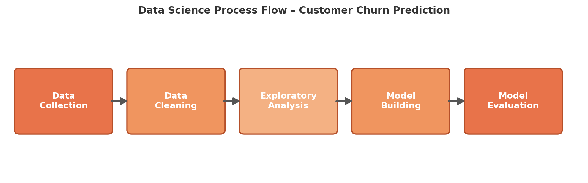
Figure 1: Data Science Process Flow for the Customer Churn Prediction project

3.1 Data Collection
Assume a hypothetical dataset of customer records containing fields such as customer ID, tenure, contract type, monthly charges, total charges, support tickets raised, and a churn label (Yes/No).

3.2 Data Cleaning
Handle missing values, correct inconsistent data types (e.g., charges stored as text), remove duplicate records, and standardize categorical labels using pandas.

3.3 Exploratory Data Analysis (EDA)
Use descriptive statistics and visualizations (histograms, box plots, correlation heatmaps) with matplotlib and seaborn to understand which features are most associated with churn.

3.4 Modeling
Split data into training and test sets. Start with an interpretable baseline model (Logistic Regression) and compare against a more flexible model (Random Forest) using scikit-learn.

3.5 Evaluation
Evaluate using accuracy, precision, recall, F1-score, and a confusion matrix — precision and recall are especially important since misclassifying a churn-prone customer as safe has real business cost.

4. Timeline & Tools
The project is planned across approximately 35 hours over the 4-week internship duration, distributed as follows:
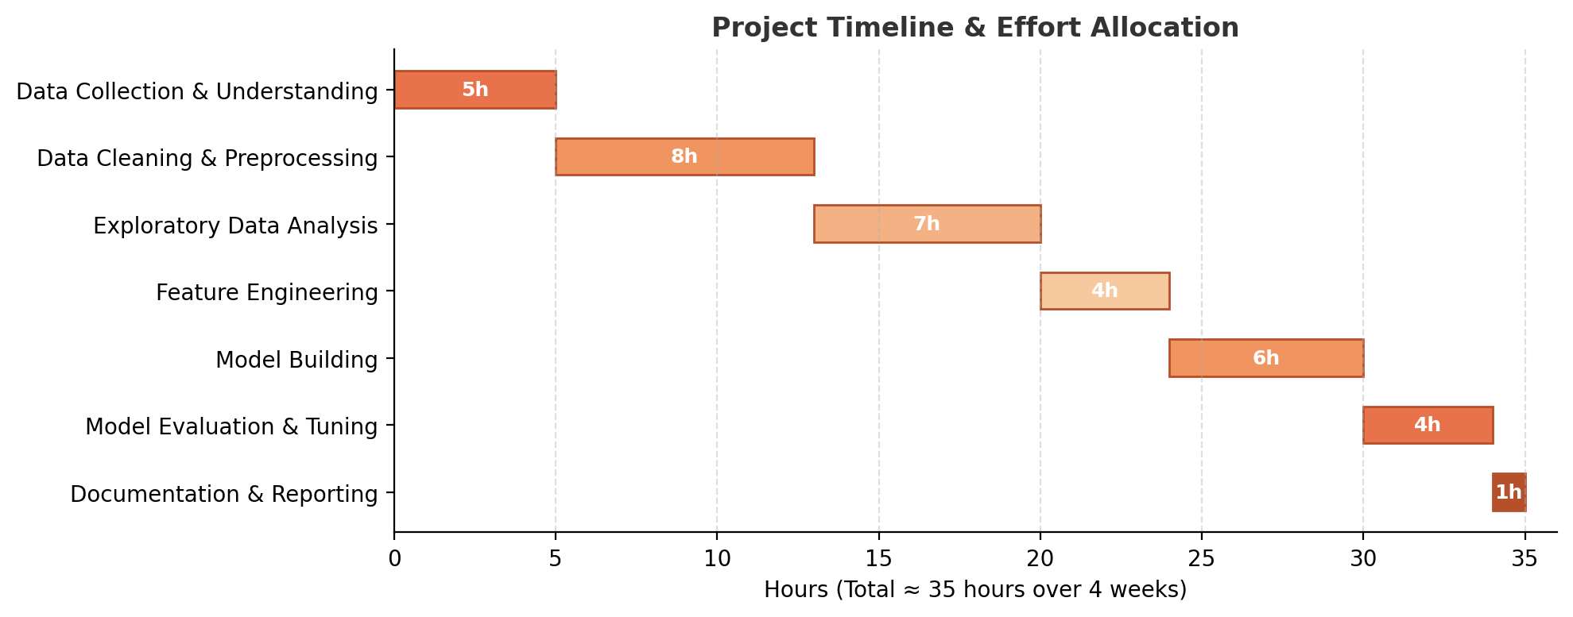
Figure 2: Project timeline and effort allocation (≈35 hours)

4.1 Tools & Python Libraries
Data Handling | pandas, numpy
Visualization | matplotlib, seaborn
Modeling | scikit-learn (Logistic Regression, Random Forest)
Environment | Jupyter Notebook / Google Colab
Version Control | Git & GitHub

5. Expected Outcomes & Challenges

5.1 Expected Outcomes
- A ranked list of factors most strongly associated with customer churn.
- A working baseline classification model with documented performance metrics.
- A set of clear visualizations that communicate churn drivers to non-technical stakeholders.

5.2 Anticipated Challenges & Mitigation
Class imbalance  (few churners vs. many non-churners) | Use techniques such as class weighting or resampling (e.g., SMOTE) and rely on precision/recall rather than accuracy alone.
Missing or inconsistent data | Apply systematic cleaning rules and document all assumptions made during preprocessing.
Overfitting on a small hypothetical dataset | Use cross-validation and keep the model interpretable rather than overly complex.

6. Conclusion
This plan lays a structured foundation for approaching the Customer Churn Prediction project. By clearly defining objectives, scope, methodology, timeline, and anticipated challenges upfront, the subsequent technical tasks in this internship can be executed efficiently and with a clear sense of direction.
Personal Note: I chose customer churn prediction as my hypothetical project because it is a problem I frequently come across as a mobile and DTH user myself — I have often wondered what data a company could use to know in advance that a customer might switch providers. Working through this planning exercise has helped me understand that a good data science project depends less on complex algorithms and more on asking the right questions early, which is the biggest takeaway I am carrying into the rest of this internship.

