EDA & Visualization Framework
A Reusable Approach for Exploratory Data Analysis in Python
Virtual Data Science Explorer Intern — Week 2 Task
Prepared by: Md Asgar Ansari

1. Introduction to EDA
In simple terms, Exploratory Data Analysis (EDA) means getting to know your data before you try to do anything smart with it — kind of like a doctor checking a patient's basic vitals (pulse, temperature, blood pressure) before deciding on treatment. You look at the data from different angles, ask basic questions about it, and only then decide what modeling or analysis makes sense.
A simple real-life example: imagine a food delivery app wants to know why some orders get cancelled. Before building any prediction model, someone would first open the order data and just look around — how many orders are being cancelled per day, is it mostly happening during certain hours (like late night or lunch rush), are cancellations higher for certain restaurants or delivery partners, and are there any missing values in fields like delivery time or distance. This initial "looking around" stage — spotting patterns, catching bad data, and forming early hunches — is exactly what EDA is.
It matters because real-world data is almost never clean. It usually comes with missing entries, duplicate rows, wrongly entered values (like a delivery distance of -5 km), or outliers that can throw off a model if they go unnoticed. Jumping straight into modeling without this step is a bit like a doctor prescribing medicine without checking symptoms first — it might work by luck, but it is not a reliable way to work. This document lays out a general EDA and visualization framework that I can reuse for any tabular dataset in the upcoming tasks of this internship, not just one specific project.

2. Data Exploration Techniques

2.1 Univariate Analysis
Examines one variable at a time to understand its distribution, central tendency, and spread. Techniques include summary statistics (mean, median, mode, standard deviation), frequency counts for categorical variables, and distribution plots such as histograms.

2.2 Bivariate Analysis
Examines the relationship between two variables at a time — for example, how a numeric feature relates to the target variable, or how two numeric features relate to each other. Scatter plots, grouped bar charts, and cross-tabulations are common tools here.

2.3 Multivariate Analysis
Looks at relationships among three or more variables simultaneously, often to detect combined effects or multicollinearity. Correlation heatmaps, pair plots, and dimensionality-reduction visualizations (like PCA scatter plots) fall into this category.

2.4 Handling Missing Data
- Detection: identify missing values using percentage-missing summaries per column.
- Deletion: drop rows/columns only when missingness is minimal and non-informative.
- Imputation: fill with mean/median/mode, or use forward-fill for time-based data, depending on context.

2.5 Handling Outliers
- Detection: use the IQR (Interquartile Range) rule and boxplots to flag extreme values.
- Treatment: cap values (winsorization), transform (log scale), or remove only if clearly erroneous.

3. Visualization Strategies
The chart below summarizes the general workflow this framework follows, from raw data to a documented report.
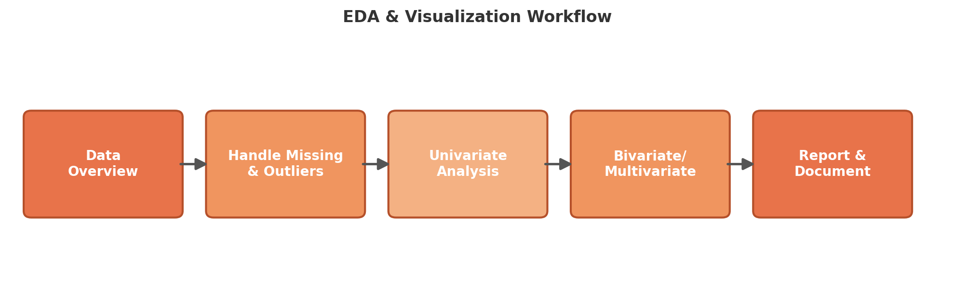
Figure 1: EDA & Visualization Workflow
The following are example plot types that would be created at each analysis stage, illustrated here using a representative sample dataset (customer tenure, monthly charges, and support tickets):

3.1 Histogram — Univariate Distribution
Used to visualize the spread and shape (skewness, modality) of a single numeric variable.
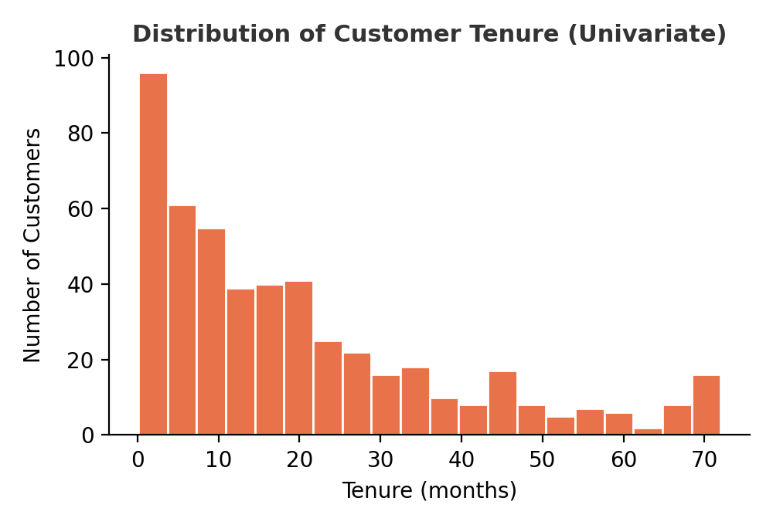
Figure 2: Example histogram showing distribution of a numeric feature

3.2 Scatter Plot — Bivariate Relationship
Used to visually inspect the relationship between two numeric variables and to spot clusters or trends, often color-coded by a target class.
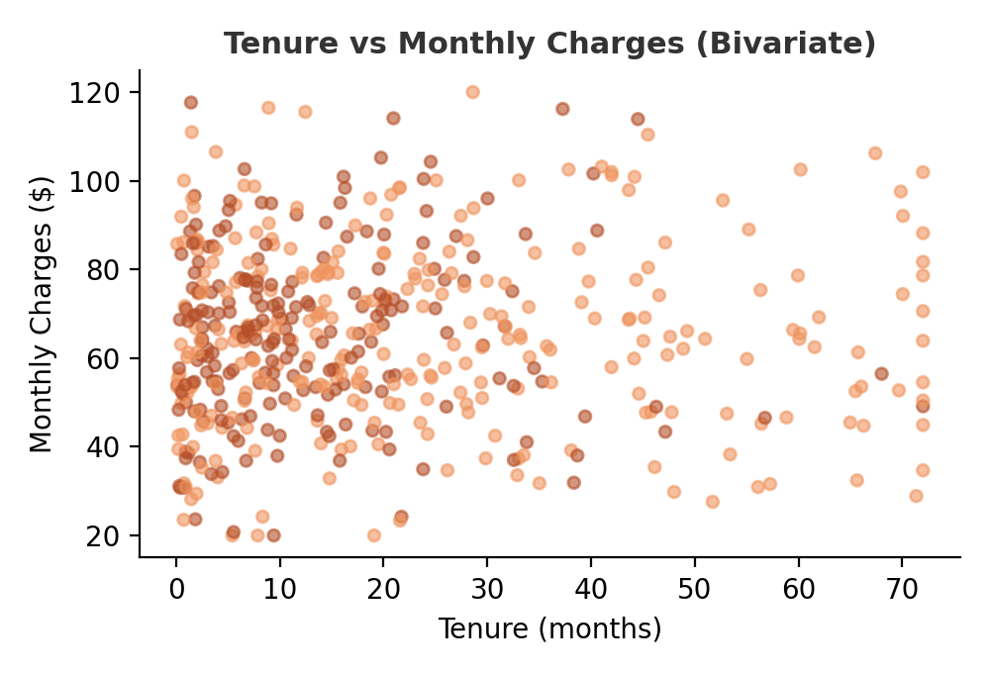
Figure 3: Example scatter plot comparing two numeric features

3.3 Correlation Heatmap — Multivariate Relationships
Used to quickly identify which numeric features are strongly correlated with each other or with the target variable, helping guide feature selection.
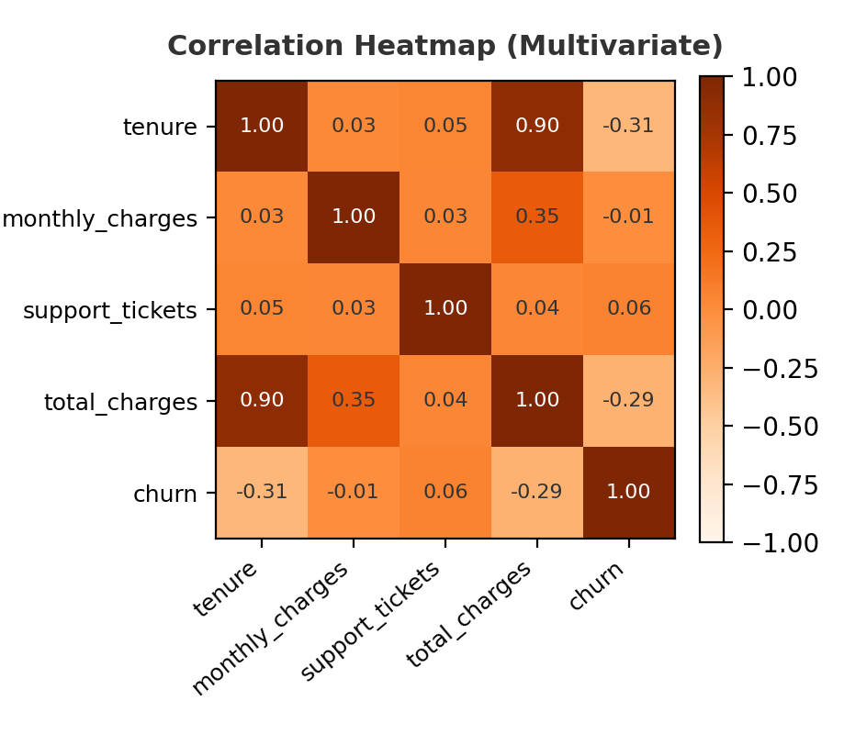
Figure 4: Example correlation heatmap across numeric features

3.4 Boxplot — Outlier Detection
Used to visualize the spread of a variable and flag potential outliers that fall beyond the whiskers of the box.
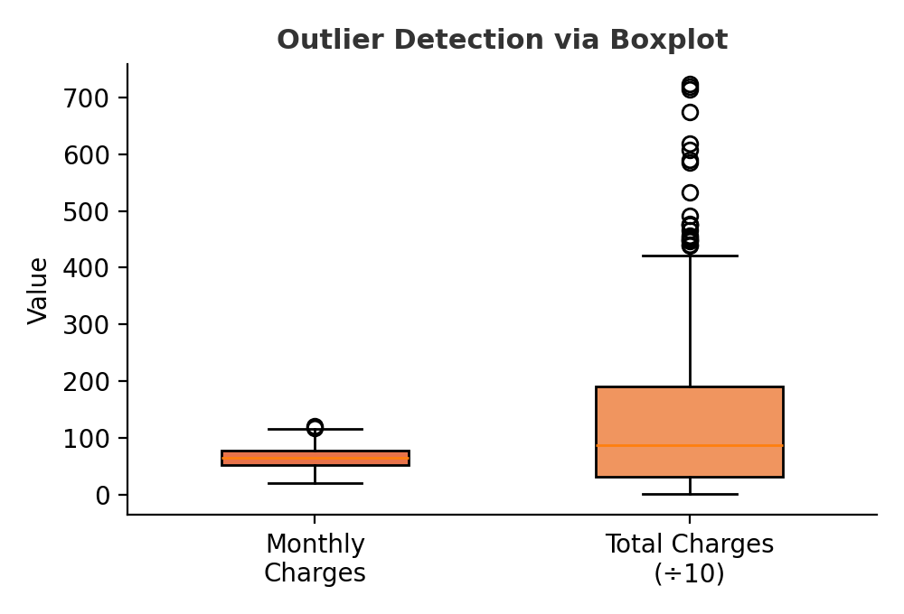
Figure 5: Example boxplot used for outlier detection

4. Tools and Libraries
pandas | Loading, cleaning, and summarizing tabular data (describe(), isnull(), groupby()).
numpy | Numerical operations, handling arrays, and supporting statistical calculations.
matplotlib | Base plotting library used for histograms, scatter plots, and boxplots.
seaborn | Built on matplotlib; simplifies statistical plots like heatmaps and pair plots with better default styling.
plotly | Used for interactive visualizations, useful when sharing exploratory results with stakeholders.

5. Reporting and Documentation Plan
Once the exploration is complete, findings will be consolidated into a structured report containing the following sections:
- Dataset Overview: dataset size, source, and a brief description of each column.
- Data Quality Summary: summary of missing values and outliers found, and how they were treated.
- Key Findings: key distributions and relationships discovered, supported by the visualizations above.
- Feature Insights: which features appear most relevant for later modeling, and why.
- Next Steps: what will be explored or built next based on these findings.
This report would be prepared in a Word or slide format depending on the audience — a detailed version for technical team members, and a summarized, chart-heavy version for non-technical stakeholders.

6. Conclusion
This framework provides a repeatable structure for exploring any new dataset — starting with an overview, moving through univariate, bivariate, and multivariate analysis, and ending with a clear, well-documented report. Because it is not tied to any specific dataset, the same framework can be reused across different projects during this internship.
Personal Note: While putting this framework together, I realized that EDA is less about memorizing chart types and more about asking the right question first and then picking the visualization that answers it. For example, a heatmap only becomes useful once I already suspect that certain features might be related — the plot confirms or challenges that idea rather than creating it. That mindset shift is what I am taking forward into the more hands-on tasks ahead.

