Machine Learning Model
Development & Evaluation Plan
Predicting Customer Churn for a Telecom Company Using Python
Virtual Data Science Explorer Intern — Week 3 Task
Prepared by: Md Asgar Ansari

1. Problem Definition
For this plan, I'm sticking with the same problem I picked in Week 1 — predicting whether a telecom customer is likely to churn (i.e., cancel their subscription) in the near future. I'm continuing with it here because it gives me a consistent thread across the internship: Week 1 was the plan, Week 2 was how I'd explore the data, and now this is how I'd actually build and evaluate a model on it.
To restate it simply: given information about a customer — how long they've been with the company, what plan they're on, how much they're billed, how many support complaints they've raised — can I build a model that flags, with reasonable confidence, which customers are at risk of leaving? This is a binary classification problem (Churn = Yes/No), and it's worth solving because retaining an existing customer is almost always cheaper than acquiring a new one, so even a moderately accurate model gives the retention team a head start on who to reach out to.

2. Data Preprocessing
Before any model can be trained, the raw customer data needs to be cleaned and shaped into something a machine learning algorithm can actually learn from. I'd approach this in the following order:
- Cleaning: check each column for missing entries — for something like 'total charges' I'd impute using the median rather than dropping rows, since dropping too much data early on can bias the sample.
- Normalization: convert categorical fields like contract type or payment method into numeric form using one-hot encoding, and scale numeric fields like monthly charges using standardization so that no single feature dominates just because of its scale.
- Feature Engineering: combine or transform raw columns into more useful signals — for example, turning 'tenure in months' into a 'tenure bucket' (new / mid / long-term customer), which often helps simpler models pick up patterns more easily.
- Feature Selection: drop features that are clearly redundant (like customer ID) or highly correlated with another feature already in the dataset, based on the correlation analysis planned in Week 2.

2.1 Potential Challenges & Solutions
Challenge | Why it happens | How I'd handle it
Class imbalance | Far fewer churners than non-churners in most real datasets | Use class-weighting in the model, or oversample the minority class with SMOTE
Data leakage | Accidentally including a feature that reveals the outcome | Carefully review each feature to ensure it would realistically be known before the churn decision
Categorical explosion | One-hot encoding creating too many columns | Group rare categories together before encoding

3. Model Selection and Training
I wouldn't jump straight to the most complex model available. My plan is to start simple and only add complexity if it's justified by the results:
- Logistic Regression — as a baseline. It's fast to train, easy to interpret (you can literally see which features push the prediction up or down), and gives me a benchmark to compare everything else against.
- Decision Tree — to see if the relationships in the data are more non-linear than logistic regression can capture, and because a tree's decisions are easy to explain to a non-technical stakeholder.
- Random Forest — as my main candidate, since it usually performs better than a single tree by averaging many trees together, and is less prone to overfitting.
- Gradient Boosting (e.g. XGBoost) — if Random Forest isn't accurate enough, since boosting methods often squeeze out extra performance on tabular data like this, at the cost of being a bit slower to tune.
My reasoning for picking Random Forest as the likely 'main' model: it strikes a good balance between accuracy and interpretability (through feature importance scores), doesn't need heavy feature scaling, and tends to be more forgiving of outliers than logistic regression — which matters here since billing data often has a few extreme values.

3.1 Training Process & Hyperparameter Tuning
I would split the data 70/15/15 into training, validation, and test sets, making sure the split is stratified so the churn/non-churn ratio stays consistent across all three. For tuning, I'd use grid search or randomized search with cross-validation on the training set — for Random Forest that mainly means tuning the number of trees, max depth, and minimum samples per leaf, since these have the biggest effect on whether the model overfits or underfits.
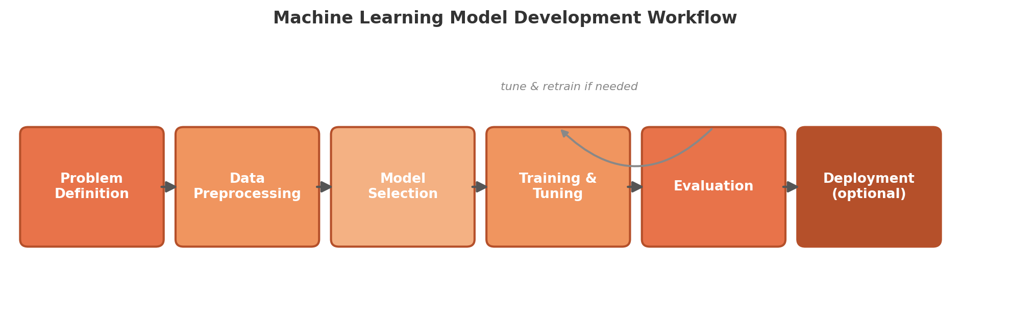
Figure 1: End-to-end ML model development workflow, including the tune-and-retrain feedback loop
For comparison purposes, here's what I would expect a rough performance comparison across candidate models to look like, based on how these algorithms typically behave on similar tabular churn datasets:
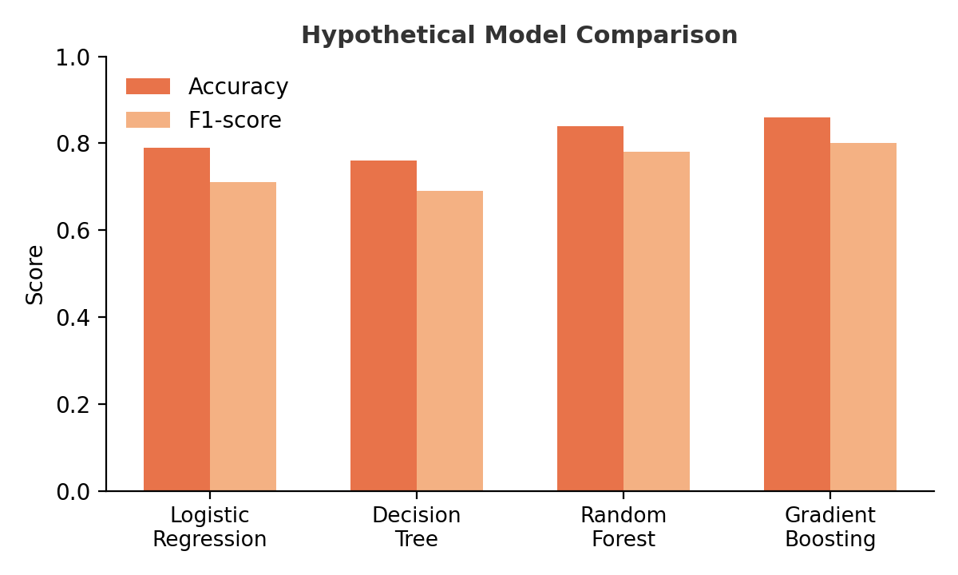
Figure 2: Hypothetical accuracy and F1-score comparison across candidate models

4. Evaluation Metrics
Accuracy alone would be misleading here because of class imbalance — a model that just predicts 'no churn' for everyone could still score 85%+ accuracy while being completely useless. So I'd rely more heavily on the following:
- Precision — out of everyone the model flagged as a churn risk, how many actually churned. Matters if the retention team has limited capacity and can't chase every flagged customer.
- Recall — out of everyone who actually churned, how many the model caught. Matters more here, since missing an at-risk customer means losing them for good.
- F1-score — the balance between precision and recall, useful as a single number to compare models when both false positives and false negatives carry a cost.
- ROC AUC — measures how well the model separates churners from non-churners across all thresholds, which is useful for comparing models independent of any one cutoff.
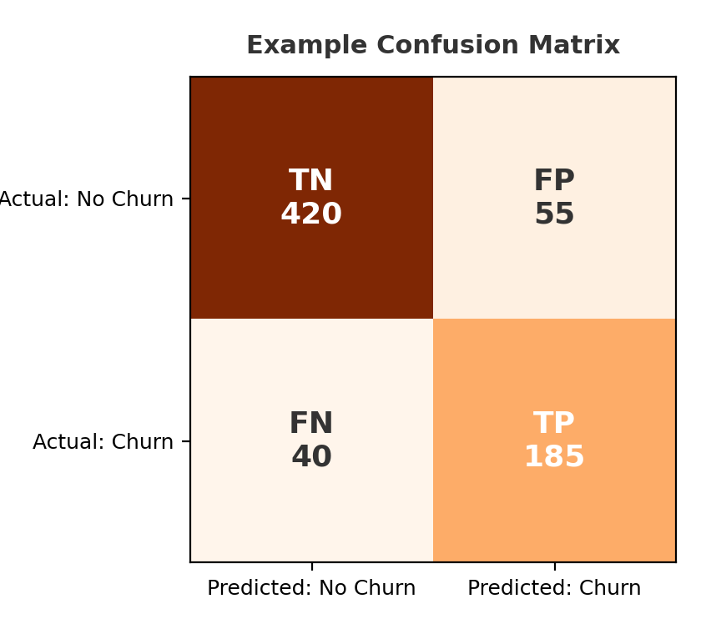
Figure 3: Example confusion matrix illustrating how predictions would be evaluated
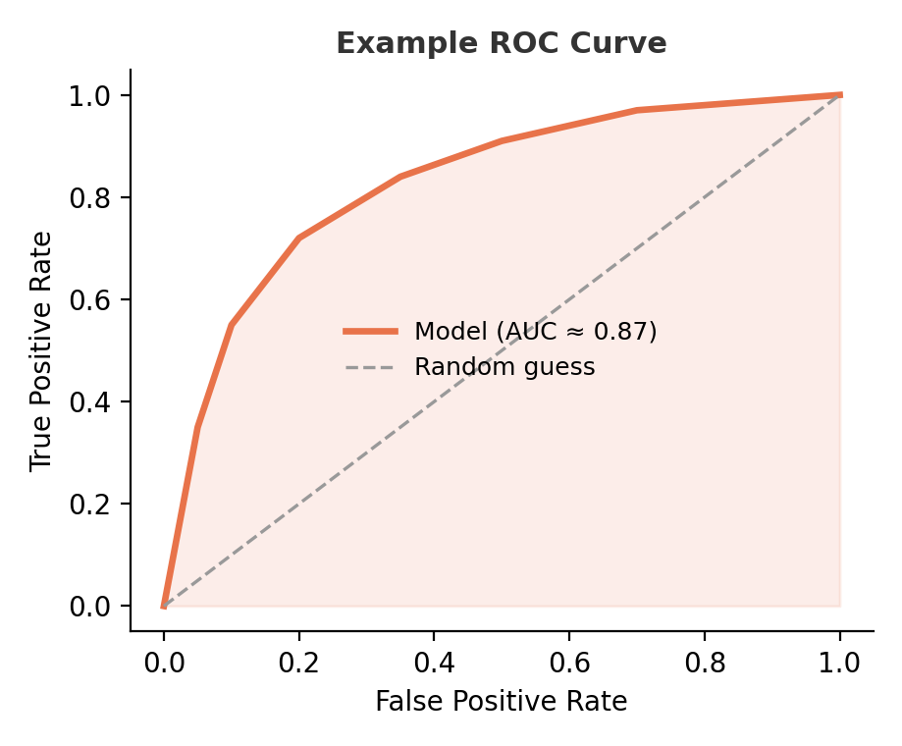
Figure 4: Example ROC curve for a hypothetical trained model
To ensure the evaluation is reliable and not just a result of a lucky train/test split, I'd use k-fold cross-validation (probably 5-fold) on the training set during model selection, and only touch the held-out test set once, at the very end, to report a final, unbiased performance number.

5. Model Deployment (Optional)
Since this task doesn't require actual deployment, I'll keep this section conceptual. If this model were to move to production, I'd wrap it behind a simple API endpoint that the retention team's dashboard could call weekly to re-score the customer base. Over time, the model's performance would need to be monitored, because customer behavior drifts — a model trained on last year's pricing plans may not stay accurate as new plans are introduced. I'd plan to retrain on a rolling basis (e.g., quarterly) and keep a log of predictions versus actual outcomes to catch this kind of drift early.

6. Conclusion
This plan walks through the full lifecycle of building a churn prediction model — from defining the problem clearly, through cleaning and preparing the data, choosing and training a model with a clear justification, and finally evaluating it with metrics that actually reflect the business cost of getting it wrong. Keeping it grounded in the same churn-prediction scenario from Weeks 1 and 2 made it easier to reason through each decision, since I already had a mental picture of what the data and the business problem looked like.
Personal Note: The part I found most useful to think through was the evaluation metrics section — before this I would have defaulted to just checking accuracy, but working through why that's misleading for an imbalanced problem like churn made me realize evaluation isn't just a final checkbox, it needs to be decided early because it shapes which model and which threshold you end up choosing. That's probably the biggest shift in how I'd approach a real ML problem going forward.

