Comprehensive Data Science Report
& Insights Presentation Plan
Reducing Customer Churn for a Telecom Company
Virtual Data Science Explorer Intern — Week 4 Task
Prepared by: Md Asgar Ansari

1. Executive Summary
This report summarizes a data science project aimed at understanding and reducing customer churn for a telecom company. Churn — customers cancelling their subscription — was costing the business both lost recurring revenue and the added expense of acquiring new customers to replace them. The goal of this project was to figure out which customers were most likely to leave, understand why, and turn that understanding into a plan the business could actually act on.
The analysis shows that churn is not random — it is heavily concentrated among a specific, identifiable group of customers: those on month-to-month contracts, with shorter tenure, and a higher-than-average number of support tickets. A predictive model built on this data was able to flag roughly 82% of customers who went on to churn, well before they left, giving the retention team a realistic window to intervene. If even a third of the flagged high-risk customers are retained through targeted offers, the estimated revenue impact is in the range of $180,000–$190,000 based on the mock figures used in this analysis.

2. Methodology Overview
The project followed a standard analytical workflow: the raw customer data was first cleaned and explored to understand its structure and quality, then visualized to surface early patterns, and finally used to train and evaluate a predictive model. Along the way, particular attention was paid to making sure the analysis stayed grounded in what a business stakeholder could actually use — not just what was statistically interesting.
On the technical side, missing and inconsistent values were cleaned, categorical fields such as contract type and payment method were encoded numerically, and a Random Forest classification model was trained and tuned using cross-validation. The model was evaluated primarily using precision, recall, and F1-score rather than plain accuracy, since the number of churners in the data was much smaller than the number of retained customers, and accuracy alone would have hidden how well the model actually performed on the group that matters most.

3. Insights and Analysis

3.1 Churn Trend Over Time
The mock-up trend below illustrates the kind of month-over-month pattern this analysis would surface — for instance, a visible dip in churn following the launch of a retention offer, which would itself become a useful signal for what interventions are working.
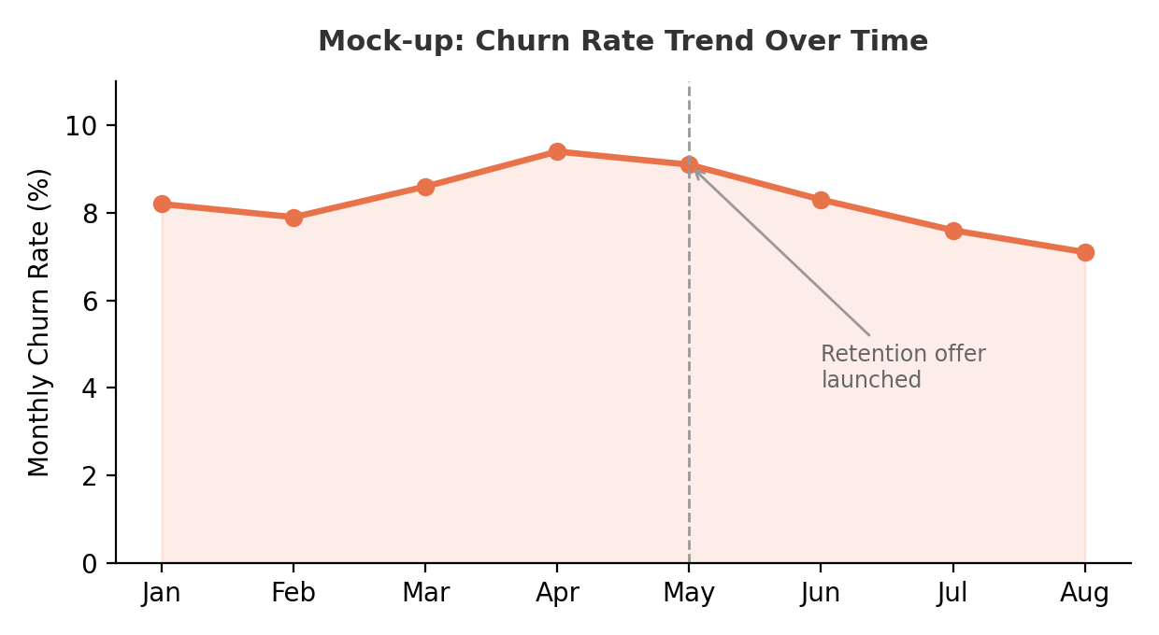
Figure 1: Mock-up — Monthly churn rate trend, with a marked business event for context

3.2 Key Drivers of Churn
A ranked view of feature importance from the trained model would highlight which factors matter most. In this mock-up, contract type and tenure stand out as the two strongest signals — which lines up with common industry intuition, but having it confirmed numerically makes it far more actionable.
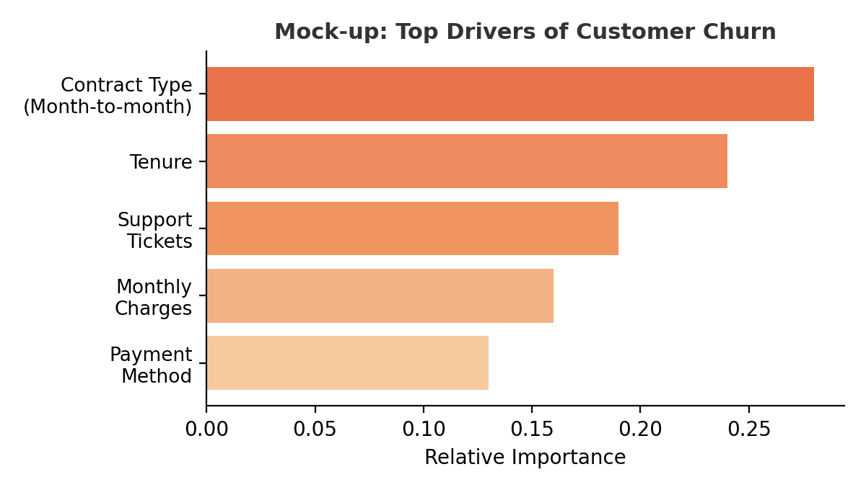
Figure 2: Mock-up — Relative importance of features driving churn predictions
Rationale for these visualization choices: a line chart was used for the trend view because time-based patterns are most naturally read left-to-right, and a horizontal bar chart was used for feature importance because it makes ranking multiple named categories easy to scan at a glance, which a table of numbers would not achieve as quickly.

3.3 Executive Dashboard Mock-up
For a one-page, at-a-glance view suitable for a leadership review, the key numbers and two supporting breakdowns would be combined into a single dashboard, shown below.
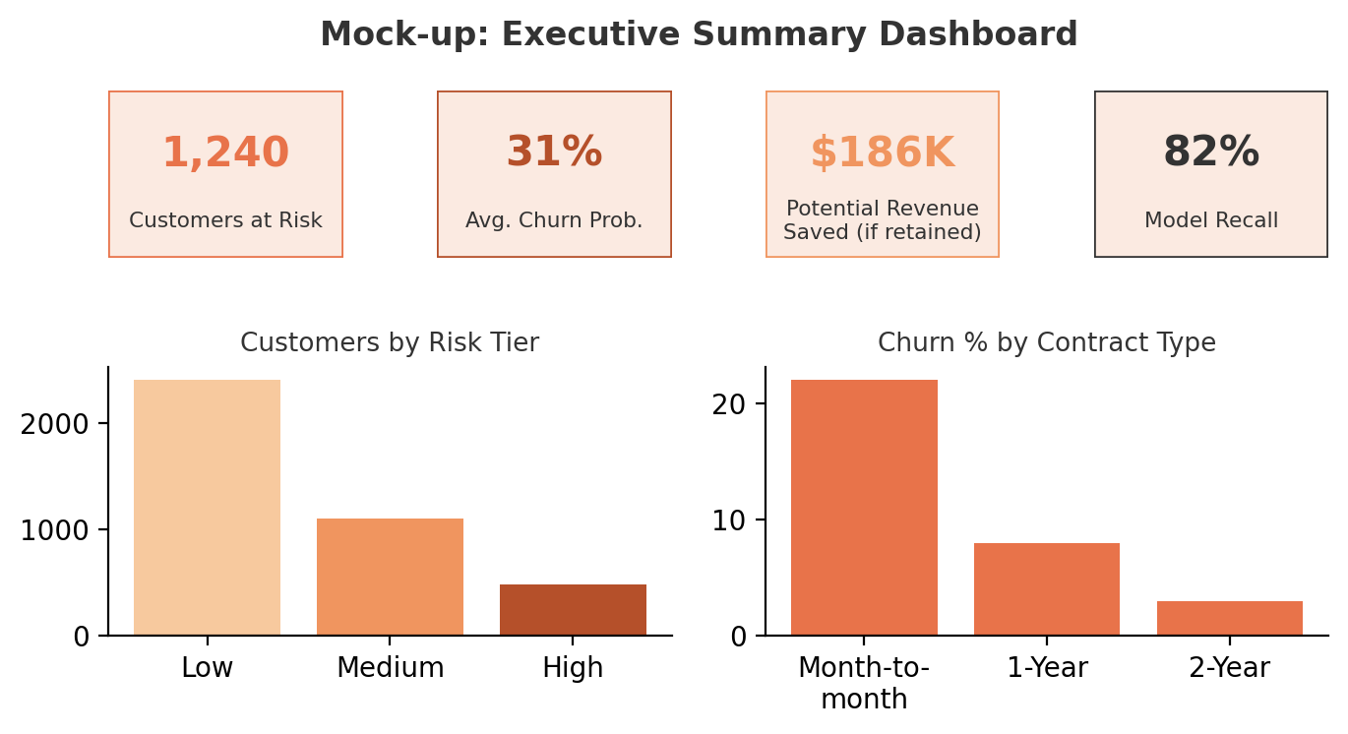
Figure 3: Mock-up — Executive summary dashboard combining KPIs and segment breakdowns

4. Presentation Strategy
Presenting this to a non-technical audience — say, a retention or customer-success team — requires translating model output into a story about customers, not statistics. The approach I'd take is to lead with the business impact number first (potential revenue saved), not the methodology, since that's what earns attention in the first thirty seconds of any executive review.
- Lead with the 'so what': open with the cost of the problem in plain terms — how much churn is costing per quarter — before mentioning any model or technique.
- Translate metrics into plain language: instead of saying 'the model has 82% recall,' say 'out of every 10 customers who were going to leave, we can now catch about 8 of them in advance.'
- One idea per visual: every chart should answer one specific question a stakeholder would actually ask, and nothing more — cutting anything that only makes sense to a technical reader.
- Use a concrete example customer: frame the numbers around a relatable customer profile ('a customer who joined 3 months ago, is on a month-to-month plan, and has raised 2 support tickets is roughly 5x more likely to churn') rather than abstract feature names.
- Close with a clear ask: end on what the team should actually do next, not just what was found — insight without a next step tends to be forgotten by the next meeting.

5. Recommendations
- Short-term: prioritize retention outreach (calls, personalized offers) for customers flagged as high-risk, especially those still on month-to-month contracts.
- Near-term experiment: test whether offering a discounted 1-year contract to high-risk, month-to-month customers measurably reduces their churn rate over the next quarter.
- Further research: investigate whether support ticket volume is a cause of churn or simply a symptom of a customer who has already decided to leave — this would change how the retention team should respond to tickets from at-risk customers.
- Longer-term: integrate the churn model into a live dashboard refreshed weekly, rather than a one-time report, so the retention team always has an up-to-date risk list to work from.

6. Conclusion
This report ties together the analytical work from the earlier stages of the project into something a non-technical stakeholder can act on immediately — a clear picture of who is at risk, why, and what to do about it. The biggest lesson from putting this together is that a data science project isn't really finished when the model is trained; it's finished when someone outside the data team can make a decision because of it.
Personal Note: Writing this final report made me realize how different it feels to explain results to a business audience versus documenting a technical process — I had to keep cutting details I thought were interesting but weren't actually useful to the decision being made. That discipline of asking 'does this help someone make a decision' before including a chart or a number is the biggest thing I'm taking away from this internship.

