CUSTOMER DATA ANALYSIS PROJECT
1. Project Introduction
Customer Data Analysis is a data analytics project focused on understanding customer shopping behaviour and purchasing patterns across different shopping malls in Istanbul, Turkey.
The project uses a retail shopping transaction dataset containing information about customer demographics, product categories, quantities purchased, prices, payment methods, invoice dates, and shopping mall locations.
MySQL was used to explore, validate, and analyse the dataset. Power BI was used to create an interactive dashboard to present key performance indicators and business insights.
The main purpose of this project is to identify customer preferences, understand purchasing behaviour, evaluate product category performance, and provide data-driven business recommendations.
2. Project Objectives
The main objectives of this project are:
- Analyse customer distribution based on gender and age.
- Identify the most popular product categories.
- Evaluate customer purchasing behaviour across different age groups.
- Analyse the usage of cash, credit card, and debit card payment methods.
- Compare sales performance across different shopping malls.
- Calculate total shopping records, products sold, and revenue.
- Develop an interactive Power BI dashboard to communicate the findings.
- Provide meaningful business insights and recommendations based on the analysis.
3. Dataset Description
The dataset used in this project contains retail shopping transaction records from 10 shopping malls located in Istanbul, Turkey.
3.1 Dataset Overview
Description | Details
Total Records | 99,457
Total Columns | 10
Shopping Malls | 10
Product Categories | 8
Gender Groups | 2
Payment Methods | 3
Minimum Age | 18 years
Maximum Age | 69 years
Start Date | 1 January 2021
End Date | 8 March 2023
3.2 Dataset Columns
The dataset contains the following 10 columns:
- invoice_no: Unique invoice number for each shopping transaction.
- customer_id: Customer identification number.
- gender: Gender of the customer.
- age: Age of the customer.
- category: Product category purchased.
- quantity: Number of products purchased.
- price: Price of the product.
- payment_method: Payment method used for the transaction.
- invoice_date: Date of the shopping transaction.
- shopping_mall: Name of the shopping mall.
3.3 Tools Used
- MySQL Workbench: Used for data exploration, validation, SQL queries, and analysis.
- Microsoft Power BI: Used for data visualization and interactive dashboard development.
- Microsoft Word: Used for project documentation and reporting.
3.4 Dataset Period
The supplied CSV contains 99,457 transaction records dated from 1 January 2021 to 8 March 2023. The dataset therefore includes records from part of 2023, but not the complete 2023 calendar year.
4. Data Cleaning and Validation
Before performing the analysis, the dataset was examined to check its quality, consistency, and accuracy.
4.1 Data Completeness
- Total records checked: 99,457.
- Total columns checked: 10.
- No SQL NULL values were found in the dataset.
- No exact duplicate rows were identified.
- Invoice numbers and customer IDs were unique across all records.
4.2 Data Validation
The following checks were performed:
Column | Minimum | Maximum | Average
Age | 18 | 69 | 43.43
Quantity | 1 | 5 | 3.00
Price (TL) | 5.23 | 5,250.00 | 689.26
- No zero or negative values were found in quantity.
- No zero or negative values were found in price.
- Transaction dates ranged from 1 January 2021 to 8 March 2023.
- All expected gender, payment method, and product category values were checked.
4.3 Data Quality Summary
The dataset was found to be consistent across the validation checks performed. No exact duplicate records, SQL NULL values, or invalid numeric values were identified.
The dataset was therefore considered suitable for further SQL analysis and Power BI visualization.
Note: These checks do not necessarily rule out empty strings, whitespace issues, or partial duplicates.
5. SQL Analysis and Results
SQL queries were used to analyse customer demographics, purchasing behaviour, product categories, payment preferences, and shopping mall performance.
5.1 Customer Analysis by Gender
The dataset contains more female shopping records than male shopping records.
Gender | Shopping Records | Products Sold | Revenue (TL)
Female | 59,482 | 178,659 | 150,207,136.02
Male | 39,975 | 120,053 | 101,298,658.23
Total | 99,457 | 298,712 | 251,505,794.25
Finding: Female customers account for approximately 59.81% of shopping records and generate approximately 59.72% of total revenue.
5.2 Customer Analysis by Age Group
Customers were divided into five age groups for analysis.
Age Group | Shopping Records | Products Sold | Revenue (TL)
18–25 | 15,359 | 46,028 | 38,118,271.35
26–35 | 19,059 | 57,265 | 47,879,659.58
36–45 | 19,436 | 58,483 | 50,184,235.79
46–55 | 19,016 | 57,086 | 48,219,742.64
56–69 | 26,587 | 79,850 | 67,103,884.89
Finding: The 56–69 age group has the highest shopping records, product purchases, and revenue. The 18–25 age group has the lowest revenue.
5.3 Product Category Analysis
Clothing generated the highest revenue among the eight product categories.
The analysis showed that:
- Clothing was the leading revenue category.
- Shoes and Technology were also important revenue-generating categories.
- Books and Souvenir had comparatively lower sales performance.
5.4 Payment Method Analysis
Payment Method | Shopping Records | Products Sold | Revenue (TL) | Share
Cash | 44,447 | 133,370 | 112,832,243.02 | 44.69%
Credit Card | 34,931 | 105,045 | 88,077,123.77 | 35.12%
Debit Card | 20,079 | 60,297 | 50,596,427.46 | 20.19%
Finding: Cash is the most frequently used payment method, followed by credit cards and debit cards.
5.5 Shopping Mall Analysis
The dataset includes transactions from 10 shopping malls in Istanbul.
- Mall of Istanbul recorded the highest number of shopping records (19,943).
- Kanyon recorded the second-highest number (19,823).
- Metrocity recorded 15,011 shopping records.
Clothing was the highest-revenue product category across all 10 malls.
5.6 Overall Business Performance
The SQL analysis identified the following overall results:
- Total shopping records: 99,457.
- Total products sold: 298,712.
- Total revenue: 251,505,794.25 TL.
- Total shopping malls: 10.
Revenue was calculated using the formula:
Revenue = SUM(quantity × price)
This calculation assumes that the price column represents the unit price of each product.
5.7 Summary of SQL Findings
The analysis indicates that female customers contribute a larger share of shopping activity and revenue. Customers aged 56–69 generate the highest revenue, Clothing is the leading product category, and Cash is the most frequently used payment method.
6. Power BI Dashboard and Visualizations
Microsoft Power BI was used to create an interactive dashboard to present the results of the customer shopping analysis.
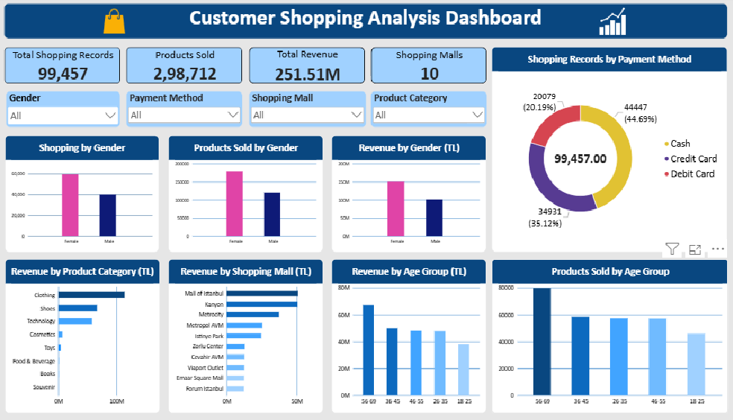
The dashboard connects directly to the MySQL database and uses the customer transaction table for visualization.

6.1 Key Performance Indicators (KPIs)
Four KPI cards were created to summarize the overall business performance.
KPI | Value
Total Shopping Records | 99,457
Products Sold | 298,712
Total Revenue | 251.51 Million TL
Shopping Malls | 10
6.2 Dashboard Visualizations
The dashboard contains the following visualizations:
- Shopping Records by Gender: Compares shopping activity between female and male customers.
- Products Sold by Gender: Shows the number of products purchased by each gender.
- Revenue by Gender: Compares revenue generated by female and male customers.
- Revenue by Product Category: Identifies the highest-revenue product categories.
- Shopping Records by Payment Method: Displays the distribution of cash, credit card, and debit card transactions.
- Revenue by Shopping Mall: Compares revenue performance across shopping malls.
- Revenue by Age Group: Identifies which age group generates the highest revenue.
- Products Sold by Age Group: Compares product quantities purchased across age groups.
6.3 Interactive Dashboard Filters
Four slicers were added to allow users to explore the data interactively:
- Gender
- Shopping Mall
- Product Category
- Payment Method
These filters allow users to view different aspects of customer shopping behaviour without creating separate reports.
6.4 Dashboard Benefits
The Power BI dashboard provides:
- A quick overview of business performance.
- Easy comparison of customer segments.
- Identification of high-performing product categories and shopping malls.
- Interactive exploration of customer purchasing patterns.
- A clear visual presentation of the SQL analysis results.
7. Key Business Insights
Based on the SQL analysis and Power BI dashboard, the following business insights were identified:
7.1 Female Customers Generate Higher Revenue
Female customers account for 59.81% of shopping records and approximately 59.72% of total revenue. This indicates that female customers contribute a larger share of shopping activity.
7.2 Older Customers Have Higher Purchasing Activity
Customers aged 56–69 generate the highest revenue, with approximately 67.10 million TL. This age group also purchases the highest quantity of products.
7.3 Clothing Is the Leading Product Category
Clothing is the highest-revenue category across genders, age groups, payment methods, and shopping malls. Shoes and Technology are also important categories.
7.4 Cash Is the Most Popular Payment Method
Cash accounts for 44.69% of shopping records, followed by credit cards at 35.12% and debit cards at 20.19%.
7.5 Shopping Mall Performance Varies
Mall of Istanbul and Kanyon have the highest shopping record counts. This indicates strong shopping activity at these locations.
7.6 Customer Preferences Show Consistent Patterns
Clothing leads across different customer segments, while cash remains the most frequently used payment method across genders, age groups, categories, and malls.
8. Business Recommendations
Based on the findings, the following recommendations are proposed:
8.1 Targeted Marketing Campaigns
Develop marketing campaigns for different customer segments, particularly female customers and the 56–69 age group, while continuing to engage younger customers.
8.2 Improve Clothing Category Performance
Maintain sufficient clothing inventory, introduce seasonal promotions, and explore customer preferences to support the strongest revenue-generating category.
8.3 Encourage Digital Payments
Although cash is the most popular payment method, businesses can encourage credit and debit card usage through loyalty rewards, cashback offers, and convenient payment options.
8.4 Strengthen Shopping Mall Strategies
Study successful practices at Mall of Istanbul and Kanyon and identify opportunities to improve customer engagement and shopping activity at other malls.
8.5 Develop Age-Based Promotions
Create suitable promotions for different age groups rather than relying on a single marketing strategy for all customers.
8.6 Monitor Business Performance
Use the Power BI dashboard regularly to monitor revenue, product sales, customer segments, and shopping mall performance. This can support better business decisions.
Limitation: Every customer ID appears only once in the supplied dataset. The analysis therefore describes transaction records and should not be interpreted as repeat-customer retention or loyalty analysis.
9. Conclusion
The Customer Data Analysis project successfully analysed 99,457 shopping transaction records from 10 shopping malls in Istanbul, Turkey.
MySQL Workbench was used to explore, validate, and analyse the dataset. SQL queries helped identify customer purchasing patterns based on gender, age groups, product categories, payment methods, and shopping mall locations.
Microsoft Power BI was used to develop an interactive dashboard containing four key performance indicators, eight visualizations, and four interactive filters.
The analysis revealed that female customers contribute a larger share of shopping activity, customers aged 56–69 generate the highest revenue, Clothing is the leading product category, and Cash is the most frequently used payment method.
Overall, this project provided practical experience in SQL data analysis, data validation, business intelligence, and data visualization. It also demonstrated how data-driven insights can help businesses understand customers, evaluate performance, and make informed decisions.
The project successfully achieved its main objectives and provided a foundation for further customer and retail business analysis.
9.1 Limitations
- The verified dataset covers 1 January 2021 to 8 March 2023, with 797 distinct transaction dates.
- The analysis is based on the available transaction records.
- Revenue calculations assume that price represents the unit price.
- The findings describe observed patterns and do not establish causal relationships.

