HR ANALYTICS PROJECT REPORT
1. Project Title
HR Analytics: Employee Workforce Analysis and Visualization
2. Project Overview
This project focuses on analysing employee data to understand workforce composition, hiring trends, employee demographics, and work location distribution.
SQL was used to retrieve, explore, validate, and analyse the data. Power BI was used to develop an interactive dashboard presenting key performance indicators (KPIs), charts, and business insights.
The findings were used to identify workforce patterns and develop data-driven recommendations to support human resource planning and decision-making.
3. Project Objectives
The main objectives of this project are:
- Retrieve employee data from the provided database.
- Understand the dataset structure and verify data quality.
- Calculate the total employee count, work location percentages, and average employee age.
- Analyse hiring trends by year.
- Analyse workforce distribution by gender, state, department, and race, subject to the availability of the required data.
- Create visualizations using Power BI.
- Identify meaningful patterns and derive actionable business insights.
- Recommend improvements to support HR planning and workforce management.
4. Tools and Technologies
- MySQL Workbench: Database connection, SQL queries, data exploration, and analysis.
- SQL: Data retrieval, validation, calculations, aggregation, and analysis.
- Microsoft Power BI: Dashboard development and data visualization.
- Microsoft Word: Project documentation and analysis report.
- Microsoft PowerPoint: Final project presentation.
5. Dataset Description
Dataset Structure Clarification:
The original project assignment describes the dataset as containing 13 columns. However, after importing and inspecting the actual dataset in MySQL, 14 columns were identified in the HR table. The analysis and subsequent SQL queries are therefore based on the 14 columns available in the imported dataset.
6. Project Methodology
The project followed these stages:
- Database connection and data retrieval.
- Dataset exploration and understanding.
- Data quality assessment.
- Data cleaning and preparation, where required.
- SQL-based KPI calculations and workforce analysis.
- Data visualization using Power BI.
- Interpretation of results and development of business recommendations.
- Final documentation and presentation.
7. Project Status
The HR Analytics project has been completed, including dataset validation, SQL-based analysis, CSV exports, Power BI dashboard development, business insights, recommendations, and final presentation preparation.
The project report documents the key stages of the work, including the SQL methodology and results, data validation findings, Power BI visualisations, and supporting screenshots. The final project files have been organised into their respective folders for submission.
8.1 Database Selection
Objective: To select the database containing the HR dataset before performing data analysis.
Tool Used: MySQL Workbench.
SQL Query:
USE project_hr_analytics;
Explanation: The USE statement selects project_hr_analytics as the default database for the current SQL session. This allows subsequent SQL queries to access tables within the selected database.
Result: The database selection query was executed in MySQL Workbench.
Next Step: Identify the available tables within the selected database.
8.2 Table Identification
Objective: To identify the tables available in the selected database.
Tool Used: MySQL Workbench.
SQL Query:
-- Display all tables in the selected database.
SHOW TABLES;
Explanation: The SHOW TABLES statement lists the tables available in the currently selected database.
Result: The query was executed to identify the table containing the HR dataset.
Next Step: Inspect the structure of the HR table to understand its columns and data types.
8.3 Dataset Structure Inspection
Objective
To understand the structure of the HR dataset and identify the columns available for analysis.
Tool Used
MySQL Workbench.
SQL Query
-- Inspect the structure of the HR table.
DESCRIBE HR;
Findings
The HR table contains 14 columns covering employee identification, personal information, demographics, department, job title, work location, hiring date, termination date, and geographic information.
Dataset Structure Clarification
The original project description specified 13 columns. However, inspection of the actual HR table using the MySQL INFORMATION_SCHEMA.COLUMNS metadata confirmed that the database contains 14 columns. All subsequent SQL analysis was performed using the actual 14-column table structure.
The id column is designated as the primary key. The Age column uses an integer data type, while birthdate, hire_date, and termdate are stored as VARCHAR fields.
Observation
The date fields require further examination because they are stored as text. Their formats and values must be validated before conducting date-based analysis.

8.4 Initial Record Verification
Objective: To verify the total number of employee records available in the HR dataset
Tool Used: MySQL Workbench.
SQL Query:
-- Count the total number of employee records in the HR table.
SELECT
COUNT(*) AS total_employee_records
FROM HR;
Validation Result:
The initial record verification confirmed that the HR dataset contains a total of 22,214 employee records.
Conclusion: The record count was successfully verified using SQL, establishing the total number of records available for the subsequent analysis.
8.5 Duplicate Employee ID Validation
Objective: To verify whether employee IDs are unique in the HR dataset.
Tool Used: MySQL Workbench.
SQL Query:
-- Identify employee IDs appearing more than once.
SELECT
id,
COUNT(*) AS occurrence_count
FROM HR
GROUP BY id
HAVING COUNT(*) > 1;
Methodology: Employee records were grouped by ID, and the number of occurrences was calculated for each ID. The HAVING clause was used to identify IDs appearing more than once.
Validation Result: The duplicate employee ID verification returned 0 duplicate records.
Conclusion: All 22,214 employee records have unique employee IDs. No duplicate employee identifiers were detected in the dataset.
Next Step: Check for missing or blank values in important employee fields.
8.6 Missing and Blank Value Analysis
Objective: To identify missing or blank values in important employee attributes before performing further analysis.
Tool Used: MySQL Workbench.
Methodology: SQL conditional expressions were used to count NULL values, empty strings, and whitespace-only strings in text columns. The Age column was checked for NULL values.
SQL Functions Used:
- CASE: Evaluates conditions and returns the appropriate result.
- IS NULL: Identifies NULL values.
- TRIM(): Removes leading and trailing spaces for the purpose of checking blank text.
- SUM(): Adds conditional results to calculate the number of affected records.
Results: The initial completeness check identified zero missing or blank values across the 13 fields excluding the termination-date field. A separate check identified 18,285 blank values in the termdate column.
Validation Result:
The data completeness validation was performed across all 14 columns of the HR dataset, containing 22,214 employee records.
- No missing or blank values were identified in the employee ID or the other 12 fields, excluding termdate.
- A total of 18,285 records contained blank termination dates.
- These blank termination dates are treated as expected values because employees without a recorded termination date have not been assigned a termination date in the dataset.
Conclusion: The dataset demonstrates complete values across all fields except termdate, where blank values represent employees without a recorded termination date. Therefore, these records are not classified as data-quality errors.
8.7 Employee Age Validation
Objective: To examine the age distribution of employees and identify potentially invalid age values.
Tool Used: MySQL Workbench.
SQL Query:
-- Calculate the minimum, maximum, and average employee age.

SELECT
MIN(Age) AS minimum_age,
MAX(Age) AS maximum_age,
ROUND(AVG(Age), 2) AS average_age
FROM HR;
Results:
- Minimum age: 20 years
- Maximum age: 57 years
- Average age: 38.43 years
Observation: The recorded employee ages range from 20 to 57 years, with an average age of 38.43 years.
Conclusion: The initial age range appears reasonable. However, further validation is needed to confirm that the recorded ages are consistent with the employees' birthdates.
Next Step: Inspect the formats of the birthdate and hire_date columns before conducting date-based analysis.
8.8 Birthdate Format Inspection
Objective: To identify the format in which employee birthdates are stored.
Tool Used: MySQL Workbench.
SQL Query:
-- Inspect birthdate values.
SELECT birthdate
FROM HR
LIMIT 10;
Observation: The inspected birthdate values follow the DD-MM-YYYY format (Day-Month-Year).
Example: The value 04-06-1991 represents 4 June 1991.
Conclusion: The birthdate column is stored as VARCHAR. The observed format will be used when converting birthdates into date values for further analysis.
Next Step: Inspect the hire_date values to determine their date format.
8.9 Hiring Date Validation
Objective: To validate the hiring dates and determine the earliest and latest hiring dates in the dataset.
Tool Used: MySQL Workbench
SQL Query:
-- Validate hiring dates and identify invalid date values.
-- Convert hire_date from DD-MM-YYYY text into date values.
-- Calculate total records, invalid dates, earliest and latest dates.

SELECT
COUNT(*) AS total_records,

SUM(
CASE
WHEN STR_TO_DATE(hire_date, '%d-%m-%Y') IS NULL
THEN 1
ELSE 0
END
) AS invalid_hiring_dates,

MIN(STR_TO_DATE(hire_date, '%d-%m-%Y'))
AS earliest_hiring_date,

MAX(STR_TO_DATE(hire_date, '%d-%m-%Y'))
AS latest_hiring_date

FROM HR;
Methodology: The STR_TO_DATE() function was used to convert the hire_date values from text into date values using the DD-MM-YYYY format. Invalid date conversions were counted to assess data quality.
Validation Result:
- Total employee records checked: 22,214
- Invalid hiring dates: 0
- Earliest hiring date: 17 October 2000
- Latest hiring date: 13 December 2020
Conclusion: All 22,214 hiring date records passed the validation check. No invalid hiring dates were identified. The recorded hiring dates range from 17 October 2000 to 13 December 2020.
8.10 Birthdate Validation
Objective: To validate the birthdate column and identify the earliest and latest birthdates in the dataset.
Tool Used: MySQL Workbench
SQL Query:
-- Validate employee birthdates and identify invalid date values.
-- Convert birthdate from DD-MM-YYYY text into date values.
-- Calculate total records, invalid birthdates, earliest and latest birthdates.

SELECT
COUNT(*) AS total_records,

SUM(
CASE
WHEN STR_TO_DATE(birthdate, '%d-%m-%Y') IS NULL
THEN 1
ELSE 0
END
) AS invalid_birthdates,

MIN(STR_TO_DATE(birthdate, '%d-%m-%Y'))
AS earliest_birthdate,

MAX(STR_TO_DATE(birthdate, '%d-%m-%Y'))
AS latest_birthdate

FROM HR;
Methodology: The STR_TO_DATE() function was used to convert the birthdate values from text into date values using the DD-MM-YYYY format.
Results:
- Total records checked: 22,214
- Invalid birthdates: 0
- Earliest birthdate: 16 October 1965
- Latest birthdate: 13 September 2002
Observation: All 22,214 birthdate values were successfully converted using the specified date format. No invalid birthdates were identified by this validation query.
Conclusion: The birthdate column passed the date-conversion validation check and can be used for further analysis, subject to additional consistency checks.
8.11 Termination Date Validation
Objective: To validate the termination-date column and identify the earliest and latest termination dates in the dataset.
Tool Used: MySQL Workbench
SQL Query:
-- Validate termination dates and identify invalid date values.
-- Remove the UTC suffix before converting text into datetime values.
-- Calculate total records, nonblank dates, invalid dates,
-- earliest termination date and latest termination date.

SELECT
COUNT(*) AS total_records,

SUM(
CASE
WHEN termdate IS NOT NULL
AND TRIM(termdate) <> ''
THEN 1
ELSE 0
END
) AS nonblank_termination_dates,

SUM(
CASE
WHEN termdate IS NOT NULL
AND TRIM(termdate) <> ''
AND STR_TO_DATE(
REPLACE(TRIM(termdate), ' UTC', ''),
'%Y-%m-%d %H:%i:%s'
) IS NULL
THEN 1
ELSE 0
END
) AS invalid_termination_dates,

MIN(
STR_TO_DATE(
REPLACE(TRIM(termdate), ' UTC', ''),
'%Y-%m-%d %H:%i:%s'
)
) AS earliest_termination_date,

MAX(
STR_TO_DATE(
REPLACE(TRIM(termdate), ' UTC', ''),
'%Y-%m-%d %H:%i:%s'
)
) AS latest_termination_date

FROM HR;
Methodology: The REPLACE() function was used to remove the UTC suffix, and STR_TO_DATE() was used to convert the remaining text into datetime values.
Results:
- Total employee records: 22,214
- Nonblank termination dates: 3,929
- Invalid termination dates: 0
- Earliest termination date: 15 April 2001
- Latest termination date: 29 October 2041
Observation: All nonblank termination dates were successfully converted into datetime values. However, the latest termination date falls in the future and requires further investigation.
Conclusion: The termination-date column passed the date-conversion validation check. Additional checks are required to identify future termination dates and determine how they should be handled in employee-status calculations.
8.12 Investigation of Future Termination Dates
Objective: To identify termination dates occurring after the reference date of 3 November 2026.
Tool Used: MySQL Workbench
SQL Query:
-- Identify future and completed termination dates.
-- Use 03 November 2026 as the project reference date.
-- Include all employee records in the total count.
-- Classify future and completed termination dates separately.

SELECT
COUNT(*) AS total_employee_records,

COUNT(termination_date) AS nonblank_termination_dates,

SUM(
CASE
WHEN DATE(termination_date) > '2026-11-03'
THEN 1
ELSE 0
END
) AS future_termination_dates,

SUM(
CASE
WHEN DATE(termination_date) <= '2026-11-03'
THEN 1
ELSE 0
END
) AS completed_terminations

FROM (
SELECT
STR_TO_DATE(
REPLACE(TRIM(termdate), ' UTC', ''),
'%Y-%m-%d %H:%i:%s'
) AS termination_date
FROM HR
) AS termination_analysis;
Methodology: The termination-date values were converted into datetime values and compared with the reference date. Sample records were retrieved for further inspection.
Results:
- Total employee records: 22,214
- Records with nonblank termination dates: 3,929
- Records with future termination dates: 1,014
- Records with termination dates on or before the reference date: 2,915
Observation: A total of 1,014 records contain termination dates after 3 November 2026. These records require careful treatment when calculating current employee counts.
Conclusion: Future termination dates were identified for further investigation. No records were deleted or modified during this validation step.
8.13 Average Employee Age KPI
Objective: Calculate the average, minimum, and maximum employee ages recorded in the HR dataset.
SQL Functions Used: COUNT(), AVG(), ROUND(), MIN(), and MAX().
Results:
- Total Records: 22,214
- Average Employee Age: 38.43 years
- Minimum Employee Age: 20 years
- Maximum Employee Age: 57 years
Interpretation:
The dataset contains 22,214 employee records, with an average recorded age of 38.43 years. Employee ages range from 20 to 57 years. These results provide an overview of the age distribution represented in the dataset.
Conclusion: The average employee age KPI has been calculated successfully and can be used in the HR Analytics dashboard.
8.14 Summary of Main HR KPIs
Objective: Calculate the three main KPIs required for the HR Analytics project: total employee records, workforce distribution by location, and average employee age.
Results:
KPI | Result
Total Employee Records | 22,214
Headquarters Employees | 16,715
Headquarters Workforce | 75.25%
Remote Employees | 5,499
Remote Workforce | 24.75%
Average Employee Age | 38.43 years
Key Findings:
- The dataset contains 22,214 employee records.
- Headquarters accounts for 75.25% of the workforce, while Remote locations account for 24.75%.
- The average recorded employee age is 38.43 years.
Conclusion: The three main HR KPIs have been calculated successfully. These metrics were used to support the development of the HR Analytics dashboard and its visualizations.
8.15 Age Data Consistency Validation
Objective: Investigate inconsistencies between the recorded employee ages and the ages calculated from birthdates.
Methodology:
The recorded Age column was compared against ages calculated using the birthdate column at three reference dates:
- 31 December 2022
- 31 December 2023
- 3 November 2026
Results:
Reference Date | Matching Records | Percentage
31 December 2022 | 16,393 | 73.79%
31 December 2023 | 5,821 | 26.21%
3 November 2026 | 0 | 0.00%
Key Findings:
- Most recorded ages match ages calculated at the end of 2022.
- The remaining records match ages calculated at the end of 2023.
- None of the recorded ages match the ages calculated as of 3 November 2026.
Conclusion:
The age validation identified a discrepancy between the recorded ages and ages calculated using the project's reference date. The results suggest that the recorded ages may reflect earlier calculations. However, the original calculation date cannot be confirmed from the available data alone.
The original Age column has not been modified. This limitation should be considered when interpreting the average employee age KPI.
8.16 Age Calculation Using Birthdates
Objective: Calculate employee ages directly from birthdates to obtain an age KPI based on a defined reference date.
Reference Date: 3 November 2026
Methodology:
The birthdate column was converted from text into a date format using STR_TO_DATE(). The TIMESTAMPDIFF() function was then used to calculate each employee's age as of the reference date.
Results:
Metric | Result
Total Records | 22,214
Average Calculated Age | 42.01 years
Minimum Calculated Age | 24 years
Maximum Calculated Age | 61 years
Comparison with the Original Age Column:
The original Age column has an average of 38.43 years, a minimum of 20 years, and a maximum of 57 years. The birthdate-derived calculation produces an average age of 42.01 years, a minimum of 24 years, and a maximum of 61 years.
The average calculated age is 3.58 years higher than the original average. This discrepancy indicates that the two age measures should not be treated as interchangeable without further investigation.
Conclusion:
The age calculation based on birthdates was completed successfully for all 22,214 records. The original Age column remains unchanged. For reporting purposes, the birthdate-derived age may be used as the age KPI if the reference date of 3 November 2026 is clearly documented.
8.17 Distribution of Age Differences
Objective: Determine the size and frequency of differences between the recorded employee ages and ages calculated from birthdates.
Reference Date: 3 November 2026
Results:
Age Difference | Employee Count | Percentage
3 years | 9,267 | 41.72%
4 years | 12,947 | 58.28%
Total | 22,214 | 100.00%
Key Findings:
- A total of 9,267 employees (41.72%) have calculated ages that are three years higher than their recorded ages.
- A total of 12,947 employees (58.28%) have calculated ages that are four years higher than their recorded ages.
- All 22,214 records have age differences of either three or four years.
Conclusion:
The analysis identifies a consistent discrepancy between the recorded ages and the ages calculated from birthdates as of 3 November 2026. The pattern suggests that the original ages may reflect an earlier reference period, although the exact date cannot be established from the available data.
The original age values have not been modified. The methodology and reference date should be documented when presenting the age KPI.
8.18 Hire and Termination Date Validation
Objective: Verify that employee termination dates do not occur before their respective hire dates.
Methodology:
The hire_date and termdate columns were converted into date formats and compared to identify invalid employment date sequences.
Results:
Metric | Records
Records with Both Dates | 3,929
Termination Before Hire Date | 0
Termination On or After Hire Date | 3,929
Key Findings:
- All 3,929 records containing termination dates have valid date sequences.
- No records were identified where the termination date occurred before the hire date.
Conclusion:
The hire and termination date validation was successful. No invalid date sequences were identified. However, future termination dates were identified in an earlier analysis and are treated separately when determining employee status.
8.19 Dataset Workforce Structure
Objective: Identify the total number of employee records, unique job titles, and unique departments.
Methodology:
The SQL functions COUNT() and COUNT(DISTINCT) were used to calculate the total records and unique categories.
Results:
Metric | Result
Total Employee Records | 22,214
Unique Job Titles | 185
Unique Departments | 13
Key Findings:
- The dataset contains 22,214 employee records.
- A total of 185 distinct job titles are represented.
- Employees are distributed across 13 departments.
Conclusion:
The dataset represents a diverse workforce with multiple job roles and departmental structures. These findings provide an overview of the organizational structure and support further workforce analysis.
8.20 Cleveland Work Location Analysis
Objective: To investigate the distribution of Cleveland employees between Headquarters and Remote work locations.
Findings:
- Total employees in Cleveland: 16,871
- Headquarters employees: 16,715 (99.08%)
- Remote employees: 156 (0.92%)
Analysis:
The analysis confirms that 156 employees in Cleveland are classified as Remote, while the remaining 16,715 are classified as Headquarters. This explains why the total number of Cleveland employees is higher than the overall Headquarters employee count.
Conclusion:
The difference is explained by the presence of Remote employees whose recorded city is Cleveland. No data modification was required.
8.21 City and State Validation
Objective: To identify city names associated with multiple states and check the geographical consistency of the dataset.
Findings:
The analysis identified three city names associated with more than one state:
City | Associated states | Employee count
Springfield | Illinois, Ohio | 168
Warren | Michigan, Ohio | 44
Bloomington | Illinois, Indiana | 33
Total | 3 city names | 245
Analysis:
The same city name can exist in multiple states. Therefore, using only the city name for geographical analysis could combine employees from different locations.
Conclusion:
These results do not necessarily indicate incorrect data. For accurate geographical analysis, the combination of city and state should be considered instead of using the city name alone. No data modifications were required.
8.22 Gender Distribution Analysis
Objective: To analyse the workforce distribution across gender categories and calculate the percentage representation of each category.
Findings:
Gender | Employee count | Percentage
Male | 11,288 | 50.81%
Female | 10,321 | 46.46%
Non-Conforming | 605 | 2.72%
Total | 22,214 | 99.99%
Analysis:
Male employees represent the largest group, accounting for 50.81% of the workforce. Female employees represent 46.46%, while Non-Conforming employees account for 2.72%.
The percentages add up to 99.99% because of rounding.
Conclusion:
The workforce has a relatively balanced distribution between male and female employees, with male employees representing a slightly larger share. A Donut Chart was used in Power BI to visualise the gender distribution.
8.23 Employee Distribution by State
Objective: To analyse the geographical distribution of employees across different states.
Findings:
State | Employee count | Percentage
Ohio | 18,025 | 81.14%
Pennsylvania | 1,115 | 5.02%
Illinois | 868 | 3.91%
Indiana | 700 | 3.15%
Michigan | 673 | 3.03%
Kentucky | 451 | 2.03%
Wisconsin | 382 | 1.72%
Total | 22,214 | 100.00%
Analysis:
Ohio has the highest employee concentration, accounting for 81.14% of the total workforce. Pennsylvania ranks second with 5.02%, while Wisconsin has the lowest representation at 1.72%.
The results indicate that the workforce is heavily concentrated in Ohio, with the remaining 18.86% distributed across six other states.
Conclusion:
The state-wise distribution highlights a significant geographical concentration of employees in Ohio. A horizontal Bar Chart will be used in Power BI to compare employee counts across the seven states.
8.24 Employee Distribution by Department
Objective: To analyse the distribution of employees across the organisation's departments.
Findings:
Department | Employee count | Percentage
Engineering | 6,686 | 30.10%
Accounting | 3,333 | 15.00%
Sales | 1,832 | 8.25%
Human Resources | 1,807 | 8.13%
Training | 1,692 | 7.62%
Services | 1,686 | 7.59%
Business Development | 1,642 | 7.39%
Research and Development | 1,084 | 4.88%
Support | 954 | 4.29%
Product Management | 641 | 2.89%
Marketing | 494 | 2.22%
Legal | 311 | 1.40%
Auditing | 52 | 0.23%
Total | 22,214 | 99.99%
Analysis:
Engineering is the largest department, representing 30.10% of the workforce, followed by Accounting at 15.00%. Together, these two departments account for 45.10% of all employee records.
Auditing is the smallest department, with only 52 employees (0.23%).
Conclusion:
The department-wise analysis shows that employee distribution is concentrated in Engineering and Accounting. A horizontal Bar Chart was used in Power BI to compare employee counts across all 13 departments.
8.25 Employee Distribution by Race
Objective: To analyse the distribution of employees across the different race categories recorded in the dataset.
Findings:
Race category | Employee count | Percentage
White | 6,328 | 28.49%
Two or More Races | 3,648 | 16.42%
Black or African American | 3,619 | 16.29%
Asian | 3,562 | 16.03%
Hispanic or Latino | 2,501 | 11.26%
American Indian or Alaska Native | 1,327 | 5.97%
Native Hawaiian or Other Pacific Islander | 1,229 | 5.53%
Total | 22,214 | 99.99%
Analysis:
White employees represent the largest category, accounting for 28.49% of the workforce. Two or More Races, Black or African American, and Asian categories each represent approximately 16% of the employee records.
Native Hawaiian or Other Pacific Islander is the smallest category, representing 5.53%.
Conclusion:
The dataset contains seven race categories. A horizontal Bar Chart was used in Power BI to compare employee counts across these categories. These figures describe the recorded workforce composition and should not, by themselves, be interpreted as evidence of workplace inclusion or equality.
8.26 Year-wise Hiring Trend Analysis
Objective: To analyse the number of employees hired each year and identify hiring patterns over the period from 2000 to 2020.
Findings:
Year | Employees hired
2000 | 220
2001 | 1,122
2002 | 1,067
2003 | 1,142
2004 | 1,135
2005 | 1,097
2006 | 1,118
2007 | 1,090
2008 | 1,108
2009 | 1,140
2010 | 1,099
2011 | 1,101
2012 | 1,103
2013 | 1,105
2014 | 1,053
2015 | 1,059
2016 | 1,122
2017 | 1,091
2018 | 1,147
2019 | 1,083
2020 | 1,012
Total | 22,214
Analysis:
The highest hiring count was recorded in 2018, with 1,147 employees, while 2000 had the lowest count, with 220 employees.
From 2001 to 2020, annual hiring remained relatively consistent, generally ranging between approximately 1,050 and 1,150 employees.
A noticeable observation is the significantly lower hiring count in 2000 compared with subsequent years. The dataset does not establish the reason for this difference.
Conclusion:
The year-wise hiring analysis provides an overview of recruitment patterns between 2000 and 2020. A Line Chart was created in Power BI to visualise the annual hiring trend.
8.27 Employee Status Analysis
Objective:
To identify the number of current and former employees in the HR dataset.
Methodology:
Employee status was classified using 03 November 2026 as the reference date.
The following conditions were applied:
- Employees with blank termination dates were classified as Current Employees.
- Employees with future termination dates were classified as Current Employees.
- Employees with termination dates on or before 03 November 2026 were classified as Former Employees.
MySQL CASE statements, STR_TO_DATE(), and COUNT() functions were used to perform the classification.
Results:
Employee Status | Employee Count | Percentage
Current Employee | 19,299 | 86.88%
Former Employee | 2,915 | 13.12%
Total | 22,214 | 100%
Key Findings:
- 19,299 employees (86.88%) were classified as current employees.
- 2,915 employees (13.12%) were classified as former employees.
- The majority of employee records belong to the current workforce category.
Conclusion:
The analysis provides an overview of the workforce status and helps understand the proportion of current and former employees in the organisation.
8.28 Employee Status Data Export
Objective:
To export the employee status analysis results from MySQL into CSV format for Power BI visualisation.
Exported File:
07_Employee_Status.csv
Storage Location:
HR_Analytics_Project/05_CSV_Data/
Dataset Structure:
Column Name | Description
employee_status | Employee classification
employee_count | Number of employees in each category
Records Exported: 2 data rows.
Export Verification:
The exported CSV file was checked to ensure that both employee status categories and their corresponding employee counts were correctly saved.
Purpose:
The CSV dataset was imported into Power BI to create a donut chart comparing current and former employees.
8.29 Importing Employee Status Data into Power BI
Objective:
To import the employee status dataset into Power BI for workforce analysis and visualisation.
Data Source:
The CSV file 07_Employee_Status.csv, exported from MySQL, was imported into the existing HR Analytics Power BI project.
Import Methodology:
- Opened the existing HR Analytics Power BI report.
- Navigated to Home → Get Data → Text/CSV.
- Selected the employee status CSV file.
- Reviewed the data preview.
- Loaded the dataset into Power BI.
Imported Table:
The imported dataset contains the following columns:
Column Name | Description
employee_status | Employee classification
employee_count | Number of employees in each category
Data Verification:
The imported table was checked to confirm that both employee status categories and their corresponding employee counts were available.
Purpose:
The imported dataset was used to create a donut chart comparing Current Employees and Former Employees on the Workforce Analysis dashboard page.
8.30 Current vs Former Employee Distribution – Power BI
Objective:
To visually represent the distribution of current and former employees using a donut chart.
Visualisation Tool:
Microsoft Power BI Desktop.
Chart Type:
Donut Chart.
Data Source:
07_Employee_Status.csv.
Fields Used:
- Legend: employee_status
- Values: employee_count (Sum)
Results:
Employee Status | Employee Count | Percentage
Current Employee | 19,299 | 86.88%
Former Employee | 2,915 | 13.12%
Total | 22,214 | 100%
Formatting:
- Chart title: Current vs Former Employees.
- Font: Arial.
- Title size: 16 pt.
- Data label size: 11 pt.
- Current Employees: Dark Navy Blue.
- Former Employees: Light Orange.
- Background: White.
Key Finding:
The donut chart indicates that 86.88% of employee records are classified as current employees, while 13.12% are classified as former employees, using 03 November 2026 as the reference date.
Conclusion:
The visualisation provides a clear comparison of current and former employee records and supports workforce composition analysis.
8.31 Workforce Location Distribution Analysis
Objective:
To analyse the distribution of employees working at Headquarters and Remote locations.
Methodology:
MySQL GROUP BY and COUNT() functions were used to calculate the number of employees in each location category.
The percentage distribution was calculated by dividing the employee count in each category by the total employee records (22,214) and multiplying by 100.
Results:
Location | Employee Count | Percentage
Headquarters | 16,715 | 75.25%
Remote | 5,499 | 24.75%
Total | 22,214 | 100%
Key Findings:
- Headquarters employees account for 75.25% of the workforce.
- Remote employees account for 24.75%.
- The dataset shows that the majority of employees are classified under Headquarters.
Conclusion:
The analysis highlights the distribution of employees across physical headquarters and remote work categories, providing insight into the organisation's workforce location structure.
8.32 Importing Workforce Location Data into Power BI
Objective:
To import the workforce location distribution dataset into Power BI for visual analysis.
Data Source:
08_Location_Distribution.csv, exported from MySQL.
Import Methodology:
- Opened the existing HR Analytics Power BI report.
- Selected Home → Get Data → Text/CSV.
- Selected the location distribution CSV file.
- Reviewed the data preview.
- Loaded the dataset into Power BI.
Imported Fields:
- location
- employee_count
- percentage
Verification:
The imported dataset was checked to confirm the presence of Headquarters and Remote categories and their corresponding employee counts and percentages.
Purpose:
The dataset was used to create a donut chart showing the distribution of employees between Headquarters and Remote locations.
8.33 Workforce Location Distribution – Power BI
Objective:
To visually compare employees working at Headquarters and Remote locations.
Visualisation Tool: Microsoft Power BI Desktop.
Chart Type: Donut Chart.
Data Source: 08_Location_Distribution.csv.
Fields Used:
- Legend: location
- Values: employee_count (Sum)
Results:
Location | Employee Count | Percentage
Headquarters | 16,715 | 75.25%
Remote | 5,499 | 24.75%
Total | 22,214 | 100%
Formatting:
- Chart title: Workforce Location Distribution.
- Font: Arial.
- Title size: 16 pt.
- Data label size: 11 pt.
- Headquarters: Dark Navy Blue.
- Remote: Orange.
- Background: White.
Key Finding:
The visualisation shows that 75.25% of employee records are classified under Headquarters, while 24.75% are classified as Remote.
Conclusion:
The donut chart provides a clear overview of the workforce location structure.
8.34 City-wise Employee Distribution Analysis
Objective:
To analyse the distribution of employees across different cities and states.
Methodology:
MySQL GROUP BY and COUNT() functions were used to calculate employee counts for each city-state combination.
Both city and state fields were included to distinguish cities sharing identical names across different states.
A separate DISTINCT query was used to identify the total number of unique city-state combinations.
Results:
- Total employee records analysed: 22,214.
- Unique city-state combinations: 80.
- Highest employee concentration: Cleveland, Ohio (16,871).
- Second-highest concentration: Chicago, Illinois (351).
Top 10 Cities by Employee Count:
City | State | Employee Count
Cleveland | Ohio | 16,871
Chicago | Illinois | 351
Philadelphia | Pennsylvania | 326
Pittsburgh | Pennsylvania | 293
Cincinnati | Ohio | 285
Louisville | Kentucky | 228
Detroit | Michigan | 203
Dayton | Ohio | 202
Indianapolis | Indiana | 200
Lexington | Kentucky | 199
Key Findings:
- Cleveland, Ohio, has the highest employee concentration.
- Chicago, Illinois, ranks second.
- Some city names occur in multiple states, including Springfield, Warren and Bloomington.
- Using both city and state provides more accurate geographical classification.
Conclusion:
The analysis identifies geographical workforce concentration and provides a foundation for city-level workforce visualisation in Power BI.
8.35 City-wise Employee Distribution Data Export
Objective:
To export the city-wise employee distribution dataset from MySQL for Power BI geographical analysis.
Exported File:
09_City_Distribution.csv
Storage Location:
HR_Analytics_Project/05_CSV_Data/
Dataset Columns:
- location_city
- location_state
- employee_count
Records Exported: 80 city-state combinations.
Purpose:
The exported dataset was used to analyse employee concentration across cities and states through Power BI visualisations.
8.36 Importing City-wise Employee Distribution Data into Power BI
Objective:
To import city-wise employee distribution data into Power BI for geographical workforce analysis.
Data Source:
09_City_Distribution.csv, exported from MySQL.
Import Methodology:
- Opened the existing HR Analytics Power BI report.
- Selected Home → Get Data → Text/CSV.
- Selected the city distribution CSV file.
- Reviewed the data preview.
- Loaded the dataset into Power BI.
Imported Fields:
- location_city
- location_state
- employee_count
Dataset Size: 80 unique city-state combinations.
Verification:
The imported dataset was checked for the presence of all three columns and the expected city-level employee counts.
Purpose:
The dataset was used to create geographical workforce visualisations and analyse employee concentration across different cities and states.
8.37 City-wise Geographical Workforce Visualisation
Objective: To represent employee distribution across different cities and states using a geographical map in Power BI.
Visualisation Tool: Microsoft Power BI Desktop
Visual Type: Azure Maps
Data Source: 09_City_Distribution.csv
Fields Used:
- Location: location_city and location_state
- Bubble Size: employee_count (Sum)
Dataset Details:
- Total employee records: 22,214
- Unique city-state combinations: 80
- Highest employee concentration: Cleveland, Ohio (16,871)
Key Finding: Cleveland, Ohio, has the highest employee concentration, accounting for 16,871 employee records. The geographical visualisation provides a regional perspective of workforce distribution.
Conclusion: The map helps identify workforce concentration across cities and states and supports geographical workforce analysis.
8.38 Key HR Insights
Based on the SQL analysis and Power BI visualisations, the following insights were identified:
1. Workforce Distribution
The organisation has 22,214 employee records. Approximately 75.25% of employees are assigned to headquarters, while 24.75% work remotely. This indicates a predominantly headquarters-based workforce.
2. Employee Status
The analysis identifies 19,299 current employees (86.88%) and 2,915 former employees (13.12%), using 3 November 2026 as the reference date. Future-dated termination records were classified as current employees.
3. Hiring Trends
The highest number of hires occurred in 2018, with 1,147 employees. The lowest was recorded in 2000, with 220 employees. Hiring numbers remained relatively consistent across most years from 2001 to 2020.
4. Gender Distribution
Male employees account for 50.81% of the workforce, female employees account for 46.46%, and non-conforming employees account for 2.72%.
5. Department Distribution
Engineering has the highest employee count, with 6,686 employees, followed by Accounting with 3,333. Auditing has the lowest count, with 52 employees.
6. Geographical Concentration
Ohio accounts for 81.14% of the employee records. Cleveland alone has 16,871 records, representing approximately 75.95% of the dataset. This indicates a significant geographical concentration of the workforce.
7. Workforce Age
The average age recorded in the source Age column is 38.43 years. However, validation identified inconsistencies between the source Age values and ages calculated from birthdates. This should be considered when interpreting age-related results.
8. Data Quality
The analysis identified age inconsistencies, future-dated termination records, and city names shared across different states. These findings highlight the importance of data validation and standardisation before making HR decisions.
Overall Finding: The organisation has a predominantly headquarters-based workforce, significant concentration in Ohio, and a large Engineering department. The analysis also highlights opportunities to improve HR data quality and workforce reporting.
8.39 HR Business Recommendations
Based on the findings from the HR Analytics Project, the following recommendations are proposed:
1. Improve Workforce Data Quality
The organisation should regularly validate employee records, particularly age and date fields. Automated validation rules can help identify incorrect or inconsistent information.
2. Review Geographical Workforce Concentration
Since a significant proportion of employees are concentrated in Ohio, management should evaluate regional workforce dependencies and consider geographical diversification where business requirements support it.
3. Monitor Workforce Location Strategy
With 75.25% of employees assigned to headquarters and 24.75% working remotely, HR should periodically review workforce location patterns and assess whether the current arrangement supports organisational and employee needs.
4. Strengthen Employee Retention Analysis
HR should regularly monitor employee exits and calculate turnover rates over defined periods. Further analysis of exit reasons, tenure and departmental turnover can help identify retention challenges.
5. Monitor Departmental Staffing
Engineering and Accounting represent the largest departments in the dataset. HR should review staffing levels across departments to ensure that workforce allocation remains aligned with operational requirements.
6. Track Hiring Trends
The organisation should continue monitoring annual hiring patterns to support recruitment planning, workforce forecasting and resource allocation.
7. Promote Inclusive HR Practices
Aggregated gender and race distribution should be monitored to support fair and inclusive HR policies. Employment decisions should remain based on relevant skills, qualifications and job requirements.
8. Establish Consistent Employee Status Reporting
HR should define a standard reference date and consistent rules for classifying current and former employees. Future-dated termination records should be handled appropriately to avoid inaccurate workforce reporting.
Conclusion: Implementing these recommendations can help improve HR data reliability, workforce planning, recruitment decisions, retention monitoring and overall people-management practices.
8.40 Power BI Dashboard Screenshots
Objective: To capture and preserve screenshots of the completed Power BI dashboard for project documentation and submission.
Screenshots Captured:
- 01_HR_Overview.png – HR Overview dashboard containing the main HR KPIs, hiring trend, gender distribution, and department, state, and race charts.
- 02_Workforce_Analysis.png – Workforce Analysis dashboard containing current-versus-former employee distribution, headquarters-versus-remote distribution, and the city-level map.
- 03_City_Distribution_Map.png – Enlarged screenshot of the city-level Azure Maps visual for clearer geographical review.
Storage Location: 06_Screenshots
Conclusion: Three screenshots were captured and saved as visual evidence of the completed Power BI dashboard. The first two screenshots document the two dashboard pages, while the third provides an enlarged view of the city distribution map.
8.40.1 HR Overview Dashboard
This screenshot presents the HR Overview page. It includes the total employee KPI, headquarters and remote workforce percentages, average recorded employee age, annual hiring trend, gender distribution, and employee distribution by department, state, and race.
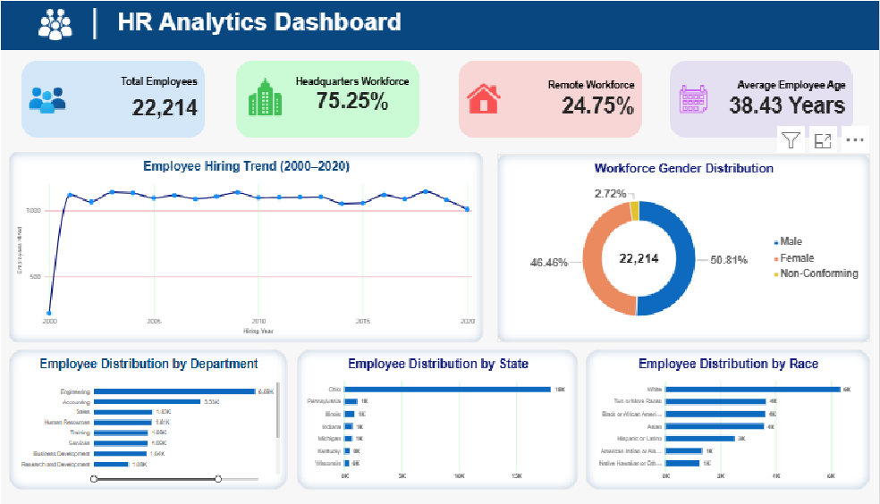

Figure 8.40.1 – HR Overview dashboard captured from Power BI.

8.40.2 Workforce Analysis Dashboard
This screenshot presents the Workforce Analysis page. It includes the current-versus-former employee donut chart, headquarters-versus-remote location donut chart, and a city-level geographical map.
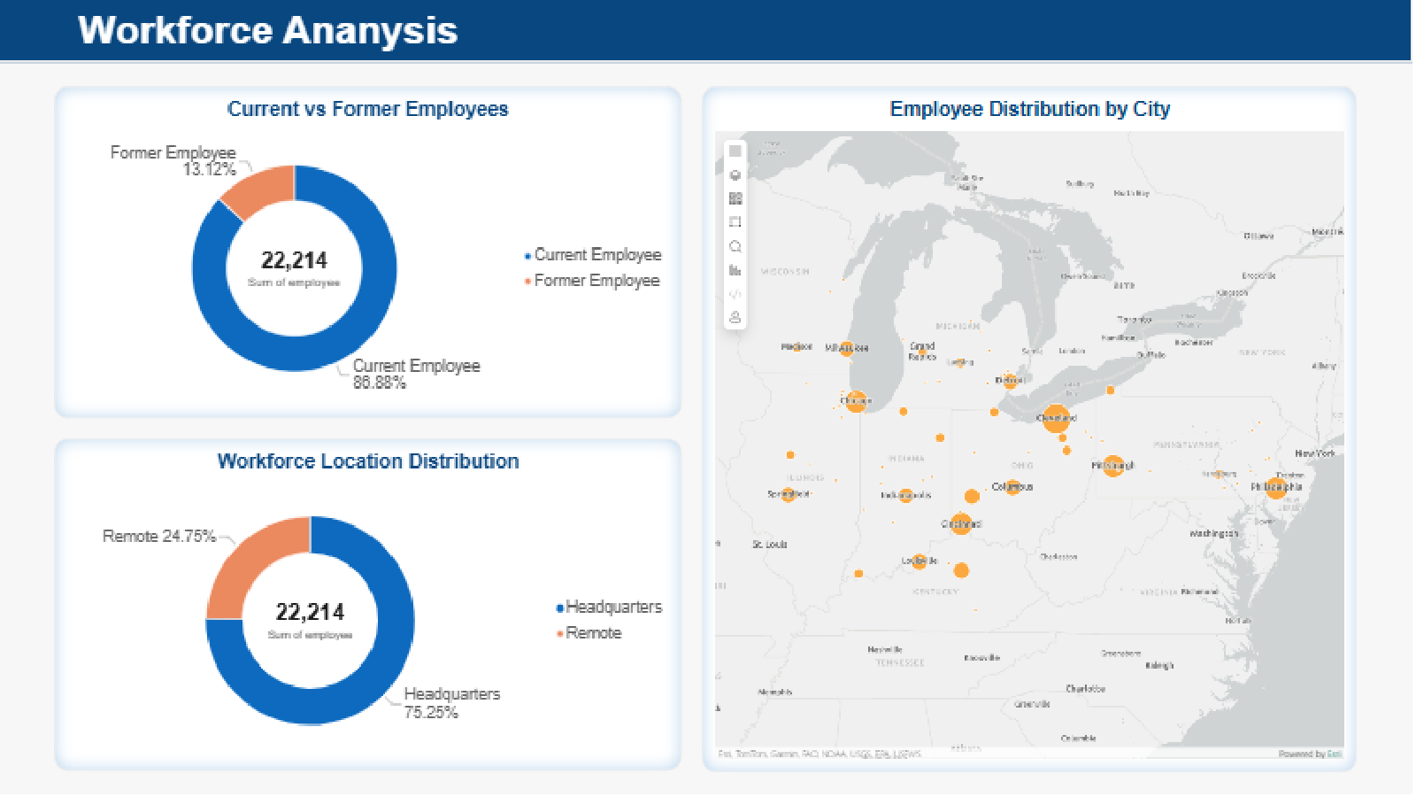

Figure 8.40.2 – Workforce Analysis dashboard with the city distribution map.
8.40.3 City Distribution Map
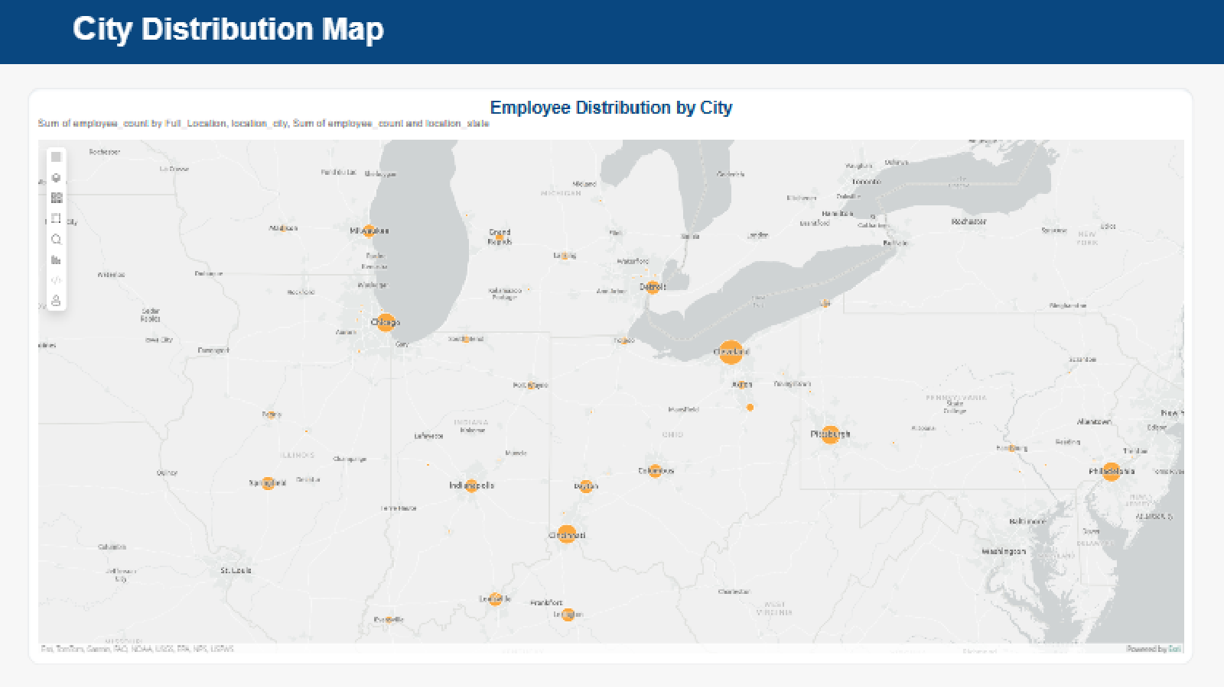
This enlarged screenshot provides a clearer view of the Azure Maps visual documented in Section 8.37. The map uses city and state location fields, with employee_count used to size the bubbles. Orange bubbles indicate the mapped employee concentrations across the locations represented in the dataset.

Figure 8.40.3 – Enlarged Azure Maps visual showing employee distribution by city.

Screenshot inventory: 01_HR_Overview.png, 02_Workforce_Analysis.png, and 03_City_Distribution_Map.png. Store all three files in HR_Analytics_Project/06_Screenshots/.
8.41 Power BI Dashboard Visualisation Review
Objective: To review the submitted dashboard screenshots and confirm that the planned workforce and geographical visualisations are represented in the captured report pages.
HR Overview review: The supplied screenshot contains four KPI cards, an annual hiring trend line chart, a gender distribution donut chart, and horizontal bar charts for department, state, and race distribution.
Workforce Analysis review: The supplied screenshot contains the current-versus-former employee donut chart, the headquarters-versus-remote donut chart, and an Employee Distribution by City map.
City map review: The city map is present in the Workforce Analysis screenshot. A separate enlarged screenshot has also been included to make the geographical visual easier to inspect in the report. The map displays orange bubble markers across the mapped locations.
Data interpretation note: The city-level analysis in Sections 8.34 and 8.45 identifies Cleveland, Ohio, as the largest recorded city concentration, with 16,871 employee records. The map should be interpreted together with the city-and-state grouped SQL results because identical city names can occur in more than one state.
Conclusion: The three supplied screenshots provide visual evidence of the two Power BI dashboard pages and the enlarged city map. The city distribution map is therefore represented in the captured dashboard and in the supporting report evidence.
8.42 Job Title Analysis
Objective
To analyse the distribution of employees across different job titles and identify the most common roles within the organisation.
SQL Analysis
The jobtitle column was grouped using GROUP BY and employee counts were calculated using COUNT(*). Employee percentages were calculated against the total workforce of 22,214 records. Results were sorted in descending order to identify the most populated job titles.
Validation Results:
The following checks were performed to validate the job-title data:
Metric | Result
Total employee records | 22,214
Unique job titles | 185
Non-NULL job-title records | 22,214
Missing job titles | 0

Key Findings
- Research Assistant II was the most common job title, with 754 employees (3.39%).
- Business Analyst ranked second, with 708 employees (3.19%).
- Human Resources Analyst II accounted for 613 employees (2.76%).
- The dataset contained 185 distinct job titles.
- No missing or blank job titles were detected.
Conclusion
The organisation has a diverse workforce distributed across 185 job titles. The analysis identifies the most populated roles and provides a more detailed understanding of workforce composition.
Output File: 10_Job_Title_Analysis.csv
SQL Script: 10_Job_Title_Analysis.sql
8.43 Employee Age Distribution Analysis
Objective
To examine the age composition of the workforce and identify the most represented employee age groups using the supplied Age column.
SQL Analysis
Employees were initially grouped by individual age using GROUP BY and counted using COUNT(*). A second query categorised employees into five age brackets: 18–25, 26–35, 36–45, 46–55 and 56+.
Age Group Distribution
The workforce distribution across the five age groups is as follows:
- 18–25: 3,292 employees (14.82%)
- 26–35: 6,123 employees (27.56%)
- 36–45: 5,929 employees (26.69%)
- 46–55: 6,048 employees (27.23%)
- 56+: 822 employees (3.70%)
Validation Results
- Total employee records: 22,214
- Number of age groups: 5
- Total employees across all age groups: 22,214
- Missing age-group classifications: 0
The age-group counts reconcile with the total employee records.
Total Employees: 22,214 (100.00%)
Key Findings
- The 26–35 age group is the largest, representing 27.56% of employees.
- The 46–55 age group accounts for 27.23%.
- Employees aged 26–55 represent approximately 81.48% of the workforce.
- Employees aged 56 and above represent 3.70%.
- The age-group counts reconcile with the total dataset of 22,214 records.
Conclusion:
The workforce is predominantly represented by employees aged between 26 and 55. The age-group analysis provides a clearer understanding of workforce composition and can support workforce planning and succession planning.
Data Consideration: This analysis uses the supplied Age column rather than recalculating employee ages from birthdates. A discrepancy was identified between the supplied Age values and birthdate-derived ages. Since the original reference date used to calculate the supplied Age column could not be confirmed, the original values were retained without modification. This limitation should be considered when interpreting age-related findings.
8.44 Employee Termination Analysis
Objective
To analyse employee termination patterns by year and distinguish completed terminations from future termination dates.
SQL Analysis
Three SQL queries were used for termination analysis:
- The first query grouped all valid termination dates by year and calculated the number of termination records for each year.
- The second query calculated completed terminations by year, excluding dates after 03 November 2026.
- The third query validated the total employee records, completed terminations and future termination dates.
The STR_TO_DATE() function was used to convert the termination-date text into a date-time value after removing the trailing UTC text using REPLACE(). This allowed accurate date comparisons using the project reference date of 03 November 2026.
Termination Validation
The termination records were validated using 03 November 2026 as the project reference date.
- Total employee records: 22,214
- Completed terminations: 2,915
- Future termination dates: 1,014
- Records without a termination date: 18,285
The validation confirms that completed terminations, future termination dates and records without a termination date reconcile with the total employee count of 22,214.
Key Findings
- The analysis covers termination years from 2001 to 2026.
- 2021 recorded the highest number of terminations, with 205 employees.
- 2001 recorded the lowest number, with 7 employees.
- The 2026 count was 125, representing a partial year up to 03 November 2026.
- The completed termination count of 2,915 matches the former employee count in the workforce-status analysis.
- A further 1,014 records contain future termination dates relative to the reporting date.
Conclusion
The analysis provides an overview of historical employee departures and highlights the importance of applying a consistent reporting date when calculating workforce status. Future termination dates must not be counted as completed departures.
Output File: 12_Termination_Year_Analysis.csv
SQL Script: 12_Termination_Analysis.sql
8.45 City and State Distribution Analysis
Objective
To analyse employee distribution across cities and states and identify geographical workforce concentrations.
SQL Analysis
The location_city and location_state columns were grouped together using GROUP BY. Employee counts were calculated for each city–state combination and sorted in descending order. Workforce percentages were calculated separately by dividing each city–state employee count by the total employee records (22,214) and multiplying by 100.
Key Findings
- The dataset contains 80 unique city–state combinations.
- Cleveland, Ohio, has the largest workforce, with 16,871 employees (75.95%).
- Chicago, Illinois, ranks second with 351 employees.
- Philadelphia, Pennsylvania, ranks third with 326 employees.
- Ohio has the largest state workforce, with 18,025 employees (81.14%).
- The workforce is highly concentrated in Cleveland and Ohio.
Conclusion
The analysis identifies a significant geographical concentration of employees in Cleveland, Ohio. These findings can support regional workforce planning, location strategy and geographical risk assessment.
SQL Script: 09_City_Distribution.sql
SQL Queries Included:
- Step 49A: Calculate employee distribution by city and state.
- Step 49B: Count the total number of unique city-state combinations.
Validation: The analysis identified 80 unique city-state combinations across 22,214 employee records.

Note: This analysis validates the existing city and state distribution results and does not require duplicate CSV exports or dashboard visuals.

