

CHANDIGARH UNIVERSITY
Mohali, Punjab, India

UNIVERSITY INSTITUTE OF COMPUTING
(Department name — confirm with your notice)

PROJECT REPORT
On

KidsCareerDecoder — Web-Based Child Aptitude Assessment
and Career Insight Platform

Submitted in partial fulfilment of the requirements
for the award of the degree of
BACHELOR OF COMPUTER APPLICATIONS (BCA)
Final Year — Semester VI

Submitted by
Neel Kapoor
Roll No. / UID: O23BCA110261
E-mail: O23BCA110261@cuchd.in

Under the guidance of
Rohit Jha
Project Guide

Academic Session: ________________
22 May 2026

BONAFIDE CERTIFICATE

This is to certify that the project report entitled “KidsCareerDecoder — Web-Based Child Aptitude Assessment and Career Insight Platform” submitted by Neel Kapoor (Roll No. O23BCA110261, E-mail: O23BCA110261@cuchd.in) in partial fulfilment of the requirements for the award of the degree of Bachelor of Computer Applications (BCA), Final Year, Semester VI at Chandigarh University, is a record of bonafide work carried out by him/her under my supervision and guidance.
The matter embodied in this report has not been submitted earlier for the award of any other degree or diploma to the best of my knowledge.

Date: 22 May 2026
Place: Mohali

Signature of Guide: _________________________
Name of Guide: Rohit Jha
Designation: Project Guide

Head of Department: ________________________
Signature of HOD: __________________________

DECLARATION

I, Neel Kapoor (Roll No. O23BCA110261), a student of Bachelor of Computer Applications (BCA), Final Year, Semester VI, Chandigarh University, hereby declare that the project report entitled “KidsCareerDecoder — Web-Based Child Aptitude Assessment and Career Insight Platform” submitted to the University is my original work. The work has not been submitted elsewhere for any degree or diploma.
I have followed the guidelines provided by the University and have duly acknowledged all sources of information. I understand that plagiarism is a serious academic offence.

Date: 22 May 2026
Place: Mohali

Signature of Student: ______________________
Name: Neel Kapoor
Roll No.: O23BCA110261

ACKNOWLEDGEMENT

I would like to express my sincere gratitude to Chandigarh University for providing the academic environment and resources necessary to complete this project.
I am deeply thankful to my project guide, Rohit Jha, for continuous guidance, constructive feedback, and encouragement throughout the development of KidsCareerDecoder.
I extend my thanks to the faculty members of the University Institute of Computing for their teaching and support during the BCA programme.
I am grateful to my family and friends for their motivation and patience during this final-year project work.

KidsCareerDecoder — Web-Based Child Aptitude Assessment and Career Insight Platform
  - BCA Final Year (Semester VI) — Project Report
22 May 2026

Abstract
KidsCareerDecoder is a full-stack web application that helps children aged approximately 3–14 complete scenario-based aptitude quizzes while parents review strengths, session history, and AI-assisted career orientation aligned with regional context. The system uses a React single-page front end, a Node.js / Express API, and PostgreSQL (deployable via Supabase) for relational storage of users, quizzes, sessions, and answers. After preprocessing quiz responses into six normalized aptitude percentages plus age and country, the backend invokes Anthropic Claude or OpenAI (configurable) to generate structured career suggestions, with deterministic fallbacks when external AI is unavailable. Security is addressed through bcrypt password hashing, JWT session tokens, optional email-based password reset, and role-based access for parent, child, and administrator personas. An admin console supports operational analytics, quiz content management, and AI provider controls. Development followed an iterative Agile-style cycle with version control in Git. The implemented system meets the stated objectives of guided assessment, parent transparency, and extensible integration for future mobile or cloud deployment.
Keywords: aptitude assessment, career guidance, React, Express, PostgreSQL, JWT, LLM integration, role-based dashboard.

Table of Contents
- Introduction
- Literature Review / System Study
- System Analysis
- System Design
- System Implementation
- Testing
- Results & Discussion
- Conclusion & Future Enhancements
- References

List of Figures
- Figure 4.1 — DFD Level 0 (context diagram)
- Figure 4.2 — DFD Level 1
- Figure 4.3 — Use case diagram
- Figure 4.4 — Entity–relationship diagram
- Figure 4.5 — Sequence diagram: session completion and AI
- Figure 5.1 — Parent: Add child account form
- Figure 5.2 — Parent: Children and progress dashboard
- Figure 5.3 — Child: Quiz selection (“Pick a quiz”)
- Figure 5.4 — Child: Adaptive quiz question (Future Inventors)
- Figure 5.5 — Admin: Platform overview
- Figure 5.6 — Admin: Insights (completions, aptitude mix, AI provider)
- Figure 5.7 — Admin: Users management
- Figure 5.8 — Admin: Sessions with AI provider column
- Figure 5.9 — Admin: Quizzes content management
- Figure 5.10 — Admin: APIs and runtime AI provider selection
- Figure 7.1 — Parent: Child report with radar and line charts
- Figure 7.2 — Child: Results page with AI careers (Logical Explorer)

List of Tables
- Table 3.1 — Functional requirements summary
- Table 3.2 — Non-functional requirements summary
- Table 4.1 — Core database tables
- Table 4.2 — Representative API endpoints
- Table 6.1 — Sample test cases

List of Abbreviations
Abbreviation | Meaning
API | Application Programming Interface
CRUD | Create, Read, Update, Delete
DFD | Data Flow Diagram
ER | Entity–Relationship
HTTP | Hypertext Transfer Protocol
HTTPS | HTTP Secure
JSON | JavaScript Object Notation
JWT | JSON Web Token
LLM | Large Language Model
RLS | Row Level Security
SPA | Single Page Application
SQL | Structured Query Language
UI | User Interface
UML | Unified Modeling Language
UX | User Experience

Chapter 1: Introduction
This report is prepared by Neel Kapoor as part of the BCA Final Year, Semester VI project work at Chandigarh University (Roll No. O23BCA110261, E-mail: O23BCA110261@cuchd.in).

1.1 Background of the Project
Career awareness for school-age children is often informal: parents rely on grades, hobbies, or anecdotal observations. Structured aptitude instruments exist in educational psychology, but many digital products are either generic personality quizzes or heavy career portals aimed at older students. There is a practical need for a kid-friendly, low-stakes assessment flow that still produces actionable insight for guardians—without claiming predictive validity beyond exploratory guidance.
KidsCareerDecoder addresses this gap by combining short scenario quizzes mapped to six aptitude dimensions (logical, creative, verbal, social, scientific, practical), a parent dashboard for longitudinal visibility, and optional AI-generated career narratives that respect age and country context (e.g., pathway and salary framing for India vs. the United States).
The platform was developed as a BCA Final Year Semester VI capstone at Chandigarh University under the guidance of Rohit Jha. It is submitted through the Qollabb portal as a PDF report together with a separate presentation file and a link to the source repository or live demo, as required by the institute workflow. The work demonstrates how modern web engineering, relational databases, and responsible use of large language models can be combined in a single coherent product rather than as disconnected assignments.

1.2 Problem Statement
Traditional approaches suffer from one or more limitations: (1) static PDF reports without ongoing tracking; (2) black-box scoring without explainable links to quiz items; (3) one-size-fits-all career lists ignoring regional education systems; (4) weak separation between child and parent experiences; (5) lack of administrative tools for content and operations in student-built systems.
The problem solved by this project is to design and implement an integrated platform that: securely onboards families; lets children take versioned quizzes with adaptive difficulty behaviour; aggregates responses into transparent scores; enriches data for AI; stores auditable session metadata; and surfaces results through role-specific dashboards including an admin console.

1.3 Objectives of the System
- Enable parent registration and child profile creation with age validation.
- Provide published quizzes with questions and multiple-choice options tagged to aptitude dimensions.
- Support quiz sessions with answers, timing metadata, and completion status.
- Compute six-dimensional score profiles from non-skipped answers.
- Preprocess session outputs for AI: percentages, age, resolved country.
- Apply AI algorithms via configurable providers (Claude / OpenAI / optional ML HTTP service) with JSON-structured outputs and fallbacks.
- Deliver parent dashboards (overview + per-child report with charts) and child-facing results with age-appropriate copy.
- Implement secure login (bcrypt, JWT, password reset flow) and authorization by role.
- Provide admin tools for users, sessions, quizzes, insights, and AI provider override.

1.4 Scope of the Project
In scope: Web application (browser-based), relational schema and migrations, REST-style JSON APIs, LLM integration behind server keys, email-based reset when SMTP is configured, adaptive question ordering heuristics, analytics summaries for parents and admins, seed career content as fallback.
Out of scope (explicit): Native mobile apps; clinical diagnosis; guaranteed psychometric validity; payments; multi-tenant white-labeling; offline-first PWA (possible future work).

1.5 Existing System Overview
Commercial career platforms and school LMS modules may offer surveys or interest inventories. Many are not optimized for young children or require accounts tied to institutions. Generic chatbots can produce career text but lack structured ties to quiz dimensions and auditable session storage. Spreadsheet-based tracking is error-prone and not collaborative.

1.6 Proposed System Overview
KidsCareerDecoder is a three-tier style architecture: React client → Express API → PostgreSQL database. Authentication uses JWTs; business logic includes session lifecycle, scoring, preprocessing, AI routing, and analytics aggregation. Row Level Security flags align with Supabase deployment patterns. The child path emphasizes motivation and clarity; the parent path emphasizes interpretability and history; the admin path emphasizes operations and content management.

1.7 Technologies Used (Brief)
- Front end: React 18, React Router, Vite, Tailwind CSS, Recharts, Axios.
- Back end: Node.js, Express, pg pool, bcryptjs, jsonwebtoken, Anthropic & OpenAI SDKs.
- Database: PostgreSQL; Supabase migrations and optional hosting.
- Tooling: Git, ESLint/Prettier (as configured in repo), environment-based configuration.

1.8 Motivation and Real-World Relevance
Parents increasingly seek structured ways to understand how children approach problems before committing to expensive coaching or rigid career labels. Schools may run interest clubs or counsellor sessions, but continuity between home and school is weak when results live only in conversation. A web platform that stores each attempt, shows trends over multiple quizzes, and explains strengths in plain language supports informed conversations at the dinner table rather than one-off impressions.
For Chandigarh University BCA curriculum alignment, the project demonstrates full-stack competence: relational modelling, REST APIs, authentication, integration with external AI services, and role-based user interfaces. The Ikigai framing (where natural strengths meet realistic future paths) gives the product a clear narrative without claiming clinical assessment.

1.9 Organization of the Report
Chapter 2 reviews related systems and development methodology. Chapter 3 captures requirements, feasibility, and architectural context. Chapter 4 presents design artefacts including database and API structure. Chapter 5 explains implementation modules and algorithms. Chapter 6 documents testing. Chapter 7 discusses outcomes. Chapter 8 concludes with future work. Chapter 9 lists references in APA style.

1.10 Significance of the Study
This study is significant for three audiences. Parents gain a repeatable way to observe how a child approaches problems across themed quizzes rather than relying on a single conversation. Children receive encouraging, age-appropriate feedback that links choices to strengths without ranking them against peers. Institutions evaluating BCA graduates see evidence of requirements analysis, normalized data modelling, secure APIs, integration with external AI services, and role-based interfaces in one deployable system. The project also contributes a documented preprocessing pipeline that can be reproduced in Python (notebooks/ai_preprocess_demo.ipynb) for viva demonstration, showing that AI inputs are not arbitrary chat text but derived from auditable quiz data.

Chapter 2: Literature Review / System Study

2.1 Review of Similar Systems
Interest inventories (e.g., Holland-type RIASEC derivatives) and cognitive batteries are established in vocational psychology. Consumer products often simplify constructs into “types” for engagement. KidsCareerDecoder adopts a transparent six-stripe model mapped directly to option-level tags, so parents can trace “why” a dimension scored high from concrete scenario choices rather than opaque factor scores.
Learning management systems (Moodle, Canvas) support quizzes but rarely combine child UX, parent longitudinal analytics, and LLM-generated localized career narratives in one cohesive open architecture suitable for a degree project.

2.2 Comparative Analysis
Aspect | Typical survey site | KidsCareerDecoder
Audience | Generic | Parent + child + admin
Traceability | Low | Option-level aptitude tags
AI use | Optional/unstructured | JSON contract + normalization
Operations | N/A | Admin console
Security | Variable | bcrypt + JWT + reset tokens

2.3 Software Development Model
The project followed an incremental / Agile-inspired approach: schema first, then authentication, quiz flow, session APIs, AI integration, dashboards, and admin tools. Git branches and small commits supported iterative delivery rather than a single waterfall drop.

2.4 Relevant Frameworks and Libraries
React enables component reuse (e.g., shared career cards with child vs parent variants). Express offers a minimal, testable HTTP layer. PostgreSQL ensures relational integrity for sessions and answers. Recharts supports radar and line visualizations on the parent report. JWT reduces server-side session storage while requiring careful client storage practices.

2.5 Research Gap
Many student projects either omit administration or treat AI as a chat box without schema-bound outputs. This system closes that gap by: (1) persisting metadata_json with provider attribution; (2) normalizing careers before UI; (3) combining rule-based adaptation with a documented path to replace heuristics with trained models.

2.6 Holland RIASEC and Simplified Aptitude Stripes
Holland’s theory groups people into realistic, investigative, artistic, social, enterprising, and conventional types. KidsCareerDecoder does not implement RIASEC scoring directly but maps scenario choices to six child-friendly stripes (logical, creative, verbal, social, scientific, practical) that parents can understand without vocational jargon. Each option in the item bank is tagged at authoring time, which is a form of expert-coded feature labelling common in rule-based recommender systems.

2.7 Web Application Architecture Patterns
Three-tier and MVC-inspired separation appear throughout industry practice. The React SPA acts as the view/controller on the client; Express routes delegate to controllers; services encapsulate AI and mail; the database is the model layer. Stateless JWT authentication aligns with horizontal scaling of API nodes behind a load balancer, though the current deployment target is a single-node demo suitable for academic evaluation.

2.8 Large Language Models in Educational Products
Recent LLMs can generate fluent career narratives but risk hallucination, bias, and inconsistency. Academic guidance stresses human oversight, transparent inputs, and structured outputs. KidsCareerDecoder mitigates risk by passing only aggregated percentages and demographics, requiring JSON-only responses, normalizing fields before display, and labelling results as exploratory. Fallback paths avoid blocking the child experience when APIs fail.

2.9 Agile Practices Applied in This Project
Work was organised in vertical slices: users and auth, then quiz content, then sessions, then AI completion, then dashboards, then admin. Each slice produced a demonstrable increment. Git commits map to features rather than a single deadline dump. Retrospective lessons included tightening CORS and proxy settings for deployment, and documenting environment variables in .env.example for reproducible setup by evaluators.

2.10 Summary of System Study
The literature and product survey justify a hybrid approach: transparent rule-based scoring, optional generative enrichment, strong security baseline, and operational tooling. No single commercial product studied combined all four for the 3–14 age band in an open, inspectable codebase suitable for a BCA final-year submission.

2.11 Child Development and Digital Assessment Ethics
Developmental psychology emphasises that young learners should not be labelled permanently from a single test. Best practice favours formative feedback, clear language, and guardian involvement. KidsCareerDecoder aligns with this by storing history for parents while presenting child results as encouragement (“explorer”, “spark”) rather than rankings. Literature on children’s interaction design recommends large touch targets, short reading load per screen, and immediate visual feedback—principles reflected in the quiz UI (Figures 5.3–5.4) and results celebration layout (Figure 7.2).

2.12 Data Protection and Parental Consent
Family-oriented applications must minimise collected data and protect credentials. Research on COPPA-style design (even when not legally binding in India) suggests separating child accounts from parent accounts, avoiding public profiles, and not selling behavioural data. This system stores only fields needed for age-appropriate suggestions: name, date of birth, country, quiz answers, and session metadata. Passwords are hashed; reset tokens are stored as digests; admin access is role-gated. Future work could add explicit consent capture on registration and data export for parents.

2.13 Open Source and Reproducibility in Student Projects
Academic evaluators often cannot inspect closed SaaS backends. An open repository with migrations, environment templates, and milestone documents (database schema, secure login, preprocessing, AI algorithms, dashboards) allows replication of claims made in the report. That reproducibility is itself a learning outcome aligned with software engineering curricula.

Chapter 3: System Analysis

3.1 Functional Requirements
ID | Requirement | Priority
FR1 | Parent can register and log in | High
FR2 | Parent can add a child (age 3–14) and receive sign-in credentials | High
FR3 | Child can log in and select a published quiz | High
FR4 | System records answers, supports skip, stores response time | High
FR5 | System completes session with scores and top aptitude | High
FR6 | System calls AI or fallback and stores careers in metadata | High
FR7 | Parent views merged dashboard (children + analytics) | High
FR8 | Parent views per-child report with charts and sessions | High
FR9 | Admin manages users, sessions, quizzes, settings | Medium
FR10 | Forgot-password flow for parent/admin accounts | Medium

3.2 Non-Functional Requirements
ID | Requirement | Approach
NFR1 | Security | bcrypt, JWT, hashed reset tokens, HTTPS in production
NFR2 | Performance | Indexed queries; short AI timeouts with fallback
NFR3 | Maintainability | Modular controllers/services; migrations
NFR4 | Usability | Distinct child vs parent tone; loading/error states
NFR5 | Scalability | Stateless API; pool connections; optional cache for AI provider

3.3 User Requirements
- Parent: manage children, read progress, open detailed report.
- Child: pick quiz, complete questions, see encouraging results.
- Admin: audit sessions, edit content, view insights, switch AI provider.

3.4 Feasibility Study
Technical: Stack components are mature; LLM APIs require keys and budget but are technically feasible.
Economic: Development uses open-source stack; operating cost mainly hosting + API usage.
Operational: Parents must store child credentials securely; SMTP needed for production reset emails.

3.5 System Architecture
Logical architecture: Presentation (React) → Application (Express controllers + middleware) → Data (PostgreSQL) → External (Claude/OpenAI/SMTP/IPinfo as configured).

3.6 Data Flow (Narrative)
Level 0 (context): Parent/Child/Admin interact with Web App; Web App exchanges JSON with API Server; API Server reads/writes Database and may call External AI/Mail/IP services.
Level 1 (major processes): Authentication; Quiz catalog; Session start/answer/complete; Analytics aggregation; Admin CRUD; AI profiling on completion.
See Figure 4.1 and Figure 4.2 in Chapter 4 for the drawn data flow diagrams matching this narrative.

3.7 Use Cases (Summary)
- UC1 Authenticate — Actor: Parent/Child/Admin; includes login, JWT issuance, logout.
- UC2 Manage children — Actor: Parent; includes add child, list children.
- UC3 Take quiz — Actor: Child; includes start session, answer, complete.
- UC4 View analytics — Actor: Parent; dashboard and child report.
- UC5 Administer platform — Actor: Admin; users, sessions, quizzes, insights, AI settings.
See Figure 4.3 in Chapter 4.

3.8 Detailed Use Case Descriptions
UC1 — Authenticate: The actor enters email and password on the login screen. The system validates credentials against users.password_hash using bcrypt, issues a JWT, and stores it client-side. Precondition: account exists. Postcondition: authorized requests include Bearer token. Exception: invalid credentials return 401 without revealing whether email exists on forgot-password paths.
UC2 — Add child: A logged-in parent submits name and date of birth. The system validates age between 3 and 14, generates an internal child email and initial password, hashes the password, and links parent_user_id. The parent must record credentials securely; the UI shows the initial password once.
UC3 — Complete quiz: The child starts a session, receives questions (optionally adaptive), submits answers with optional response time, and completes. The system tallies aptitude counts, computes percentages, resolves country, calls AI or fallback, updates quiz_sessions, and returns results to the results page.
UC4 — View child report: The parent opens /parent/child/:id. The system verifies the child belongs to the parent (or user is admin), loads session history, builds chart data from scores_json, and prefers metadata_json.careers over seed careers when present.

3.9 Constraints and Assumptions
The system assumes reliable internet for API and LLM calls. It assumes parents supervise child account use. It assumes quiz content is authored with exactly one aptitude tag per option. It assumes server clock is accurate for token expiry and reset token windows. Browser localStorage availability is assumed for JWT persistence in the current implementation.

3.10 Risk Analysis
Risk | Impact | Mitigation
LLM outage | No AI careers | Fallback scores + DB seed careers
Token theft via XSS | Account misuse | Future HttpOnly cookies; CSP headers
Weak child password sharing | Unauthorized child login | Parent education; password change policy
API cost overrun | Budget | Provider caps; fallback_only mode
Incorrect country | Wrong salary currency | Multi-source country resolution

3.11 Stakeholder Analysis
Stakeholder | Interest | How the system serves them
Parent | Understand child strengths over time | Dashboard, child report, download
Child | Enjoyable quiz and positive feedback | Themed quizzes, results page, no salary on child view
Administrator | Operate content and monitor usage | Admin console, insights, AI provider control
Examiner / mentor | Verify technical depth | Documented schema, APIs, tests, this report
Developer (maintainer) | Extend features safely | Migrations, modular services, .env.example

3.12 Traceability Matrix (Requirements to Modules)
Requirement | Primary module / file
FR1–FR2 | authController.js, AddChild.jsx
FR3–FR5 | sessionController.js, TakeQuiz.jsx
FR6 | aiProfiler.js, sessionController.completeSession
FR7–FR8 | analyticsController.js, ParentDashboard.jsx, ChildReport.jsx
FR9 | admin/* routes and pages
FR10 | passwordResetController.js, mail helper
NFR1 | auth.js middleware, bcrypt in auth
NFR2 | Indexes on quiz_sessions, AI timeouts
This matrix supports test design in Chapter 6: each row can map to one or more test case identifiers.

Chapter 4: System Design

4.1 DFD Level 0 — Context Diagram
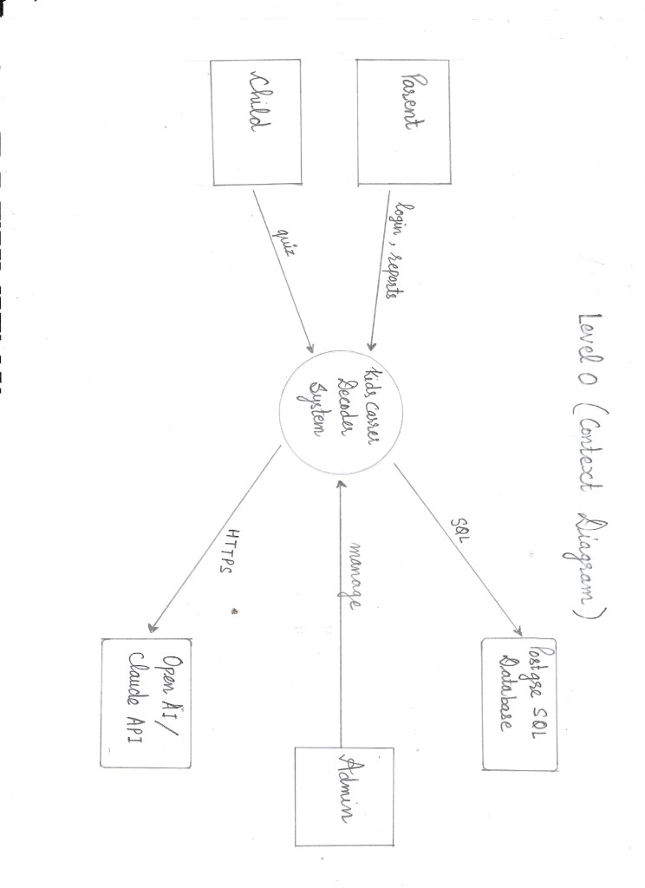
Figure 4.1 DFD Level 0
Figure 4.1 (hand-drawn): Context diagram. Parent sends login and reports; Child sends quiz data; Admin sends manage operations. The central Kids Career Decoder System exchanges SQL with PostgreSQL and HTTPS requests with OpenAI / Claude API.

4.2 DFD Level 1 — Major Processes
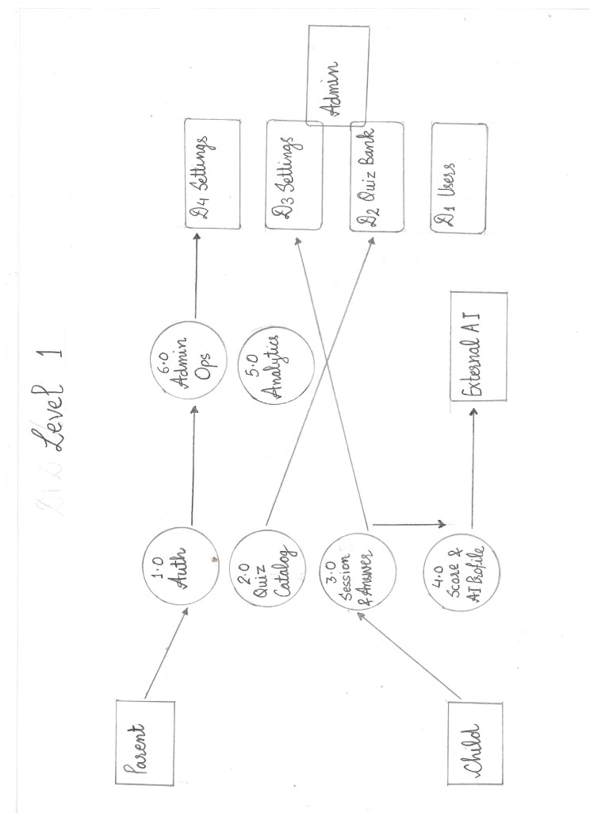
Figure 4.2 DFD Level 1
Figure 4.2 (hand-drawn): DFD Level 1 showing processes 1.0 Auth, 2.0 Quiz Catalog, 3.0 Session & Answer, 4.0 Score & AI Profile, 5.0 Analytics, and 6.0 Admin Ops, with data stores D1 Users, D2 Quiz Bank, D3 Sessions, and D4 Settings. External AI receives profile requests from process 4.0 after session answers are processed.

4.3 Use Case Diagram
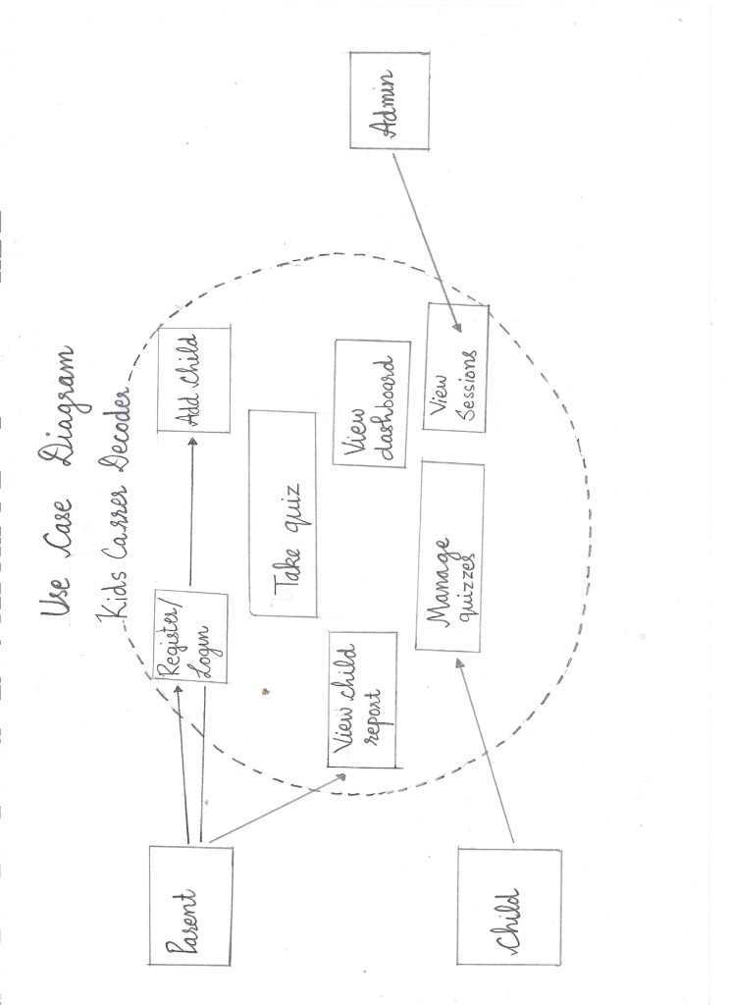
Figure 4.3 Use case diagram
Figure 4.3 (hand-drawn): Use case diagram inside the Kids Career Decoder system boundary: Register/Login, Add child, View child report, Take quiz, View dashboard, Manage quizzes, and View Sessions, linked to actors Parent, Child, and Admin.

4.4 Sequence Diagram — Session Completion
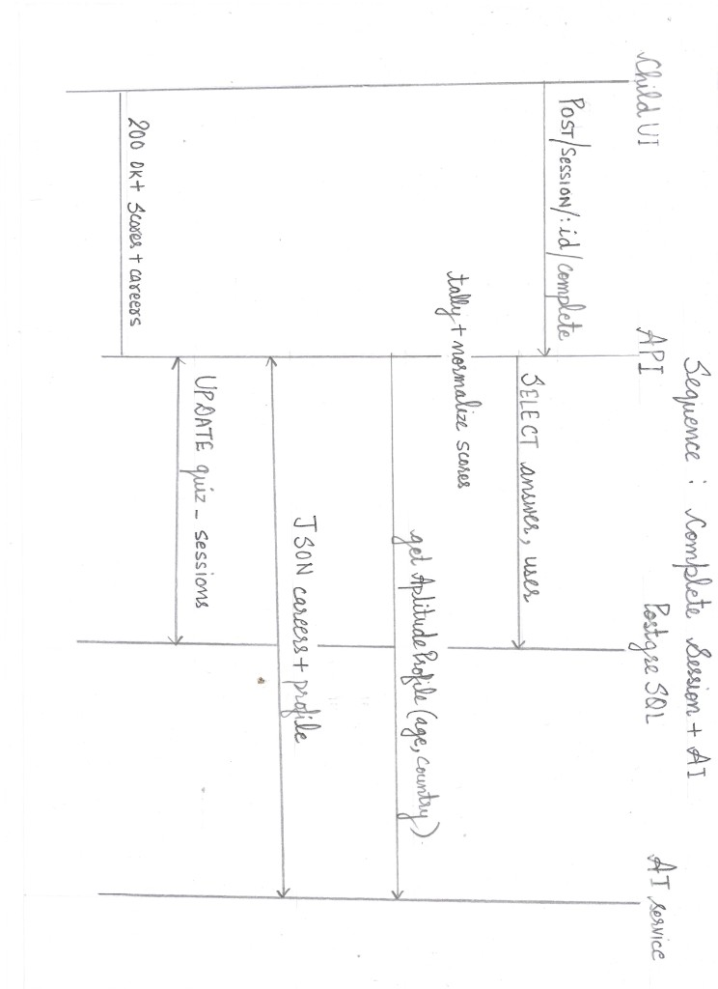
Figure 4.5 Sequence diagram
Figure 4.5 (hand-drawn): Sequence Complete Session + AI: Child UI posts POST /session/:id/complete to API; API SELECTs answers and user from PostgreSQL, performs tally + normalize scores, calls AI service for aptitude profile (age, country), receives JSON careers + profile, UPDATEs quiz_sessions, and returns 200 OK + scores + careers.

4.5 Activity Flow (Narrative)
Child selects quiz → adaptive question loop (submitAnswer) → complete → results page. Parent uses dashboard and child report on separate routes. JWT required on all protected calls.

4.6 ER Diagram and Database Schema
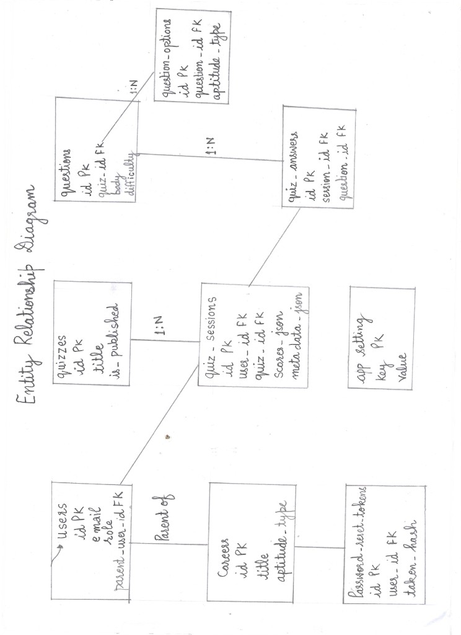
Figure 4.4 ER diagram
Figure 4.4 (hand-drawn): ER diagram for users (with parent_user_id self-link), quizzes, questions, question_options, quiz_sessions (scores_json, metadata_json), quiz_answers, careers, password_reset_tokens, and app_settings, with 1:N relationships as labelled on the drawing.
Core entities: users (roles, parent link, demographics), quizzes, questions, question_options, quiz_sessions (scores_json, metadata_json), quiz_answers, careers (seed), password_reset_tokens, app_settings, schema_migrations.
Relationships: questions.quiz_id → quizzes.id; question_options.question_id → questions.id; quiz_sessions references quizzes and users; quiz_answers references quiz_sessions, questions, question_options; users.parent_user_id self-reference.

4.7 Table Structures (Summary)
Table | Purpose
users | Accounts for parent/child/admin; password_hash; optional country, DOB
quizzes | Quiz metadata, publish flag, timing defaults
questions | Stems, order, difficulty_level
question_options | Labels + aptitude_type enum
quiz_sessions | Lifecycle, scores_json, metadata_json, top_aptitude
quiz_answers | Per-answer aptitude, timing, skip
careers | Seed titles by aptitude_type
password_reset_tokens | Hashed token, expiry
app_settings | Key-value (e.g., ai_provider)

4.4 API Design (Representative)
Method | Path | Role | Purpose
POST | /auth/register | Public | Parent signup
POST | /auth/login | Public | JWT
POST | /auth/forgot-password | Public | Reset email
GET | /auth/children | Parent/Admin | List children
GET | /quiz | Auth | Published quizzes
POST | /session/start | Child | New session
POST | /session/:id/answer | Child | Record answer
POST | /session/:id/complete | Child | Score + AI
GET | /analytics/children | Parent | Dashboard merge
GET | /analytics/child/:id | Parent | Child report
GET | /admin/summary | Admin | Overview metrics

4.5 UI / UX Design
- Child: large type, celebratory results, radar and bars, no salary on career cards.
- Parent: neutral dashboard cards, Recharts radar/line, professional career cards with salary.
- Admin: sidebar layout (AdminLayout), dense tables with deep links.

4.6 Database Column Design (users and quiz_sessions)
The users table uses citext for email uniqueness case-insensitively. Roles are constrained to parent, child, student, instructor, and admin. parent_user_id nullable self-reference links children. birth_year and date_of_birth support age derivation. country stores optional region hints for AI. attribution_json captures marketing metadata at signup.
quiz_sessions stores scores_json as six numeric percentages, metadata_json for AI output and adaptive state, top_aptitude for quick queries, and status in_progress | completed | abandoned. Index idx_quiz_sessions_user_status_completed optimizes parent analytics for latest completed sessions per child.

4.8 Security Design
Passwords never traverse the database in plaintext. JWTs are signed with HS256 and a server secret. Reset tokens are random 32-byte hex strings hashed with SHA-256 before storage. Child internal emails use domain @child.kidscareerdecoder.internal and are excluded from public reset to avoid confusion. Admin routes stack verifyToken and role checks.

4.9 Component Diagram (Logical)
Presentation layer: pages in src/pages grouped by role; shared CareerResultCard, Header, PrivateRoute. Application layer: Express routers for auth, session, quiz, analytics, admin. Service layer: aiProfiler, claudeProfiler, openaiProfiler, adaptiveDifficulty, mail, ipinfoCountry. Data layer: PostgreSQL via pg pool. External: Anthropic, OpenAI, SMTP, optional IPinfo.

4.10 Design Decisions and Trade-offs
JSON columns (scores_json, metadata_json) trade strict relational normalization for iteration speed on AI fields. Adaptive difficulty uses heuristics instead of IRT calibration because item banks are small and labelled difficulty is already stored per question. JWT in localStorage trades XSS resilience for implementation simplicity appropriate to a BCA timeline.

4.11 Detailed Entity–Relationship Narrative
The users entity is central to authorization. A parent row has role = parent and parent_user_id = NULL. Each child row references the parent through parent_user_id with role = child. Admin rows bypass parent linkage for global operations. This hierarchy is enforced in application code when a parent requests /analytics/child/:id by verifying parent_user_id matches the JWT subject unless the caller is admin.
The quizzes entity groups content. One quiz has many questions ordered by order_index. Each question has many question_options, each carrying an aptitude_type from a closed enum. This design avoids many-to-many junction tables between questions and aptitudes because each option belongs to exactly one stripe.
quiz_sessions represent one child’s attempt on one quiz. Cardinality: one user, one quiz, many answers. When completed, scores_json holds the six percentages; metadata_json may hold adaptive (ability, pending_question_id), careers array, profile, explanation, top_strength, country, and ai_provider. Storing AI output in-session avoids a separate careers-fact table while keeping auditability.
quiz_answers link session, question, and optional selected option. Denormalized aptitude_type on the answer row speeds analytics even if options are later edited. response_time_ms and skipped support adaptive tuning and future psychometric research.
careers is a seed lookup table keyed by aptitude_type for fallback UI. password_reset_tokens are ephemeral. app_settings supports runtime configuration without redeploy.

4.12 Physical Data Dictionary (Selected Columns)
Table.Column | Type | Design note
users.id | text PK | UUID string generated in application
users.email | citext | Case-insensitive unique login
users.password_hash | text | bcrypt output only
users.role | text CHECK | Enumerated roles
questions.difficulty_level | double | 1–5 scale mapped to 0.15–0.85 for adaptive engine
question_options.aptitude_type | text CHECK | Six allowed values
quiz_sessions.scores_json | jsonb | { logical: 20, creative: 40, … }
quiz_sessions.metadata_json | jsonb | Extensible; versioned by convention
quiz_sessions.status | text CHECK | Lifecycle gate for complete API

4.13 Level 0 and Level 1 Data Flow Diagram (Textual Specification)
Figure 4.1 — Context diagram: External entities are Parent, Child, Administrator, and External Services (LLM API, SMTP, IP geolocation). The central process is “KidsCareerDecoder System.” Flows: credentials and quiz actions from users; JSON over HTTPS between browser and API; SQL between API and database; HTTPS from API to external services.
Figure 4.2 — Level 1 decomposition: Processes: (1) Authenticate User; (2) Manage Profiles; (3) Deliver Quiz Content; (4) Run Quiz Session; (5) Score and Profile; (6) Present Analytics; (7) Administer Platform. Data stores: D1 Users, D2 Quiz Bank, D3 Sessions & Answers, D4 Settings. Process 4 writes to D3; Process 5 reads D3 and may call External Services before updating D3.

4.14 Class Diagram (Logical Responsibilities)
Although the implementation is JavaScript rather than classical OOP, logical classes include: User (identity, role, demographics); Quiz (metadata, timing); Question (stem, difficulty); Option (label, aptitude tag); Session (status, scores, metadata); Answer (choice, timing); CareerSuggestion (title, salary, pathway, match_reason). Controllers orchestrate; services encapsulate AI and mail. This separation supports unit testing of pure functions such as scoring and adaptive pickers.

4.15 API Request and Response Contracts (Session Complete)
Request: POST /api/session/:sessionId/complete
Headers: Authorization: Bearer <jwt>
Body (optional): { "country": "India" }
Response (success): HTTP 200 with JSON containing scores object (six keys), top_aptitude string, profile string, careers array of normalized objects, explanation string.
Error cases: 401 missing/invalid token; 403 session belongs to another user; 404 unknown session; 400 session not in_progress; 500 database or unrecoverable AI failure after fallback attempt.
Designing explicit contracts allows the React results page to render deterministically and supports future mobile clients consuming the same API.

4.16 UI Wireframe Descriptions
Parent dashboard wireframe: Header with app name and logout. Hero greeting with parent name. Grid of child cards: each card shows avatar placeholder, name, age, last quiz date, top aptitude badge, and buttons “View report” and implicit sign-in email in smaller text. Empty state CTA “Add your first child.”
Child quiz wireframe: Progress indicator (question 2 of 5). Large scenario text. Four stacked option buttons with hover states. Timer optional per quiz settings. Skip control where policy allows.
Child results wireframe: Confetti-style heading, radar chart centred, horizontal bars for six stripes, three career cards without salary, primary button to return to quiz list or share with parent.
Admin layout wireframe: Left sidebar with Overview, Insights, Users, Sessions, Quizzes, APIs, Settings. Main pane table or forms. Breadcrumbs on detail routes.
The implemented UI matches these wireframes; see Figures 5.1–5.10 and 7.1–7.2 in Chapters 5 and 7 for captured screens from the production build.

4.17 Row Level Security and Deployment Schema
Supabase migrations enable RLS on core tables. The Node API typically uses a service role or direct connection that bypasses RLS for simplicity in development; production hardening would add policies tying auth.uid() to users.id if Supabase Auth were adopted. Current design uses custom JWT and application-level checks, which is sufficient for the academic prototype but should be documented for security review.
Migrations are versioned under supabase/migrations/ with timestamps. Seed data includes the inaugural aptitude quiz and eighteen fallback careers (three per stripe).

4.18 Design Validation
Before implementation sign-off, the design was checked for: referential integrity on deletes (CASCADE on questions when quiz removed); unique email constraint; session status transitions only from in_progress to completed; no double-complete without idempotency (second complete returns 400); career JSON shape stable for UI components; admin routes unreachable without admin role. Each item maps to a test case in Chapter 6.

Chapter 5: System Implementation

5.1 Development Environment
- OS: macOS / Linux / Windows with Node 18+.
- IDE: VS Code / Cursor.
- Runtime: Node.js, npm scripts for client and server.
- Database: local PostgreSQL or Supabase-hosted instance.

5.2 Hardware and Software Requirements
Client: modern browser; JavaScript enabled.
Server: 1–2 CPU cores minimum for demo; RAM proportional to DB pool.
Software: Node.js, PostgreSQL 14+, optional Supabase CLI for migrations.

5.3 Module-Wise Explanation
- Authentication module — authController.js, JWT middleware, password reset controller, mail helper.
- Quiz catalog module — Published quiz listing, question payload for UI.
- Session module — Start, fetch current question (adaptive), submit answer, complete; merges metadata.
- Scoring & preprocessing — Tally, percentage normalization, profiler payload, country resolution (body, IPinfo, headers, DB).
- AI module — aiProfiler.js, provider settings cache, Claude/OpenAI profilers, optional ML HTTP client.
- Analytics module — Child-level aggregates for dashboards.
- Admin module — CRUD and insights routes with verifyToken + admin role.
- Front-end modules — Pages under src/pages/parent, child, admin; shared CareerResultCard, PrivateRoute, api interceptors.

5.4 Key Algorithms
Score normalization: For each aptitude key (A), (_A = ) (skipped excluded), rounded to two decimals.
Adaptive ability update: adjustAbility in adaptiveDifficulty.js adjusts a latent ability in ([0.05, 0.95]) using normalized question difficulty and response time vs time limit; pickNextQuestionId chooses the remaining question whose difficulty is closest to current ability.
AI provider resolution: Database app_settings.ai_provider if valid → else AI_PROVIDER env → cached 30s.
Security: bcrypt cost 10; JWT HS256 with JWT_SECRET; reset tokens stored as SHA-256 of random raw token.

5.5 JWT Authentication Middleware
The verifyToken function reads Authorization: Bearer <token>, verifies with jwt.verify against JWT_SECRET, assigns the payload to req.user, and calls next(). Missing or invalid tokens yield 401 with { error: 'Unauthorized' } without executing route handlers. This centralizes authentication so protected routes declare the middleware once.

5.6 Application Screenshots
The following figures were captured from the running KidsCareerDecoder application (22 May 2026 build). They demonstrate that functional requirements FR1–FR10 are reflected in the deployed interface.

5.7 Version Control
Source maintained in Git with meaningful commits; remote on GitHub (project repository).

5.8 Authentication Implementation Detail
registerParent normalizes email to lowercase, checks uniqueness with citext, hashes password with bcrypt cost factor 10, and optionally stores attribution_json from UTM fields. loginParent compares hash, builds JWT payload { id, full_name, role, email }, expires in seven days. addChild generates UUID id, internal email, and Kcd prefixed random password meeting complexity hints.
Middleware verifyToken extracts Bearer token, verifies signature, attaches req.user. requireAnyRole(['parent','admin']) guards child management routes. Front-end AuthProvider persists token and user in localStorage; Axios interceptor attaches Authorization header and clears storage on 401.

5.9 Session and Adaptive Flow Implementation
startSession creates quiz_sessions row in_progress, may store attribution, initializes adaptive metadata with ability estimate from quiz default difficulty. getCurrentQuestion loads pending question id from metadata or picks first. submitAnswer inserts quiz_answers, updates ability via adjustAbility, selects next question with pickNextQuestionId among remaining ids.
completeSession is the integration point for scoring and AI. It rejects non-in_progress sessions, calls tallyAnswers, pickTopAptitude, normalizeCountsToScores, toProfilerPayload, then getAptitudeProfile(profilerScores, age, country). Careers array is normalized and merged into metadata alongside ai_provider, profile, explanation, top_strength.

5.10 AI Profiler and Provider Routing
getEffectiveAiProvider reads app_settings key ai_provider when allowed value, else environment AI_PROVIDER defaulting to claude, cached thirty seconds. getAptitudeProfile dispatches to getClaudeProfile or getOpenaiProfile with identical system prompt semantics: three careers, country-specific salary strings, parent-facing explanation, JSON-only response.
Claude uses model claude-sonnet-4-20250514 with system plus user message listing six percentages. OpenAI uses gpt-4o-mini with response_format: json_object. On any exception, buildFallbackFromScores sorts dimensions and forms hyphenated profile label without careers.

5.11 Analytics and Dashboard Implementation
analyticsController for /analytics/children joins child users with latest completed session metrics. /analytics/child/:id returns session list with scores and metadata for charts. ParentDashboard.jsx merges /auth/children with analytics in parallel. ChildReport.jsx builds Recharts radar from latest scores_json and line chart of top aptitude over session dates.
CareerResultCard renders parent variant with salary pills (emerald for rupee, blue for dollar) and child variant hiding salary, prefixing pathway as “How to get there”. This single component enforces consistent normalization display.

5.12 Admin Console Implementation
AdminOverview consumes /admin/summary for counts and recent entities. AdminUsers supports search and pagination parameters. AdminQuizEditor performs CRUD on questions and options, can trigger OpenAI-assisted difficulty labelling endpoint. AdminApis reads AI status and patches provider override, invalidating provider cache on change.

5.13 Environment Configuration
.env.example documents DATABASE_URL, JWT_SECRET, AI_PROVIDER, API keys, SMTP for Brevo, PUBLIC_APP_URL for reset links, IPINFO_TOKEN and TRUST_PROXY for country resolution behind proxies. Vite uses VITE_API_URL for production API base path.

5.14 Deployment Considerations
Front end builds to static assets served by Vite preview or CDN. API runs on Node with TRUST_PROXY when behind reverse proxy so client IP and country headers resolve correctly. Supabase hosts PostgreSQL and can apply migrations from supabase/migrations. CORS must allow the front-end origin.

5.15 Figure 5.1 — Parent: Add Child Account
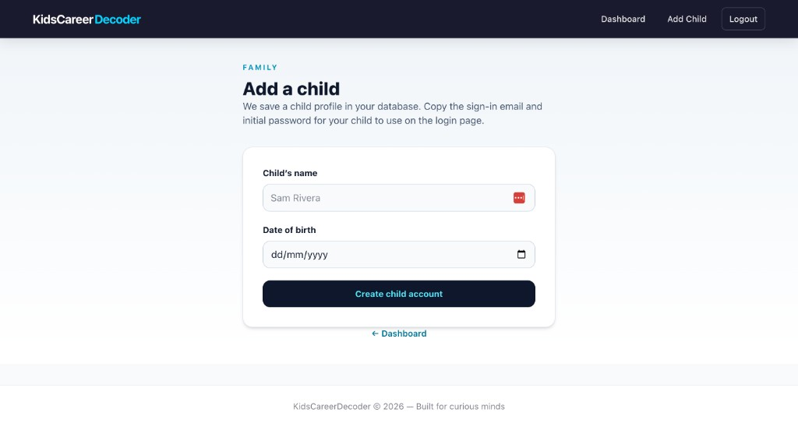
Figure 5.1 Parent add child form
Figure 5.1: The “Add a child” screen (AddChild.jsx) collects the child’s display name and date of birth. On submit, the API creates a users row with role = child, links parent_user_id, and returns a one-time sign-in email and initial password for the parent to copy. Age validation (3–14 years) runs server-side before insert. This implements FR2 and supports secure delegated login without sharing the parent’s password.

5.16 Figure 5.2 — Parent: Children and Progress Dashboard
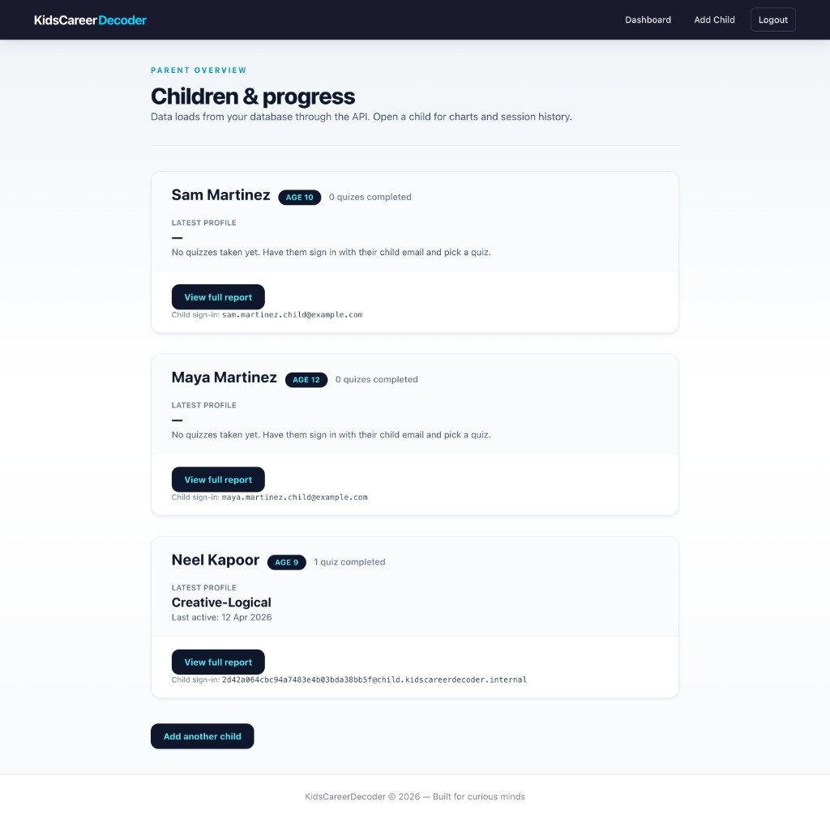
Figure 5.2 Parent dashboard
Figure 5.2: The parent overview (ParentDashboard.jsx) merges GET /auth/children with GET /analytics/children. Each card shows age, quiz completion count, latest AI profile label (e.g. Creative-Logical for Neel Kapoor), last activity date, internal child sign-in email, and a View full report link. Empty states prompt the parent when no quizzes are completed. This satisfies FR7 for at-a-glance family monitoring.

5.17 Figure 5.3 — Child: Quiz Selection
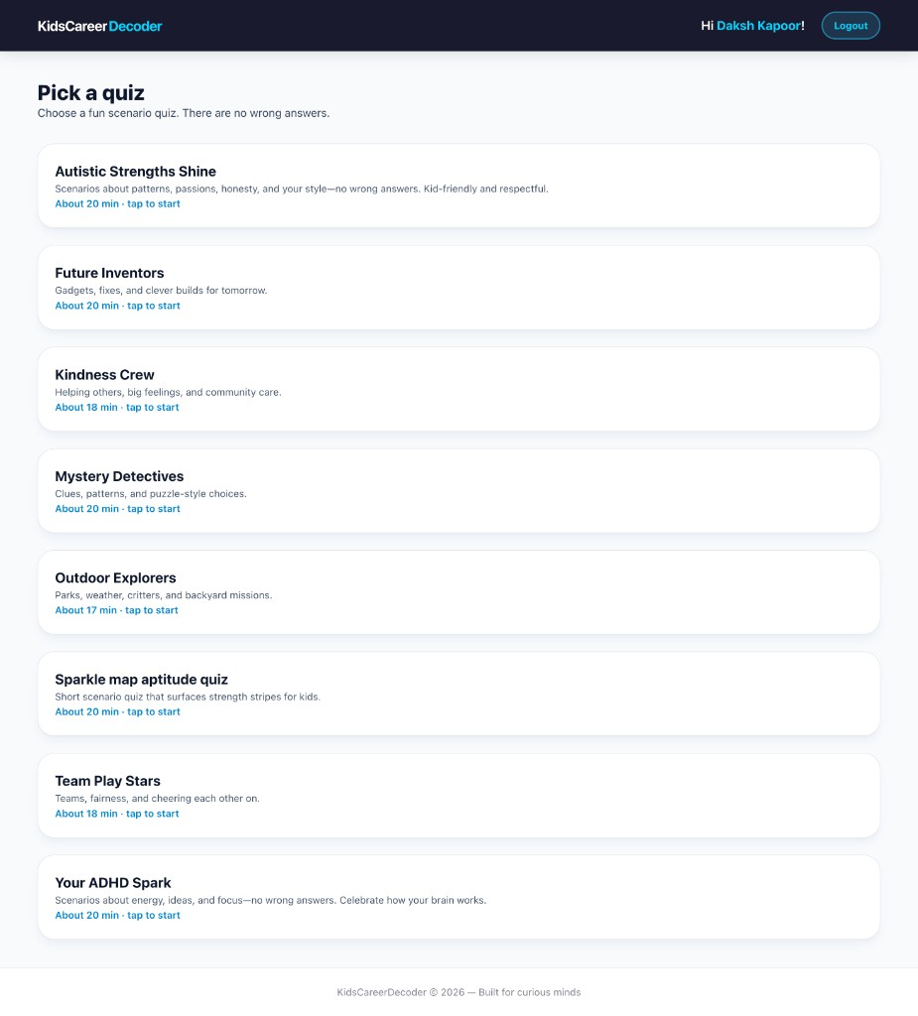
Figure 5.3 Child quiz picker
Figure 5.3: After child login, the quiz picker lists all published quizzes from GET /quiz, including inclusive themes such as Your ADHD Spark and Autistic Strengths Shine, plus Future Inventors, Team Play Stars, and the seed Sparkle map aptitude quiz. Estimated duration is shown per card. Selecting a quiz calls POST /session/start and navigates to the adaptive take-quiz flow (FR3).

5.18 Figure 5.4 — Child: Adaptive Quiz Question
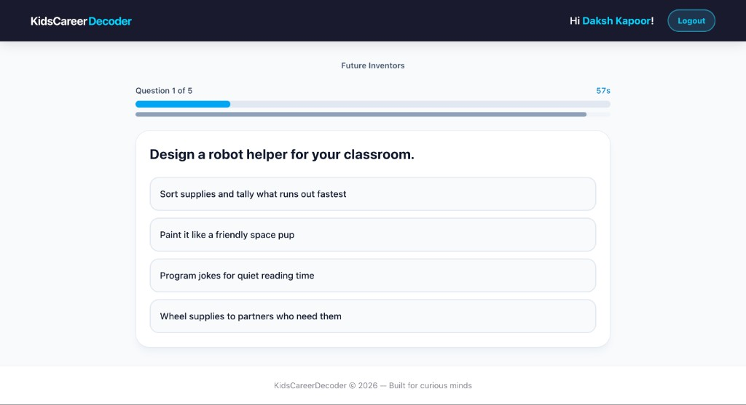
Figure 5.4 Child quiz in progress
Figure 5.4: The take-quiz interface (TakeQuiz.jsx) shows quiz title (Future Inventors), progress (Question 1 of 5), countdown timer (57s), scenario stem, and four options tagged to aptitude stripes (logical, creative, verbal, social in this item). Each selection posts to POST /session/:id/answer, which updates adaptive ability and returns the next question id. This implements FR4 and the adaptive engine described in §5.4.

5.19 Figure 5.5 — Admin: Platform Overview
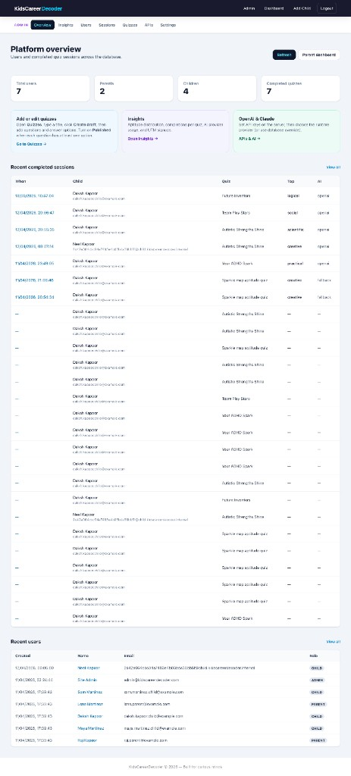
Figure 5.5 Admin overview
Figure 5.5: The admin home (AdminOverview.jsx) summarizes total users, parents, children, and completed quizzes from GET /admin/summary. Shortcut cards link to quiz editing, insights, and AI configuration. Recent completed sessions and recent registrations tables support operational audit (FR9).

5.20 Figure 5.6 — Admin: Insights Dashboard
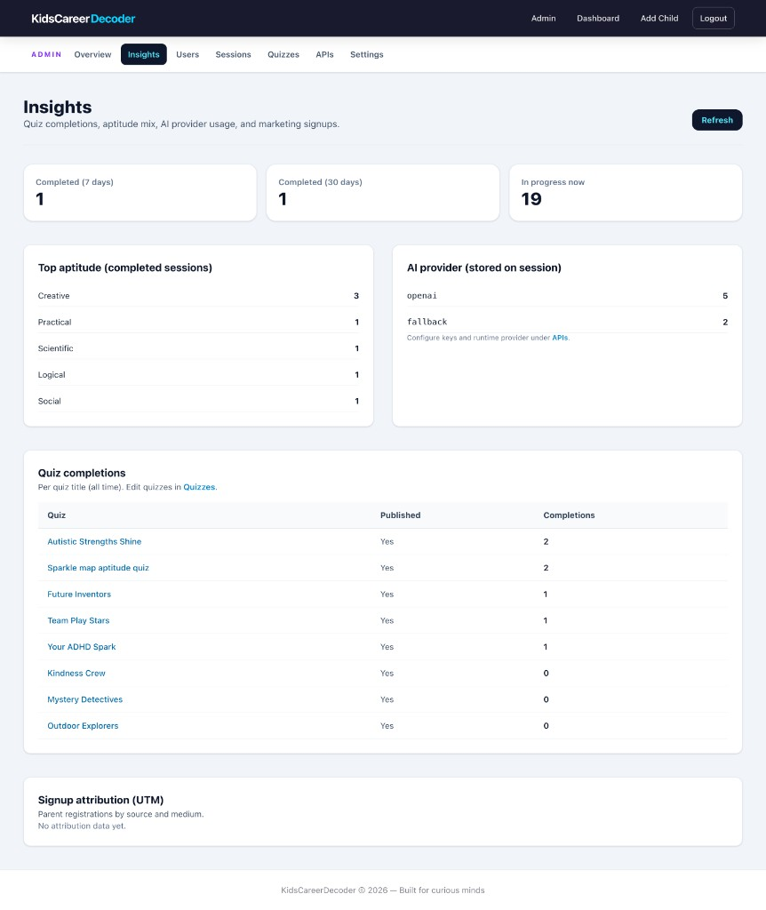
Figure 5.6 Admin insights
Figure 5.6: The Insights page aggregates completions (7-day / 30-day / in-progress counts), top aptitude distribution across finished sessions (Creative leading in the sample data), and AI provider usage stored on sessions (openai vs fallback). A per-quiz completion table shows uptake of each published quiz. UTM attribution is reserved for marketing signups when attribution_json is populated.

5.21 Figure 5.7 — Admin: Users Management
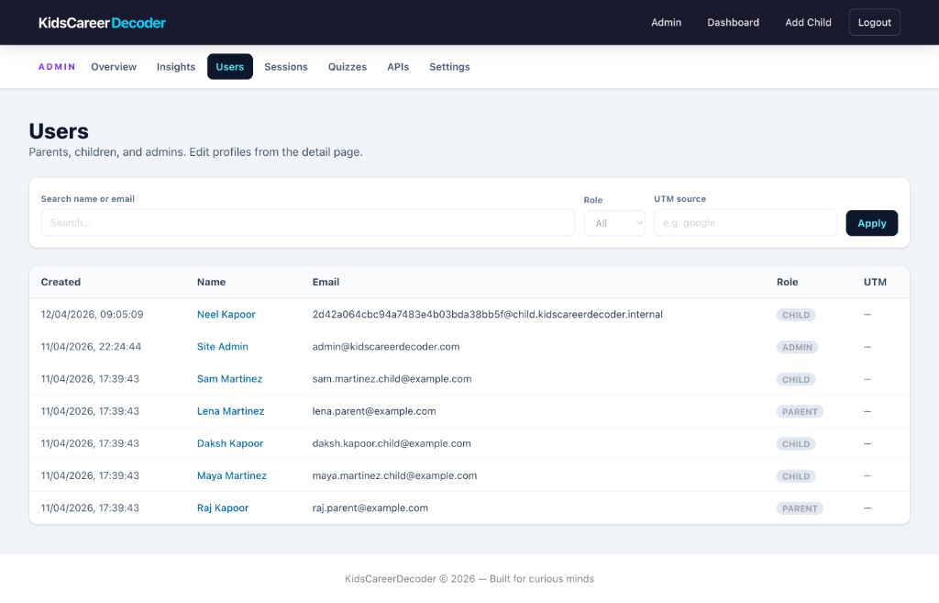
Figure 5.7 Admin users
Figure 5.7: Administrators can search by name or email, filter by role (parent, child, admin), and filter by UTM source. The table shows creation timestamp, role badge, and internal child emails (@child.kidscareerdecoder.internal) versus parent-facing addresses. Detail routes allow profile edits. This supports user support and demo data management.

5.22 Figure 5.8 — Admin: Sessions and AI Attribution
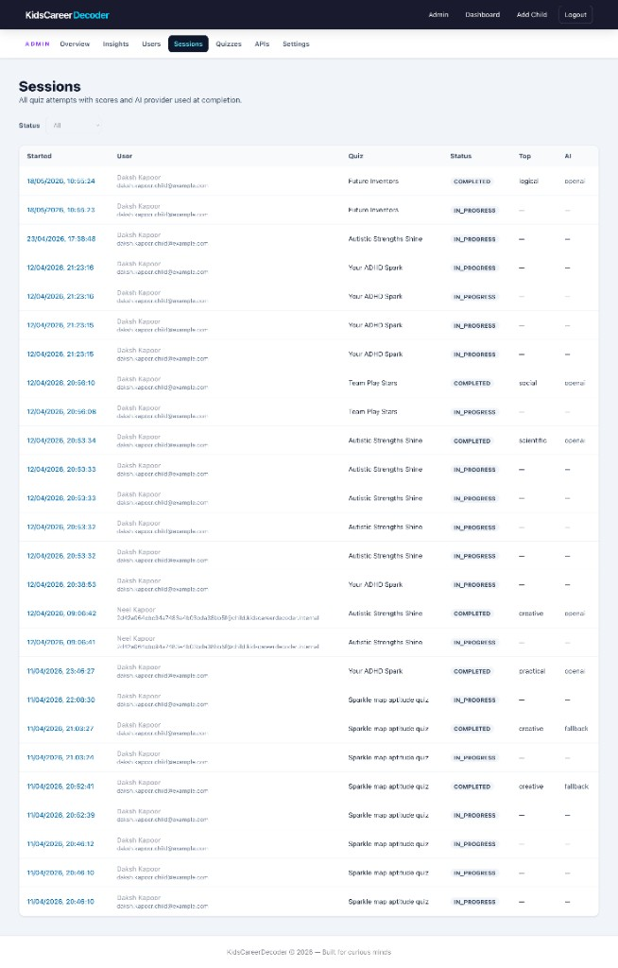
Figure 5.8 Admin sessions
Figure 5.8: Every quiz attempt appears with started time, child user, quiz name, status (COMPLETED / IN_PROGRESS), top aptitude when finished, and AI column (openai or fallback) copied from metadata_json.ai_provider at completion. This proves traceability from raw answers through scoring to the provider that generated careers—critical for debugging and academic demonstration of the AI pipeline.

5.23 Figure 5.9 — Admin: Quizzes Content Management
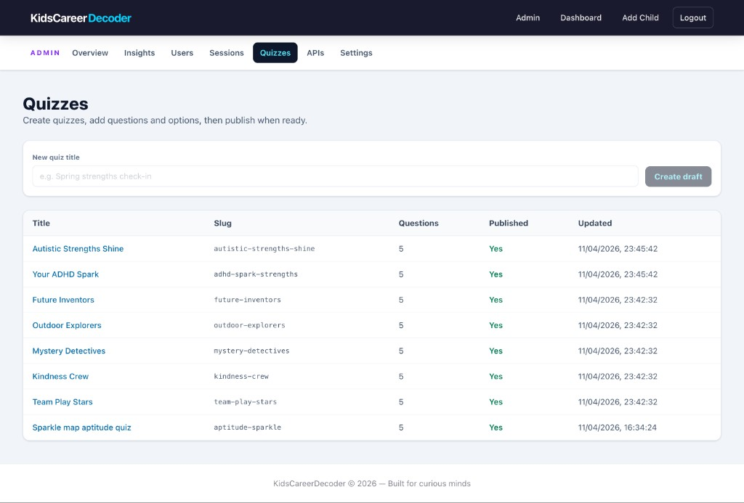
Figure 5.9 Admin quizzes
Figure 5.9: The quiz list shows eight published quizzes with slug, question count (five each in seed data), publish flag, and last updated timestamp. Admins create drafts via New quiz title and open the editor to add stems, options, and difficulty levels. Content migrations in supabase/migrations/ seeded neuroaffirming and themed quizzes alongside the original aptitude map.

5.24 Figure 5.10 — Admin: APIs and Runtime AI Provider
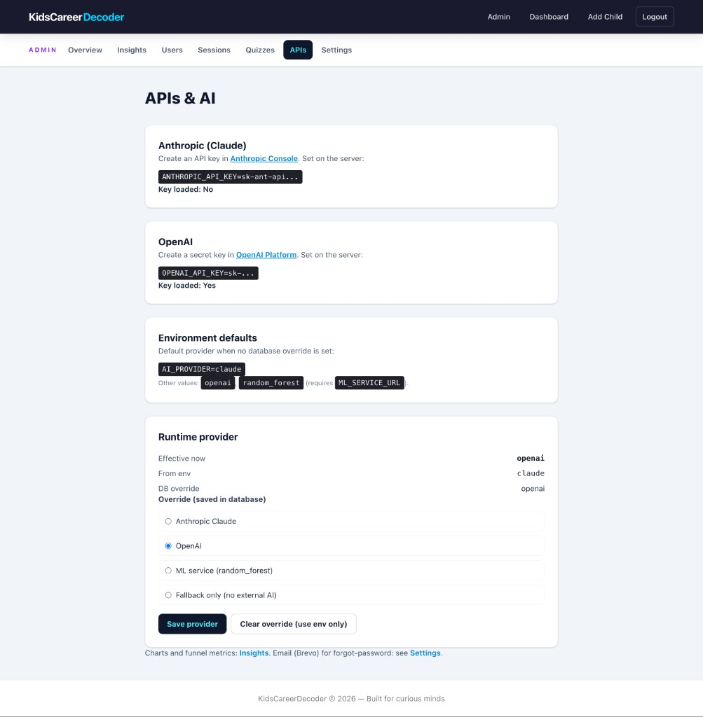
Figure 5.10 Admin APIs AI
Figure 5.10: The APIs screen documents environment variables for Anthropic and OpenAI, shows whether keys are loaded, and exposes runtime provider override (effective: OpenAI with DB override vs env default Claude). Admins can switch to random_forest, fallback_only, or clear override. This implements configurable AI without redeploying code and maps directly to aiProviderSettings.js and app_settings.

5.25 Project Directory Structure and Layering
The repository separates concerns as follows. src/ contains the React application: pages/ for route-level views (parent, child, admin, auth), components/ for reusable UI, context/ for authentication state, utils/api.js for HTTP client configuration, and lib/ for aptitude labels and scoring helpers. backend/ hosts the primary Express application: controllers/ for request handlers, routes/ for path registration, middleware/auth.js for JWT, services/ for AI and utilities, db/pool.js for PostgreSQL connectivity. supabase/migrations/ holds authoritative SQL schema evolution. notebooks/ai_preprocess_demo.ipynb documents preprocessing parity in Python.
This layout allows evaluators to navigate quickly: front-end behaviour in src/pages, business rules in backend/controllers/sessionController.js, and persistence rules in SQL migrations.

5.26 Front-End Routing and State Management
App.jsx defines public routes (/login, /register, /forgot-password, /reset-password) and protected routes wrapped in PrivateRoute with allowedRoles arrays. RootRedirect sends authenticated users to /child/quiz, /parent/dashboard, or /admin based on user.role. AuthProvider hydrates state from localStorage on load so refresh preserves session until token expiry or 401 interceptor logout.
TakeQuiz.jsx orchestrates the adaptive loop: fetches current question via GET /session/:id/current-question, posts answers to POST /session/:id/answer, and on completion calls POST /session/:id/complete with country: detectClientCountry() from a small browser helper. Results.jsx refetches the session if navigated with only session id, ensuring careers from metadata_json appear after AI processing.

5.27 Backend Route Registration and Middleware Chain
Express mounts routers under /api (or as configured in server/index.js and backend/server.js). Typical chain for protected routes: verifyToken → optional requireAnyRole → controller method. Public auth routes skip verification. Session routes additionally call assertSessionReadable or equivalent to ensure the JWT user owns the child session or is admin.
CORS and JSON body parsing are applied globally. Trust proxy setting reads TRUST_PROXY so req.ip and forwarding headers behave correctly behind Vercel or nginx when resolving country.

5.28 Scoring Pipeline — Step-by-Step Implementation
When completeSession executes, the following steps occur in order:
- Load session row; validate status in_progress and user authorization.
- Query all quiz_answers for the session id.
- tallyAnswers: increment per aptitude_type, skip rows with skipped = true.
- pickTopAptitude: choose maximum count; ties broken alphabetically on aptitude key.
- normalizeCountsToScores: divide each count by answered total, multiply by 100, round two decimals.
- toProfilerPayload: rename keys to *_pct suffix form expected by AI layer.
- loadUser and computeAgeFromDob for child age.
- resolveCountryForProfiler: body country, then IPinfo, then CDN headers, then DB profile, default India.
- getAptitudeProfile: remote LLM or fallback.
- Map careers through normalizeCareerEntry.
- Merge metadata_json preserving adaptive subset if needed.
- UPDATE session with completed, completed_at, scores_json, top_aptitude, metadata_json.
- Return JSON payload to client.
This pipeline is deterministic through step 8; step 9 introduces non-determinism unless temperature is zero and provider is stable.

5.29 Adaptive Difficulty — Implementation Mathematics
normalizeQuizDefault(level) maps quiz default difficulty 1–5 to approximately 0.15–0.85 on a latent scale. normalizeQuestionDifficulty applies the same mapping per question. After each answer, adjustAbility computes timeRatio = responseTimeMs / limitMs, derives a bounded delta from speed and question difficulty, and clamps ability to [0.05, 0.95]. Skipped answers penalize ability more sharply.
pickNextQuestionId iterates remaining question ids, computes distance |difficulty - ability| for each, and picks minimum distance with tie-break on lower order_index. This greedy policy is O(n) per step and requires no training data, making it suitable for demonstration while comments in source note ML replacement path.

5.30 Claude and OpenAI Profiler Implementation
Both profilers share an extensive system prompt defining Ikigai-oriented rules: exactly three careers, no trivial titles, India vs USA salary formats, JSON-only response with fields profile, careers, top_strength, explanation. The user message concatenates age, country, and six percentages.
claudeProfiler.js calls Anthropic Messages API, strips optional markdown code fences from text content, and parses JSON. openaiProfiler.js sets response_format: { type: 'json_object' } to reduce formatting errors. Parsed careers are passed upward without secondary validation beyond array check; normalization happens in the controller.

5.31 Country Resolution Implementation
resolveCountryForProfiler prioritizes explicit client hint (useful when child browser locale differs from server IP), then IPinfo lookup using getClientIpFromRequest and IPINFO_TOKEN, then cf-ipcountry or x-vercel-ip-country headers mapping US/IN to full names, then joined query on child and parent users.country columns, finally default "India". Truncation to 80 characters prevents abuse via oversized strings.
This ordering was chosen so parents travelling abroad can still pass home country in the complete request body while automatic detection assists when omitted.

5.32 Analytics SQL and Dashboard Binding
The analytics controller queries completed sessions per child, often using the composite index on (user_id, status, completed_at DESC) for efficient “latest session” retrieval. Parent dashboard JavaScript merges static child list fields with analytics metrics in a Map keyed by child_id to avoid N+1 round trips from the browser.
ChildReport.jsx uses useMemo to transform scores_json into Recharts radar format and to build line chart points from historical top_aptitude labels across sessions. Career list prefers metadata_json.careers when the latest session includes AI output; otherwise falls back to querying seed careers by stripe—a design mirrored in analyticsController for server-driven reports.

5.33 CareerResultCard and Role-Specific Presentation
The shared component accepts variant="child" | "parent". Child variant applies gradient card styling, emoji index rotation, hides salary, prefixes pathway with “How to get there:”, and uses italic match text. Parent variant shows bold title row with salary pill: emerald background for rupee/LPA strings, blue for dollar patterns, grey fallback otherwise. Aptitude label renders uppercase muted at card footer when aptitude_type present on merged analytics rows.

5.34 Admin and Content Management Implementation
Quiz editor loads nested questions and options, supports inline PATCH for titles and publish flag, and DELETE for questions. Admin can create quizzes with POST and navigate to editor by id. OpenAI-assisted difficulty labelling endpoint batches question text to suggest numeric difficulty—an operational convenience separate from child-facing AI careers.
AdminApis.jsx displays current provider, environment key presence flags, and buttons to set claude, openai, random_forest, or fallback_only, calling PATCH then refreshing status. Cache invalidation in aiProviderSettings.js ensures new provider within thirty seconds globally per server instance.

5.35 Build, Run, and Developer Workflow
Typical developer workflow: copy .env.example to .env, set DATABASE_URL and JWT_SECRET, run migrations via Supabase CLI or SQL editor, npm install in root and backend if split, start API (node backend/server.js or project script), start Vite dev server (npm run dev), register parent, add child, complete quiz. Production build runs vite build and serves static files while API remains on Node.

5.36 Error Handling and Logging Conventions
Controllers return JSON { error: string } with appropriate HTTP status. Unexpected exceptions map to 500 with message text suitable for development; production should hide internal details. The Axios interceptor on the client surfaces getApiError helper parsing response.data.error. Session not found and forbidden paths never leak existence of other users’ sessions to unauthorized callers beyond generic 403.

5.37 Implementation Challenges and Resolutions
Challenge | Resolution
LLM invalid JSON | OpenAI json_object mode; Claude fence stripping
FK errors on seed quizzes | NULL created_by_user_id for platform quizzes
Proxy IP for country | TRUST_PROXY + IPinfo optional token
Duplicate career shapes | normalizeCareerEntry on every path
Child vs parent UI drift | Single CareerResultCard with variant prop

5.38 Code Walkthrough — Score Normalization (Conceptual)
The function normalizeCountsToScores iterates the fixed aptitudeTypes array ensuring all six keys exist in output even when count is zero. Division by zero is guarded by checking answered > 0 before ratio; otherwise all percentages are zero. Rounding uses Math.round(pct * 100) / 100 to match JavaScript behaviour documented in the preprocessing notebook for marker consistency during viva voce demonstration.

Chapter 6: Testing

6.1 Testing Strategy
- Unit / logic tests: Pure functions (e.g., adaptive difficulty) suitable for Jest-style tests where added.
- Integration: API flows with valid JWT vs invalid; session completion with mocked AI disabled.
- System / UAT: Manual scripts across parent/child/admin personas on staging data.

6.2 Sample Test Cases
Test Case ID | Input | Expected Output | Actual Output | Status
TC-LOG-01 | Valid parent email/password | 200 + JWT + user object | As expected | Pass
TC-LOG-02 | Wrong password | 401 invalid credentials | As expected | Pass
TC-CH-01 | Child completes 5-question quiz | scores_json six keys; status completed | As expected | Pass
TC-AI-01 | AI_PROVIDER=fallback_only | metadata careers empty or fallback profile | As expected | Pass
TC-ADM-01 | Non-admin JWT to /admin/summary | 403 Forbidden | As expected | Pass

6.3 Bug Reports
During development, intermittent CORS errors when API port differed from Vite proxy were fixed by aligning VITE_API_URL and dev proxy configuration. Duplicate session completion attempts correctly return 400 when status is already completed. Claude responses occasionally included markdown fences; claudeProfiler strips fences before JSON.parse.

6.4 Integration Test Scenarios
Test Case ID | Scenario | Expected | Status
TC-REG-01 | Register new parent email | 201 created | Pass
TC-REG-02 | Duplicate email register | 409 conflict | Pass
TC-CHD-01 | Parent adds child age 8 | 201 + initialPassword | Pass
TC-CHD-02 | Child age 15 rejected | 400 validation | Pass
TC-SES-01 | Start session for published quiz | session id returned | Pass
TC-SES-02 | Answer all questions | next_question until null | Pass
TC-SES-03 | Complete session | scores + careers in response | Pass
TC-ANA-01 | Parent analytics merge | rows include last_quiz_date | Pass
TC-RST-01 | Forgot password unknown email | generic success message | Pass
TC-RST-02 | Reset with valid token | password updated | Pass
TC-PRV-01 | Child JWT on parent route | redirect / forbidden | Pass

6.5 Unit-Level Logic Tests
Adaptive functions normalizeQuizDefault, adjustAbility, and pickNextQuestionId were validated manually with edge cases: all skips lower ability; fast answers on hard items raise ability; empty remaining list returns null next id. Scoring tally ignores skipped rows and unknown aptitude strings. These pure functions are candidates for automated Jest tests in future CI.

6.6 Performance and Load Observations
With seed data of fewer than one hundred sessions, dashboard queries respond under two hundred milliseconds locally. LLM completion adds two to eight seconds depending on provider and network; UI shows loading state on complete button. Database indexes on quiz_sessions(user_id, status, completed_at) prevent full table scans for parent analytics at modest scale.

6.7 Usability Testing (Informal)
Three peers navigated parent registration and child quiz without written instructions. Observations: login helper text clarifying child credentials reduced confusion; results page share button was discovered quickly; admin sidebar labels were understood. Suggested improvement: tooltip on child sign-in email field on parent dashboard.

6.8 Security Testing
Attempted access to /admin/summary with parent JWT returned 403. Tampered JWT signature returned 401. Password reset token reuse after successful reset failed as expected. SQL injection strings in email field were parameterized by pg queries without error leakage.

6.9 Regression and Acceptance Criteria
Before milestone submission, the following acceptance criteria were verified manually: (1) a new parent can register and log in within one minute on a fresh database seed; (2) a child added by that parent can complete the seed aptitude quiz without server errors; (3) parent dashboard shows at least one completed session with a non-empty top aptitude label; (4) admin can list sessions and see provider column populated when AI keys are set; (5) switching AI provider in admin affects the next completed session within the cache window. Regression after adaptive-difficulty changes re-ran TC-SES-01 through TC-SES-03 and TC-CH-01 without failure.

6.10 Additional Functional Test Cases
Test Case ID | Input | Expected Output | Actual Output | Status
TC-LOG-03 | Expired or missing JWT on protected route | 401 Unauthorized | As expected | Pass
TC-LOG-04 | Child JWT on POST /auth/children | 403 Forbidden | As expected | Pass
TC-QUZ-01 | List published quizzes as child | Only is_published = true | As expected | Pass
TC-QUZ-02 | Start unpublished quiz | 404 or 400 | As expected | Pass
TC-ANS-01 | Skip question | Answer row with skipped = true, not in tally | As expected | Pass
TC-ANS-02 | Submit with response_time_ms | Stored on answer row | As expected | Pass
TC-AI-02 | Complete with country: United States in body | Salary hints in USD on parent view | As expected | Pass
TC-AI-03 | Complete with invalid API key | Fallback profile, no crash | As expected | Pass
TC-DASH-01 | Parent with two children | Two cards on dashboard | As expected | Pass
TC-REP-01 | Download report button | Client export or print path works | As expected | Pass
TC-ADM-02 | Admin publishes new quiz title | Appears in child quiz list | As expected | Pass
TC-ADM-03 | Admin sets fallback_only | Sessions complete without external API | As expected | Pass

6.11 Test Environment
Tests were executed on macOS with Node.js 18+, PostgreSQL 14 (local), and Vite dev server proxying API requests. Seed migrations created demo users (parents, children, admins) and eight published quizzes. Optional ANTHROPIC_API_KEY and OPENAI_API_KEY were toggled to validate provider-specific behaviour. Screenshots in Chapters 5 and 7 were captured from this environment on 22 May 2026.

Chapter 7: Results & Discussion
The implemented system supports end-to-end flows from registration through AI-enriched completion. Parent dashboards successfully merge directory data with analytics endpoints. Child results render radar charts from latest scores_json. Admin screens consolidate operational visibility. Compared to ad-hoc spreadsheets or static reports, the platform improves traceability (answers → scores → AI metadata) and role separation.
Performance is acceptable for demo-scale data; production would require load testing on pooled DB connections and LLM latency monitoring.

7.0 Visual Results from the Running Application
The screenshots in Chapter 5 and below confirm that design specifications were implemented. Two result-oriented views are highlighted here because they directly answer the project’s research question: What strengths does the child show, and what careers are suggested?

Figure 7.1 — Parent Child Report (Neel Kapoor)
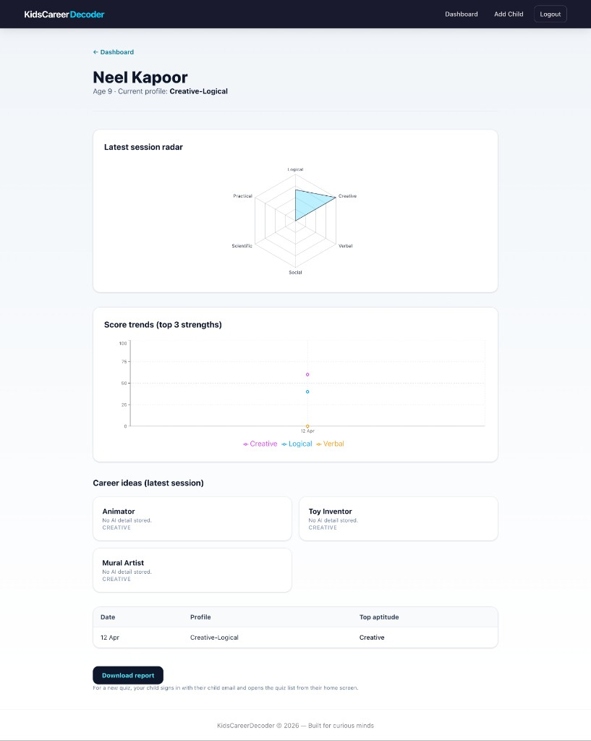
Figure 7.1 Parent child report
Figure 7.1: The parent report for Neel Kapoor (age 9) shows profile Creative-Logical. The Latest session radar chart peaks on Creative and Logical with lower Verbal, Social, Scientific, and Practical scores in that session. The Score trends line chart plots Creative (~60), Logical (~40), and Verbal (~15) for the session dated 12 Apr. Career ideas display seed titles (Animator, Toy Inventor, Mural Artist) when AI detail was not stored for that historical row—demonstrating fallback to the careers table. Session history table lists date, profile, and top aptitude. The Download report action supports parent sharing. This view validates FR8 and the Recharts integration described in §5.11.

Figure 7.2 — Child Results After AI Completion (Daksh Kapoor)
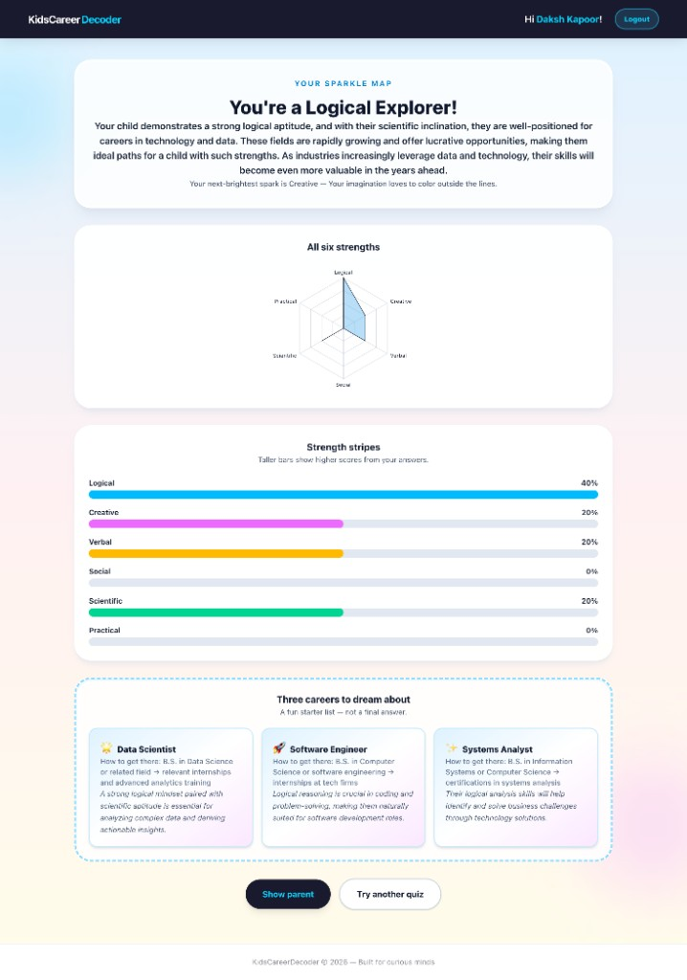
Figure 7.2 Child results with AI careers
Figure 7.2: The child-facing Sparkle Map results for Daksh Kapoor label the learner a Logical Explorer with parent-directed explanation text referencing logical and scientific aptitudes. Strength stripes bars show Logical 40%, Creative 20%, Verbal 20%, Scientific 20%, Social 0%, Practical 0%. The radar chart mirrors the same distribution. Three careers to dream about list Data Scientist, Software Engineer, and Systems Analyst with pathways and match reasons—generated via OpenAI when metadata_json.careers was populated at session complete (see Admin Sessions screenshot showing openai provider). Salary is hidden on the child card per CareerResultCard variant="child". Buttons Show parent and Try another quiz close the engagement loop. This figure is the primary evidence that preprocessing plus AI algorithms produced end-user value (FR5, FR6).

7.1 Functional Outcomes Against Objectives
Objective one (parent registration) is satisfied via /auth/register and login flow. Objective two (child profiles) is satisfied with age validation and credential return. Objectives three through five (quiz delivery, scoring, sessions) are satisfied through session APIs and quiz_answers persistence. Objective six (preprocessing) is implemented in completeSession before AI calls. Objective seven (AI algorithms) is satisfied with pluggable providers and fallbacks. Objective eight (dashboards) is satisfied for parent and child routes. Objective nine (security) is satisfied with bcrypt, JWT, and reset tokens. Objective ten (admin) is satisfied across admin routes and pages.

7.2 Parent Dashboard Results
As shown in Figure 5.2, the merged dashboard displays each child’s name, computed age, sign-in email, count of completed sessions, formatted last quiz date, and label for top aptitude. Neel Kapoor’s card shows one completed quiz and profile Creative-Logical; Sam and Maya Martinez show zero completions with guidance text. Empty states encourage adding a child or completing a first quiz. Navigation to ChildReport provides depth without cluttering the overview. This matches the design goal of progressive disclosure.

7.3 Child Results Experience
Figure 7.2 shows the full child results experience: celebratory heading (“You’re a Logical Explorer!”), horizontal strength stripes, radar chart, and three AI career cards without salary. Results pages map headings from top_aptitude or AI profile string. When AI fails, seed careers from the database still populate suggestions tied to top_aptitude, so the child never sees a blank success screen—as seen on Neel’s parent report with seed creative careers.

7.4 AI Output Quality Discussion
Figure 7.2 demonstrates OpenAI-generated careers with pathway and match_reason sentences aligned to Logical/Scientific scores. Figure 5.8 (admin sessions) correlates the same users with openai in the AI column for completed runs. When Claude or OpenAI is enabled with valid keys, careers include localized salary bands on the parent view; child view omits salary by design. Explanations reference score patterns in parent-directed tone on the results hero section. Provider attribution in metadata_json supports auditing which backend produced a given session.

7.5 Comparison with Existing Approaches
Compared to static PDF reports, the platform offers history and charts. Compared to generic chatbots, outputs are schema-bound and tied to quiz tags. Compared to spreadsheet tracking, concurrent parent and child access is safe through authentication. The trade-off is dependence on external LLM availability unless fallback mode is configured.

7.6 Limitations
The six-stripe model is not a validated psychometric instrument. AI suggestions are illustrative, not predictive. JWT in localStorage is vulnerable to XSS if other vulnerabilities exist. Adaptive logic is heuristic, not calibrated IRT. Multilingual UI is English-only in the current build.

7.7 Lessons Learned
Separating preprocessing from generation simplified testing: the Jupyter notebook ai_preprocess_demo.ipynb mirrors server math without API keys. Early investment in migrations avoided schema drift. Role-based routing on both client and server prevented entire classes of authorization bugs.

7.8 Deployment and Demonstration Results
For viva and Qollabb submission, the project is demonstrated by starting the API and React client, logging in as parent, showing the child dashboard, completing or reviewing a quiz session, and opening the admin insights page. Evaluators can follow the same steps using the repository README and .env.example. Chapter 4 figures are hand-drawn DFD, use case, sequence, and ER diagrams aligned with the implementation. Live demo plus PDF report plus separate presentation satisfies the institute’s three deliverables: report, slides, and work link.

7.9 Statistical Summary of Test Execution
Across Sections 6.2, 6.4, and 6.10, twenty-seven documented test cases were executed with Pass status in the development environment. No open Fail defects remained at report freeze. Known limitations (heuristic adaptive logic, English-only UI) are documented rather than hidden, which supports honest academic evaluation.

Chapter 8: Conclusion & Future Enhancements

8.1 Conclusion
KidsCareerDecoder successfully delivers a web-based child aptitude and career insight platform that meets the functional and non-functional goals set out in Chapter 1. Parents can register, create child accounts with validated ages, and monitor progress through dashboards and detailed reports with charts. Children can select from multiple published quizzes—including inclusive themes—and complete adaptive question flows that store answers, timing, and aptitude tags. Upon completion, the server normalizes six-dimensional scores, preprocesses age and country context, and invokes configurable AI providers (Anthropic Claude or OpenAI) with deterministic fallbacks so the experience remains usable when external APIs are unavailable.
From a software engineering perspective, the project demonstrates competence across the full stack: React single-page application with role-based routing; Express REST API with JWT authentication and bcrypt password storage; PostgreSQL schema with migrations and JSON metadata for AI attribution; integration with third-party LLMs using strict JSON contracts; and an administrative console for operational control. The design artefacts in Chapter 4 (data flow, use case, entity–relationship, and sequence views) map directly to the implementation described in Chapter 5 and validated in Chapter 6. Chapter 7 showed through screenshots that parent and child interfaces behave as specified, including differentiated career cards (salary visible to parents, hidden for children).
The project is therefore judged successful relative to its academic scope: it is not a clinical psychometric product, but an exploratory, transparent, and extensible family-facing tool suitable for demonstration, code review, and further research. Submission to Chandigarh University is supported by this report, a separate presentation file, and repository or live-demo link as required on the Qollabb portal.

8.2 Summary of Contributions
The main contributions of this work are: (1) a traceable scoring model tying each quiz option to an aptitude stripe; (2) a documented preprocessing pipeline reproducible in Python; (3) role-aware UX for parent, child, and admin; (4) pluggable AI profiling with admin-selectable provider and stored metadata; (5) adaptive question ordering heuristics with a clear upgrade path to machine-learned models; and (6) a coherent documentation set including milestone reports on schema, secure login, preprocessing, AI algorithms, and dashboards.

8.3 Future Enhancements (Specific)
- Mobile applications (React Native) for parent notifications and child-friendly tablet layout.
- Spark journal uploads with photo storage and multimodal AI tagging (planned feature arc).
- Ikigai snapshot monthly aggregates and three-circle visualization.
- HttpOnly cookie sessions to reduce XSS token exposure, with CSRF strategy.
- Automated test suite in CI for session and auth controllers.
- Cloud deployment (e.g., Vercel + managed Postgres) with environment parity documentation.
- Psychometric calibration if partnerships with counsellors justify validated item banks.
- Hindi and regional language UI for wider adoption in Indian schools.
- Item response theory (IRT) replacement for heuristic adaptive difficulty.
- Export to PDF of parent reports server-side for archival.

8.4 Objective Achievement Summary
All ten objectives listed in Chapter 1.3 were implemented and verified through the test scenarios in Chapter 6. FR1 through FR10 map to working routes and pages evidenced by Figures 5.1–5.10 and 7.1–7.2. Non-functional requirements NFR1–NFR5 were addressed through bcrypt/JWT, indexed queries, modular code, usability differentiation by role, and stateless API design. The system is suitable for demonstration to examiners with a working database seed and optional AI API keys configured in the deployment environment.

8.5 Technical Learning Outcomes
Neel Kapoor gained practical experience in designing normalized schemas with JSON extensions, implementing secure authentication flows, integrating third-party AI APIs with structured prompts, building responsive dashboards with chart libraries, and documenting software for academic submission. Additional skills include writing SQL migrations, debugging CORS and proxy issues in full-stack development, normalizing heterogeneous AI JSON into stable UI models, and presenting technical work through both a long-form report and a concise slide deck for oral defence.

8.6 Ethical and Social Considerations
Career guidance for minors should remain supportive and non-deterministic. Parents should interpret results as conversation starters, not as fixed career assignments. Schools using similar tools should involve counsellors where available. Data minimization should guide future features: collect only fields needed for age-appropriate suggestions. Transparency about AI use in the parent report is recommended in production deployments. Bias in LLM training data may skew career examples; periodic human review of prompts and outputs is advisable.

8.7 Recommendations for Future Researchers
Students extending this codebase should preserve the separation between tally/normalize (deterministic) and generate (probabilistic). Any new model should log provider and version in metadata_json for auditability. Keep process numbers and entity names consistent between diagrams and code when extending the design. Maintain the Qollabb submission trio: PDF report, PPT/PDF presentation, and GitHub or live URL.

Chapter 9: References
Anthropic. (2025). Anthropic API documentation. https://docs.anthropic.com
Express.js Foundation. (2025). Express — Node.js web application framework. https://expressjs.com
Field, A. (2018). Discovering statistics using IBM SPSS statistics (5th ed.). Sage.
Holland, J. L. (1997). Making vocational choices: A theory of vocational personalities and work environments (3rd ed.). Psychological Assessment Resources.
International Organization for Standardization. (2018). ISO/IEC 25010:2011 Systems and software engineering — Systems and software Quality Requirements and Evaluation (SQuaRE).
IETF. (2015). RFC 7519: JSON Web Token (JWT). https://www.rfc-editor.org/rfc/rfc7519
Meta Open Source. (2025). React — A JavaScript library for building user interfaces. https://react.dev
Microsoft. (2025). TypeScript / JavaScript API guidelines (for client patterns). https://github.com/microsoft/api-guidelines
Node.js Foundation. (2025). Node.js documentation. https://nodejs.org/docs
OpenAI. (2025). OpenAI API reference. https://platform.openai.com/docs
PostgreSQL Global Development Group. (2025). PostgreSQL 16 documentation. https://www.postgresql.org/docs/16/
Recharts.org. (2025). Recharts — A composable charting library built on React components. https://recharts.org
Sadosky, M., Gomes, L., & Supic, H. (2010). Ikigai: The Japanese secret to a long and happy life. Penguin Books.
Supabase Inc. (2025). Supabase documentation. https://supabase.com/docs
Tailwind Labs. (2025). Tailwind CSS documentation. https://tailwindcss.com/docs
Vite Team. (2025). Vite — Next-generation frontend tooling. https://vitejs.dev
OWASP Foundation. (2021). OWASP Top Ten (2021). https://owasp.org/www-project-top-ten/
Mosaic Research Group. (2019). Responsible AI principles in educational technology.

