In order to implement the “YouTube Example Tag”

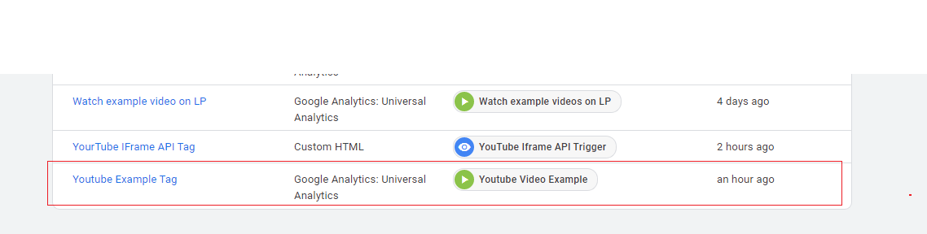

I first implement Youtube ifram API script

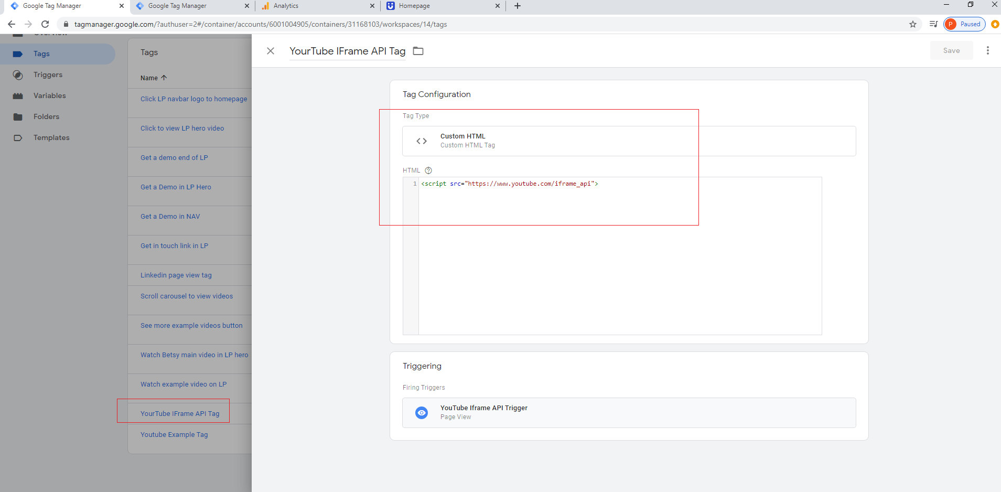

Which worked and start firing the tags, when clicked on each video on home page.

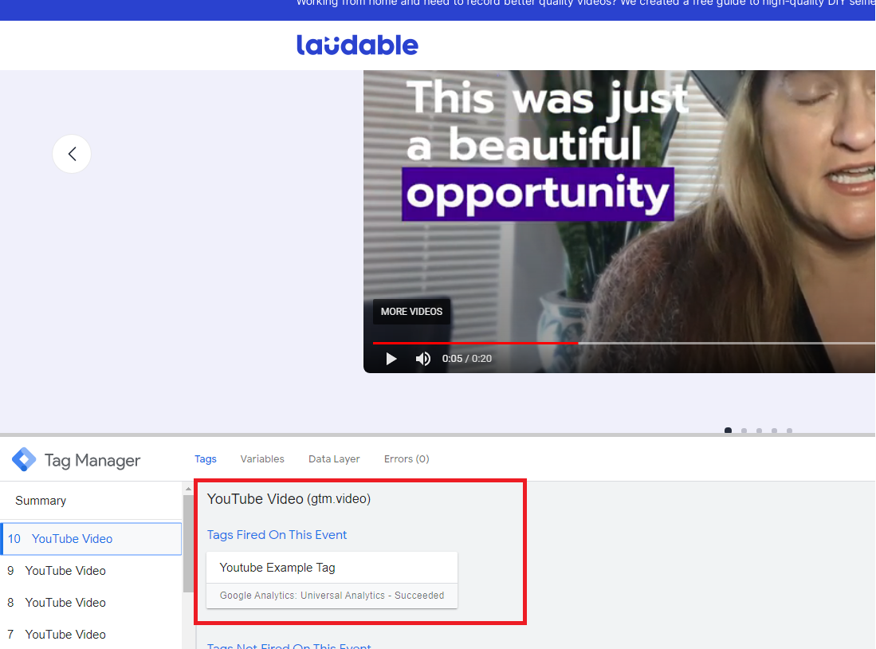

With details like “video title” and “video url “

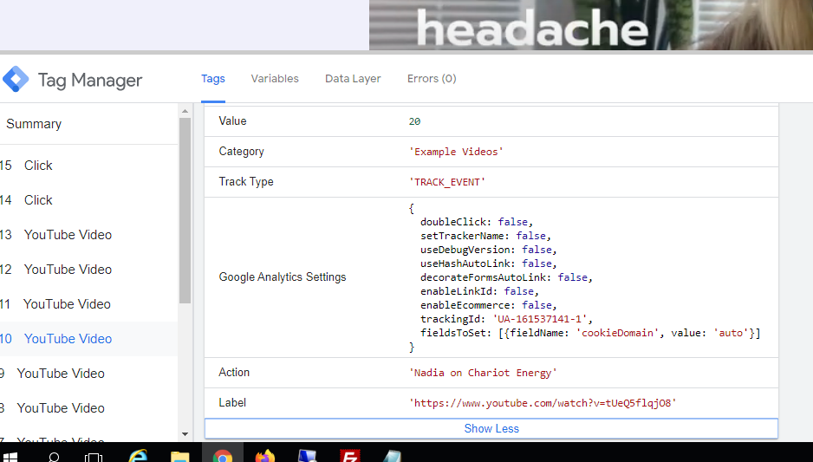

However, on Google Analytics, I was getting only details for Single Video, not for other videos.

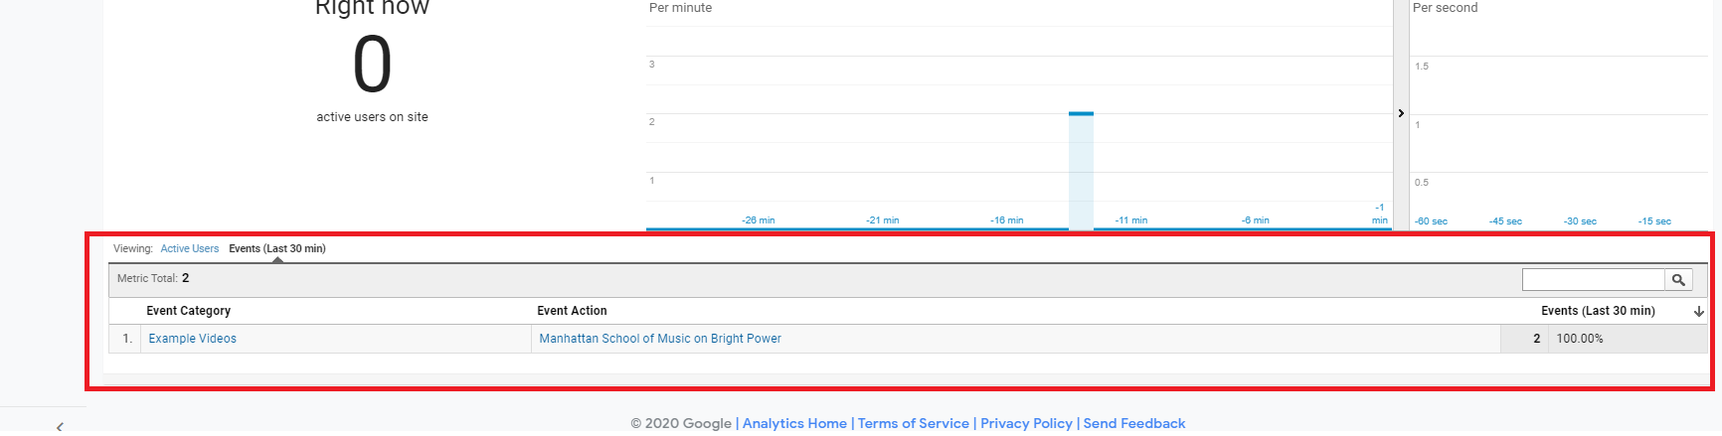

For Videos on page “Videos” they are URL bases and needs to make changes to the url in order to get that tracked.

As mentioned in this url - https://www.analyticsmania.com/post/youtube-tracking-google-tag-manager-solved/