1. Executive Summary
Cobalt Strike still matters for defenders, but the detection strategy has to change. In 2025, Google Threat Intelligence Group reported BEACON in only 2% of ransomware incidents, down sharply from prior years, while Fortra reported unauthorized Cobalt Strike use down roughly 80%. At the same time, BEACON still remained one of the most observed malware families in incident reporting, and actors increasingly mixed or replaced it with frameworks such as AdaptixC2, Havoc, Mythic, and Impacket-heavy tradecraft. The implication is clear: defenders should still hunt Cobalt Strike aggressively, but detections must generalize to “post-exploitation framework behavior,” not just Beacon defaults. Google Cloud / GTIG Fortra Cobalt Strike Sophos
What actually works in practice is multi-signal behavioral chaining. On endpoints, the highest-value signals are still process injection into odd “spawn-to” processes, suspicious named pipes, token theft/GetSystem patterns, LSASS access, ETW tampering, no-command-line LOLBins with network connections, and memory-only execution. On the network side, reliable detections come from periodic outbound traffic with jitter, rare destinations, HTTP/S metadata incongruity, TLS/certificate anomalies, DNS staging artifacts, and cloud/CDN abuse that does not match the host’s role. Single static signatures still catch sloppy operators, but customized Malleable C2, Sleep Mask, BeaconGate, indirect syscalls, and User-Defined C2 reduce the value of one-off IOCs. Red Canary Vectra Elastic Security Labs Unit 42 White Knight Labs White Knight Labs
Two practical conclusions stand out. First, endpoint-only or proxy-only detection is not enough against modern Beacon tradecraft; you need correlation. Second, defenders should preserve legacy Cobalt Strike detections, but tune them into higher-confidence chains: “suspicious process + suspicious memory behavior + suspicious egress” beats any one artifact alone. The DFIR Report Splunk Security Research Hunt.io

Selected visual references
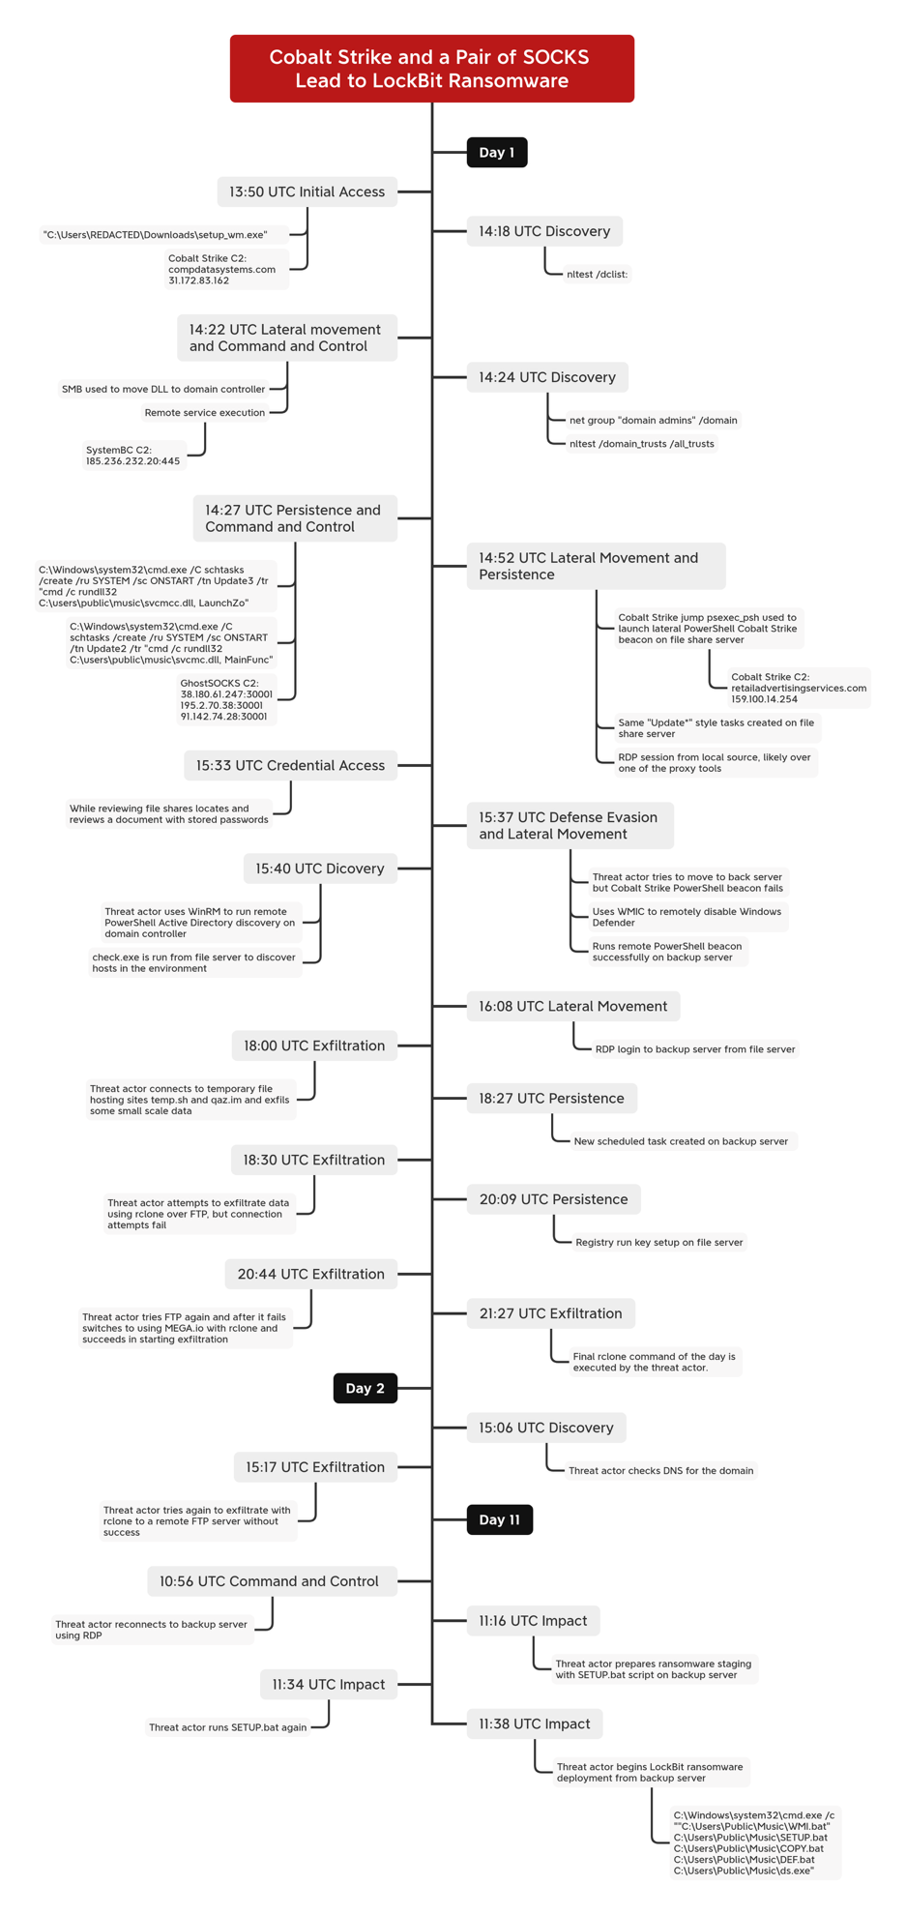
DFIR timeline showing a multi-day intrusion where Beacon, proxy tooling, lateral movement, credential theft, and exfiltration preceded ransomware deployment. The DFIR Report
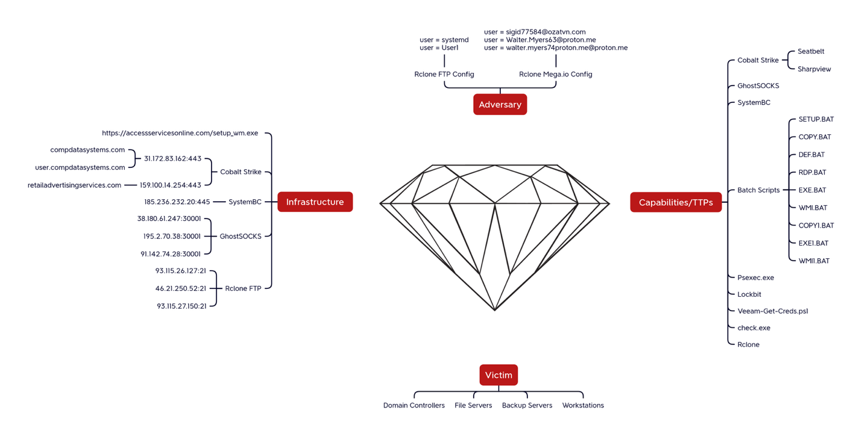
Useful as a hunting model: initial access → Beacon foothold → proxying/pivoting → credential access → exfiltration → impact. The DFIR Report

2. Cobalt Strike Beacon Tradecraft Overview
Modern Beacon activity still centers on the same core architecture: Team Server, listeners, staged or stageless Beacon payloads, redirectors, and Malleable C2. HTTP/S remains the dominant listener type, but DNS, SMB, and raw TCP still matter operationally, especially for segmented environments and chained beacons. DNS supports both hybrid mode and pure-DNS mode; SMB and raw TCP enable internal pivoting where outbound internet access is restricted. Google Cloud / Mandiant
Beacon’s stealth comes from how configurable it is. Malleable C2 can change URIs, headers, User-Agent, host headers, staging, submit paths, and even post-ex process behavior. Publicly available profiles are frequently reused with light edits, so defenders still see recurring themes like WordPress-like paths, CryptoAPI-like user agents, and fake “normal web” URIs, but exact signatures are brittle because operators can swap those values quickly. Unit 42 Hunt.io
The most important endpoint evolution is memory-resident execution. Beacon commonly uses reflective DLL loading, process injection, hollowing, shellcode loaders, Sleep Mask-style obfuscation, BOFs, and temporary spawn-to processes for post-ex jobs. Elastic notes that modern BOF-based execution often bypasses traditional Windows event logging because it avoids file creation and standard API-heavy behavior; that is exactly why deep EDR telemetry into memory, syscalls, and injection is now more important than classic log-only SIEM coverage. Elastic Security Labs Google Cloud / Mandiant
The newest evasion-oriented features publicized in 2025-2026 push this further: BeaconGate, post-ex.cleanup, transform-obfuscate, indirect syscalls, PrependLoader, ObfSetThreadContext, and User-Defined C2. These features reduce static memory residue, alter thread-start behavior, intercept API usage via Sleep Mask logic, and let operators proxy Beacon traffic through custom channels like Slack while preserving native Beacon sleep/jitter and evasion. In short, “default Beacon” detections still work on low-effort actors, but mature operators increasingly look like “generic in-memory post-exploitation framework” activity. White Knight Labs White Knight Labs
Cross-platform expansion is now real, not theoretical. JPCERT documented CrossC2 use to extend Beacon to Linux and macOS, paired with Nim-based loading and anti-analysis measures. That means detection programs that assume Beacon is only a Windows memory/injection problem are behind current tradecraft. JPCERT/CC
Post-exploitation behavior remains highly recognizable even when C2 is customized. In a 2025 LockBit intrusion, operators used a fake Windows Media utility to launch Beacon, then moved to discovery, WinRM, WMI, PsExec, PowerShell remoting, LSASS credential access via injected WUAUCLT.exe, Defender/GPO tampering, Rclone exfiltration, and finally ransomware. This is typical of real-world Beacon use: it is rarely “just Beacon,” it is Beacon plus operator hands-on-keyboard activity. The DFIR Report

3. EDR Detection Techniques

3.1 Process injection, hollowing, and spawn-to anomalies
The most durable endpoint detections focus on Beacon’s execution model, not its binary appearance. Splunk’s Cobalt Strike analytic story emphasizes no-command-line dllhost.exe, gpupdate.exe, rundll32.exe, and SearchProtocolHost.exe with network activity; Red Canary and Vectra call out the same family of odd spawn-to processes and rundll32.exe -> cliconfg.exe as a strong UAC-bypass-related pattern. These are high-signal because legitimate instances usually have expected lineage, arguments, and behavior; Beacon-spawned ones often do not. Splunk Security Research Red Canary Vectra
What works in practice: alert when common “host utility” processes have empty or highly atypical command lines and establish external connections and/or exhibit unbacked executable memory. A single one of those may be noisy; all three together is strong.

3.2 Named pipe usage and SMB beacon patterns
Named pipes remain one of the best host-level Beacon clues, especially for SMB beacons, pivoting, and post-ex jobs. Red Canary specifically highlights pipes such as \pipe\msagent_, \pipe\interprocess_, \pipe\lsarpc_, \pipe\samr_, \pipe\netlogon_, \pipe\srvsvc_, \pipe\postex, and \pipe\status_. Sigma’s named-pipe rules expand this with patterns like \msrpc_, \windows.update.manager, \win_svc, \wkssvc, \spoolss, and \SearchTextHarvester. Red Canary Detection.FYI
Operational caveat: pipe names alone are not enough. Sigma explicitly notes false positives around Chrome mojo.* pipes and Websense DserNamePipe*. In practice, the best version of this detection is “pipe pattern + unusual image + adjacent network activity or service creation.” Detection.FYI

3.3 GetSystem and token/privilege escalation patterns
Red Canary’s Beacon GetSystem analytic remains practical because it looks for a very specific behavioral shape: cmd.exe /c echo <hex> > \\.\pipe\<hex>, which is uncommon in normal admin activity. Sigma’s “Potential CobaltStrike Process Patterns” adds related logic around cmd.exe /C whoami, pipe-echo behavior, and conhost.exe 0xffffffff -ForceV1. Red Canary SigmaHQ raw rule
What works in practice: catch the pipe-echo construction, then look backward for token-related APIs or odd privilege changes and forward for service creation, lateral movement, or SYSTEM-context child processes.

3.4 Reflective loading, unbacked memory, and ETW tampering
Elastic’s 2025 testing reinforces a key point: log-only stacks miss memory-only execution, BOFs, reflective injection, direct syscalls, and ETW patching. Beacon and its extensions can run without file writes and with minimal process creation, so defenders need telemetry for memory mapping, thread creation, syscall usage, and API patching—especially around ntdll!EtwEventWrite, shellcode injection, and thread start addresses that do not map cleanly to loaded images. Elastic Security Labs
YARA is still useful, but mainly as a second-stage memory triage tool. The widely used apt_cobaltstrike.yar rules look for Beacon strings such as date/time format patterns, service-start text, XOR’d variants, the 4.2 deobfuscation routine, and older beacon indicators. These help in memory dumps, extracted payloads, and sandbox triage, but not as a primary control against well-obfuscated current builds. Neo23x0 signature-base

3.5 LOLBins, command-line anomalies, and low-frequency behaviors
Beacon operators still abuse LOLBins heavily: powershell.exe, rundll32.exe, regsvr32.exe, wmic, mshta.exe, wscript.exe, cscript.exe, msxsl.exe, bitsadmin, and native service tooling. Red Canary’s C2-framework guidance specifically calls out suspicious PowerShell DLL loads inside proxy-execution binaries; DFIR Report casework shows PowerShell remoting, WMI, PsExec, BITSAdmin, registry autoruns, and GPO tampering after Beacon foothold. Red Canary The DFIR Report
What works in practice: long-tail analytics outperform static allowlists here. Hunt the rare forms of common binaries: first-seen command-line shapes, empty-command-line launch + network, odd parentage, unusual DLL loads (System.Management.Automation.dll, clr.dll, amsi.dll, scripting runtimes), or “normally local-only” utilities suddenly talking outbound. Splunk Security Research Red Canary

3.6 Behavioral vs. signature-based detection
Signature-based detection still absolutely has value for default certificates, default watermarks, default pipes, and poor actor OPSEC. But Unit 42, Vectra, White Knight Labs, and Elastic all point the same direction: profile variability, runtime obfuscation, and modern evasion features make static-only detection insufficient. Behavior-first detection—then enriched by signatures, extracted configs, YARA, JA3/JA4, and infrastructure reputation—is the practical model. Unit 42 Vectra White Knight Labs Elastic Security Labs

4. Web Proxy / Network Detection Techniques

4.1 Beaconing interval and jitter analysis
Beacon timing is still a top network primitive. Mandiant explains Beacon’s sleep+jitter model clearly; the 2025 PCAP-based academic study showed that autocorrelation and FFT-style analysis can still surface stable encrypted callback intervals. Hunt.io’s 2025 infrastructure work also treats sleeptime and jitter as key clustering features and highlights that both very low-latency beacons and longer-interval “low and slow” implants are common. Google Cloud / Mandiant International Journal of Cyber Engineering, 2025 Hunt.io
What actually works: don’t look for exact periodicity. Look for bounded periodicity. Use sliding windows, coefficient of variation, and minimum event counts. Fixed-interval detectors miss jittered Beacon; overly loose ones drown in software updaters.

4.2 HTTP/S anomalies: User-Agent, URI, and header incongruity
Recent reporting shows the same operational pattern over and over: actors try to look “normal,” but their normality is shallow. Hunt.io found WordPress-like /wp-* submit paths, action-verb URIs like login, post, submit, browser-style UAs on suspicious infrastructure, and repeated use of Microsoft-CryptoAPI/6.1 with OCSP-like URIs. Unit 42 showed attackers reusing public profiles with light edits rather than inventing truly realistic traffic models. Hunt.io Unit 42
Best heuristic: detect incongruity, not strings alone. Examples: a “browser” UA from a server process, a CryptoAPI UA from a host not performing revocation checks, a CMS-like path on a domain with no CMS content, or header order/shape that differs from genuine traffic for that application class. Vectra Hunt.io

4.3 TLS fingerprinting, certificate anomalies, and infrastructure traits
Default Cobalt Strike Team Server certificates, port 50050, and default-like TLS properties remain easy wins against sloppy infrastructure. Vectra still recommends watching for TCP 50050, default-ish certificates, and JA3-style TLS anomalies; Hunt.io shows that many servers still expose common Beacon ports on 443/80/8443/8080 plus more distinctive ports like 4444 or 50050. Vectra Hunt.io Google Cloud / Mandiant
Reality check: this is triage/enrichment, not full coverage. Mature operators use valid certs, reverse proxies, redirectors, and CDNs. Treat certificate/TLS matches as “queue this up for correlation,” not “incident closed.” Google Cloud / Mandiant Unit 42

4.4 DNS anomalies
Public Sigma coverage for Beacon DNS focuses on default staging markers like aaa.stage., post.1, and .stage.123456.. Vectra adds a practical behavior: some Cobalt Strike DNS servers return 0.0.0.0 when busy, and Mandiant reminds defenders that hybrid DNS+HTTP mode is common. Detection.FYI Vectra Google Cloud / Mandiant
What works in practice: keep the default-string Sigma rules, but build broader hunts around rare DNS destinations, unusual subdomain churn, TXT-heavy behavior, repeated failed lookups, and DNS-only egress from hosts that normally use HTTP/S. The default strings catch older or careless operators; the rarity models catch the rest.

4.5 Rare domain and long-tail analysis
The academic 2025 PCAP study and Hunt.io’s infrastructure hunting both reinforce the value of rarity. Suspicious domains, rare ASNs, first-seen destinations, and low-prevalence encrypted flows are far more useful operationally than “bad domain” blocklists alone. In the paper, one malicious domain was only flagged by a minority of vendors, yet traffic regularity and TLS metadata still exposed the channel. International Journal of Cyber Engineering, 2025 Hunt.io

4.6 Legitimate platform abuse, CDNs, and custom egress
This is the area where many proxy programs still underperform. Mandiant explains domain fronting and redirectors; White Knight’s 2026 User-Defined C2 work shows how Beacon can be proxied over Slack APIs; Vectra notes CDN/domain-fronted traffic as a common blending mechanism. That means defenders must understand what normal Slack, CDN, cloud API, and enterprise SaaS use looks like for each host role. Google Cloud / Mandiant White Knight Labs Vectra
What works: detect role mismatch. A workstation or server suddenly posting machine-timed data to Slack/Web API endpoints, or a backup server making persistent CDN-fronted traffic, is often more actionable than any one network fingerprint.

5. Cross-Telemetry Correlation Strategies
The strongest Beacon detections are correlation stories, not single detections. A common high-confidence chain is: suspicious spawn-to process (dllhost.exe, rundll32.exe, SearchProtocolHost.exe) with no meaningful command line → named pipe creation or injected-memory alert → outbound 443 to a rare destination with bounded periodicity → later WMI/WinRM/PsExec or LSASS access. That is much more resilient to profile changes than any one IOC. Splunk Security Research Detection.FYI Vectra
The 2025 DFIR case shows the next layer of correlation: after initial Beacon, the actors used remote services, PowerShell remoting, RDP, Defender tampering, WUAUCLT injection, LSASS access, and then Rclone exfiltration. Mapping “host starts beaconing” to “same host begins credential access and lateral movement” is what turns a noisy alert into a priority intrusion. The DFIR Report
Another effective correlation path is “server role mismatch.” If a file server or backup host that rarely browses the internet suddenly makes periodic HTTPS callbacks, then also launches PowerShell remoting or WMI, then later communicates with Mega/FTP/CDN infrastructure, you have a much stronger signal than proxy telemetry alone. This matters because GTIG’s 2025 ransomware analysis shows actors increasingly targeting virtualization and backup infrastructure while also tampering with defenses. Google Cloud / GTIG
For DNS and SMB Beacon, cross-telemetry correlation is even more valuable. A suspicious DNS staging string or odd named pipe may be weak on its own, but if the same host also spawns a no-command-line utility process or later opens a WinRM/PsExec session, the confidence rises sharply. Detection.FYI Red Canary Vectra

6. Detection Engineering Playbook
Below are operational examples. The queries are derived from the public detections and tradecraft above and meant to be adapted, not pasted blindly.

6.1 Query examples

Example KQL: suspicious Beacon spawn-to process with outbound network
let suspicious_procs = dynamic(["dllhost.exe","rundll32.exe","gpupdate.exe","searchprotocolhost.exe"]);
DeviceProcessEvents
| where FileName in~ (suspicious_procs)
| where isempty(ProcessCommandLine) or ProcessCommandLine matches regex @"^\s*""?.+?\.exe""?\s*$"
| join kind=inner (
DeviceNetworkEvents
| where ActionType =~ "ConnectionSuccess"
| where RemoteUrl !endswith ".corp.local"
) on DeviceId, InitiatingProcessId
| summarize firstSeen=min(Timestamp), lastSeen=max(Timestamp),
remoteHosts=make_set(RemoteUrl, 20), remoteIPs=make_set(RemoteIP, 20)
by DeviceName, FileName, ProcessCommandLine, InitiatingProcessParentFileName, InitiatingProcessAccountName
This operationalizes Splunk/Red Canary/Vectra guidance around “spawn-to process with no arguments + network.” Splunk Security Research Red Canary Vectra

Example KQL / Sysmon-backed hunt: suspicious Beacon named pipes
DeviceEvents
| where ActionType in ("NamedPipeEvent","NamedPipeCreated")
| where AdditionalFields has_any ("\\msagent_","\\interprocess_","\\status_","\\postex",
"\\msrpc_","\\win_svc","\\windows.update.manager",
"\\wkssvc","\\ntsvcs","\\SearchTextHarvester")
| where not(AdditionalFields has "mojo.") // Chrome FP review
| summarize count(), pipes=make_set(AdditionalFields, 50) by DeviceName, InitiatingProcessFileName, InitiatingProcessCommandLine
Tune out environment-specific false positives such as Chrome mojo.* and Websense DserNamePipe*. Detection.FYI

Example Splunk SPL: bounded beaconing over proxy logs
index=proxy earliest=-24h
| bin _time span=1m
| stats count as hits values(uri_path) as uri values(user_agent) as ua by src dest _time
| streamstats current=f last(_time) as prev by src dest
| eval delta=_time-prev
| eventstats avg(delta) as avg_delta stdev(delta) as sd_delta count as n by src dest
| where n >= 10 AND avg_delta >= 30 AND avg_delta <= 3600
| eval cv=sd_delta/avg_delta
| where cv < 0.35
| table src dest n avg_delta cv ua uri
This is the practical version of “interval + jitter” analysis recommended by Mandiant/Vectra and supported by the 2025 PCAP paper. Google Cloud / Mandiant Vectra International Journal of Cyber Engineering, 2025

Example generic SQL / Elastic-style proxy heuristic: UA + URI incongruity
SELECT src_ip, dest_domain, user_agent, uri_path, COUNT(*) AS hits
FROM proxy_logs
WHERE (
user_agent LIKE 'Microsoft-CryptoAPI/%'
AND uri_path ILIKE '%ocsp%'
)
OR (
user_agent LIKE '%Mozilla%'
AND (uri_path ILIKE '/wp%' OR uri_path ~ '(login|post|submit)')
)
GROUP BY src_ip, dest_domain, user_agent, uri_path
HAVING COUNT(*) >= 3;
This is derived from Hunt.io and Unit 42 reporting on reused Malleable C2 patterns. Hunt.io Unit 42

6.2 Rule examples

Sigma: DNS defaults for Beacon staging
title: Cobalt Strike DNS Beaconing
detection:
selection1:
query|startswith:
- 'aaa.stage.'
- 'post.1'
selection2:
query|contains: '.stage.123456.'
condition: 1 of selection*
Good for legacy/default coverage; weak alone against customized DNS C2. Detection.FYI

Sigma: named-pipe patterns
title: CobaltStrike Named Pipe Patterns
detection:
selection_malleable_profile_generic:
- PipeName|startswith:
- '\msrpc_'
- '\win_svc'
- '\windows.update.manager'
- '\wkssvc'
- '\ntsvcs'
- '\SearchTextHarvester'
Best used with Sysmon Event IDs 17/18 plus image/process filters. Detection.FYI

Sigma: GetSystem/process-pattern chain
title: Potential CobaltStrike Process Patterns
detection:
selection_generic_2:
ParentImage|endswith:
- '\runonce.exe'
- '\dllhost.exe'
CommandLine|contains|all:
- 'cmd.exe /c echo'
- '> \\\\.\\pipe'
selection_conhost_1:
ParentCommandLine|contains|all:
- 'cmd.exe /C echo'
- ' > \\\\.\\pipe'
CommandLine|endswith: 'conhost.exe 0xffffffff -ForceV1'
Useful because it keys on a behavior chain, not a file hash. SigmaHQ raw rule

YARA: memory triage for Beacon
The practical strings from apt_cobaltstrike.yar worth operationalizing are the Beacon date/time formatter, service-start text, %s as %s\\%s: %d, XOR’d variants, and the Beacon 4.2 decrypt routine. This is particularly useful in memory dumps or extracted payloads, less so as an at-rest preventive control. Neo23x0 signature-base

6.3 Heuristics that operationalize well
- Host utility process with empty command line + outbound network + odd parent is one of the best broad Beacon heuristics. Splunk Security Research
- Named pipe creation from nonstandard images remains high value, especially if followed by remote execution or SMB traffic. Detection.FYI
- Rare domain + bounded periodicity + server process origin is strong for proxy data. Vectra International Journal of Cyber Engineering, 2025
- Defender/GPO tampering shortly after Beacon foothold is common in ransomware-linked intrusions. The DFIR Report Google Cloud / GTIG
- Cloud/API role mismatch is increasingly important for UDC2/cloud-abuse scenarios. White Knight Labs

6.4 Gaps and false positives
- Default DNS strings, default certs, and pipe names are useful but incomplete. Mature actors change them. Unit 42
- Pipe detections can collide with Chrome/Websense and similar software. Detection.FYI
- Beaconing analytics collide with software updaters, EDR agents, telemetry collectors, and backup tools unless rarity and role context are applied. Vectra
- TLS/JA3 detections are enrichment, not truth. Reverse proxies/CDNs/valid certs reduce fidelity. Google Cloud / Mandiant

7. Evasion Techniques vs Detection Countermeasures
Evasion technique | Why it works for attackers | Defensive countermeasure
Malleable C2 profile changes | Changes UA, URIs, headers, submit paths, and protocol appearance | Detect metadata incongruity and host-role mismatch, not exact strings; cluster on rarity + cadence + process origin. Unit 42 Hunt.io
Sleep + jitter | Breaks naive fixed-period beacon detectors | Use bounded periodicity, coefficient of variation, sliding windows, and minimum event counts. Google Cloud / Mandiant International Journal of Cyber Engineering, 2025
Reflective loading / BOFs / memory-only execution | Avoid file IOCs and standard Windows logs | Use EDR memory telemetry: unbacked RX, shellcode injection, thread-start anomalies, ETW patching, syscall visibility. Elastic Security Labs
BeaconGate / indirect syscalls / ObfSetThreadContext | Bypass API-hook-centric detection and make thread behavior look cleaner | Detect call-stack/thread-context anomalies, suspicious gadget-based starts, and post-injection behavior rather than just Win32 API calls. White Knight Labs
post-ex.cleanup / transform-obfuscate | Reduces memory residue and weakens old YARA | Scan at execution/decryption boundaries and correlate with suspicious child-process, network, and memory events. White Knight Labs
Domain fronting / redirectors / CDN abuse | Hides operator infrastructure behind legitimate services | Monitor SNI/Host/header relationships where visible, restrict egress to required CDNs, and flag new CDN/API usage by inappropriate hosts. Google Cloud / Mandiant
User-Defined C2 / legitimate platform APIs | Makes Beacon look like business SaaS/API traffic | Build app-aware baselines: who normally talks to Slack/Teams/AWS APIs, at what volume and cadence, from which hosts. White Knight Labs
CrossC2 on Linux/macOS | Evades Windows-centric detection programs | Extend memory/process/network hunting to Linux/macOS; hunt for forked children, odd env vars like CCHOST/CCPORT, and cross-platform HTTPS C2. JPCERT/CC
A broader trend is that attackers are diversifying away from Beacon where it is convenient to do so. GTIG saw AdaptixC2, Havoc, Mythic, Metasploit, and ExplorationC2 in 2025 ransomware cases, while Sophos highlighted Impacket’s rise and Beacon’s decline in overall tooling prevalence. So the countermeasure is not “replace Beacon detections”; it is “elevate Beacon detections into framework-agnostic post-exploitation detections.” Google Cloud / GTIG Sophos
AI/ML has a role here, but mainly in prioritization and anomaly surfacing. Unit 42 argues that heuristic-only coverage cannot handle the permutation space of Malleable C2, while Elastic shows AI-assisted detection engineering can help identify gaps after controlled detonation. In practice, ML is best used to rank rare/novel traffic and process behavior for analyst review, not as an opaque replacement for grounded detections. Unit 42 Elastic Security Labs

8. Key Takeaways for Threat Hunters
- Keep Cobalt Strike detections, but stop thinking “Beacon only.” The tradecraft is increasingly shared across Sliver, Havoc, AdaptixC2, Mythic, and Impacket-led operations. Hunt for post-exploitation behaviors first, Beacon artifacts second. Google Cloud / GTIG Sophos
- Endpoint behavior is still your highest-fidelity signal. Named pipes, injection, hollowing, no-CLI spawn-to processes, token/LSASS access, and ETW tampering consistently outperform pure network signatures. Elastic Security Labs Red Canary Splunk Security Research
- Proxy/network detection works best when it uses rarity and role context. Periodicity with jitter, rare destinations, weird UA/URI combinations, first-seen TLS/certs, and cloud/API misuse are far more useful than static blocklists. Vectra Hunt.io
- Correlation is the force multiplier. The practical winning pattern is host anomaly + memory anomaly + egress anomaly + lateral movement follow-on. The DFIR Report Google Cloud / GTIG
- Preserve older rules, but tune them as triage accelerators. Default DNS strings, named pipes, certs, and watermarks still catch real intrusions—just not all of them. Detection.FYI Detection.FYI Fortra

9. References

Security vendors / threat intelligence / incident response
- Google Cloud / GTIG: Ransomware TTPs in a Shifting Threat Landscape
- Google Cloud / Mandiant: Defining Cobalt Strike Components & BEACON
- The DFIR Report: Cobalt Strike and a Pair of SOCKS Lead to LockBit Ransomware
- JPCERT/CC: CrossC2 Expanding Cobalt Strike Beacon to Cross-Platform Attacks
- Unit 42: Attackers Exploiting Public Cobalt Strike Profiles
- Vectra: Cobalt Strike Detection & Defense Guide
- Elastic Security Labs: Detonating Beacons to Illuminate Detection Gaps
- White Knight Labs: Harnessing the Power of Cobalt Strike Profiles for EDR Evasion, Part 2
- White Knight Labs: The New Chapter of Egress Communication with Cobalt Strike User Defined C2
- Fortra: New Report Highlights Rogue Cobalt Strike Down by 80%
- Cobalt Strike blog: Update: Stopping Cybercriminals from Abusing Cobalt Strike
- Sophos: 2026 Active Adversary Report
- Hunt.io: The Complete Guide to Hunting Cobalt Strike – Part 2

Open-source detection engineering content
- Detection.FYI / Sigma: Cobalt Strike DNS Beaconing
- Detection.FYI / Sigma: CobaltStrike Named Pipe Patterns
- SigmaHQ raw rule: Potential CobaltStrike Process Patterns
- Neo23x0 signature-base: apt_cobaltstrike.yar
- Splunk Security Research: Cobalt Strike analytic story

Academic / research papers
- International Journal of Cyber Engineering (2025): Network Forensics of Contact Forms BazarLoader and Cobalt Strike Based on PCAP File Analysis
- Politecnico di Torino thesis (2025): Implementation and Testing of an Open Source NDR Solution

If you want, I can turn this into a hunt package next:
- a Sigma/YARA/KQL/SPL bundle,
- a Beacon-focused detection matrix mapped to ATT&CK, or
- a SOC runbook for triaging suspected Cobalt Strike from EDR + proxy logs.

