|  |
| --- |
| Keyboard Optimization with Genetic Algorithm Author  School of Computing, KAIST |
| **Abstract** | |

**I. Introduction**

Nowadays, most people use "QWERTY" keyboard. However, current keyboard is not designed with considering typing sequence. For fast typing, it needs two condition. First condition is that to minimize the movement of the finger. When using the keyboard, humans' finger always locate middle line of keyboard. It means that, if users typing a sentence without moving finger on middle line, user can type fast. Second condition is that to use left hand and right hand alternately.

Figure 1 represents that comparing Dvorak keyboard with QWERTY keyboard. Dvorak keyboard is well known as faster keyboard than QWERTY keyboard. Dvorak keyboard satisfies two conditions which we mentioned above. First, frequently used alphabets locate middle line of keyboard. Alphabets which locate middle line of Dvorak keyboard use 70% English documents but alphabets which locate middle line of QWERTY keyboard use only 32% English documents. Also, all vowels locate left side of Dvorak keyboard therefore Dvorak keyboard has high potential to use left hand and right hand alternately because almost English words combine consonant, vowel, consonant, vowel… order.

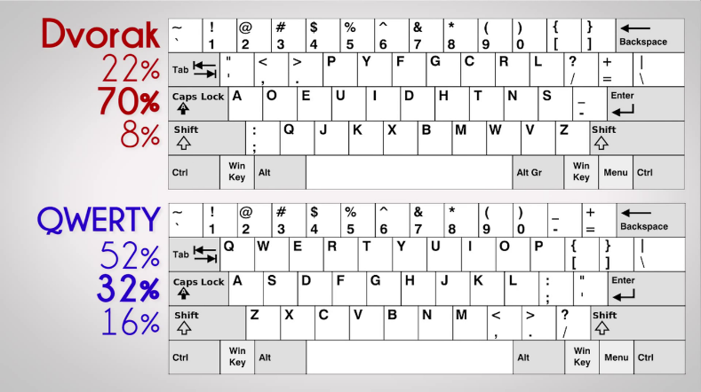

Figure 1. Compare Dvorak with QWERTY

The goal of this project is that to create optimizing keyboard layout using genetic algorithm. We use the Corpus of Contemporary American English (COCA) to optimizing target. We find the best keyboard layout when u9ser typing the COCA.

The contributions of our project are as follow:

1. Our method can apply different situation. We find the best layout for COCA but some people want find the best keyboard layout for writing paper. So, people can find the best keyboard layout that they want.
2. We use Voronoi diagram to make keyboard layout. We do not assume the best shape of keyboard buttons are square. We use Voronoi diagram to fine the best shape of keyboard buttons.
3. We implement crossover technique to apply keyboard layout. There are too many conditions to use crossover generally. So, we implement crossover technique to use keyboard layout.
4. We makes fit function to consider various situation. We consider kind on finger, area of keyboard and distance of finger movement with fitts law. We explain our fit function section 3.

The remainder of this paper is organized as follows. Section II explains background of our project such as Voronoi diagram and fitts law. Section III shows our fit function. Section IV shows our genetic algorithm, crossover and mutation method. Section V shows results our project and Section VI is discussion and conclusion.

**II. Background**

In this section, we explain Voronoi diagram and fitts law.

**II.I Voronoi Diagram**

**II.II Fitt’s law**

As long as our project is about optimizing keyboard layout, we need to evaluate our keyboard by using HCI(Human Computer Interaction) method. Fitt’s Law is a predictive model of human movement primarily used in HCI field. This is a metric to quantify the difficulty of target task, it predict the time that required to move and hit a target by function of distance and width of target object. Following formula is based on the Fitt’s Law.

$$MT=a+b⋅\log_{2}\left(\frac{2D}{W}\right)$$

* MT is the average time to complete the movement
* a and b are constants that depend on the environment, so usually these are determined empirically by regression
* D is distance between target and starting point
* W is width of the target object

This law imply that when the target gets bigger and closer, required time to hit the target object decrease, which means it gets faster. In this way, we can measure the usability of the physical UI by predicting the required time.

**III. Fitness function**

Size

Corpus (sequence and frequency)

Distance from finger

Left / Right hand

**IV. Algorithm**

**(짧게나마 pseudo-code를 넣어도 괜찮을 듯)**

**IV.I Crossover**

**IV.II Mutation**

**V. Result**

**VI. Discussion and Conclusion**

References