HW1 Report

themis12@kaist.ac.kr / 010 2830 3651  
20184448 Jo MinKi

1. **Introduction**This work conduct the image searching task with neural network feature.
2. 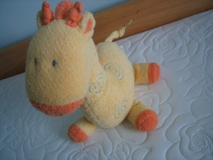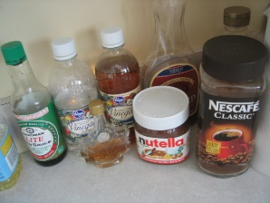Result   
   Correct case   
   Query   
     
     
     
     
     
     
     
     
     
     
     
     
     
     
     
     
     
     
     
     
     
     
   dist = [3.6398244, 90.92494, 107.60222, 110.9077]  
     
   Error cases   
   Query   
     
     
     
     
     
     
     
     
     
   dist = [4.801503, 88.44673, 96.51866, 97.753426]  
     
     
     
     
     
     
     
     
   VGG19_fc6 layer  
   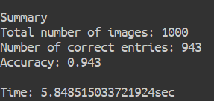  
     
   VGG19_fc7 layer  
   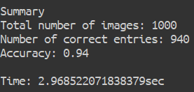  
     
   VGG16_fc6 layer  
   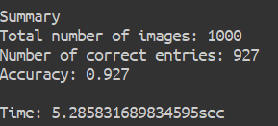  
     
   VGG16_fc7 layer   
   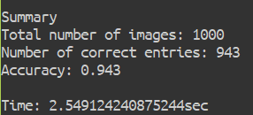  
     
   VGG16_pool5 layer   
   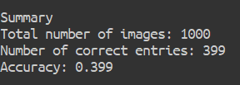  
     
   ResNet v1_50 block5 conv3 layer  
   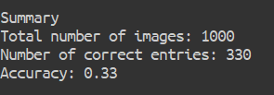  
     
   According to the observation, feature FC6 layer of the VGG model dramatically works better than the feature from the end of the ResNet, VGG pooling layer (or the end of the conv layer). In addition, the processing time took around 5.5 second for 250 queries when you use the L2 distance. If you use L1 distance, it will takes around 2.5 sec for 250 queries.   
   VGG model has the Fully Connected layer which is avoided by recent trend because FC layer prone to make the model overfit. However, if the model does not have the FC layer at all, such like a ResNet or Inception net or VGG Net bellow the Pool5 layer, there is no pixel-wise non-linear operation. In other words, the fc layer makes the model be robust on the rotation. However, the strength of the ResNet is the capacity of the expressional dimension of the function. Which means that the ResNet is able to express more difficult function, so if you train the model in the searching purpose, it can get better.
3. Discussion   
   a. Approach  
   The problem of this is that this task used the Neural network model but this model was not trained for the searching task. In other word, there was no Training.   
   If there are enough data for this task, the model performance can be improved by adding one more embedding layer or replacing the FC layer for the image embedding purpose. Image embedding or Metric learning concepts can be applied for the improvement.   
     
   b. Exhaustive search  
   For this assignment, any compression or coding method and fancy data structure has been used. It was fine for this assignment which require searching only 1000 images. However, when the number of the image gets bigger such like a search engine, this method will not work.   
   There could be a solution such like quantization. You can quantize the weight and find the cluster based on the distance. If you choose the exhaustive way for quantization, then it also takes $n^{2}$ times, but it must be much faster when you conduct a search. (If you group each portion with 256 images, it will only take 256 time. Furthermore, there are many ways that conduct the quantization in $n\log{n}$ time.