PA2 Report

themis12@kaist.ac.kr / 010 2830 3651  
20184448 Jo MinKi

1. **Introduction**This report contains the summary of classic classifier matlab implementation and experiments.   
   * Input/Output format이 정해져 있지 않아 **제공된 데이터 형식에 대해서** 동작하도록 작성하였습니다.   
   (트레이닝 데이터TRAIN_DATA/black and white/character data001.bmp,   
   테스트 글자 데이터 VALID_DATA/CharA.bmp  
   테스트 단어 데이터 VALID_DATA/word data001.bmp)
2. **Implementation**Extract each character parts of the training data and save it as a frame. After that, calculate the cross correlation between the training data and the test data by rotating the image. Based on that, find the nearest characters and rank those classes. Finally, the classifier decide the highest ranked class.  
     
     
   * The word data has the label so we can calculate the accuracy automatically, but in the case of the word, there is no way to give the ground truth label so there is not evaluation code for the word data.
3. 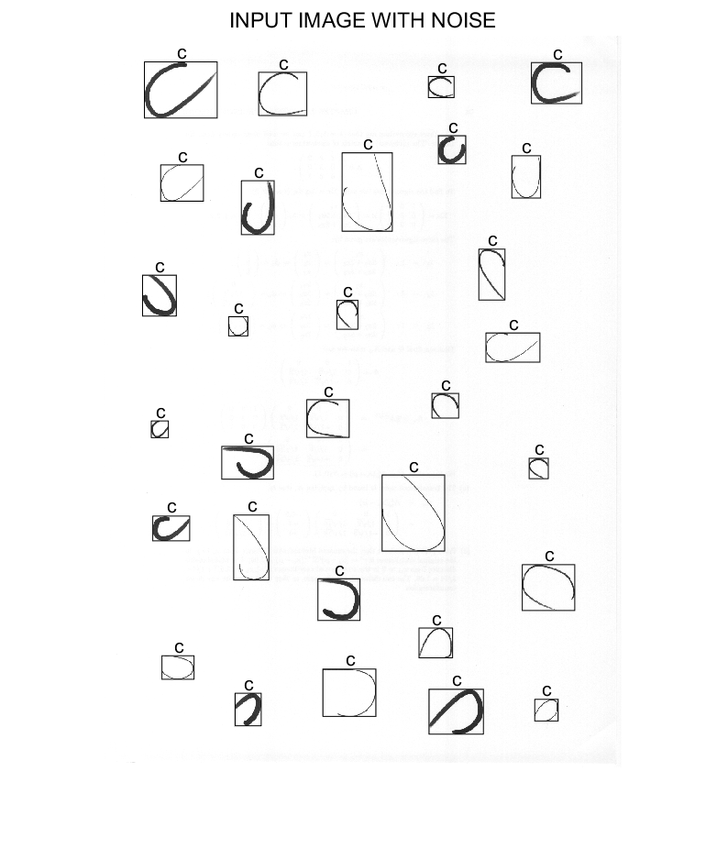**Result**The error number of the prediction   
   Err_A = 1  
   Err_B = 4  
   Err_C = 0  
   Err_D = 5  
   Err_E = 2  
     
   Total Error rate = 10.0%

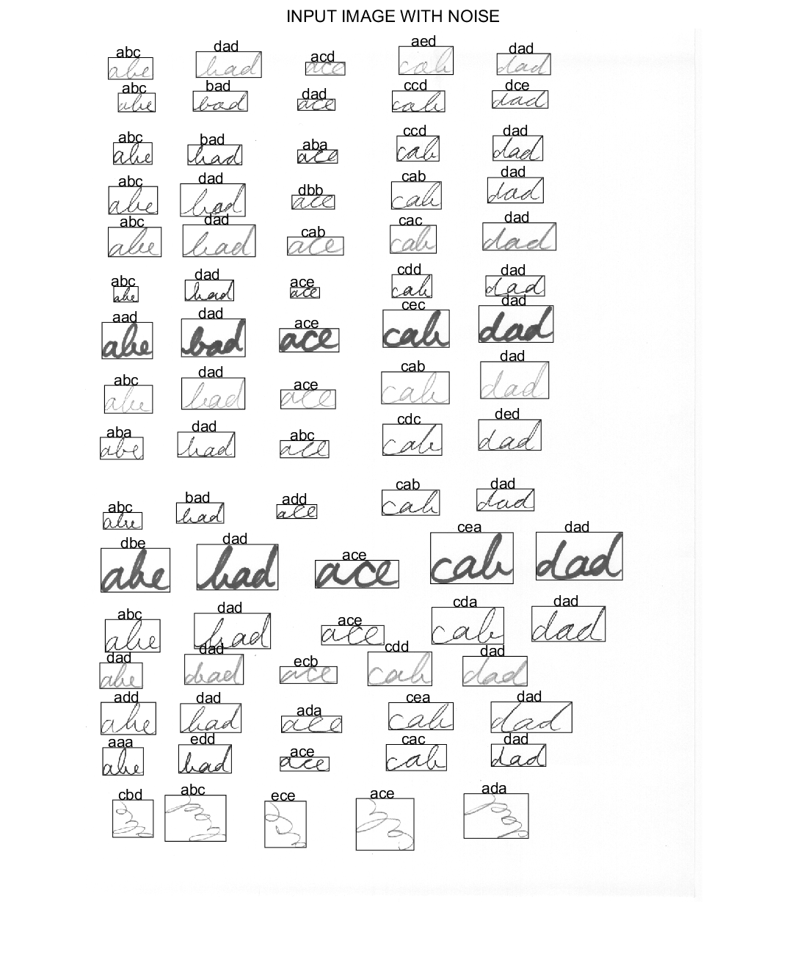  
Number of error prediction   
abc : 7/16  
bad: 13/16

ace: 9/16  
cab: 13/16  
dad: 3/16  
Total: 45/80,   
Error rate = 56.25%

evaluation code for the word data.   
Following is the result of the other test data.

