HW3 Report

themis12@kaist.ac.kr / 010 2830 3651  
20184448 Jo MinKi

1. **Introduction**   
   This model conduct the interpolation task with the video sequeance. Similarly to the pix2pix, every input data has the assigned target data. Basically this model make a same size of image which has high color range. The detail about the implementation are written in the README.md and in the python files.
2. **Environment**

* L1 loss for the cost
* Adam optimizer (epsilon = 0.002)
* Learning rate: 0.0001

1. **Result**   
   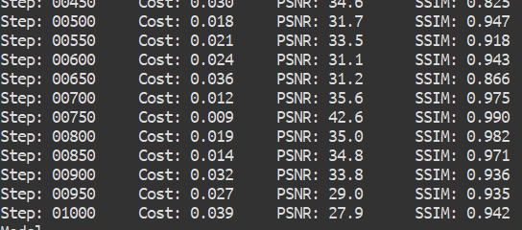  
     
   Average PSNR = 32.3

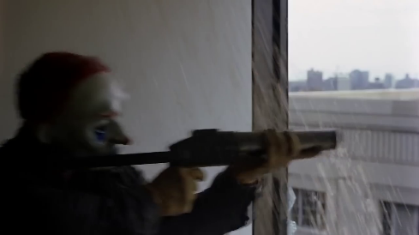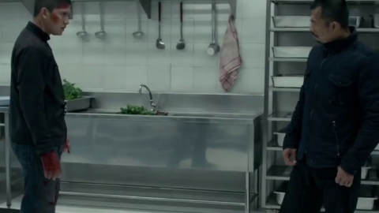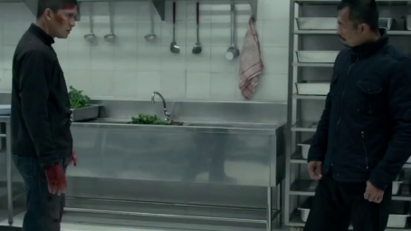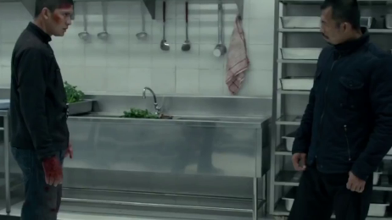  
Test example First & Third is input, middle one is the output

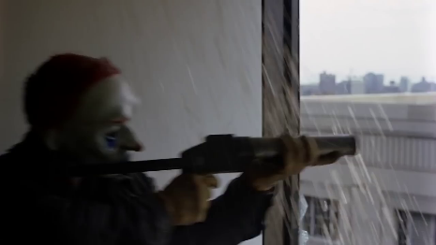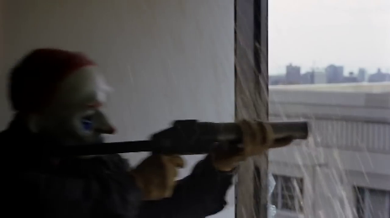

The produced image tends to show the luminance around the edge, which seems as a mixture of the former and later image. However, even though the edge part not recovered perfectly, the result image shows high PSNR and SSIM because most of the object are almost similar with the former & later image.  
  
At the following example, first one is one of the input image and last one is the target image, and middle one is the output image that produced by the network.

