HW3 Report

themis12@kaist.ac.kr / 010 2830 3651  
20184448 Jo MinKi

1. **Introduction**   
   This model conduct the de-blurred image generation (translation) task with single image. Similarly to the pix2pix, every input data has the assigned target data. Basically this model make a same size of image which has high color range. The detail about the implementation are written in the README.md and in the python files.
2. **Environment**

* L1 loss for the cost
* Adam optimizer (epsilon = 0.002)
* Learning rate: 0.00005

1. 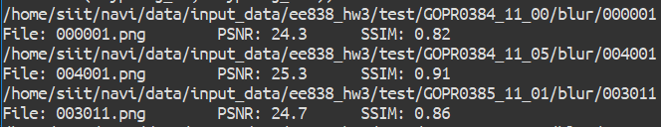**Result**For the asked test data  
   For other test data   
   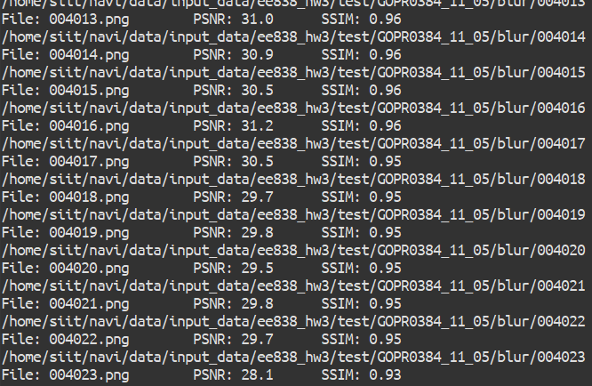  
     
   After 26200 step,   
   Average training cost: 0.05  
   Average PSNR = 28.3

At the following example, first one is the input image and last one is the target image, and middle one is the output image that produced by the network.

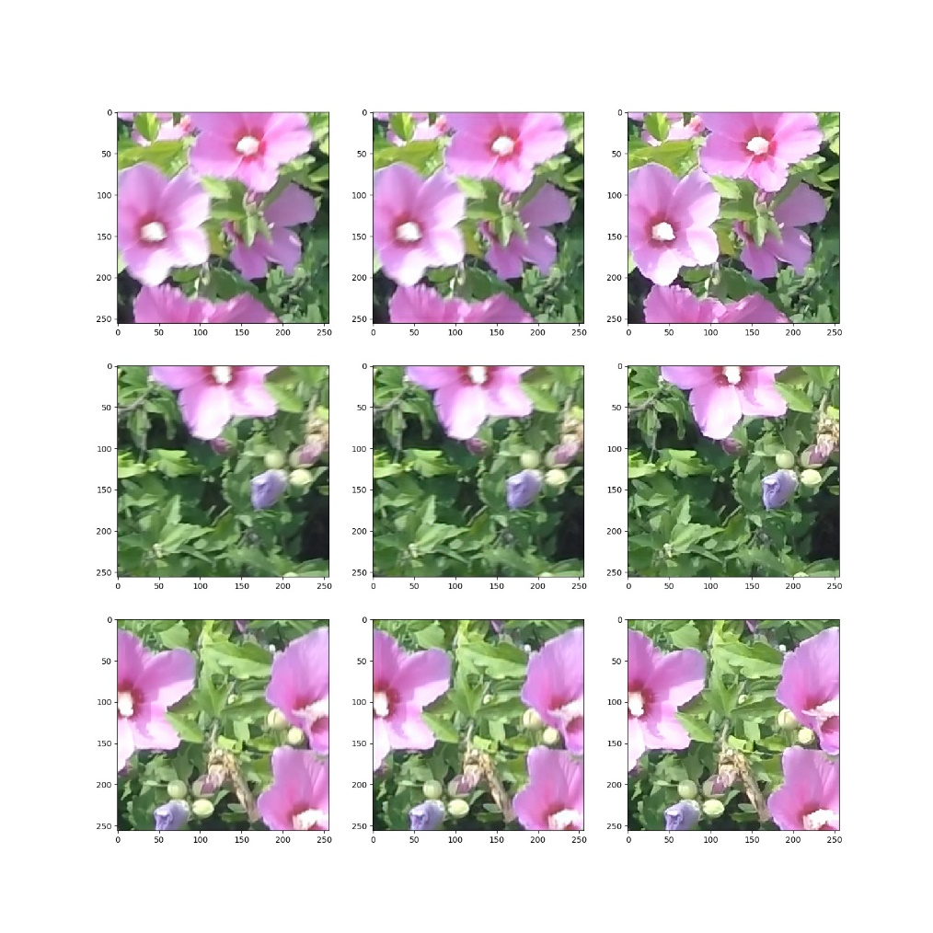Training example  
  
Test example   
 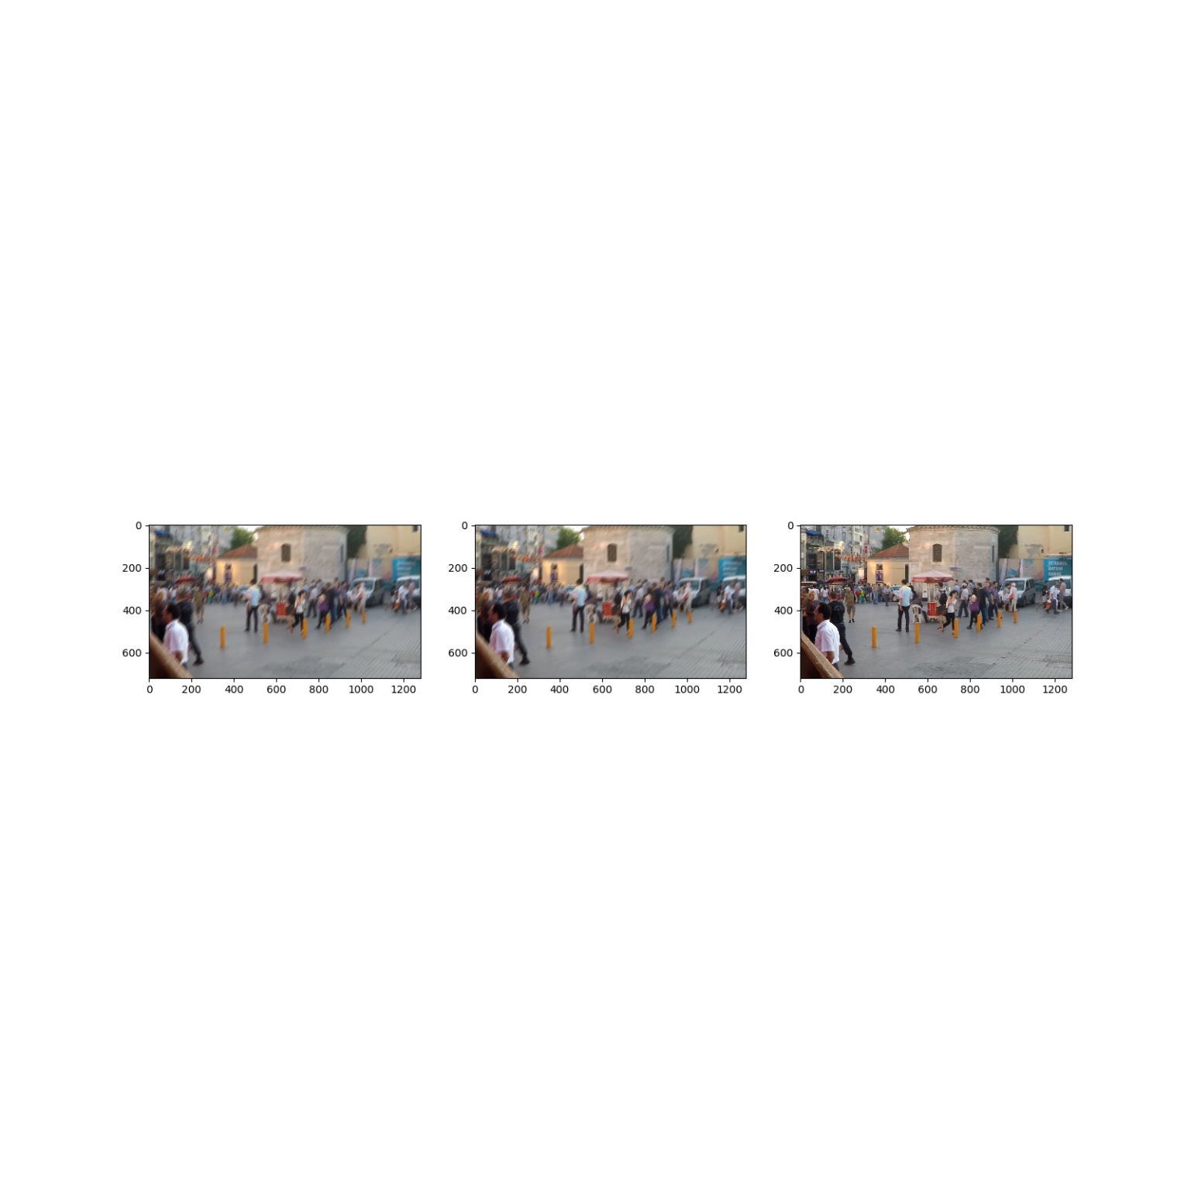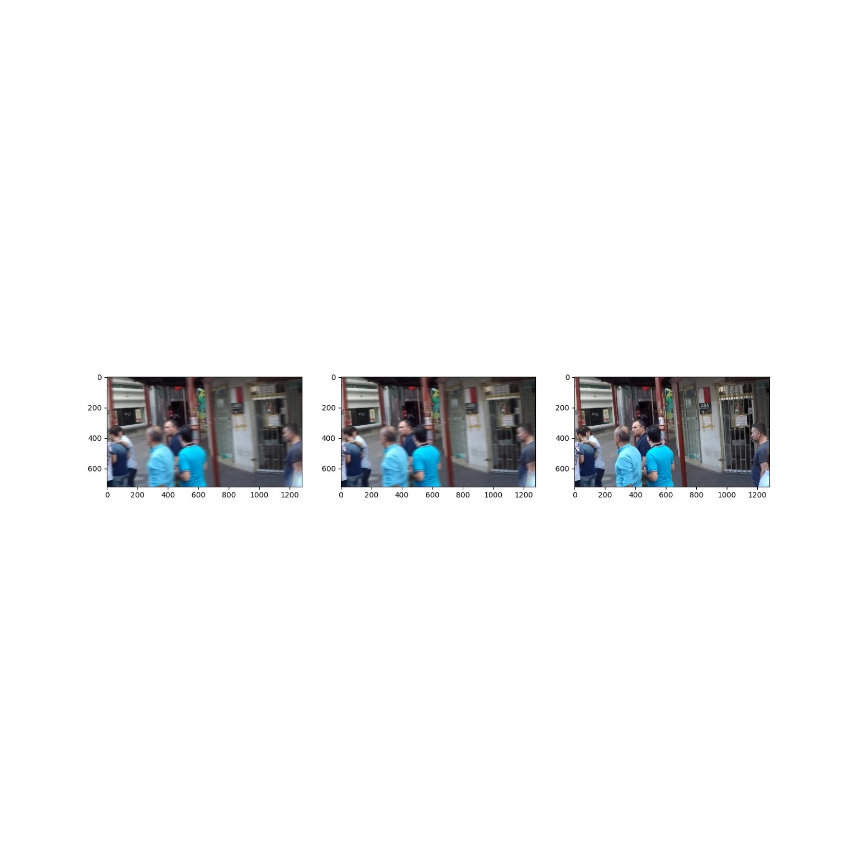



The produced image tend to clustered each other so the texture looks like a carton a little bit. In addition, the network still does not recover the image when the image heavily blurred so the test examples that asked by homework showed very low performance such as showed the girl in above pizza hut example. However, the network perform fine for the slightly blurred example (almost 29 PSNR). In other word, the performance of the network depends on the degree of the blurred of the input data.