HW1 Report

Jo MinKi

1. **Introduction**   
   There was a weird and critical problem in neural network field. Everybody think that deeper network can solve more complex problem. But in reality, when the network gets deeper, the performance (validation error or testing error) of it gets worse. On top of that, when the depth of network goes further than 50 layers, even training error going to down. Which means that network lose the learning ability when the depth goes too far. This phenomena called ‘degradation problem’.
2. **Environment**

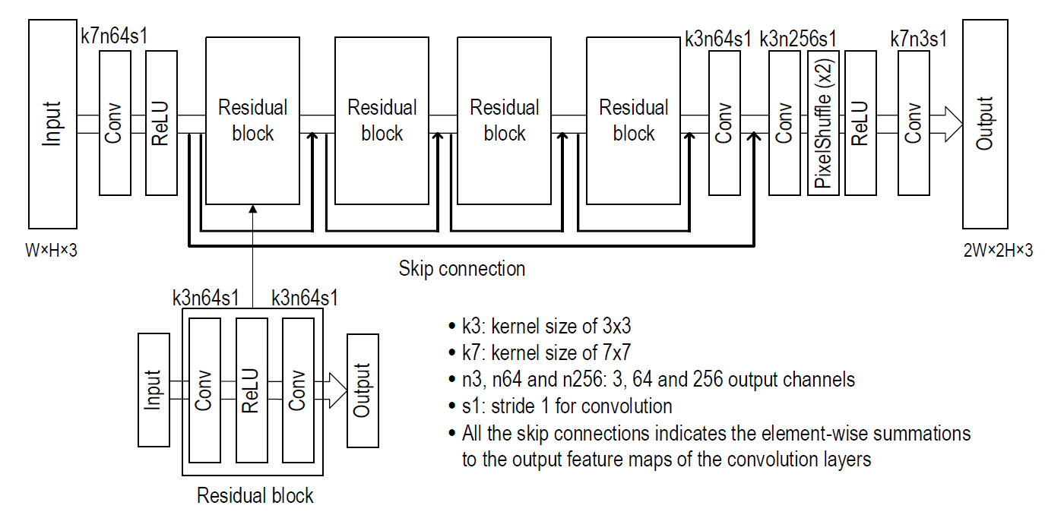

* L1 loss for the cost
* Adam optimizer
* Learning rate: 0.0005 without decade.

1. 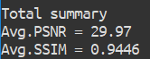**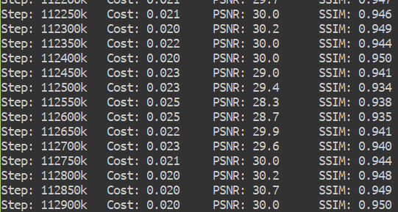Result**   
     
   After 112k step,   
   Average training cost: 0.02  
   Average PSNR = 30.3   
   Average SSIM = 0.947  
     
   For the validation data,  
   Average PSNR = 29.97   
   Average SSIM = 0.9446   
     
     
     
   Example recovery for the training set  
     
   First column is the input data, second column is the output (recovered) data, and the last column is the target.  
     
   Example recovery for the validation (test) set  
   #15 (PSNR = 27.2, SSIM = 0.928 )  
   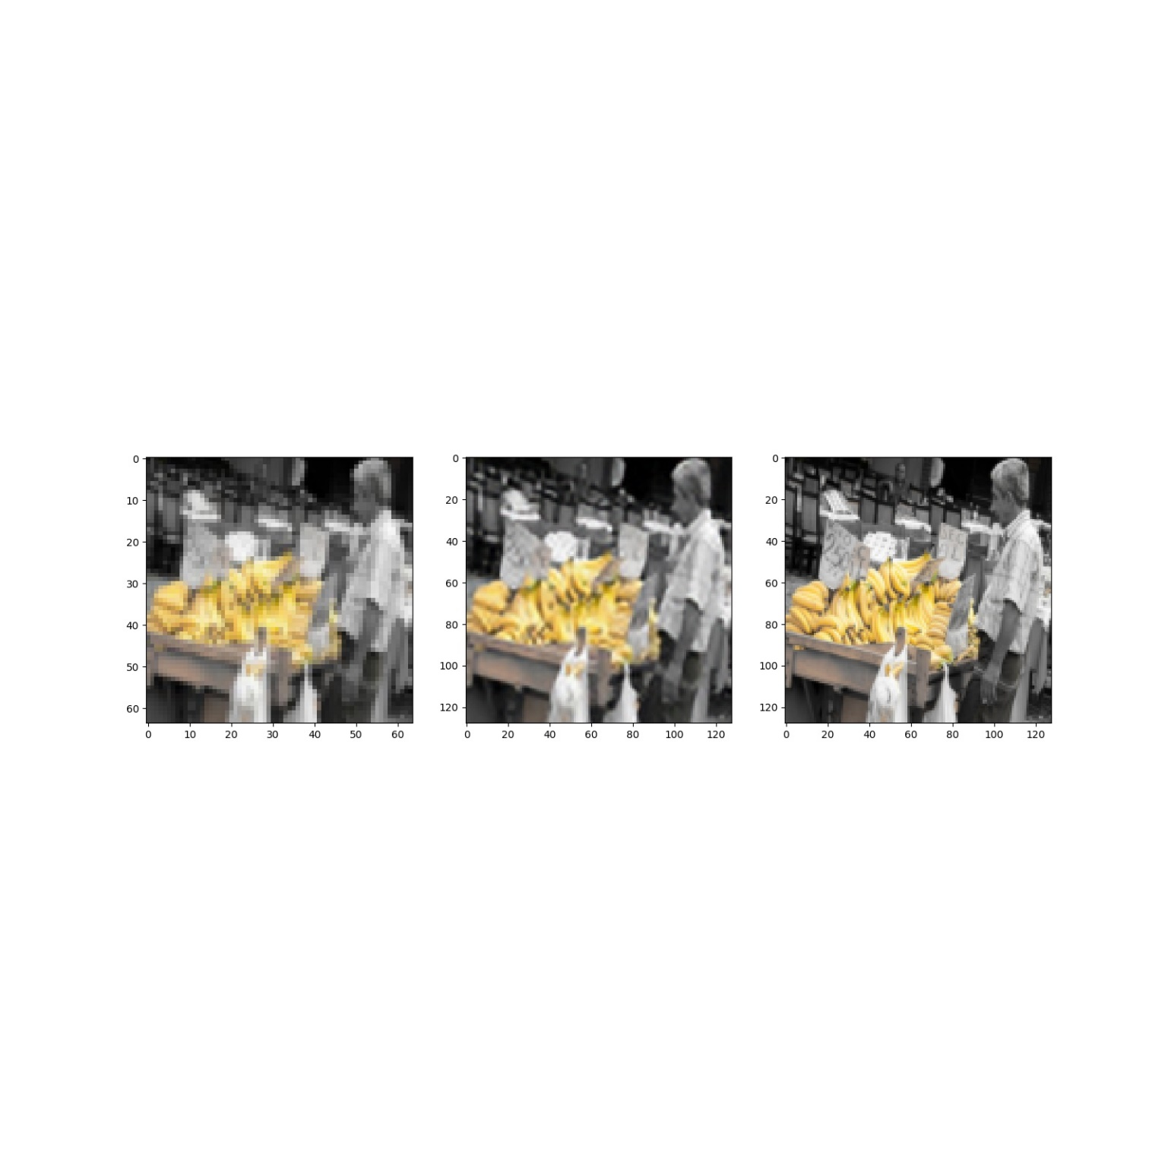  
     
   #35 (PSNR = 28.7, SSIM = 0.929)  
   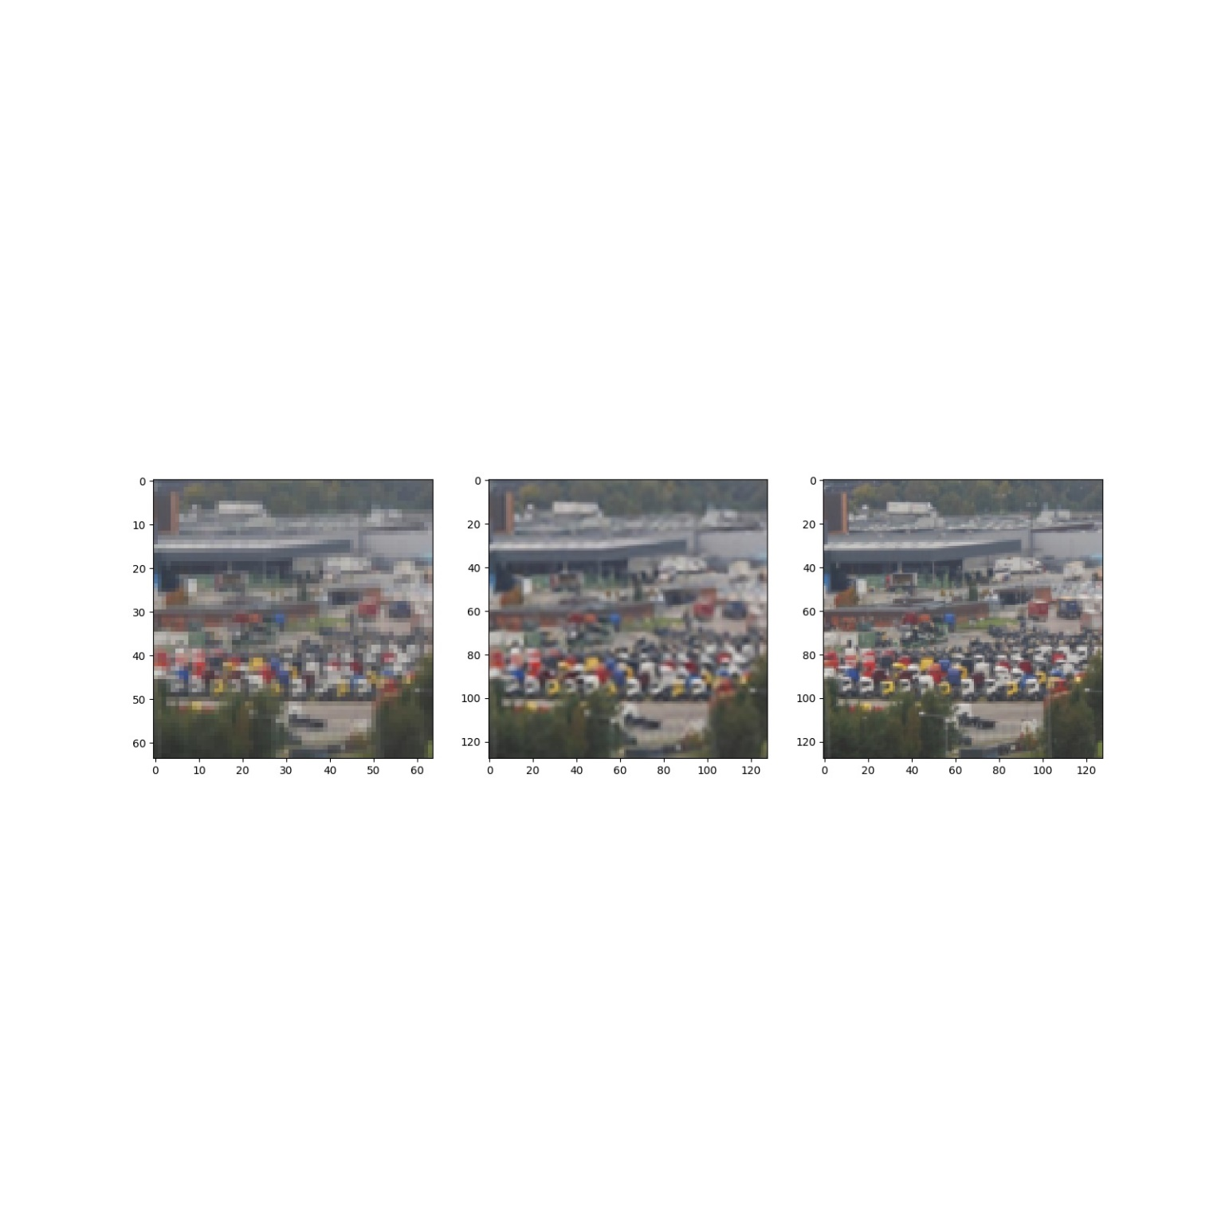  
   #55 (PSNR = 35.2, SSIM = 0.978)  
     
   #75 (PSNR = 29.1, SSIM = 0.935)  
   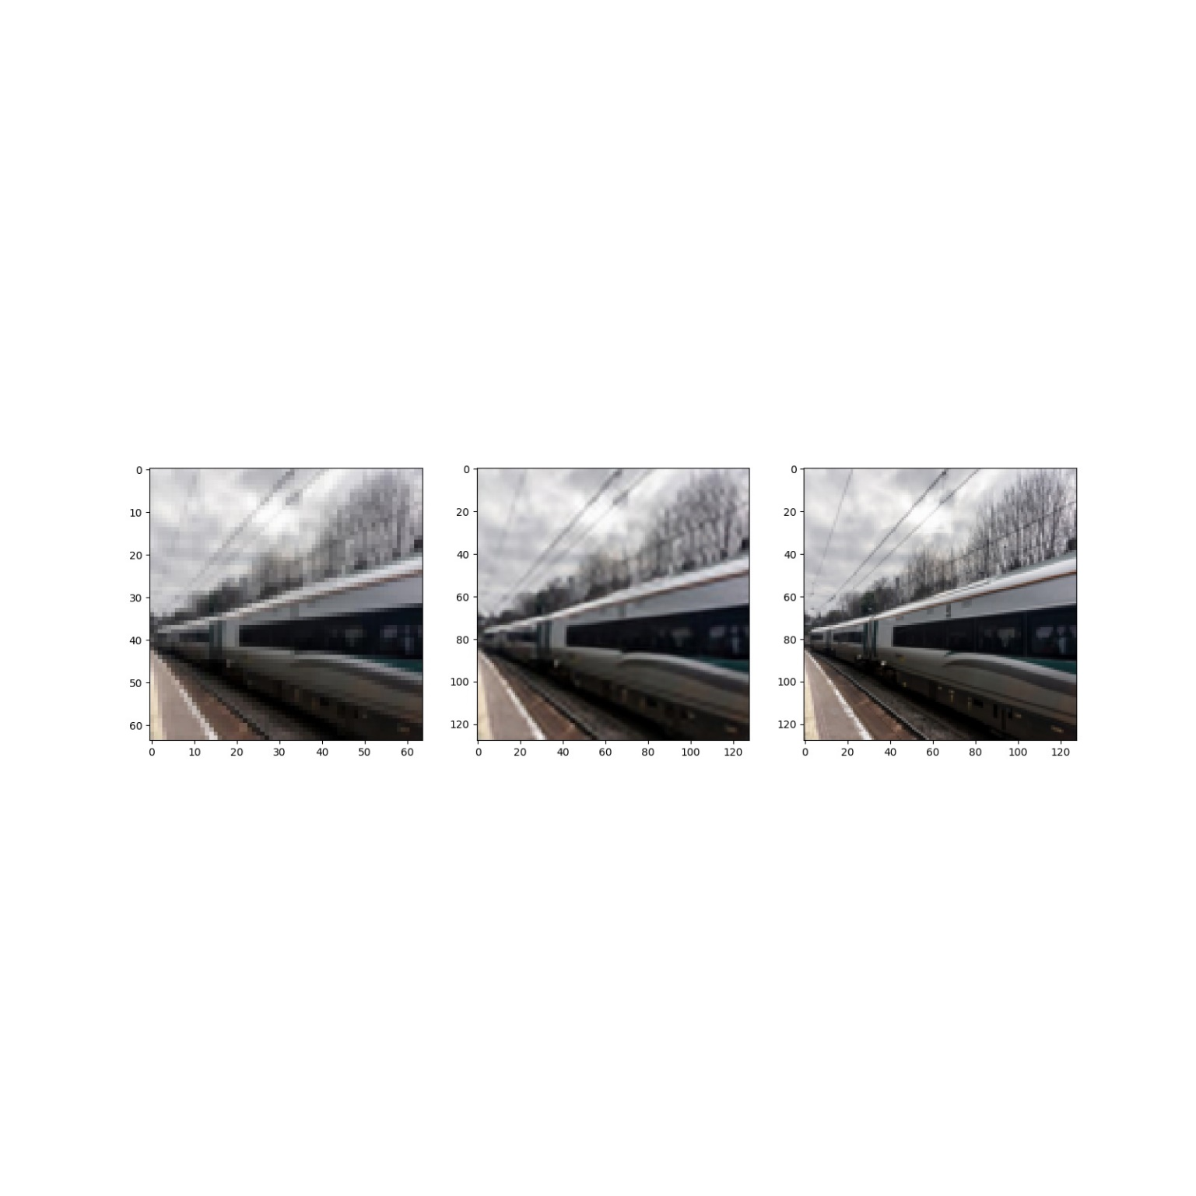  
   #95 (PSNR = 30.5, SSIM = 0.961)  
   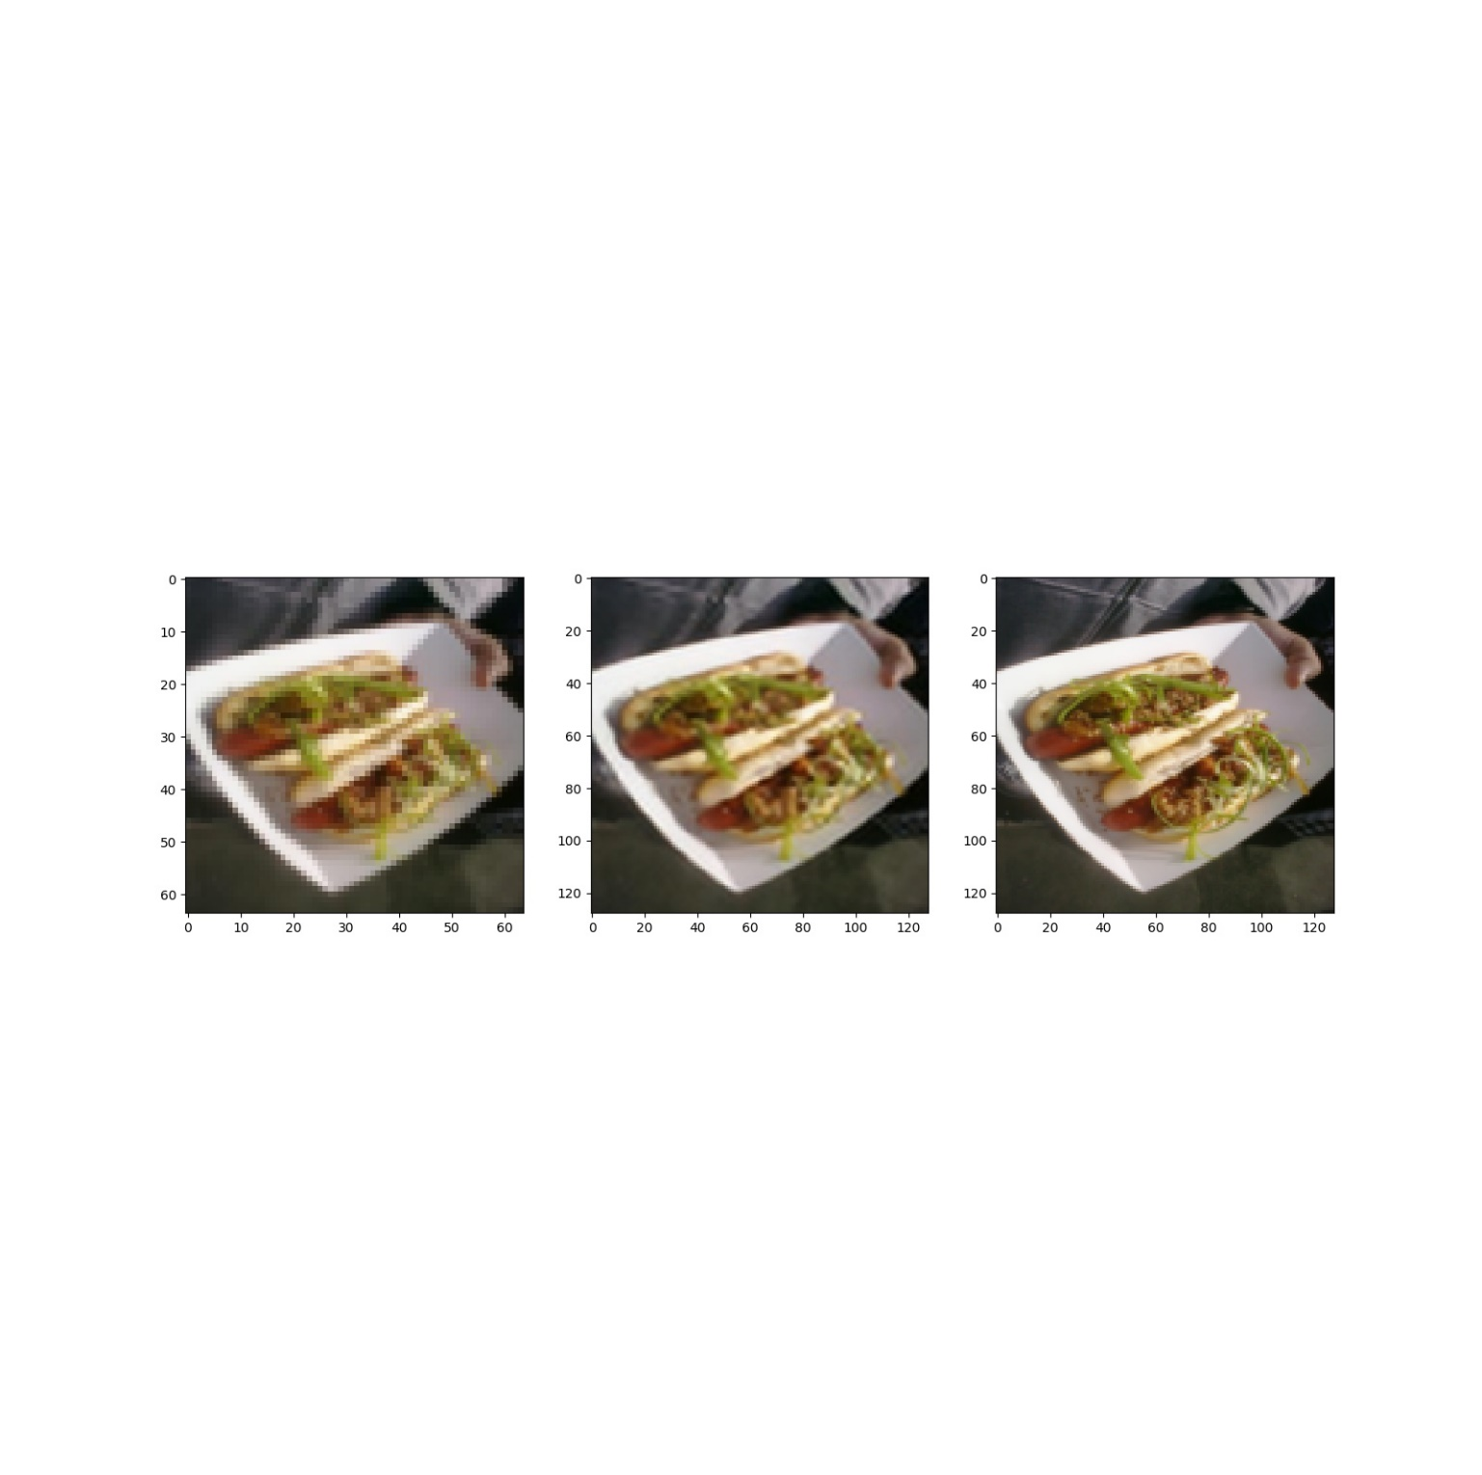

1. **Discussion**

The model make the LR image more smoother such like a bilinear or bicubic interpolation. In addition, compare to those mathematical interpolation method (average PSNR = 27.6) the neural network model infer better for the invisible pixel.

Furthermore, according to the observation, there was a tendency that the image with simple texture shows good performance while the image with complex texture shows bad performance.   
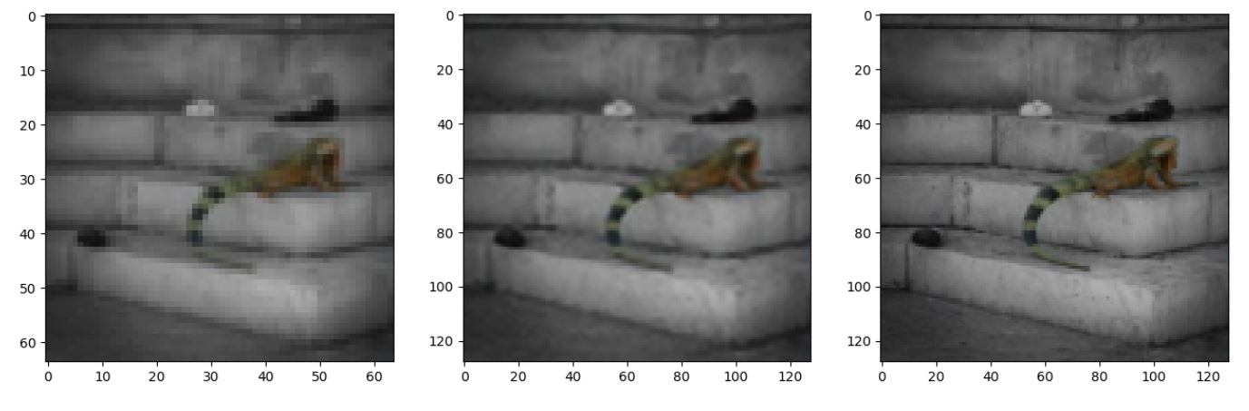

Figure Image with simple texture(#68), PSNR = 35.0, SSIM = 0.969

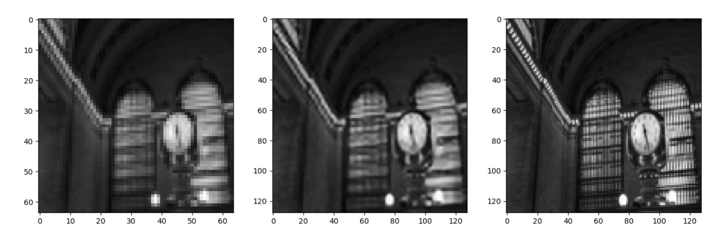

Figure Image with complex texture(#98), PSNR = 24.8, SSIM = 0.907

Question.

1. Do we know the ? If we don’t, where are we heading for?  
   1. No. we are not knowing the exact function that we should head for. In practically, we are just adding a skip connection on the network so we get the ­­ as a result. So don’t take the explanations on the 3.1 too much seriously.
2. Are they saying lots of layers need the identity mapping function?