Midterm Exams￼￼

Theoretical Phonology: Suprasegmental Phonology

Name____________________________ Surname ____________________________

1. Decide whether the final sound of the following words is voiced (V) or voiceless (VSL) (20 marks)

set________ use (noun)________ he plays ________ they breath _______ club _______ off_______ buzz_______ use (verb) ________ teeth _______ rule _______

1. Choose the sound, which differs in its place of articulation from the others (10 marks)
2. [t d s ʃ l] (b) [ɸ p f b m] (c) [k c ɣ ɡ ŋ x]

________________________________________________________________________________________________________________________________________________________________________________________________________________________________________________________________________________________________________________________________________________________________________________________

a.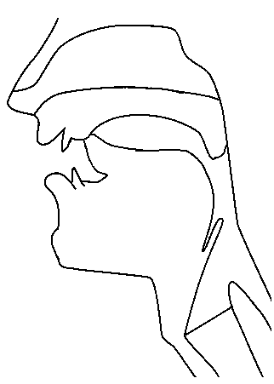 b. 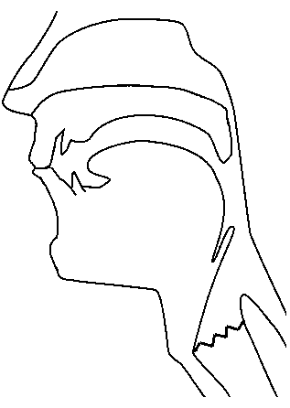

1. Which sounds do productions in figures a. and b. represent (20 marks)?

___________________________________________________________________________________________________________________________________________________________________________________________________________________________________________________________________________________________________________________________________________________________________________________________________________________________________________________________________________________________

The morpheme /z/ indicates plural forms in English but it is realized in different ways. Describe these different ways. Which is the main difference between the environments that trigger the different realizations of /s/? (20 marks)

|  |  |  |
| --- | --- | --- |
| Singular | Plural | IPA |
| Breath | breaths | [ˈbrɛθs] |
| Coast | Coasts | [ˈkəʊsts] |
| Hen | Hens | [ˈhɛnz] |
| Idea | ideas | [ʌɪˈdɪəz] |
| Kite | kites | [ˈkʌɪts] |
| Song | Songs | [ˈsɒŋz] |

__________________________________________________________________________________________________________________________________________________________________________________________________________________________________________________________________________________________________________________________________________________________________________________________________________________________________________________________________________________________________________________________________________________________________________________________

4. Transcribe the following text (20 marks)

Changing the entire food system is a big and complicated issue. But changing your own relationship to food is just as important — and more easily addressed.

__________________________________________________________________________________________________________________________________________________________________________________________________________________________________________________________________________________________________________________________________________________________________________________________________________________________________________________________________________________________________________________________________________________________________________________________

5. In what way ingressive and the eggressive sounds differ? (10 marks)

__________________________________________________________________________________________________________________________________________________________________________________________________________________________________________________________________________________________________________________________________________________________________________________________________________________________________________________________________________________________________________________________________________________________________________________________