**Animation**

* Animation means giving life to any object in computer graphics.
* Some typical applications of computer-generated animation are entertainment (motion pictures and cartoons), advertising, scientific and engineering studies, and training and education.
* Although we tend to think of animation as implying object motions,
* the term computer animation generally refers to any time sequence of visual changes in a scene.
* In addition to changing object position with translations or rotations, a computer-generated animation could display time variations in object size, color, transparency, or surface texture.
* Advertising animations often transition one object shape into another: for example, transforming a can of motor oil into an automobile engine.
* Computer animations can also be generated by changing camera parameters, such as position, orientation, and focal length.
* And we can produce computer animations by changing lighting effects or other parameters and procedures associated with illumination and rendering.
* Many applications of computer animation require realistic displays.
* An accurate representation of the shape of a thunderstorm or other natural phenomena described with a numerical model is important for evaluating the reliability of the model also **,**
* simulators for training aircraft pilots and heavy-equipment operators must produce reasonably accurate representations of the environment.
* Entertainment and advertising applications, on the other hand, are sometimes more interested in visual effects. Thus, scenes may be displayed with exaggerated shapes and unrealistic motions and transformations.
* There are many entertainment and advertising applications that do require accurate representations for computer-generated scenes.

**DESIGN OF ANIMATION SEQUENCES**

In general, an animation sequence is designed with the following steps:

* Storyboard layout:
* Object definitions
* Key-frame specifications
* Generation of in-between frames

**Storyboard layout**

* The ***storyboard*** is an outline of the action. It defines the motion sequence **as** a

set of basic events that ***are*** to take place.

* Depending on the **type** of animation to be produced, the storyboard could consist of a **set** of rough sketches or it could be a list of the basic ideas for the motion.

**Object definitions**

* An ***object definition*** is given for each participant in the action.
* Objects can be defined in terms of basic shapes, such as polygons or splines. In addition, the associated movements for each object **are** specified along with the shape.

**Key-frame specifications**

* **A keyframe** is a detailed drawing of the scene at a **certain** time in the animation sequence.
* Within each key frame, each object is positioned according to the time for that frame.
* Some key frames are chosen at extreme positions in the action; others are spaced **so** that the time interval between key frames is not *too* great.
* More key frames are specified for intricate motions than for simple, slowly varing motions.

**Generation of in-between frames**

* ***In-between frames*** are the intermediate frames between the key frames.
* The number of in-betweens frames needed is determined by the media to be used to display the animation.
* Film requires 24 frames per second, and graphics terminals are refreshed at the rate of ***30*** to **60** frames per second.
* Typically, time intervals for the motion are **set** up so that there ***are*** from three to five in-betweens for each pair of key frames.
* Depending on the speed specified for the motion, some key frames can **be** duplicated.
* For a 1-minute film sequence with no duplication, we would need 1440 frames. With five in-betweens for each pair of key frames, we would **need** 288 key frames

**Animation Techniques**

Animators have invented and used a variety of different animation techniques. Basically there are six animation technique.

**Traditional Animation frame by frame**

* Traditionally most of the animation was done by hand.
* All the frames in an animation had to be drawn by hand.
* Since each second of animation requires 24 frames film, the amount of efforts required to create even the shortest of movies can be tremendous.

### Key framing

* In this technique, a storyboard is laid out and then the artists draw the major frames of the animation.
* Major frames are the ones in which prominent changes take place.
* They are the key points of animation.
* Keyframing requires that the animator specifies critical or key positions for the objects.
* The computer then automatically fills in the missing frames by smoothly interpolating between those positions.

### Procedural

* In a procedural animation, the objects are animated by a procedure − a set of rules − not by key framing.
* The animator specifies rules and initial conditions and runs simulation.
* Rules are often based on physical rules of the real world expressed by mathematical equations.

### Behavioral

* In behavioral animation, an autonomous character determines its own actions, at least to a certain extent.
* This gives the character some ability to improvise, and frees the animator from the need to specify each detail of every character's motion.

### Performance Based Motion Capture

* Another technique is Motion Capture, in which magnetic or vision-based sensors record the actions of a human or animal object in three dimensions. A computer then uses these data to animate the object.
* This technology has enabled a number of famous athletes to supply the actions for characters in sports video games.
* Motion capture is pretty popular with the animators mainly because some of the commonplace human actions can be captured with relative ease.
* However, there can be serious discrepancies between the shapes or dimensions of the subject and the graphical character and this may lead to problems of exact execution.

### Physically Based Dynamics

* Unlike key framing and motion picture, simulation uses the laws of physics to generate motion of pictures and other objects.
* Simulations can be easily used to produce slightly different sequences while maintaining physical realism.
* Secondly, real-time simulations allow a higher degree of interactivity where the real person can maneuver the actions of the simulated character.

## Key Framing

* A keyframe is a frame where we define changes in animation. Every frame is a keyframe when we create frame by frame animation. When someone creates a 3D animation on a computer, they usually don’t specify the exact position of any given object on every single frame. They create keyframes.
* Keyframes are important frames during which an object changes its size, direction, shape or other properties. The computer then figures out all the in-between frames and saves an extreme amount of time for the animator. The following illustrations depict the frames drawn by user and the frames generated by computer.

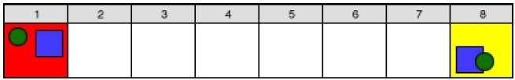

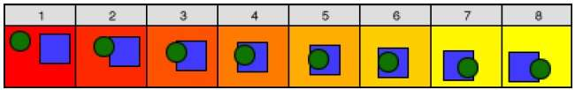

## Morphing

The transformation of object shapes from one form to another form is called morphing. It is one of the most complicated transformations.

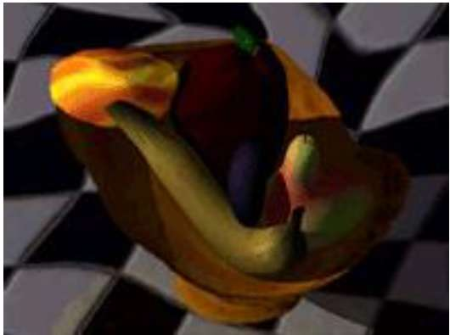

A morph looks as if two images melt into each other with a very fluid motion. In technical terms, two images are distorted and a fade occurs between them.