Personal Finance Power BI Dashboard Report

# 1. Introduction

This report provides an overview of a personal finance tracking system built in Power BI. The dashboard visualizes income, expenses, savings, and net worth trends over a four-year period. It helps in making data-driven financial decisions by offering insights on spending behavior, investment patterns, and monthly savings.

# 2. Expense Overview

The following chart displays categorized monthly expenses from January 2018 to January 2021. Major categories include EMIs, Groceries & Food, Health, House Rent, Leisure, and Shopping.

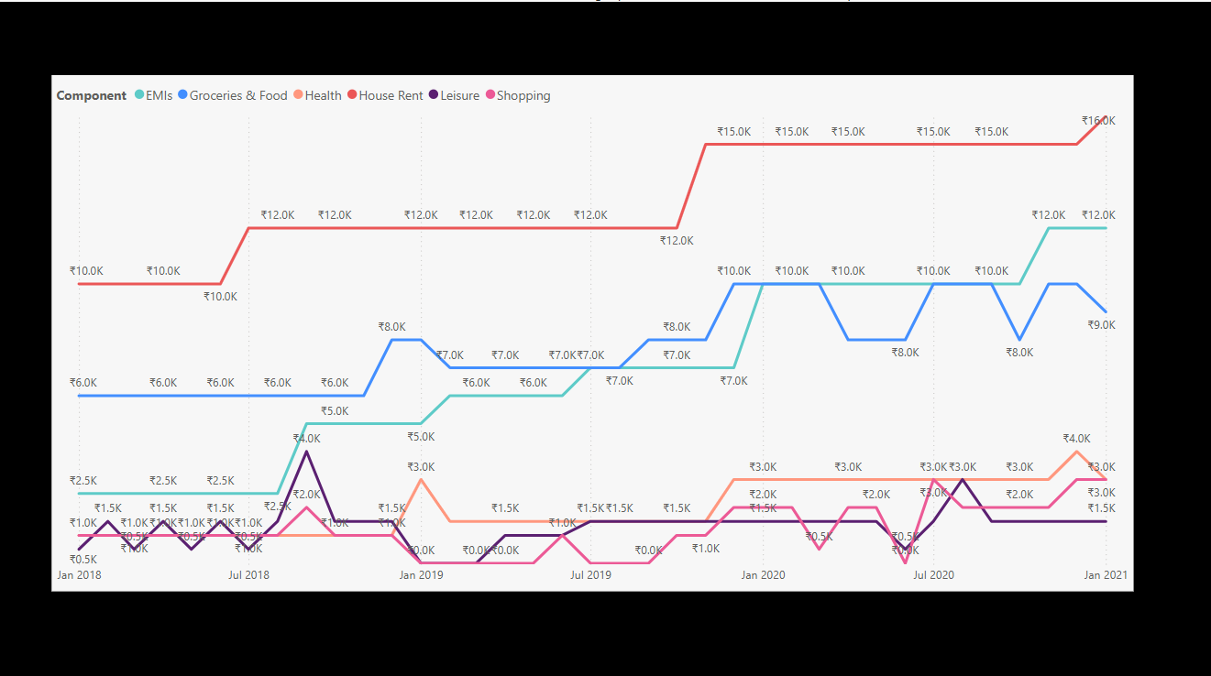

# 3. Net Worth Trend

This chart represents the cumulative net worth trend. It shows consistent growth with a noticeable increase post mid-2019.

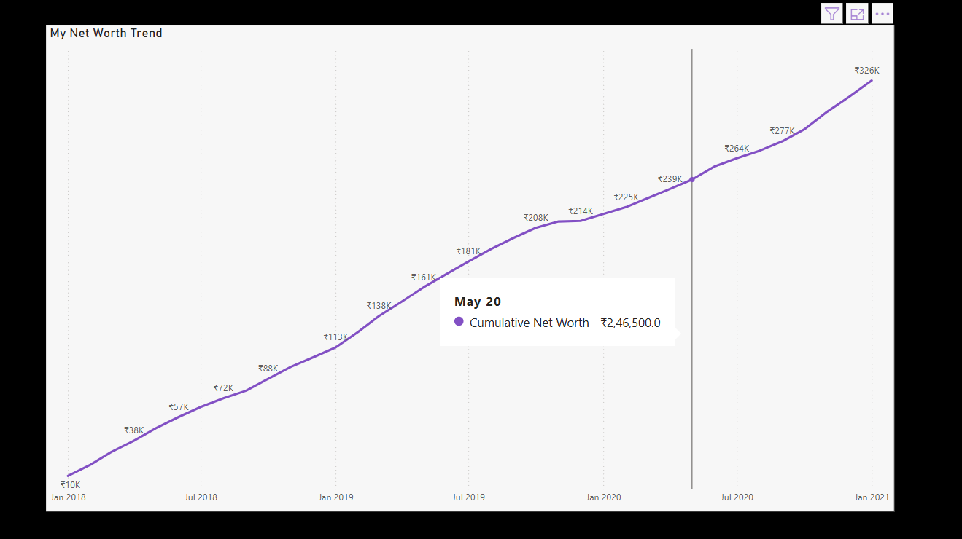

# 4. Dashboard Summary

The dashboard provides key metrics such as total income, expense percentage, savings percentage, and net worth. It breaks down income and expense by source/type and shows spending/saving behaviors in graphical form.

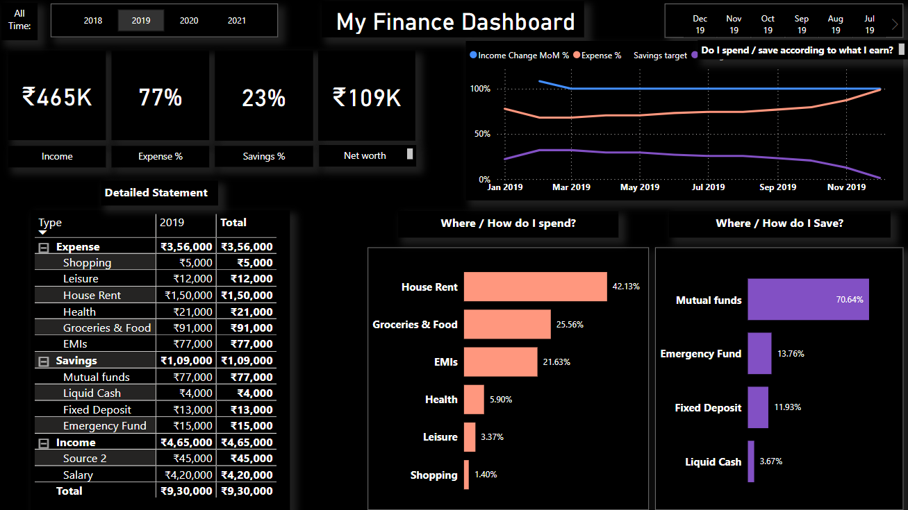

# 5. Savings Analysis

Savings are broken into categories: Mutual Funds, Emergency Fund, Fixed Deposit, and Liquid Cash. This line chart tracks these savings vehicles over time.

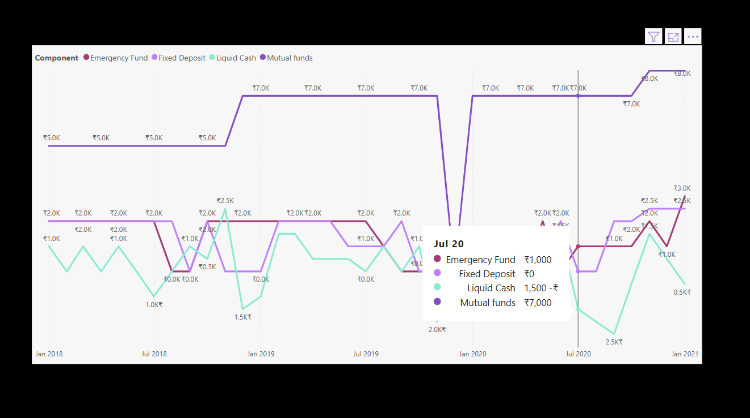

# 6. Income vs Expense vs Savings %

The chart below compares total income, total expenses, and savings percentage to understand month-over-month performance and trends.

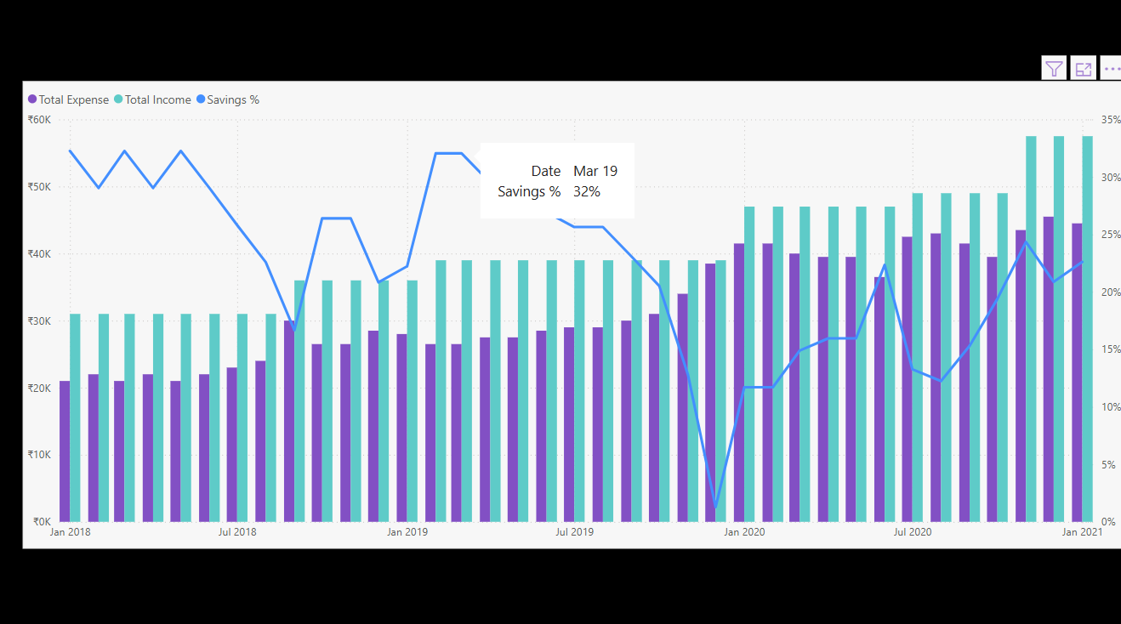

# 7. Conclusion

This Power BI dashboard offers a comprehensive view of personal financial health. By monitoring and comparing various components, one can identify areas for improvement, optimize savings, and plan future investments more efficiently.