ASSIGNMENT NO. 10
Date: 29 March 2026
Title: Cassandra Clustering and IoT Weather Data Management

Objective / Aim
• Set up a multi-node Cassandra cluster on a single Windows machine.
• Configure and monitor the cluster using DataStax OpsCenter.
• Design a distributed database for IoT-based weather station temperature data.
• Demonstrate cluster operations and data handling using OpsCenter.

Introduction
Apache Cassandra is a highly scalable, distributed NoSQL database designed for handling large amounts of data across multiple nodes without a single point of failure. It uses a peer-to-peer architecture where all nodes are equal and communicate with each other.
In this assignment, a multi-node Cassandra cluster is created on a single Windows machine and extended to multiple physical machines. The cluster is monitored using DataStax OpsCenter. A real-world IoT use case is implemented where weather stations send temperature data every 5 minutes to the cluster.

Theory / Algorithms
1. Cassandra Cluster Architecture
• Peer-to-peer distributed system
• No master node (all nodes are equal)
• Data is distributed using partition keys
• Replication ensures fault tolerance

2. Key Concepts
• Node: Individual Cassandra instance
• Cluster: Collection of nodes
• Keyspace: Similar to a database (defines replication strategy)
• Table: Stores structured data
• Partition Key: Determines data distribution
• Replication Factor: Number of copies of data

3. Replication Strategy
• SimpleStrategy (for single data center)
• NetworkTopologyStrategy (for multi-data center)

4. IoT Data Model Design
Weather station sends data every 5 minutes:
Fields:
• weatherStationID
• timestamp
• temperature

5. Query Requirements
System should support:
• Fetch data by station
• Fetch data by time range
• Aggregate temperature trends

Documentation
Cluster Configuration
• Cluster Name: 2026GRP
• Nodes: Multiple nodes on single system + physical machines
• Ports configured uniquely for each node
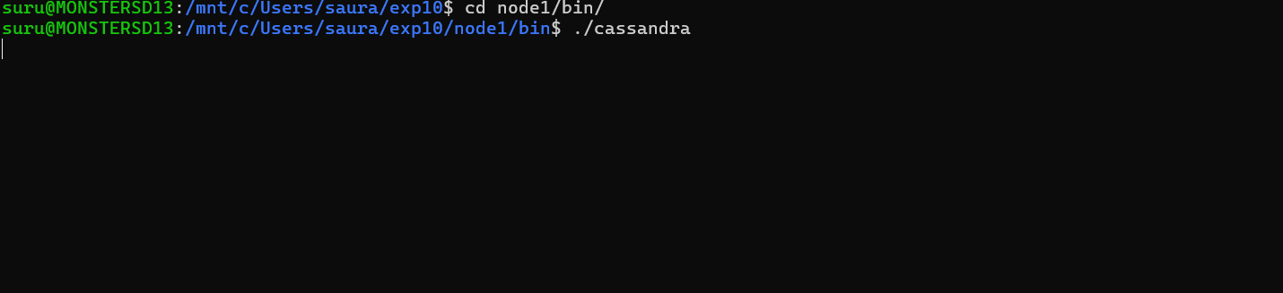
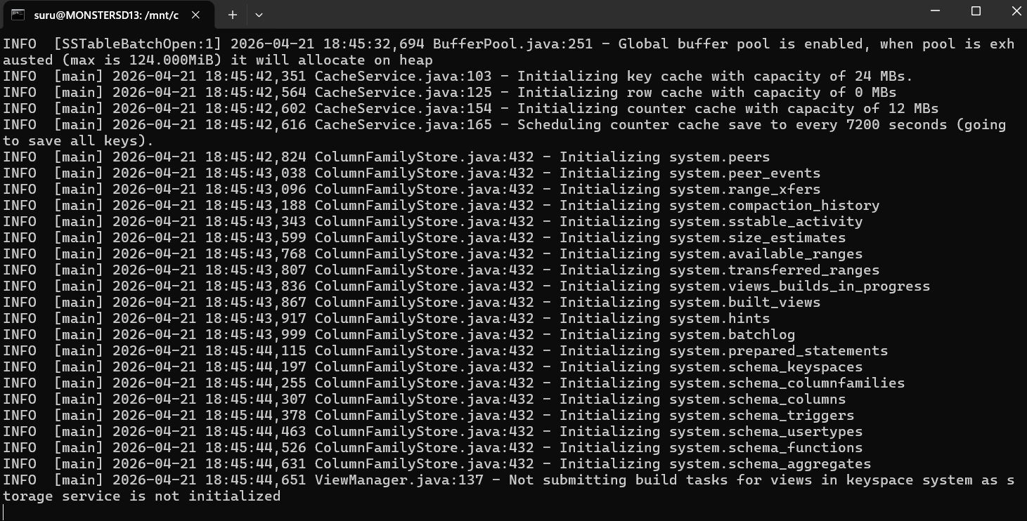

Keyspace Design
CREATE KEYSPACE weather_keyspace
WITH replication = {
'class': 'SimpleStrategy',
'replication_factor': 3
};

Table Design
CREATE TABLE weather_keyspace.temperature_data (
weatherStationID text,
timestamp timestamp,
temperature float,
PRIMARY KEY (weatherStationID, timestamp)
) WITH CLUSTERING ORDER BY (timestamp DESC);

Why This Design?
• Partition key → weatherStationID (data distributed across nodes)
• Clustering key → timestamp (efficient time-based queries)
• Optimized for high write throughput

Procedure
Part 1: Cassandra Cluster Setup (Single Machine)
- Download and install Apache Cassandra.
- Create multiple Cassandra instances (nodes).
- Configure each node:
• Change ports (storage, RPC, JMX)
• Set unique data directories
- Edit cassandra.yaml:
• Set cluster_name = 2026GRP
• Configure seeds (first node as seed)
- Start all Cassandra nodes.
- Verify cluster using:
nodetool status

Part 2: Multi-Machine Cluster Setup
- Install Cassandra on 3+ lab machines.
- Configure same cluster name (2026GRP).
- Add seed node IP addresses.
- Start nodes and verify connectivity.

Part 3: Install DataStax OpsCenter
- Download OpsCenter Community Edition.
- Install and start OpsCenter service.
- Open browser:
http://localhost:8888
- Add Cassandra cluster.
- Monitor nodes, metrics, and performance.

Part 4: Insert IoT Data
INSERT INTO weather_keyspace.temperature_data
(weatherStationID, timestamp, temperature)
VALUES ('WS101', toTimestamp(now()), 28.5);

Part 5: Query Data
SELECT * FROM weather_keyspace.temperature_data
WHERE weatherStationID = 'WS101';
SELECT * FROM weather_keyspace.temperature_data
WHERE weatherStationID = 'WS101'
AND timestamp > '2026-03-29 10:00:00';

Actual Experiments / Results / Observations
• Multi-node Cassandra cluster successfully created on a single machine.
• Cluster expanded to multiple physical machines with proper communication.
• Data replication ensured fault tolerance across nodes.
• OpsCenter dashboard displayed:
• Node health
• CPU usage
• Read/write latency
• Data insertion from IoT simulation worked efficiently.
• Queries executed quickly due to optimized partitioning.
• System handled continuous data ingestion without performance issues.
• Cluster remained operational even when one node was stopped.

Conclusion
The Cassandra cluster was successfully implemented and scaled across multiple nodes. The system demonstrated high availability, fault tolerance, and efficient data distribution.
The IoT weather station use case validated Cassandra’s capability to handle high-frequency time-series data. OpsCenter provided effective monitoring and management of the cluster, making it easier to visualize performance and health.
This assignment highlights the strength of distributed databases in handling real-time, large-scale data systems.

References
• Apache Cassandra Documentation – https://cassandra.apache.org/doc/
• DataStax OpsCenter Guide – https://docs.datastax.com/en/opscenter/
• Cassandra Query Language (CQL) – https://cassandra.apache.org/doc/latest/cql/
• Distributed Systems Concepts – https://martinfowler.com/articles/

