ASSIGNMENT NO. 11
Date: 12 April 2026
Title: Neo4j Graph Database: Research Papers Citation Network using Angular
Objective / Aim
- Design and model a graph database using Neo4j for a "Research Papers Database" scenario.
- Process and load the Cora Research Paper Classification dataset (approx. 25,000 authors, 37,000 papers, and 220,000 relationships) into Neo4j.
- Implement a responsive Angular frontend to execute and visualize complex graph queries, such as transitive citation paths and hierarchical classifications.
Introduction
A Graph Database relies on nodes, relationships, and properties to represent highly interconnected data. This assignment focuses on building a Research Papers Citation Network using Neo4j. Unlike traditional relational databases, graph databases excel at traversing deep relationships, such as finding if a paper cites another paper through multiple intermediate references.
Built with an Angular frontend, the neo4j-driver for database communication, and Neo4j as the backend graph engine, the portal demonstrates modern graph data modeling, Cypher querying, and web integration.
Theory / Algorithms
- Graph Data Modeling
  - Nodes: Represent entities in the network.
    - Paper (Properties: id, title)
    - Author (Properties: id, name)
    - Classification (Properties: id, name)
  - Relationships: Represent connections between nodes.
    - (Author)-[:WROTE]->(Paper)
    - (Paper)-[:CITES]->(Paper)
    - (Paper)-[:BELONGS_TO]->(Classification)
- Data Ingestion & Constraints
  - Constraints: Creating UNIQUE constraints on paper_id, author_id, and class_id ensures data integrity and dramatically speeds up node lookups.
  - LOAD CSV: Using Cypher's LOAD CSV WITH HEADERS algorithm to parse structured flat files and incrementally build the graph using the MERGE command to prevent duplicates.
- Cypher Query Language (CQL)
  - Shortest Path / Transitive Queries: Using shortestPath((a)-[:CITES*]->(b)) to find if Paper A cites Paper B directly, or indirectly across several levels of separation.
  - Pattern Matching: Utilizing MATCH to traverse the BELONGS_TO relationship to extract paper categories.
- Client-Database Communication
  - Angular application connects directly to the Neo4j backend using the official neo4j-driver via the Bolt protocol (neo4j://localhost:7687).
  - Frontend sends parameterized Cypher queries to prevent injection and optimize execution plans.
Documentation
Database Schema (Neo4j Graph Model)
Nodes:
- Paper: { paper_id: string (unique identifier), title: string }
- Author: { author_id: string (unique identifier), name: string }
- Classification: { class_id: string (unique identifier), name: string }
Relationships:
- [:CITES]: Connects a Paper to a Paper
- [:WROTE]: Connects an Author to a Paper
- [:BELONGS_TO]: Connects a Paper to a Classification
Database Name: neo4j (Local DBMS)
Procedure
- Download and extract the raw Cora dataset.
- Execute a Python script to clean the raw data and generate relational CSV files (papers.csv, authors.csv, cites.csv, wrote.csv, classifications.csv, belongs_to.csv).
- Move the generated CSV files into the local Neo4j DBMS import directory.
- Start the Neo4j database on localhost:7687.
- Execute Cypher constraints (CREATE CONSTRAINT...) in the Neo4j Browser.
- Execute LOAD CSV commands to populate the graph nodes and wire the relationships.
- Initialize the Angular frontend project and install the neo4j-driver dependency.
- Configure the Angular neo4j.service.ts to connect to the database using basic authentication.
- Start the Angular development server on port 4200.
- Use the Angular UI form to test multi-level citation paths, classification lookups, and author queries.
Actual Experiments / Results / Observations
- Python data processing successfully converted raw text into clean, structured CSV mappings suitable for graph ingestion.
- Cypher queries effectively loaded thousands of nodes and relationships; the UNIQUE constraints successfully prevented duplicate entity creation during the MERGE operations.
- Query A Result: The citation path checker successfully utilized the shortestPath function to determine if Paper A cited Paper B, accurately returning the depth (e.g., 2 levels deep) of the transitive dependency.
- Query B Result: The classification search accurately returned the assigned topic string for the queried research paper.
- Query C Result: The user-defined query successfully traversed the WROTE relationship to aggregate and list all paper titles belonging to a specific author.
- The Angular UI handled asynchronous database promises correctly, updating the view dynamically without requiring a page refresh.
Screenshots
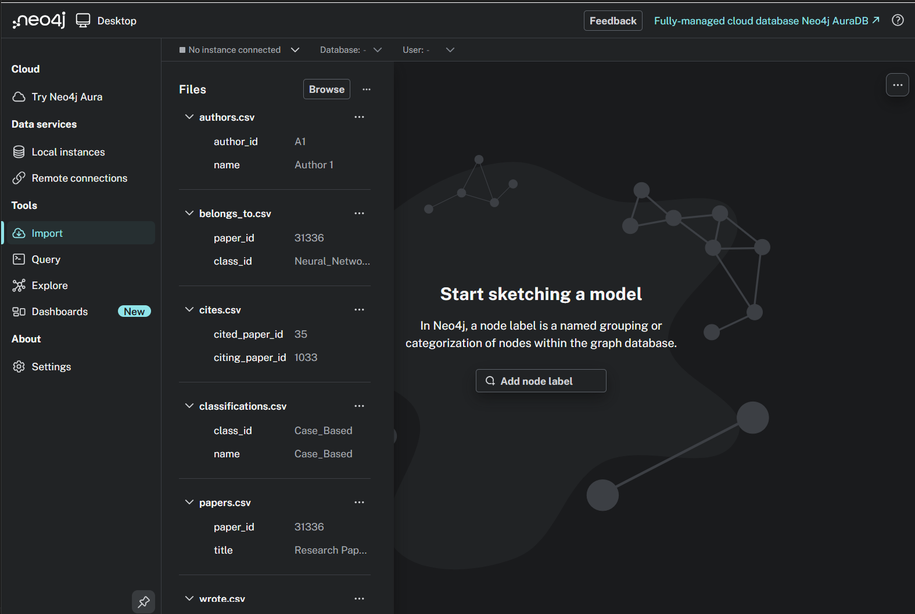
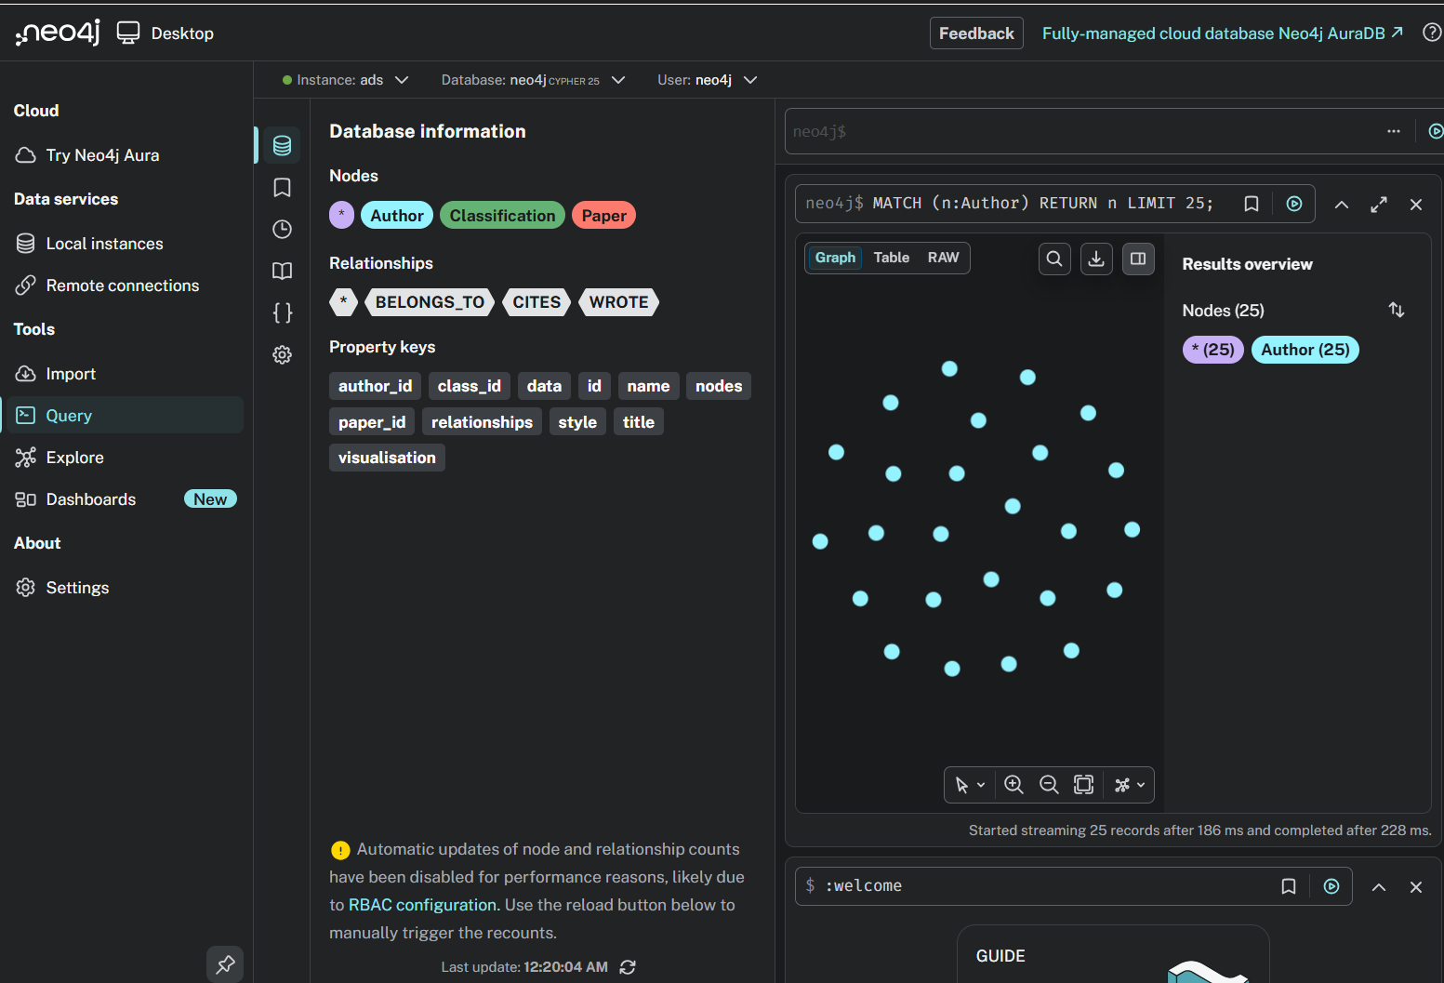
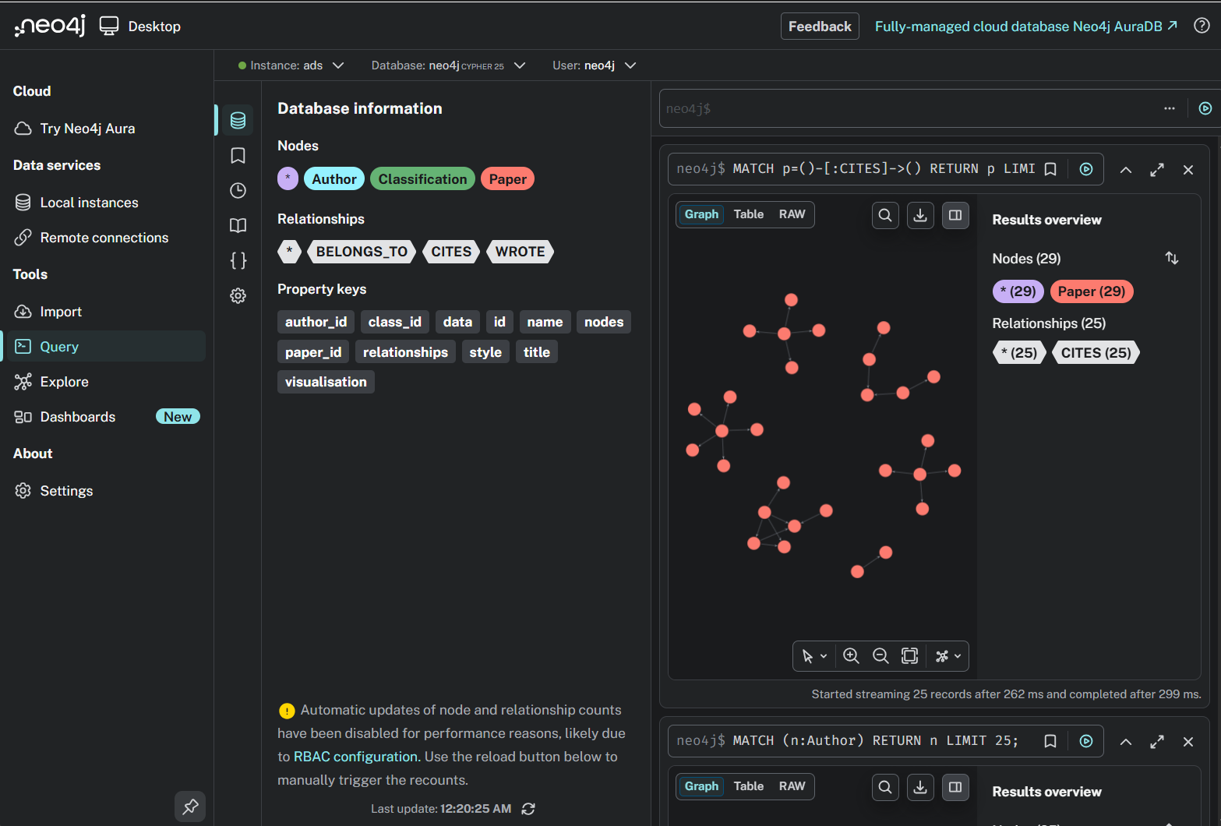
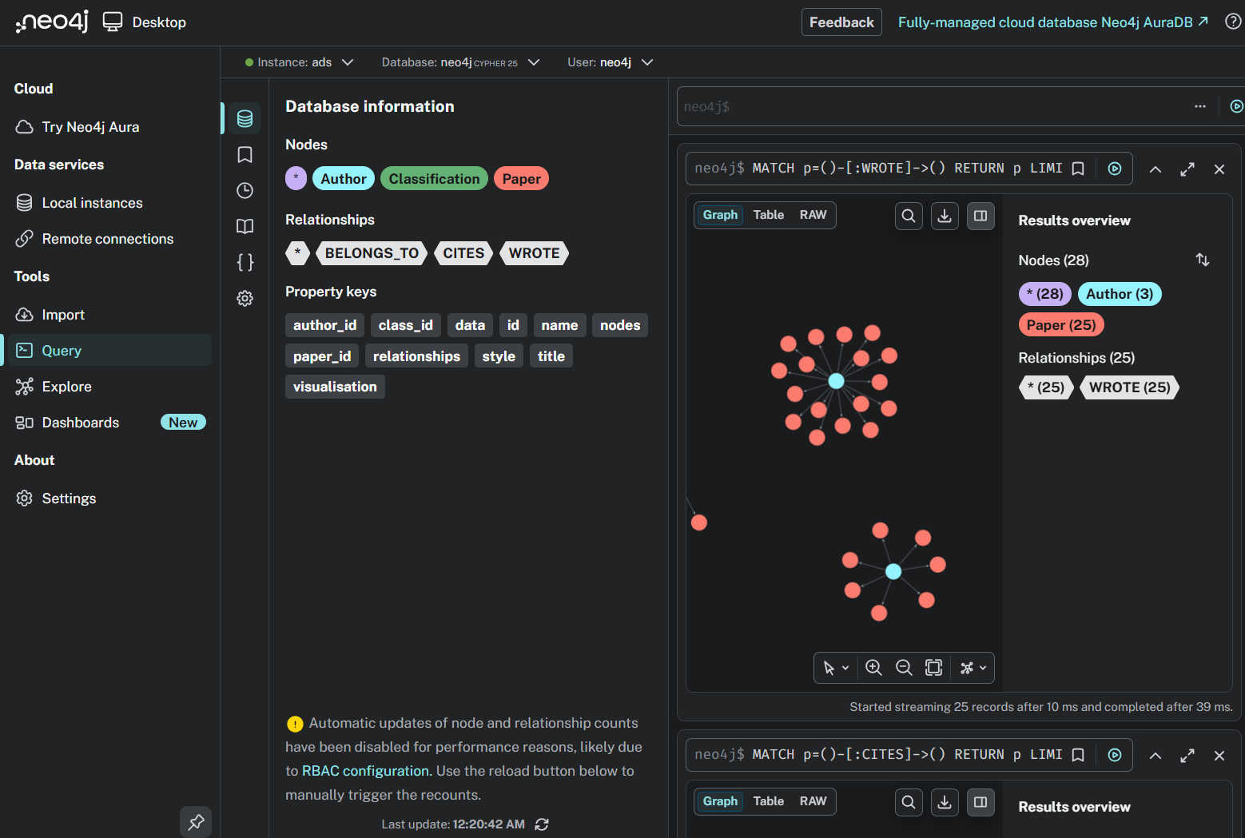


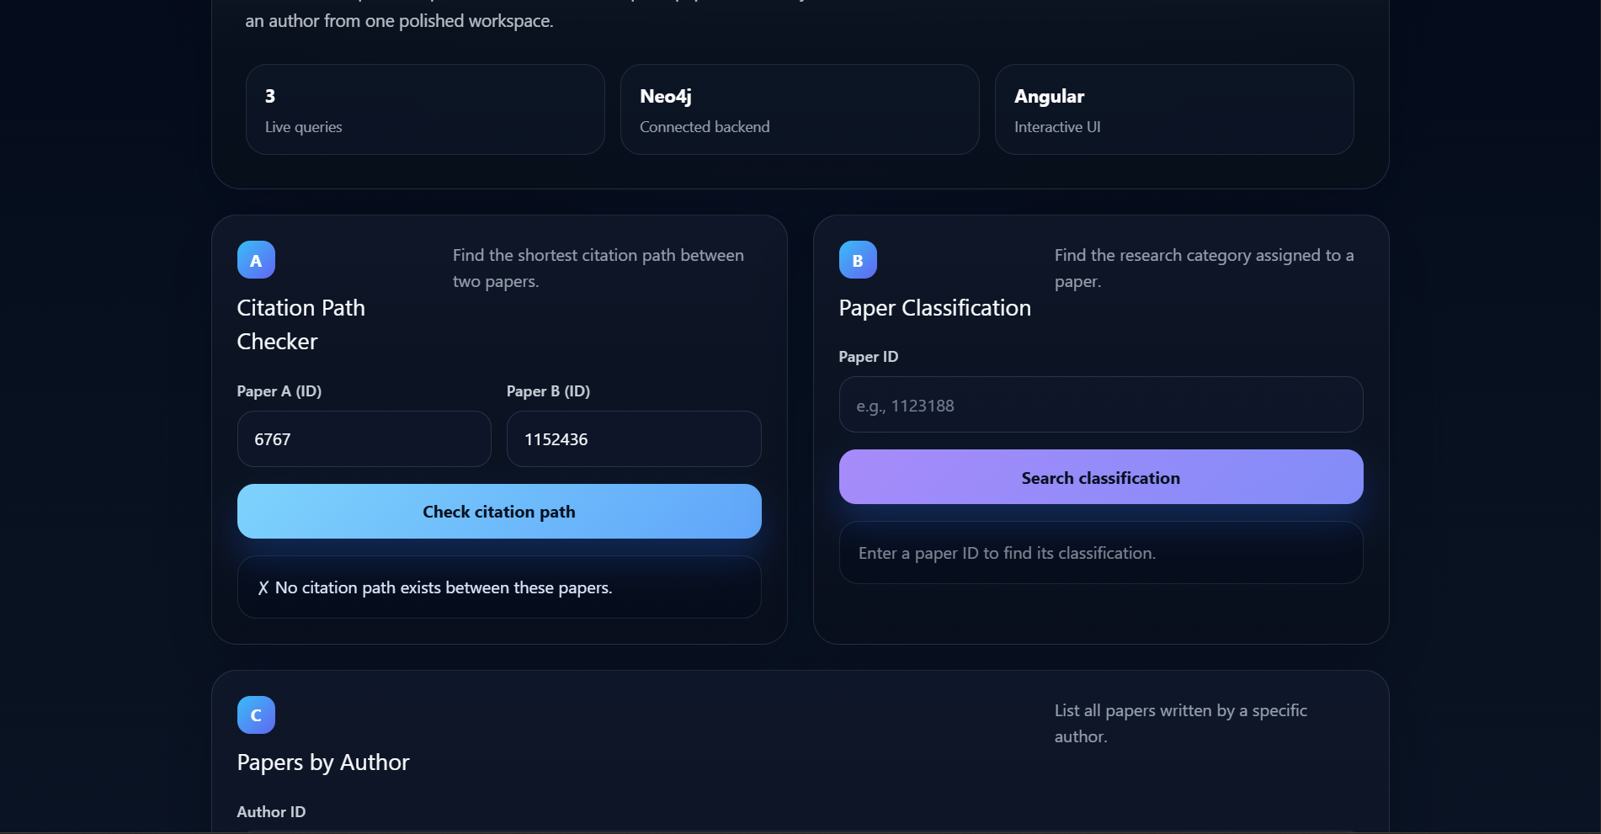

Conclusion
The assignment successfully demonstrates the power of graph databases in modeling highly interconnected data like academic citations. By leveraging Neo4j and Cypher, complex transitive queries (like multi-level citations) that would require slow, computationally expensive JOIN operations in a relational database were executed almost instantly. The integration of an Angular frontend proved the viability of building responsive, interactive, graph-driven web applications using the MERN-equivalent stack for graph tech.
References
- Neo4j Cypher Manual – https://neo4j.com/docs/cypher-manual/current/
- Angular Official Documentation – https://angular.dev/
- Neo4j JavaScript Driver – https://www.npmjs.com/package/neo4j-driver
- Cora Research Dataset – https://linqs.org/datasets/#cora

