Assignment No. 3
Date: 10 February 2026
Title: Web-enabled Student MIS (Management Information System) Portal using Angular 19, NodeJS, PostgreSQL

Objective / Aim:
- Design and implement a role-based Student MIS portal.
- Provide CRUD data entry for all entities.
- Implement a generic report generator to list any table data.

Introduction:
A Student MIS centralizes academic and administrative data in a secure web portal. The system supports multiple roles and provides data entry and reporting on key university entities. The portal uses Angular for the UI, NodeJS for the API, and PostgreSQL as the database.

Theory / Algorithms:
- Authentication & Role Resolution
- On login, the system validates username and password.
- Role is fetched from roles table via users.role_id.
- Role is stored on client to enforce permissions.
- Role-Based Access Control
- Admin and Staff can create, update, and delete records.
- Student is restricted to read-only access.
- Backend checks role from x-role header for write operations.
- Generic CRUD Algorithm
- Validate requested table name against a whitelist.
- Build parameterized queries using predefined field lists.
- Perform INSERT/UPDATE/DELETE and return updated rows.
- Generic Report Generator
- Accepts table name and returns ordered data set.
- Endpoint: /api/report/:table
- Used in UI “Run Report” action.

Documentation:
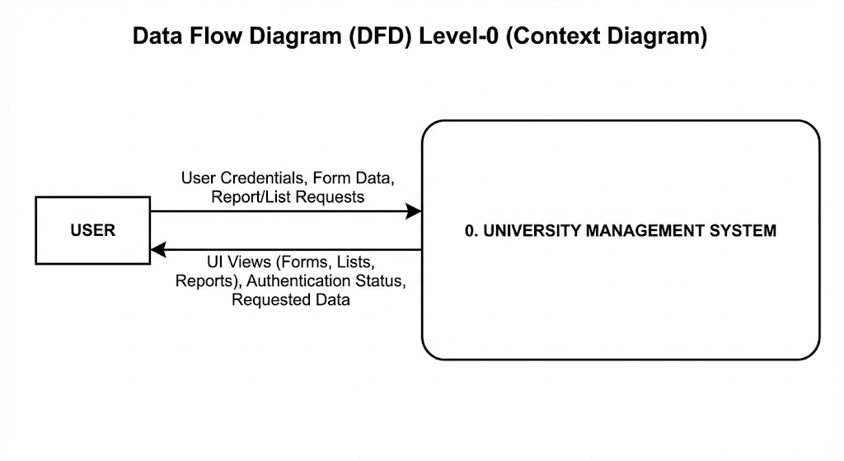
Database Schema (Entities Used)
- roles (id, name)
- users (id, username, password, role_id)
- departments (id, name)
- students (id, roll_no, name, dept_id, year)
- instructors (id, name, dept_id)
- courses (id, code, title, dept_id)
- enrollments (id, student_id, course_id, semester, grade)

Procedure
- Create database and tables using init.sql.
- Start PostgreSQL server.
- Run backend NodeJS server (Express + pg).
- Start Angular 19 frontend.
- Login using default admin/admin credentials.
- Select entity and perform CRUD.
- Use “Run Report” to list any selected entity.
- Verify role-based write restrictions.

Actual Experiments / Results / Observations
- Login successful for admin account.
- CRUD works for all tables (roles, users, departments, students, instructors, courses, enrollments).
- Dropdowns correctly populate for foreign keys (role, department, student, course).
- Reports list data for any selected entity.
- Write access denied for non-admin/staff roles.

Screenshots
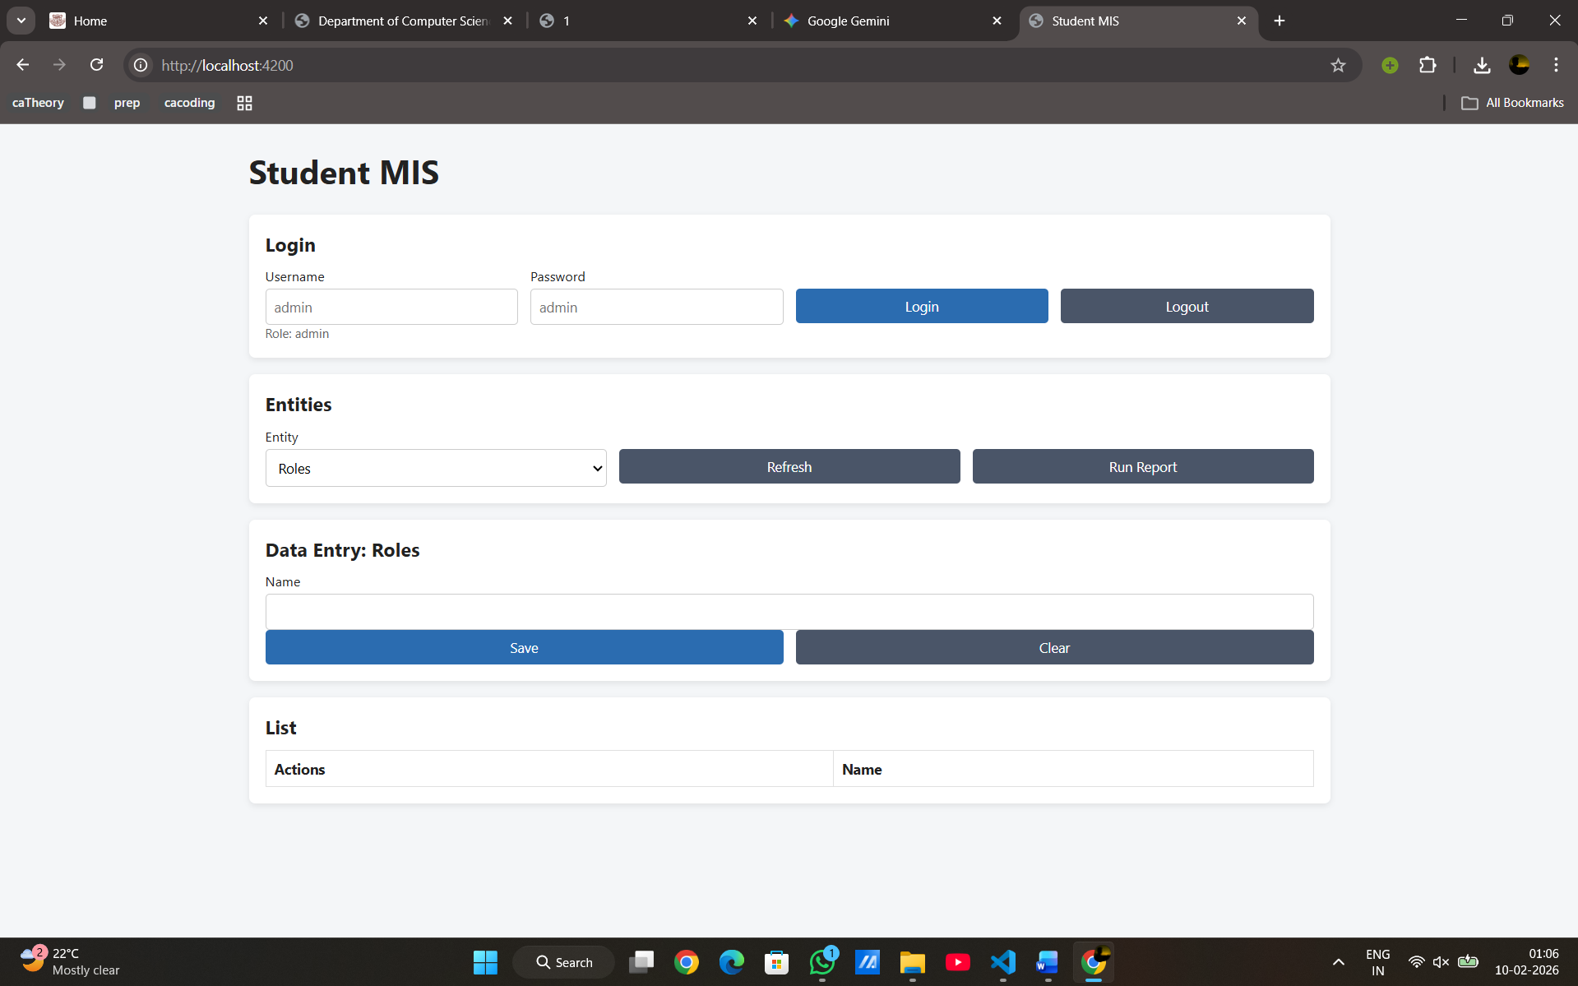
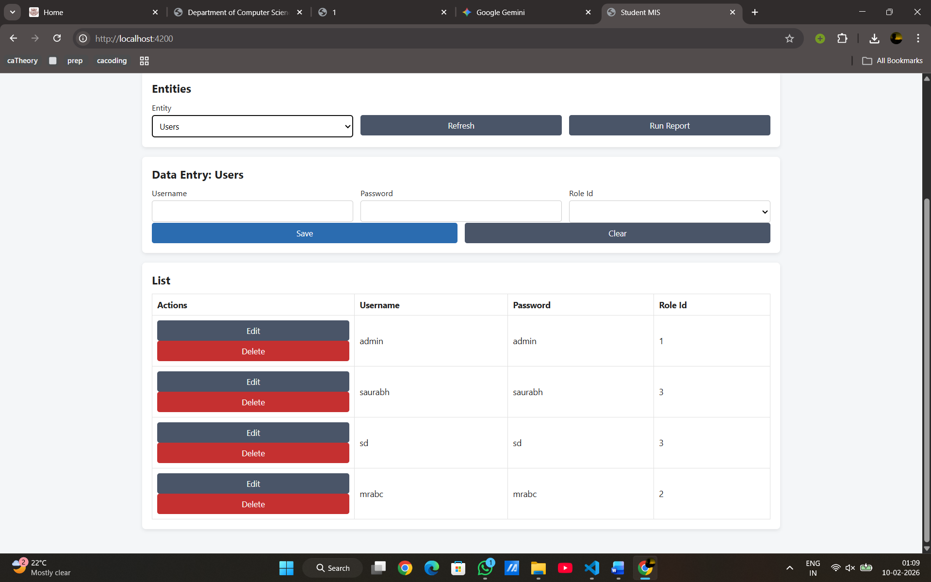

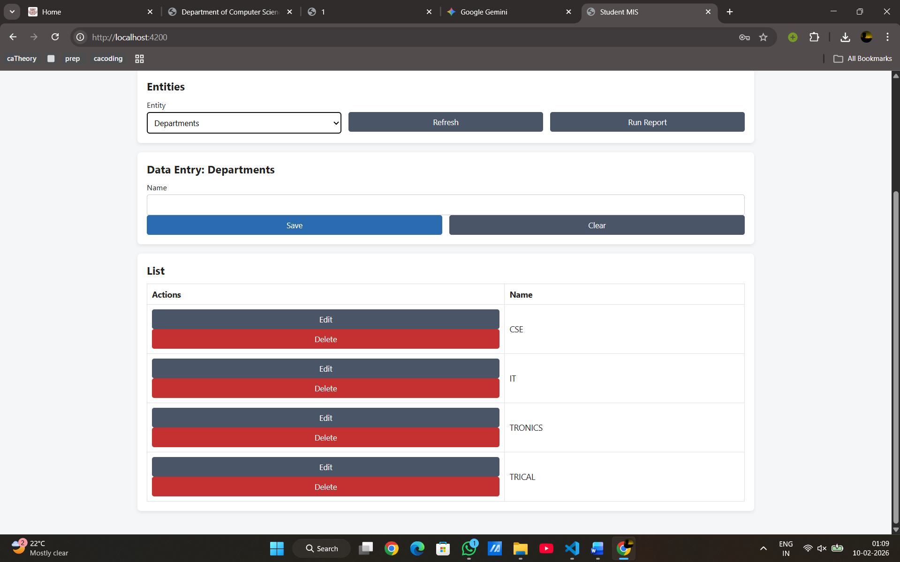

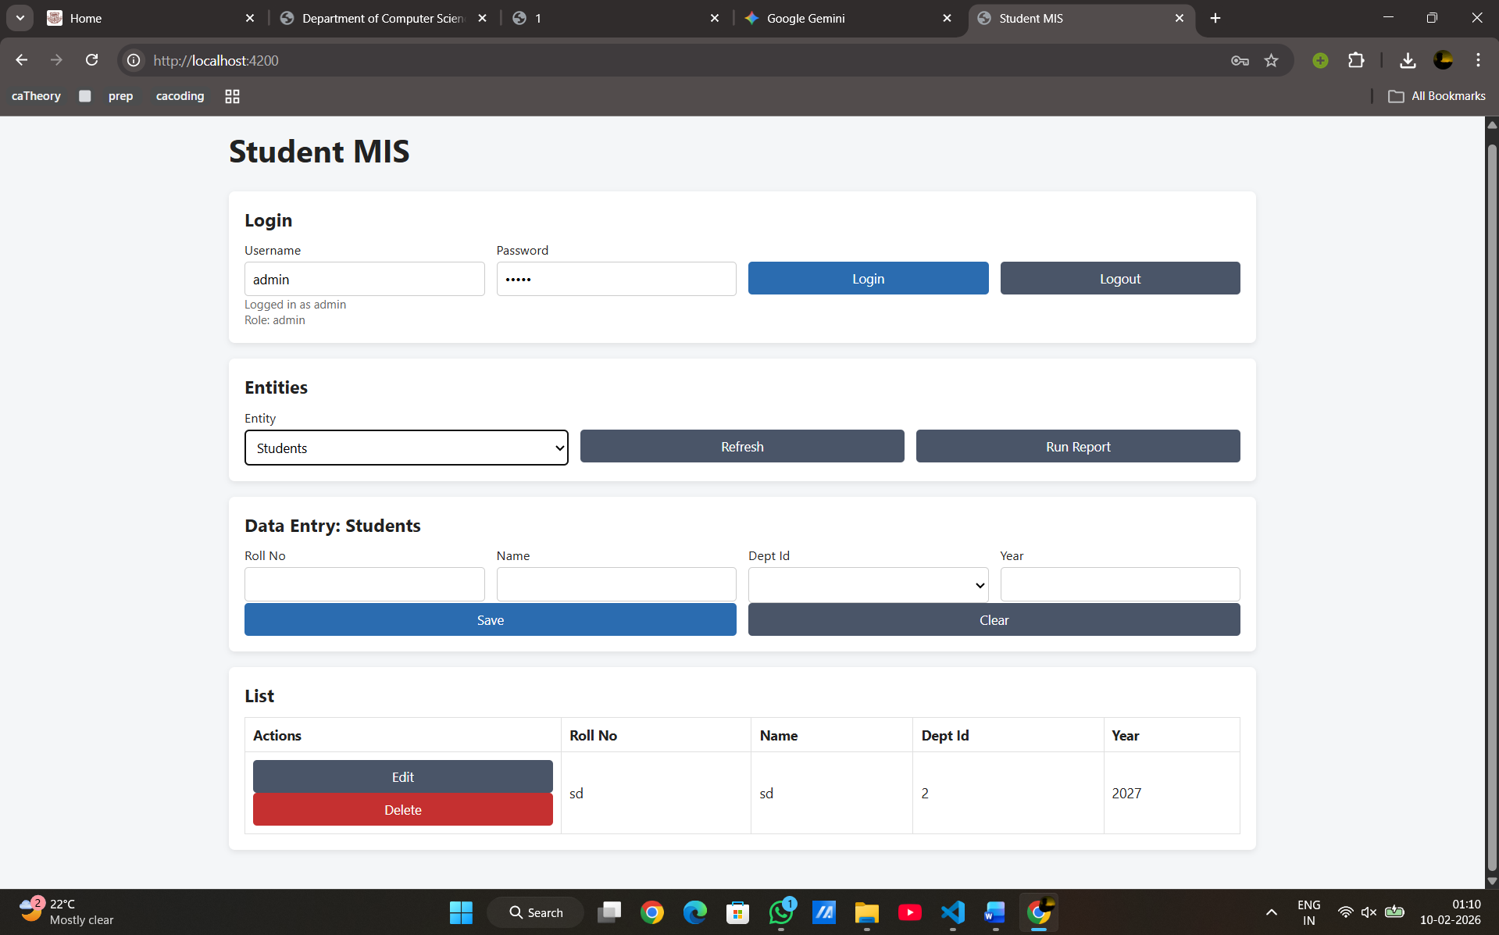

Conclusion
The Student MIS portal is successfully implemented with role-based access, complete CRUD forms for all entities, and a generic report generator. The system meets all assignment requirements using Angular 19, NodeJS, and PostgreSQL.

References
- PostgreSQL Documentation
- Angular 19 Documentation
- NodeJS and Express Documentation

