Assignment No.: 4
Date: 15 February 2026
Title: Design and Implementation of Web-Based Online MCQ Examination System using Angular, Node.js and PostgreSQL

1. Objective / Aim
To design and implement a web-based application for conducting online multiple-choice examinations with role-based access (Teacher/Student), question bank management, exam creation, timed exam execution, and result/report viewing.
2. Introduction
Online examination systems help automate assessment activities such as question management, test scheduling, student participation, and score evaluation. In this assignment, a full-stack MCQ exam platform is developed using Angular (frontend), Node.js/Express (backend), and PostgreSQL (database).
The system supports distributed question contribution and centralized exam control by teachers. Students can take exams online within a defined time limit and receive score feedback immediately after submission or upon timer timeout.
3. Theory / Algorithms
3.1 User Authentication and Role Handling
- Input: Username, password, role (Teacher/Student).
- Process: Credentials are validated via the backend API; the assigned role determines specific dashboard access.
- Output: Authenticated session/JWT user object for authorized operations.
3.2 Question Bank Management Algorithm
- Teacher enters question text, four options (A/B/C/D), and the correct option.
- Backend validates required fields and inserts the record into the PostgreSQL database.
- The question list is fetched and displayed for future exam mapping.
3.3 Exam Creation Algorithm
- Teacher enters the exam title and a specific time limit (in minutes).
- Teacher selects a set of Question IDs from the global question bank.
- Backend creates an exam record and links the selected questions via a mapping table.
3.4 Exam Attempt and Timer Algorithm
- Student selects an available exam.
- The system fetches the full question set and initializes a JavaScript countdown timer.
- If the timer reaches zero, an auto-submit function is triggered.
- Student answers are stored in a temporary state and persisted to the database upon completion.
3.5 Evaluation and Score Calculation
- Logic: Submitted options are compared against the correct options stored in the database.
- Formula:
- Status Update: The attempt status is updated (Ongoing → Completed/Terminated).

4. Functional Block Diagram / Documentation
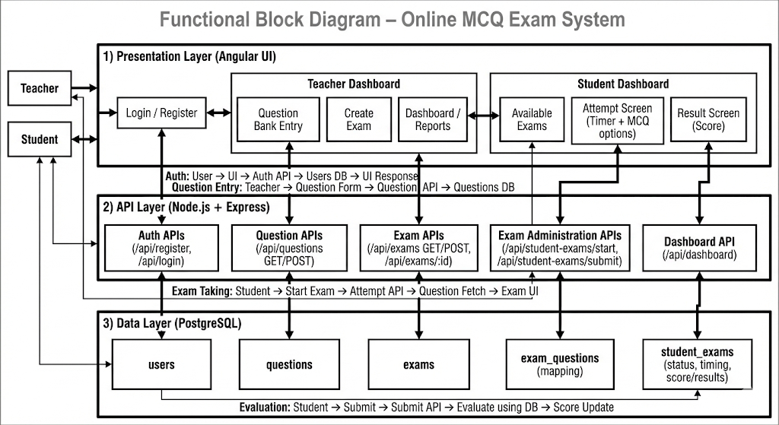
5. Procedure
- Environment Setup: Install PostgreSQL, pgAdmin, Node.js, and Angular CLI.
- Database Design: Execute SQL scripts to create schemas for users, questions, and results.
- Backend Development: Configure Node.js with pg-pool for database connectivity and define Express routes.
- Frontend Development: Build Angular components for Dashboards and the Exam Interface.
- Role Testing: Register separate Teacher and Student accounts.
- Workflow Test: Add questions, create an exam, attempt as a student, and verify the auto-calculated score in the teacher's report.

6. Observations and Results
Experiment | Description | Observation
Exp 1 | User Registration/Login | Role-based routing successfully directs users to the correct dashboard.
Exp 2 | Question Bank Entry | Questions are successfully persisted and displayed in the teacher's list.
Exp 3 | Exam Creation | Exams are correctly mapped to specific questions with a set time limit.
Exp 4 | Student Attempt | The countdown timer functions accurately; questions load sequentially.
Exp 5 | Submission | Score is calculated instantly; status updates to "Completed".
Exp 6 | Teacher Report | Aggregated data (Student name, Exam, Score) appears in the report view.

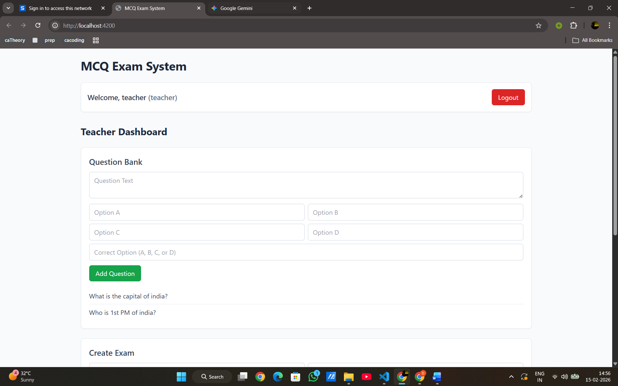
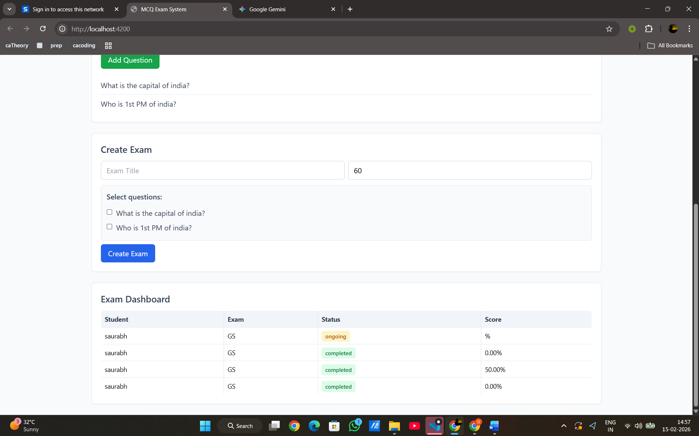
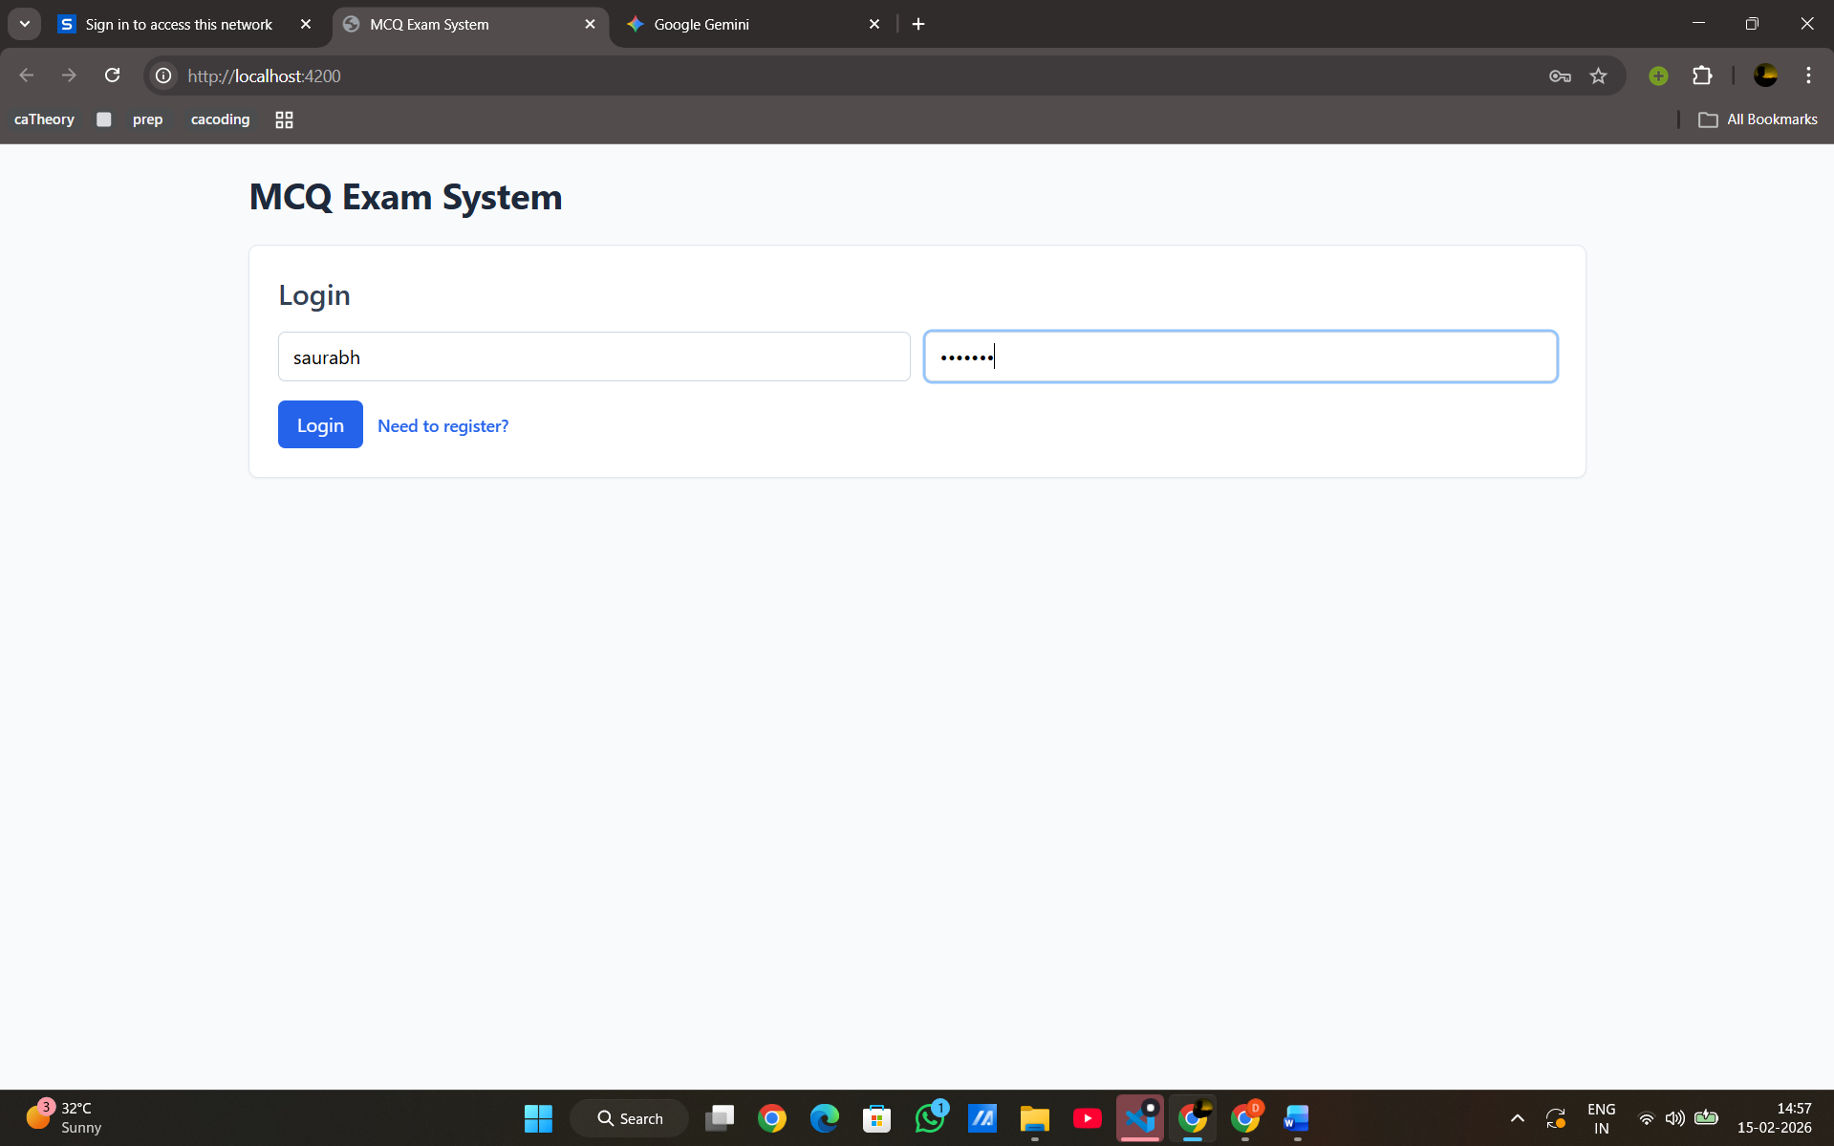
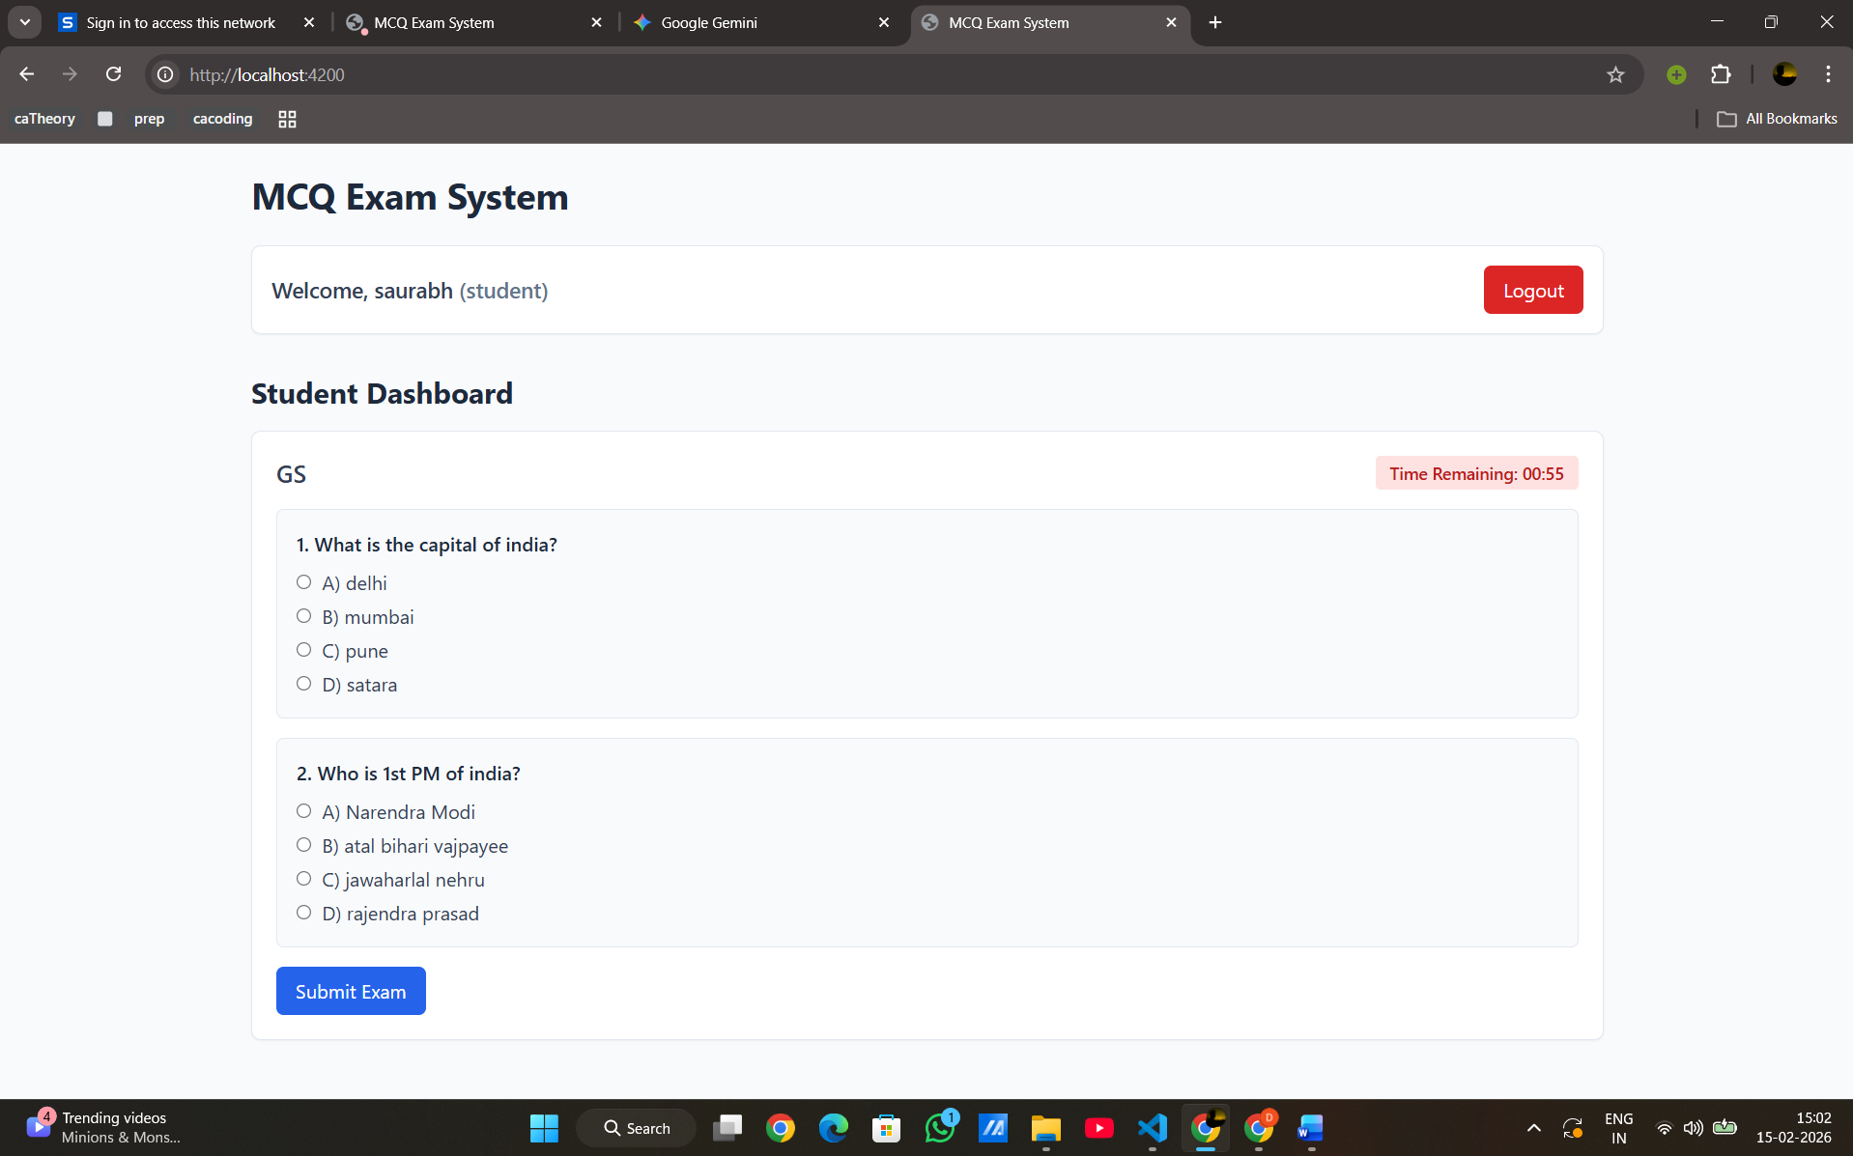

7. Conclusion
The web-based MCQ examination system was successfully implemented. The project demonstrates the practical integration of the PERN stack (PostgreSQL, Express, React/Angular, Node) for educational assessment. The system effectively handles real-time constraints like timers and role-based security.
8. References
- PostgreSQL Official Documentation
- Angular v19 Framework Documentation
- Node.js & Express.js API Reference
- Tailwind CSS Styling Guide

