Advanced Database System Lab (7CS371)
Assignment No. 6
Design and Implementation of Data Warehouse for Customer Order Processing System (Using PostgreSQL)

1. Introduction
Objective
The objective of this project is to design and implement a Data Warehouse (DW) system for a multi-store enterprise using PostgreSQL. The data warehouse integrates data from operational databases (Headquarter DB and Sales DB) and enables Online Analytical Processing (OLAP) for business intelligence.
Scope
The data warehouse will:
- Integrate customer, store, item, and order data
- Support analytical queries using:
  - Roll-up
  - Drill-down
  - Slice
  - Dice
- Provide insights such as:
  - Stock availability by city
  - Order fulfilment capability
  - Customer behaviour patterns
  - Store-level and city-level inventory summaries

2. Business Requirement
The enterprise operates:
- Multiple stores in different cities and states
- Each city has one headquarter
- Two types of customers:
  - Walk-in customers
  - Mail-order customers
Business Goals
The enterprise needs to:
- Monitor stock levels in each city
- Identify stores that can fulfil customer orders
- Track customer ordering behaviour
- Analyse order distribution by city and store
- Generate reports dynamically using OLAP operations

3. Functional Specification
Inputs
Data extracted from operational databases:
- Customer data
- Store data
- Item data
- Order data
- Stored items data
- Walk-in and mail-order customer data
Outputs
The system should generate:
- Inventory reports
- Order fulfilment reports
- Customer type reports
- City-wise stock summary
- Store-wise stock summary
- Customer location report

4. Data Warehousing Design
Step 1: Identify Fact Table
Factored
Contains measurable business data:
- Quantity ordered
- Ordered price
- Quantity held (stock)

Step 2: Identify Dimension Tables
- Dim_Customer
- Dim_Store
- Dim_City
- Dim_Item
- Dim_Time

Star Schema Design
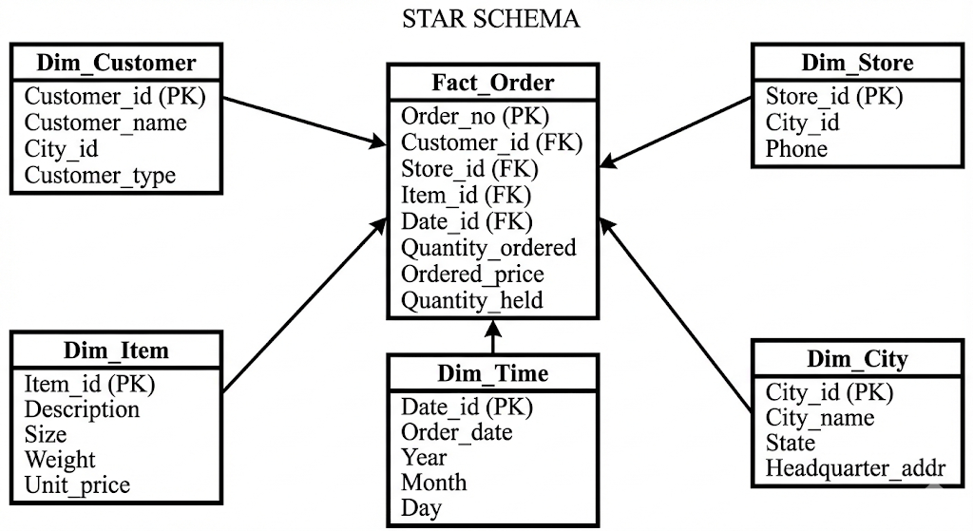

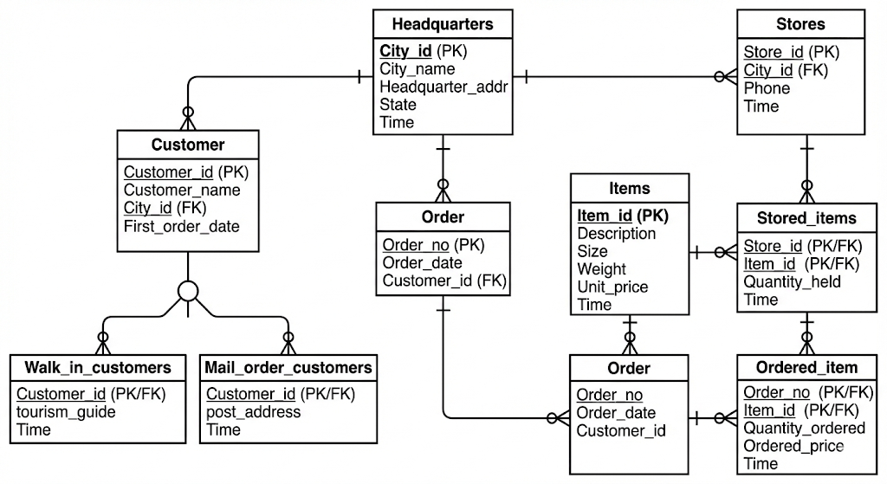
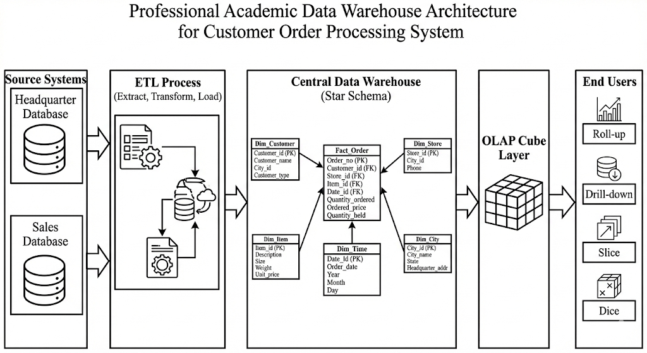

Star Schema Structure
Fact Table
Fact_Order(
Order_no,
Customer_id,
Store_id,
Item_id,
Date_id,
Quantity_ordered,
Ordered_price,
Quantity_held
)
Dimension Tables
Dim_Customer(
Customer_id,
Customer_name,
City_id,
Customer_type
)
Dim_Store(
Store_id,
City_id,
Phone
)
Dim_City(
City_id,
City_name,
State,
Headquarter_addr
)
Dim_Item(
Item_id,
Description,
Size,
Weight,
Unit_price
)
Dim_Time(
Date_id,
Order_date,
Year,
Month,
Day
)

5. PostgreSQL Implementation
Step 1: Create Dimension Tables
CREATE TABLE Dim_City (
City_id INT PRIMARY KEY,
City_name VARCHAR(100),
State VARCHAR(100),
Headquarter_addr TEXT
);
CREATE TABLE Dim_Customer (
Customer_id INT PRIMARY KEY,
Customer_name VARCHAR(100),
City_id INT,
Customer_type VARCHAR(20),
FOREIGN KEY (City_id) REFERENCES Dim_City(City_id)
);
CREATE TABLE Dim_Store (
Store_id INT PRIMARY KEY,
City_id INT,
Phone VARCHAR(20),
FOREIGN KEY (City_id) REFERENCES Dim_City(City_id)
);
CREATE TABLE Dim_Item (
Item_id INT PRIMARY KEY,
Description TEXT,
Size VARCHAR(50),
Weight FLOAT,
Unit_price FLOAT
);
CREATE TABLE Dim_Time (
Date_id SERIAL PRIMARY KEY,
Order_date DATE,
Year INT,
Month INT,
Day INT
);

Step 2: Create Fact Table
CREATE TABLE Fact_Order (
Order_no INT,
Customer_id INT,
Store_id INT,
Item_id INT,
Date_id INT,
Quantity_ordered INT,
Ordered_price FLOAT,
Quantity_held INT,
PRIMARY KEY (Order_no, Item_id),
FOREIGN KEY (Customer_id) REFERENCES Dim_Customer(Customer_id),
FOREIGN KEY (Store_id) REFERENCES Dim_Store(Store_id),
FOREIGN KEY (Item_id) REFERENCES Dim_Item(Item_id),
FOREIGN KEY (Date_id) REFERENCES Dim_Time(Date_id)
);

Step 3: Data Cube Implementation
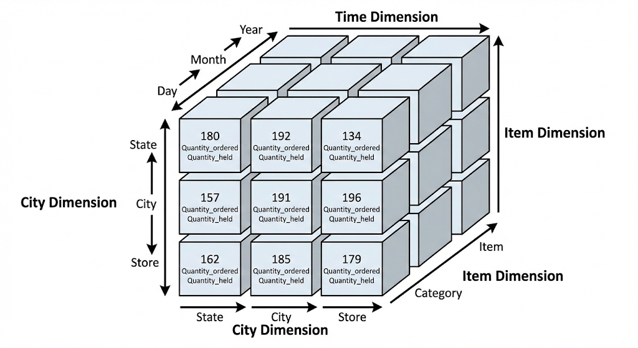
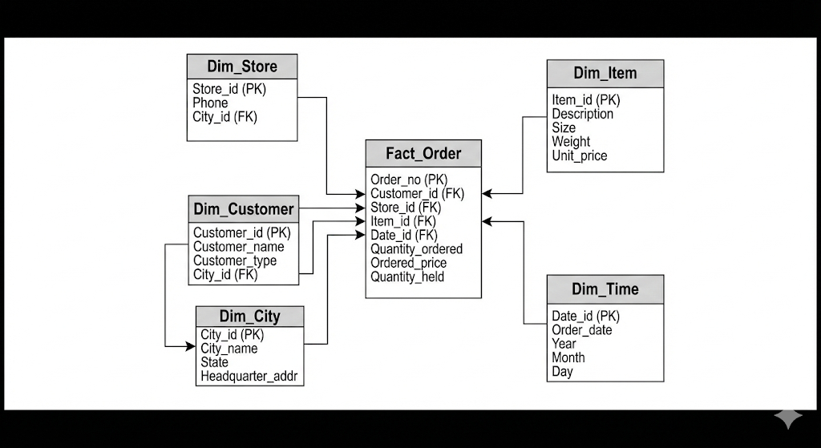
PostgreSQL supports OLAP using:
- GROUP BY
- GROUPING SETS
- ROLLUP
- CUBE
Example: Total Quantity per City
SELECT c.City_name,
SUM(f.Quantity_held) AS Total_Stock
FROM Fact_Order f
JOIN Dim_Store s ON f.Store_id = s.Store_id
JOIN Dim_City c ON s.City_id = c.City_id
GROUP BY ROLLUP(c.City_name);
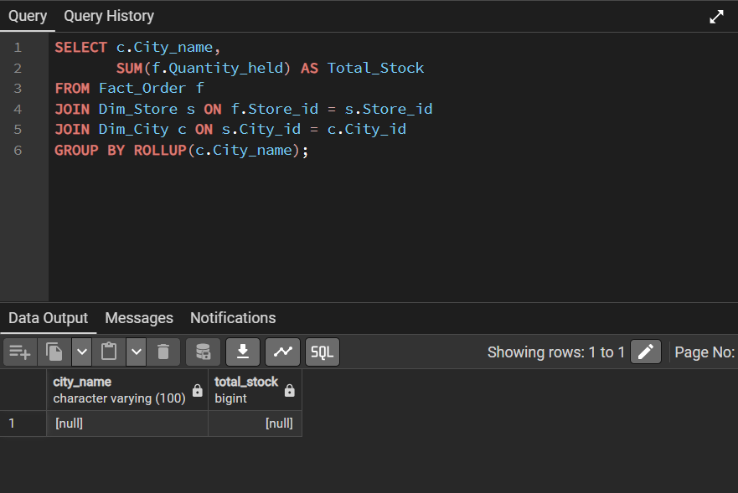

6. OLAP Queries (Business Queries)
1. Stores holding a particular item
SELECT s.Store_id, c.City_name, c.State, s.Phone,
i.Description, i.Size, i.Weight, i.Unit_price
FROM Fact_Order f
JOIN Dim_Store s ON f.Store_id = s.Store_id
JOIN Dim_City c ON s.City_id = c.City_id
JOIN Dim_Item i ON f.Item_id = i.Item_id
WHERE i.Item_id = 101;
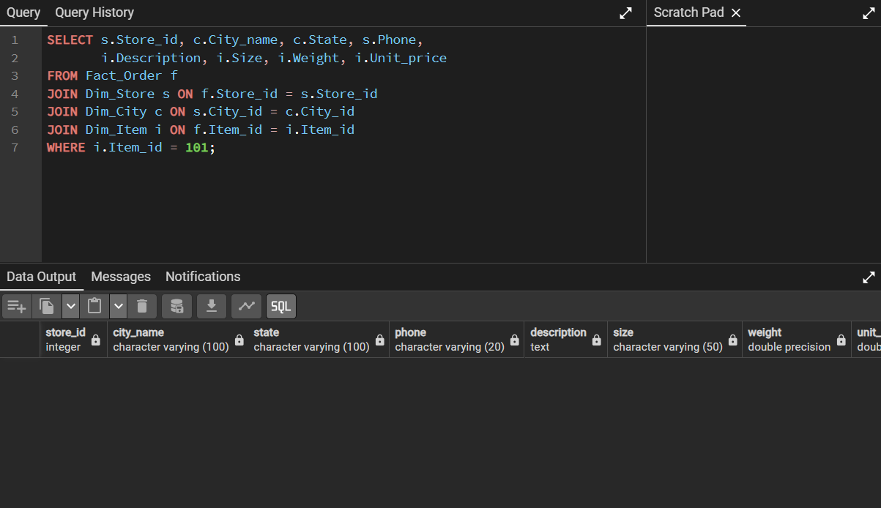

2. Orders fulfilled by a given store
SELECT f.Order_no, cu.Customer_name, t.Order_date
FROM Fact_Order f
JOIN Dim_Customer cu ON f.Customer_id = cu.Customer_id
JOIN Dim_Time t ON f.Date_id = t.Date_id
WHERE f.Store_id = 1
GROUP BY f.Order_no, cu.Customer_name, t.Order_date
HAVING SUM(f.Quantity_ordered) <= SUM(f.Quantity_held);
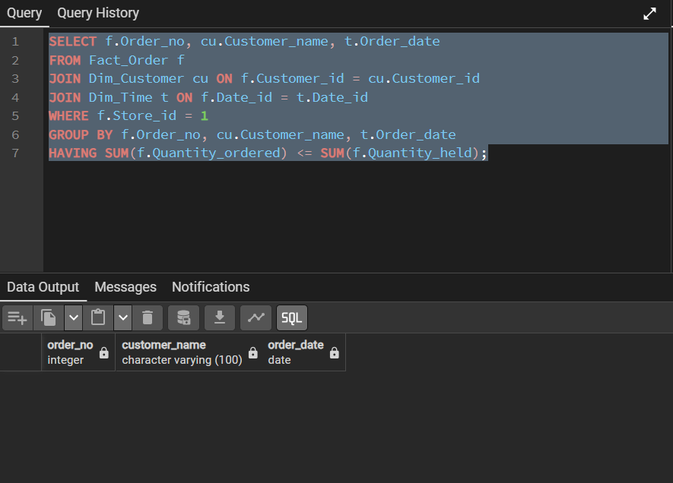

3. Stores holding items ordered by given customer
SELECT DISTINCT s.Store_id, c.City_name, s.Phone
FROM Fact_Order f
JOIN Dim_Store s ON f.Store_id = s.Store_id
JOIN Dim_City c ON s.City_id = c.City_id
WHERE f.Customer_id = 1;
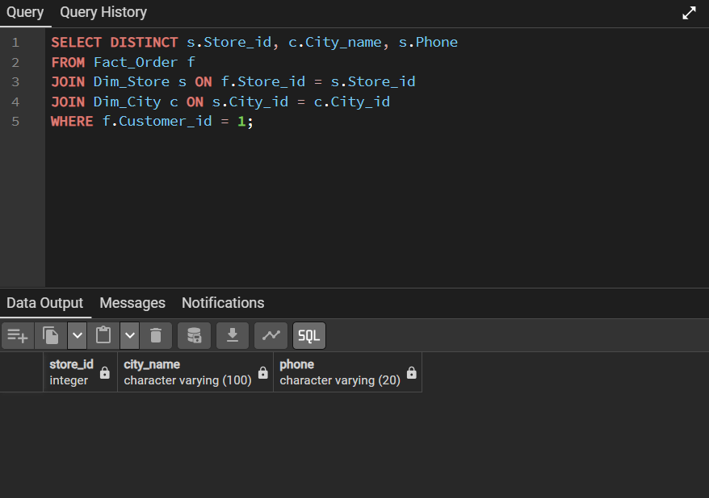

4. Headquarter address of stores holding stock above level
SELECT c.Headquarter_addr, c.City_name, c.State
FROM Fact_Order f
JOIN Dim_Store s ON f.Store_id = s.Store_id
JOIN Dim_City c ON s.City_id = c.City_id
WHERE f.Quantity_held > 50;
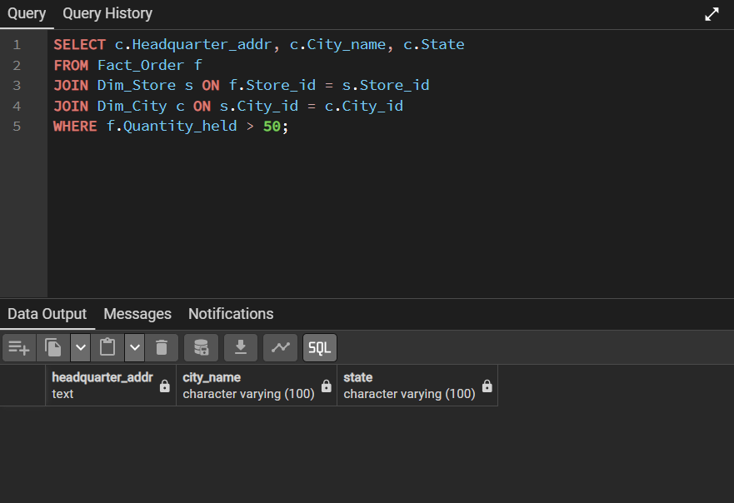

5. Items ordered with store and city
SELECT f.Order_no, i.Description, s.Store_id, c.City_name
FROM Fact_Order f
JOIN Dim_Item i ON f.Item_id = i.Item_id
JOIN Dim_Store s ON f.Store_id = s.Store_id
JOIN Dim_City c ON s.City_id = c.City_id;
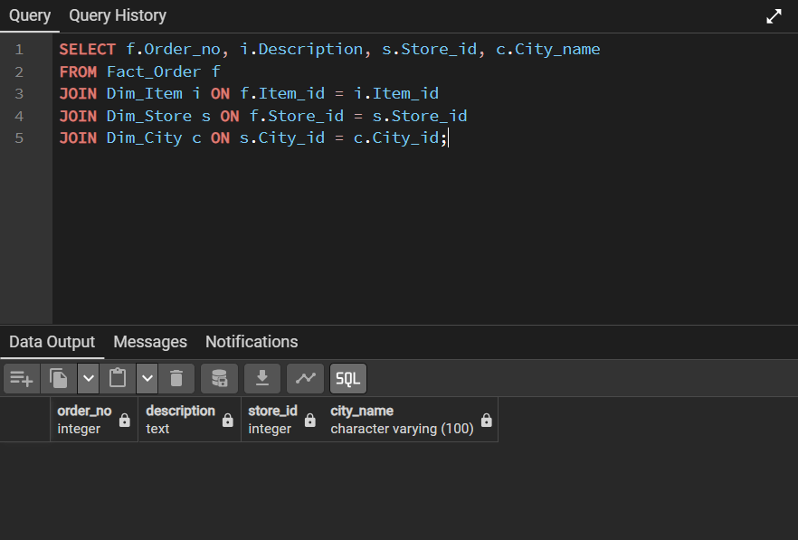

6. City and state of given customer
SELECT c.City_name, c.State
FROM Dim_Customer cu
JOIN Dim_City c ON cu.City_id = c.City_id
WHERE cu.Customer_id = 1;
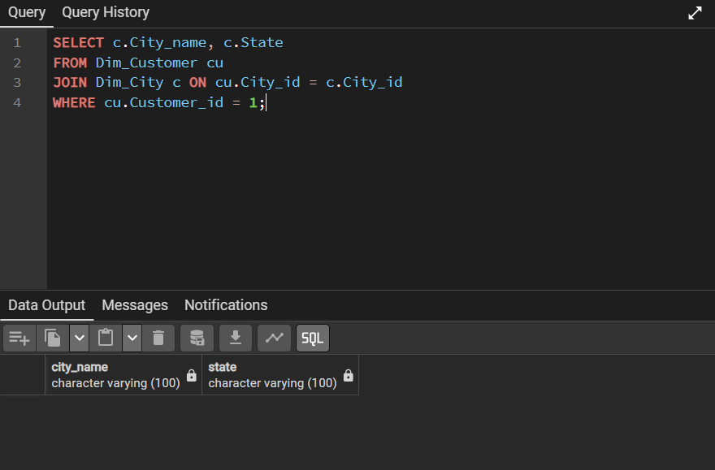

7. Stock level of item in city
SELECT s.Store_id, SUM(f.Quantity_held) AS Stock_Level
FROM Fact_Order f
JOIN Dim_Store s ON f.Store_id = s.Store_id
WHERE f.Item_id = 101
AND s.City_id = 10
GROUP BY s.Store_id;
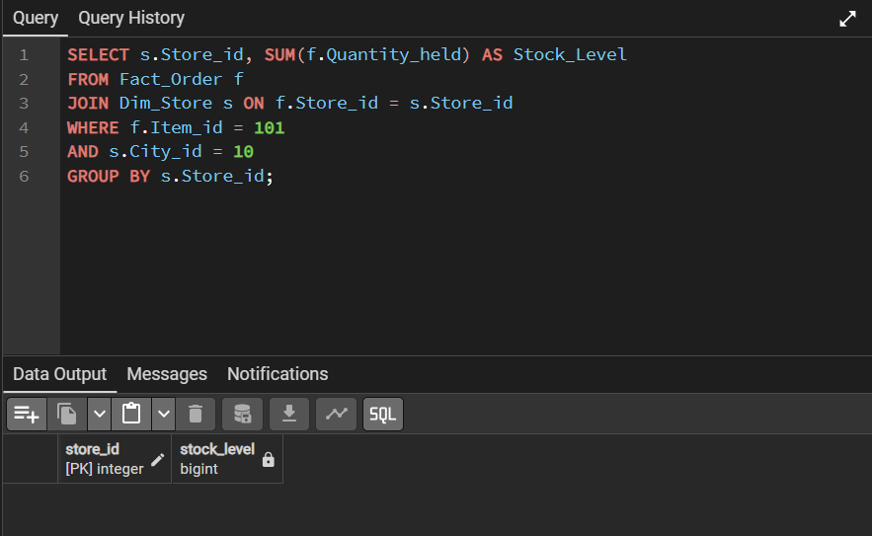

8. Items, quantity, customer, store and city of order
SELECT f.Order_no, i.Description,
f.Quantity_ordered, cu.Customer_name,
s.Store_id, c.City_name
FROM Fact_Order f
JOIN Dim_Item i ON f.Item_id = i.Item_id
JOIN Dim_Customer cu ON f.Customer_id = cu.Customer_id
JOIN Dim_Store s ON f.Store_id = s.Store_id
JOIN Dim_City c ON s.City_id = c.City_id
WHERE f.Order_no = 1001;
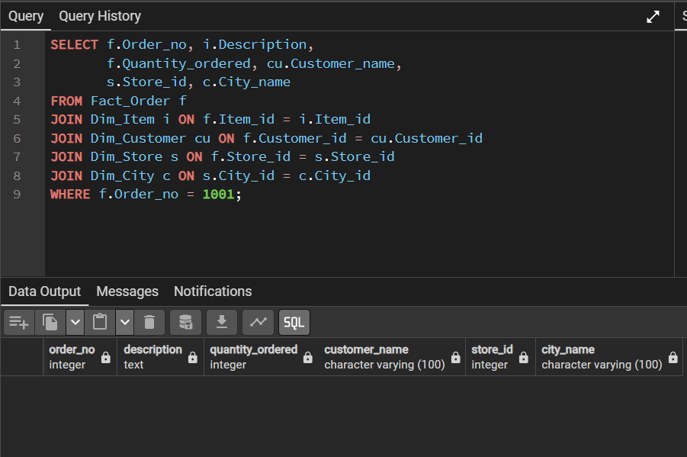

9. Walk-in, mail-order and dual customers
SELECT
CASE
WHEN w.Customer_id IS NOT NULL AND m.Customer_id IS NOT NULL THEN 'Dual'
WHEN w.Customer_id IS NOT NULL THEN 'Walk-in'
WHEN m.Customer_id IS NOT NULL THEN 'Mail-order'
END AS Customer_Type,
c.Customer_name
FROM Dim_Customer c
LEFT JOIN Walk_in_customers w ON c.Customer_id = w.Customer_id
LEFT JOIN Mail_order_customers m ON c.Customer_id = m.Customer_id;

7. Observations
(a) OLAP Reports
- Roll-up: Total stock by state
- Drill-down: State → City → Store
- Slice: Stock of one item
- Dice: Stock of multiple items in selected cities
(b) Data Verification
- Compare SUM(Quantity_held) from warehouse
- Verify with Stored_items table from operational DB
- Check consistency after ETL process
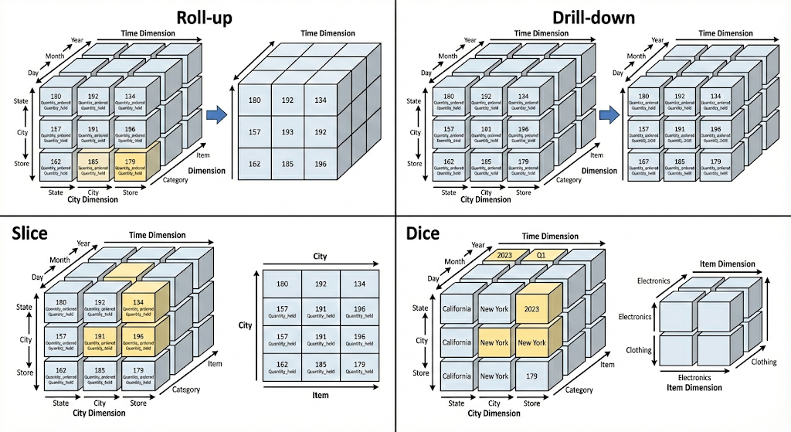

8. Conclusion
The data warehouse was successfully designed and implemented using PostgreSQL.
The system:
- Integrates multiple operational databases
- Uses star schema architecture
- Supports OLAP operations
- Provides multidimensional analytical reports
- Helps enterprise in stock monitoring and order fulfillment
This implementation improves decision-making efficiency and ensures better inventory and customer management.

