ASSIGNMENT NO. 9
Date: 23 March 2026
Title: MongoDB CRUD Portal using Angular 19 and NodeJS

Objective / Aim
- Design and implement a MongoDB-based student record management system.
- Provide complete CRUD (Create, Read, Update, Delete) operations for student data.
- Implement a responsive Angular 19 frontend with form validation and data display.

Introduction
A Student MongoDB CRUD portal is a web-based application designed to manage student records efficiently. The system provides a user-friendly interface for creating, reading, updating, and deleting student information stored in MongoDB.
Built with Angular 19 for the frontend, NodeJS/Express for the backend API, and MongoDB as the NoSQL database, the portal demonstrates modern web development practices and database operations.

Theory / Algorithms
1. MongoDB Document Structure
- Students collection stores documents with fields:
  - id (UUID)
  - name
  - email
  - course
  - created_at
- Index created on email field for fast lookups and uniqueness constraint.
2. CRUD Operations
- Create: Insert new student document into MongoDB collection.
- Read: Query all students sorted by creation date (descending).
- Update: Use findOneAndUpdate to modify student record by id.
- Delete: Remove student document by id from collection.
3. RESTful API Design
- GET /api/students – Retrieve all student records
- POST /api/students – Create new student record
- PUT /api/students/:id – Update student by id
- DELETE /api/students/:id – Delete student by id
4. Client-Server Communication
- Angular HttpClient sends JSON requests to Express backend.
- Backend validates payload (name, email, course required).
- MongoDB responds with inserted/updated/deleted documents.
- Frontend refreshes data table after each operation.

Documentation
Database Schema (MongoDB)
Collection: students
- id: string (UUID, unique identifier)
- name: string (required)
- email: string (required, unique index)
- course: string (required)
- created_at: date (timestamp)
Database Name: prn_23510009

Procedure
- Ensure MongoDB is running on localhost:27017.
- Start Express backend server on port 3100.
- Install Angular dependencies and start frontend on port 4200.
- Login to the portal at: http://localhost:4200.
- Use the form to create new student records.
- View all records in the table below the form.
- Click Edit button to modify existing records.
- Click Delete button to remove records.
- Verify data persists in MongoDB after page refresh.

Actual Experiments / Results / Observations
- Form validation successfully prevents submission of empty fields.
- Create operation generates UUID for each student and stores in MongoDB.
- All student records display in table sorted by creation date (newest first).
- Edit functionality allows updating name, email, and course fields.
- Email uniqueness constraint prevents duplicate email entries.
- Delete operation immediately removes record from both database and UI.
- Table refreshes automatically after each CRUD operation.
- Error messages display when required fields are missing.
- API health check confirms successful MongoDB connection.

Screenshot
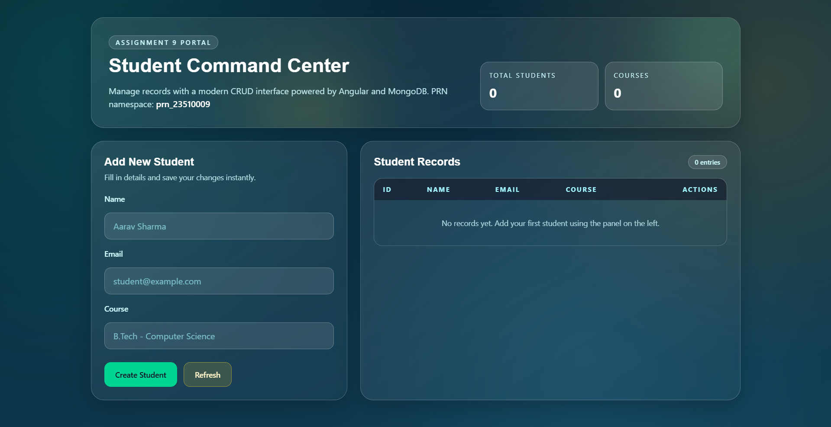
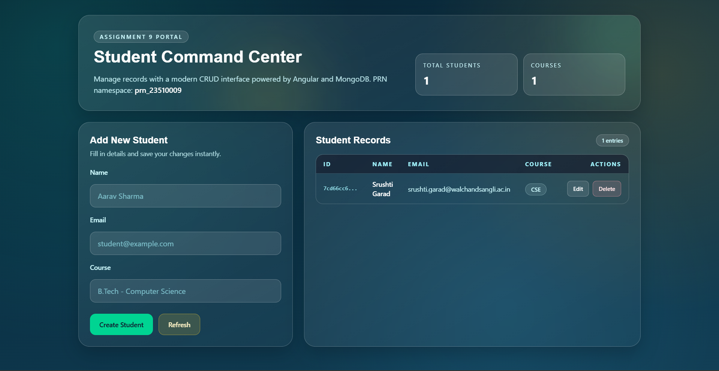
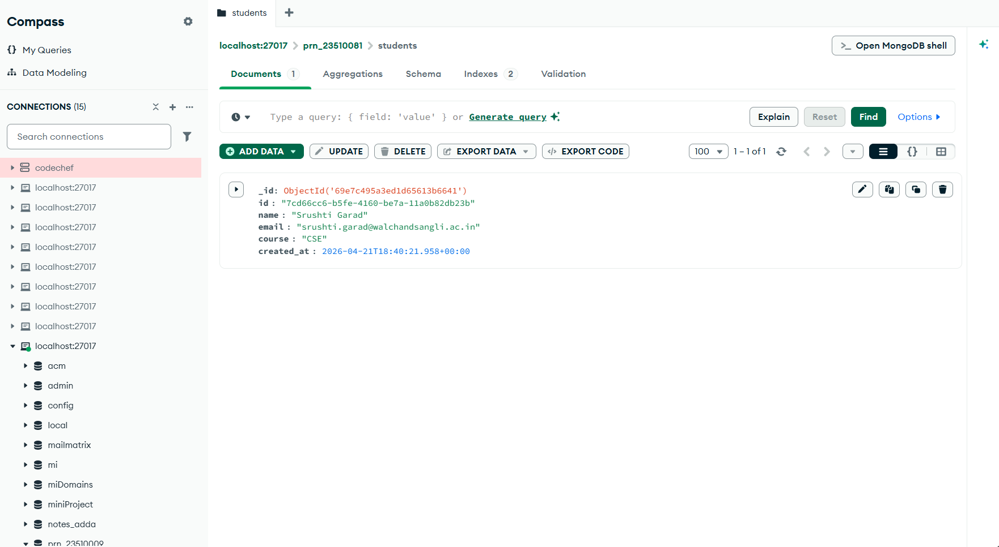

Conclusion
The MongoDB CRUD Portal successfully demonstrates full create, read, update, and delete functionality for student records. The Angular 19 frontend provides a clean, responsive interface with real-time data updates.
The Express backend efficiently handles API requests and MongoDB operations. The system meets all assignment requirements and validates the effectiveness of the MERN (MongoDB, Express, React/Angular, Node) stack for data-driven web applications.

References
- MongoDB Official Documentation – https://docs.mongodb.com/
- Angular 19 Documentation – https://angular.io/docs
- Express.js Guide – https://expressjs.com/
- NodeJS API Documentation – https://nodejs.org/docs/
- REST API Best Practices – https://restfulapi.net/

