Artificial Intelligence Techniques to Revolutionize the Marketing Strategies for Enormous Business Expansion

Palak Singh1, themoonsul@gmail.com

***Abstract*— Artificial intelligence (AI) is a rapidly growing field. It's the most recent technological disruptor with enormous marketing transformation potential. Experts from all over the world are working hard to find the best AI solutions for their marketing departments. The world is fast transitioning to a digital era, as is well acknowledged. The smart-marketing firms, which incorporate AI technology into their marketing campaigns, confirm the greater use of digital material. More businesses are turning to artificial intelligence to enhance their solutions and make their operations more efficient. The breakthroughs in machine learning, deep learning, and neural networks technologies have played a role in developing the present market structure. This paper gives an overview of Artificial Intelligence (AI), marketing and sales, and e- marketing. It then explores how marketers may embrace Artificial Intelligence's capabilities and the importance of employing this methodology for product and service marketing.**

***Keywords— Artificial Intelligence, Machine learning, Neural Networks, Deep Learning, e-marketing***

1. **INTRODUCTION**

Artificial Intelligence (AI) is one of the vast branches of computer science, which deals with intelligent machines that function and behave identically to humans. In other terms, it is a machine that can replicate human intelligence.

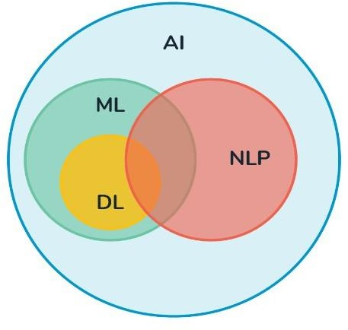

Fig.1. Interrelation of AI,ML,DL and NLP

AI is categorised into two groups: strong AI and weak AI. Artificial general intelligence is another name for powerful AI. It refers to a computer or system that

possesses logic, sensory capabilities, and mindfulness, also including the intelligence in more than just one field. Artificial narrow intelligence is another name for weak AI. It refers to machines with intelligence limited to a single domain. Machine learning (ML), natural language processing (NLP), computer vision, speech recognition, and robotics are all examples of artificial intelligence applications. These technologies open up dozens of new business prospects. Deep learning (DL) is actually a part of machine learning and it is a technique for comprehending machine learning whereas Machine learning is a mechanism for obtaining artificial intelligence. [7] DL focuses on algorithms that are guided by the structure and operations of the human brain. The extensive development of IT and communication technology has paved a way for a new era of marketing. [8] Retaining customers through better customer experience is a new way of expanding business. Working on this primary objective, many organizations have found new ways of marketing. [9] The process of creating exchanges that meet individual and organizational goals by developing and implementing the notion of a product or service, distributing services, goods, and ideas, advertising, and promoting is called Marketing. People usually mistake marketing as selling or promoting a product. While these answers are not wrong, they only involve a part of marketing. Marketing has various aspects such as product distribution, promotion, designing and many more segments. [14] Marketing as a subject involves all the actions that a company undertakes to maintain good relationships with customers. At the basic levels, it involves promotion of a company’s product and services to the users. Marketing functions on the 4P principle: 1) Product, 2) Price, 3) Promotion, 4) Place. [15] The main goal of marketing is to enhance a company’s growth and create value through customer experience.

1. **TRADITIONAL MARKET STRATERGIES**

It's one of the most important aspects of business and trade. Marketers can either trade their products to other firms (B2B) or straight to customers (B2C marketing).

1. **B2B**: Any marketing plan or material aimed towards a business or organisation is referred to as business to consumer marketing.
2. **B2C**: The strategies and techniques through which a firm markets its services and goods to particular consumers are referred to as business-to-consumer marketing.

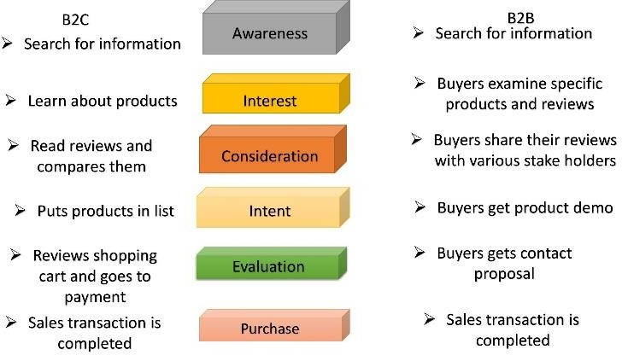

Fig.2. Representation of B2C and B2B stratergies

Given the importance of client demands in marketing, a thorough grasp of the following concepts is required. [16] **Needs:** Humans need a stable, secure, and healthy life. Some of the requirements are objective and physical, like food, water, and shelter. Others include subjective and psychological desires like being a part of a family or social group. [17]

**Wants**: They are something hoped for, aspired, and desired. Wants aren't necessary for fundamental survival. They are frequently influenced by peer groups or by culture.

**Demands**: They might potentially become economic demands, when a person's wants and needs will be subsidised by the means of payment.

The four types of Marketing are:

**Cause marketing:** It is referred to as cause-related marketing. This type of marketing connects a company's services and products to a public issue or cause.

**Relationship marketing:** It solely concentrates on client retention and satisfaction to improve existing customer relationships and boost allegiance.

**Scarcity marketing:** In this type of marketing, the marketers create an illusion of scarcity of stock to encourage people to purchase.

**Undercover marketing**: It is a way of marketing that involves the customers being unaware that they are being advertised to. It is referred to as stealth marketing.

Artificial intelligence (AI) is a diversified topic which comprises Business, functional domains, and business operations. One of them is marketing, which is every business's heart. Artificial intelligence abetted a lot in reshaping the marketing environment and will do so in the coming years.

The evolution of industries has had Artificial intelligence in E-marketing. Artificial intelligence has become an integral

part of the current market strategy. [11] For example, Instagram has helped several industries create a niche in global market statistics. Using AI, the planning and execution of service and product creation, promotion, distribution, and computerized pricing is done, in a networked environment, like the World Wide Web or Internet. Henceforth, it helps in easy exchanges and meeting client expectations. The increased use of the internet has made it possible for easy interaction between potential users and companies. [1]

The five applications of AI which require human intelligence in E-Marketing:

* Predictive and prescriptive analytics
* Programmatic advertising
* Voice recognition and search
* Content creation and experience customization
* Chatbots and intelligence agent

Marketing uses two analysis. Predictive analytics takes conversion management to another stage by assisting the prospective outcomes from the vast amount of data available to you and analyzing inbound communications and standard measures like consumer interaction, closed business, and communication channels.

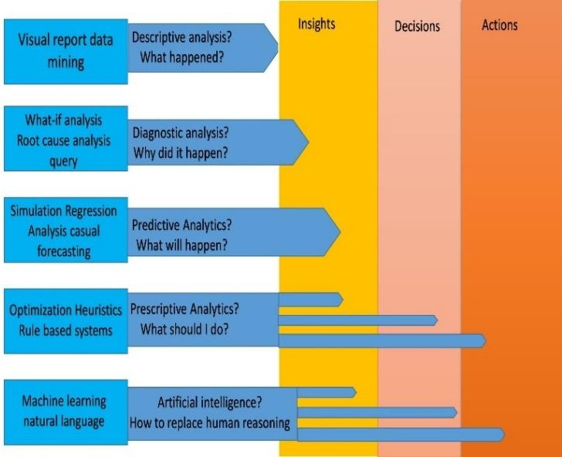

Fig.3. Analysing input data with different stratergies

For a long time, programmatic advertising is known in various forms—think search engine marketing on platforms like Google AdWords, Facebook, and Twitter. Small industries like companies like Predictive Bid and Albert service programmatic buyers.

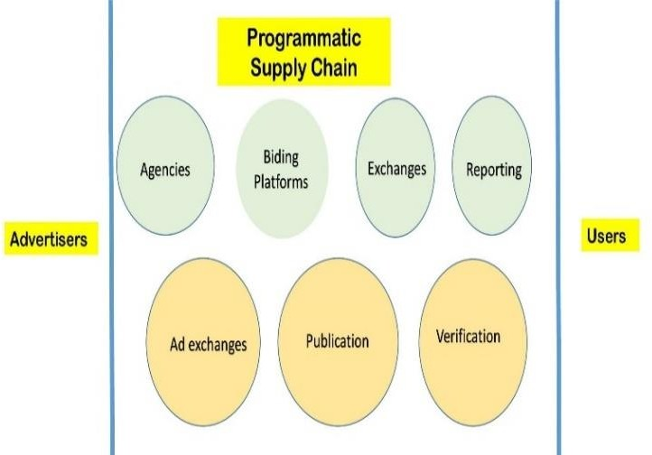

Fig.4. Flowchart of the programmatic supply chain

The automated method of purchasing and selling ad inventory through an exchange is at the basis of programmatic. The days of extended sales lunches and manual orders are long gone. Nowadays, real-time trading of stock is the norm across display, mobile, video, television, and social platforms. Bids are being based on AI-enabled insights. Algorithms may analyze a visitor's behavior to offer customized ad material in real-time. That data is being collected and used to influence future optimizations and content production. Data management platforms (DMPs) and demand and supply-side platforms (DSPs and SSPs) collect different first- and third- party data to assist in making decisions on personalization and ad purchasing.

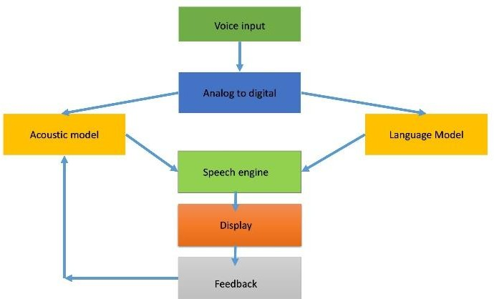

Fig.5. Voice analysis flowchart

Speech recognition has been dormant for the better part of the last two decades. Speech-enabled systems such as Siri, Alexa, and others, have gained a broader vocabulary, more natural language, and exponentially higher response quality due to their investments. Speech recognition is used in everything from Google Search to GPS navigation and other hands-free gadgets. It is also used in-home assistants like Google Home and Amazon Echo. There are programs available today that can transform specific data and information sets into material that appears to have been produced by a living, breathing human. Machine-generated content and automated personalization are being pioneered by companies like BrightEdge, for the consumer journey.The current craze is for chatbots and intelligent agents.

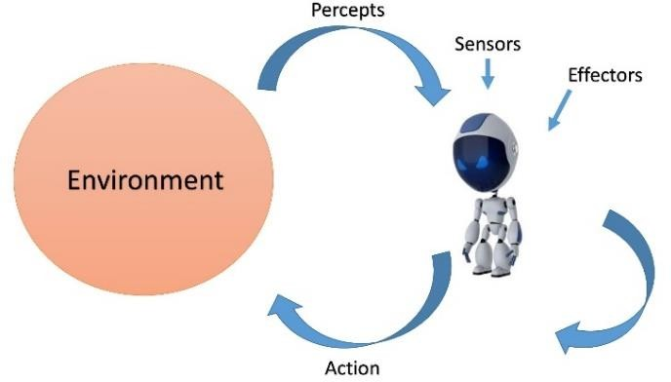

Fig.6. Interrelation between chatbots and the environment

Fig.7. Interaction between chatbots and the clients

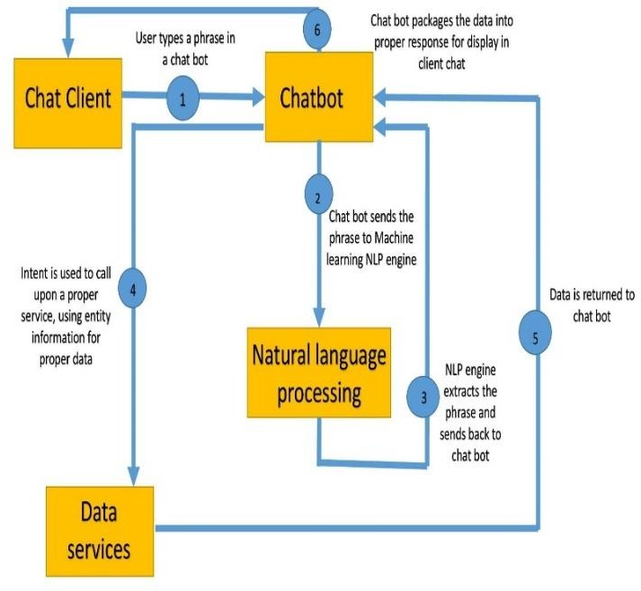Some have gotten so convincing that distinguishing them from human customer assistance is nearly impossible.

Chatbots are used, in every aspect of customer service and communication, including Facebook Messenger, Slack, Twitter, and other platforms. Ordering and finishing the transaction that includes pricing and pick-up time information is tracked by a voice-simulated robot.

Through its Messenger chatbot, you can get information on your recent Mastercard transactions and even request a Lyft from your Facebook Messenger, Slack, or Amazon Echo.

# RELATED WORKS

1. **Impact of Marketing: A marketing professional’s point of view**

The purpose is to investigate AI's impact on marketing. It is forecasted from a standpoint of Pakistani experts in the marketing domain. Qualitative research was used by the researcher. The research's main findings revealed that customers, competitive pressure, digital maturity, and media attention are the important influencing variables in integrating AI in marketing. Increased efficiency, time savings in marketing tasks, improved rates of conversion, superior knowledge of consumer data, designing marketing decisions to increase their viability, increased Return on Investment (ROI), insights, greater service, and customer pleasure are among the primary benefits. According to the data gathered, Artificial Intelligence assists in the development of marketing strategies and sales that leads to significant improvements in corporate performance.

# Artificial Intelligence, Robotics, and Machine Learning: How Do They Affect Sales and Marketing?

According to their research, the marketing profession is fast evolving due to advancements in AI, Robotics, and Machine Learning techniques. The rate of change is projected to

quicken, and the marketing landscape will shift at a breakneck pace.

# Marketing future: Impact of AI

It uses a tool for interpretation on how artificial intelligence (AI) will affect marketing tactics and customer behavior in the future. Based on current research and extensive contacts with practitioners, the authors established a multifaceted paradigm for analyzing the impact of AI that encompasses whether AI is implanted in a robot, task types, and intelligence levels. The researchers then develop a research strategy that considers not only future marketing tactics and consumer preferences but also regards fundamental policy issues like bias, ethics, and privacy. Lastly, the writers claimed that AI is quite a power, and it will complement rather than replace human beings

.

# The Use of AI in financial markets

Forecasting is an essential requirement in a stock market. [10] Different approaches such as hybrid, statistics, and sentimental analysis are applied to gather the crucial data. [3] The research mainly covers the basic requirements that are supposed to be focussed on while developing AI-based techniques in forecasting and developing financial price movements.

# AI in Stock markets

Stock markets play a vital role and generate enormous interest from the AI community. [4] The study aims to predict the use of AI in stock markets. [5] Predicting the stock market index with the help of AI is tough. But the use of clustering, voice recognition, and other features reach a closer value. [6]

# ANALYSIS

In marketing, artificial intelligence aids in:

* + Taking Sales Forecasting to the Next Level
  + Develop a more in-depth understanding of your customers
  + Make Digital Advertising Campaigns More Effective
  + Develop in-depth consumer profiles
  + Participate in real-time conversations with customers

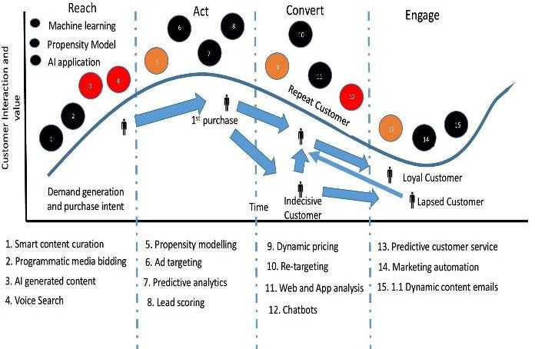

Fig.8. Effect of AI in customer interaction and value

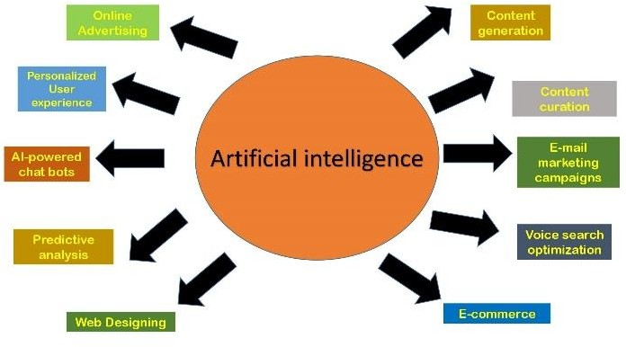

Fig.9. Use of AI in marketing strategies

1. **IMPORTANCE OF AI IN MARKETING** Market scenarios change with existing periods. Therefore, it is essential to understand the heuristics and stability.[12] Since changing market scenarios impact the productivity ratio, Ai techniques are implemented to characterize data into desired forms. The use of AI helps in productivity increase and effortless measurements of the analyzed data. [2] AI takes decisions faster and is an efficient option for a fast- growing business. For example, The use of AI in the stock market has helped companies experience immense growth. The use of the K-means algorithm has outperformed many other aspects.

Marketers may use AI marketing to quickly integrate and analyze a significant amount of data from social media, emails, and the web. Marketers may then use those insights and understanding to boost campaign performance and ROI in a shorter period. [13] AI also helps reduce complications across the board, for example, 1) Customer Satisfaction, 2) Enlarging of sales, etc. AI marketing solutions, in essence, optimize and streamline campaigns while eliminating the danger of human error.

As consumer expectations grow with technology, a need to provide personalized and customized experiences is required. Consumers want businesses to recognize and respond to their needs and expectations. AI marketing assists in determining who their target demographic is so that they can provide each consumer with a unique experience. One of the limitations of AI techniques is security and privacy in digital marketing. The AIS is an economic booster. It acts as a market representative and increases the welfare of the companies.

1. **V. BANK MARKETING ANALYSIS**

Customer satisfaction received the appropriate weighting under the new bank marketing model. It aims to fully understand consumer wants and meet them in the best way possible by identifying necessary services, potential clients, and carrying out operations based on market segmentation..This is the initial UCI Machine Learning Repository upload of the well-known marketing bank dataset. The dataset provides details on a financial institution's marketing campaign, which you must analyse to identify potential future tactics and enhance the bank's subsequent marketing efforts. In this analysis we analyse the other features using scatter plot and other techniques. [Attached Project](../../Downloads/Bank_Marketing_Analysis.ipynb)

# CONCLUSION AND FUTURE SCOPE

The Companies which will create excellent customer experiences will win, where intelligence will govern supreme. It is no longer a controversial matter. In this context, AI and machine learning have played a critical role in delivering guided experiences that fulfill user expectations. With AI poised to develop across all industries and segments, marketers should devote time and resources to experimenting with ideas and ensuring their marketing organization is set up for success now and in the future. Through data insights and analytics, the greenest marketing strategies in the coming years will adopt AI and its possibilities for reducing production time and its capabilities towards better directing and personalizing smart content crea**tion**

**VII.REFERENCES**

* 1. J. -H. Lee, "Changes in marketing brought by AI," 2021 21st ACIS International Winter Conference on Software Engineering, Artificial Intelligence, Networking and Parallel/Distributed Computing (SNPD-Winter), 2021, pp. 257-259, doi: 10.1109/SNPDWinter52325.2021.00063.
  2. J. E. Bowen, "Marketing and artificial intelligence: with neural net market segmentation example," Proceedings First International Conference on Artificial Intelligence Applications on Wall Street, 1991, pp. 251- 256, doi: 10.1109/AIAWS.1991.236593.
  3. L. Rosenberg, N. Pescetelli and G. Willcox, "Artificial Swarm Intelligence amplifies accuracy when predicting financial markets," 2017 IEEE 8th Annual Ubiquitous Computing, Electronics and Mobile Communication Conference (UEMCON), 2017, pp. 58- 62, doi: 10.1109/UEMCON.2017.8248984.
  4. T. Paul, "Fintech Empowers Prediction of Stock Market Index Using Artificial Neural Network," 2021 International Conference on Artificial Intelligence and Computer Science Technology (ICAICST), 2021, pp. 42- 46, doi: 10.1109/ICAICST53116.2021.9497817.
  5. D. Chiu, J. Zhou and Z. Wang, "Applying artificial immune algorithm to explor the seasonal effect in the stock market," International Conference on Software Intelligence Technologies and Applications & International Conference on Frontiers of Internet of Things 2014, 2014, pp. 33-38, doi: 10.1049/cp.2014.1531.
  6. A. Rokade, A. Malhotra and A. Wanchoo, "Enhancing portfolio returns by identifying high growth companies in Indian stock market using artificial intelligence," 2016 IEEE International Conference on Recent Trends in Electronics, Information & Communication Technology (RTEICT), 2016, pp. 262-266, doi: 10.1109/RTEICT.2016.7807824.
  7. A. Miklosik, M. Kuchta, N. Evans and S. Zak, "Towards the Adoption of Machine Learning-Based Analytical Tools in Digital Marketing," in IEEE Access, vol. 7, pp. 85705-85718, 2019, doi: 10.1109/ACCESS.2019.2924425.
  8. M. Draganov, M. Panicharova and N. Madzhirova, "Marketing 5.0. Transactions of Artificial Intelligence Systems in The Digital Environment," 2018 International Conference on High Technology for Sustainable Development (HiTech), 2018, pp. 1-3, doi: 10.1109/HiTech.2018.8566547.
  9. S. Khan and M. Iqbal, "AI-Powered Customer Service: Does it Optimize Customer Experience?," 2020 8th International Conference on Reliability, Infocom Technologies and Optimization (Trends and Future Directions) (ICRITO), 2020, pp. 590-594, doi: 10.1109/ICRITO48877.2020.9198004.
  10. Z. Berradi, M. Lazaar, O. Mahboub and H. Omara, "A Comprehensive Review of Artificial Intelligence Techniques in Financial Market," 2020 6th IEEE Congress on Information Science and Technology (CiSt), 2020, pp. 367-371, doi: 10.1109/CiSt49399.2021.9357175.
  11. R. Ray, P. Khandelwal and B. Baranidharan, "A Survey on Stock Market Prediction using Artificial Intelligence Techniques," 2018 International Conference

on Smart Systems and Inventive Technology (ICSSIT), 2018, pp. 594-598, doi: 10.1109/ICSSIT.2018.8748680.

* 1. R. Sachdev, "Towards Security and Privacy for Edge AI in IoT/IoE based Digital Marketing Environments," 2020 Fifth International Conference on Fog and Mobile Edge Computing (FMEC), 2020, pp. 341-346, doi: 10.1109/FMEC49853.2020.9144755.
  2. D. Rozum, N. Grazhevska and V. Virchenko, "Structural Change in Labor Market Influenced by Artificial Intelligence: Theoretical and Empirical Analysis," 2020 10th International Conference on Advanced Computer Information Technologies (ACIT), 2020, pp. 563-566, doi: 10.1109/ACIT49673.2020.9208838.
  3. J. -H. Lee, "Changes in marketing brought by AI," 2021 21st ACIS International Winter Conference on Software Engineering, Artificial Intelligence, Networking and Parallel/Distributed Computing (SNPD-Winter), 2021, pp. 257-259, doi: 10.1109/SNPDWinter52325.2021.00063.
  4. M. Tanveer, N. Khan and A. -R. Ahmad, "AI Support Marketing: Understanding the Customer Journey towards the Business Development," 2021 1st International

[16]. C. Vidal, A. Póvoa, I. Teixeira and A. Marcos, "A Nova Era do Marketing Digital: Marketing de Conteúdo e Inbound Marketing : The New Era of Digital Marketing:Content Marketing and InboundMarketing," 2021 16th Iberian Conference on Information Systems and Technologies (CISTI), 2021, pp. 1-7, doi: 10.23919/CISTI52073.2021.9476346

[17]. E. Mengelkamp, P. Staudt, J. Garttner and C. Weinhardt, "Trading on local energy markets: A comparison of market designs and bidding strategies," 2017 14th International Conference on the European Energy Market (EEM), 2017, pp. 1-6, doi: 10.1109/EEM.2017.7981938.