Artificial Intelligence Techniques For Detection as Well as Diagnosis Of Cancer And Prediction of Mutations

Palak Singh1

Dept.of EIE2

VNR VJIET3

Hyderabad, Telangana4

Themoonsul@gmail.com5

*Abstract*—Artificial intelligence (AI) is effectively making its way in medical research and individualised clinical care. The increasing availability datasets, coupled with increase in high-performance computing and novel deep learning architectures, has resulted in an increase in the use of AI in different aspects of oncology research. Cancer detection and classification, single - molecule characterization of tumours and their microenvironment, medicinal chemistry and repurposing, and predicting patient therapeutic efficacy are among the applications. We predict a paradigm shift in cancer care that will be deeply influenced by AI since these breakthroughs make their way into the clinic. In this study, we conducted an efficient search and included research articles that used AI-based learning approaches for cancer prediction, diagnosis and prediction of mutations.

***Keywords—Artificial Intelligence, Cancer, Tumor, Mutations, Deep Learning Models***

1. INTRODUCTION (*HEADING 1*)

Cancer is derived from the Greek word kapkivoc, which implies crab and tumour. Cancer was first described in the 1600s and is defined as unusually living cells that can penetrate or spread to the rest of the body. Cancer metastasis is the unrestrained growth of cells that begins in one part of body and spreads to other parts of the body. Cancer cells are categorized into benign and malignant cells. The benign cells do not spread to other parts, while malignant cells metastasize and are considered more destructive. Due to high mortality and recurrence rate, its process of treatment is very long and costly. To improve cancer patient survival, it is necessary to accurately diagnose, predict, and assess the formation of its mutations early on. It is a genetic disease caused by genetic genetic variations that control how our cells function, particularly how they grow and divide. Additional changes will happen as the tumour cells continue to grow. In a summary, cancerous cells have

more genetic changes than normal cells, such as DNA mutations. Though the immune system generally eliminates damaged or abnormal cells from the body, cancer cells have the ability to hide from the immune system [2]. The immune system is also used by the tumour to grow and survive [4]. The identity of the cancer type is based on where the tumour cells grow; for example, lung cancer is cancer that begins in the lungs and spreads to the liver [6]. Brain tumor includes three predictive predictions: cancer risk analysis, cancer recurrence prediction, and cancer survivability prediction. The probability of cancer occurrence is assessed first, followed by the prediction of cancer recurrence in the second step [9]. The final step is to forecast aspects such as advancement, mortality rates, tumor-drug sensitivity, and survivability [10]. The motivation for this study is the worldwide increase in cancer incidence and mortality. The reasons are complex, but they reflect both population ageing and growth, as well as changes in the prevalence and distribution of the main cancer risk factors [12]. Ai Technology (AI) is one of the great performance of computer science that was conceived in the 1940s. AI has established its importance in advanced diagnostic kits by offering innovative opportunities for integrating the tools into the healthcare sector [13]. The goal of artificial intelligence is to investigate the relationships between therapeutic interventions and patient outcomes [14]. In cancer research, AI has demonstrated its ability to improve the accuracy and speed of diagnosis, as well as provide more reliable clinical decisions, resulting in better health outcomes [15]. AI provides unmatched cancer prediction accuracy that is higher than that of a statistical expert. Thus, AI-based cancer detection designs can assist in health centres and help medical experts confirm their medical rulings without any hindrance. As a result, the goal of this review is to highlight the contributions made by researchers of artificial intelligence techniques for cancer detection and diagnosis.

1. COMPLICATIONS OF CANCER AND CLINICAL APPLICATIONS
2. *Cancer Applications*

Inside a cell, DNA is packaged into a number of separate genes that contain instructions that interact the cell's operations. Cancer develops as a result of DNA mutations. Because of a mistake interruption in the sequence of phases, the original functioning of the cells eventually turns cancerous.

Many complications can occur while undergoing cancer treatment, affecting the patient's health. However, not every cancers are painful, and patients may have to endure some discomfort while undergoing cancer treatment. However, there are few prescription drugs and other strategies that can be used to treat cancer-related pain. Cancer can cause fatigue and a variety of symptoms, but it is usually manageable. Tiredness can occur as a result of radiation treatment or chemotherapy treatments, but it is usually temporary. Another complication cause of cancer - related or cancer treatment is difficulty breathing. Treatments, on the other hand, may provide relief, whereas some types of cancer and cancer treatment can cause nausea. Cancerous cells deprive normal cells of essential nutrients, which can lead to weight loss. Even if nutrients are delivered artificially through vein or stomach tubes, it has little effect on weight loss.

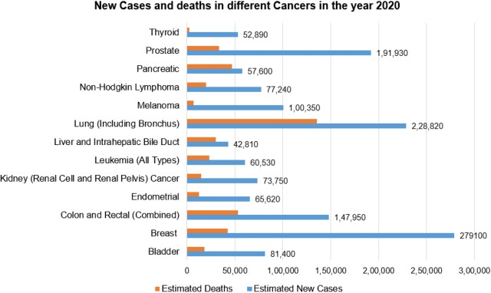

Fig.1. Statistics of cancer cases (Source: [21])

As shown in Fig.1. Cancer can also cause severe complications due to an imbalance in the human body's average chemical balance. Chemical imbalances may manifest as frequent urination, confusion, excessive thirst, and constipation. Cancer can have an impact on the body's immune system in some cases by attacking cancer cells rather than normal and fit cells. Paraneoplastic syndrome, a rare reaction, can cause a variety of symptoms and signs, including difficulty walking and seizures.

Cancer has a significant impact on the functioning of that body part because it can press on nearby nerves. If it involves the brain, it can cause headaches, stroke-like symptoms, and possibly weakness on one side of the body

. If somebody is viable in defeating cancer once, it may save one temporarily because cancer survivors are always at risk of recurrence. As a result, the patient must hear from doctor about the safety measures.

1. *Clinical Applications*

Doctors can create a future plan that includes scans and examinations at regular fixed intervals of time (months or years) just after patient's treatment to investigate radiation treatment: Cancer cells are targeted during radiation therapy. An outstanding epidemiological and rationalistic understanding of the environmental and behavioural risk factors can prevent a significant proportion of cancer cases and deaths.

Cancer therapeutics currently have the slowest clinical preliminary achievement rate of any major disease. Malignant growth will be the leading cause of death in developed countries due to a lack of effective anti-cancer drugs. Cancerous growth, as a disease embedded in the fundamentals of our science, presents perplexing difficulties that would benefit from the collaboration of specialists from a wide cross-section of linked and random fields. Along with causes, there are factors for determining the initial stage of cancer. Early cancer detection leads to higher life expectancies, less mortality rates, and less expensive care. Three critical steps must be taken in a timely manner:

* Maintain vigilance and take precautions.
* Medical analysis, valuation, and staging.
* Work in the field of therapeutics.

Early detection is critical in all situations and for the majority of cancers. Programs can be designed to reduce wait times and barriers to care, allowing patients to receive treatment on time.

1. CURRENT CANCER PREDICTION METHODOLOGIES USED IN THE MEDICAL FIELD

The section provides a description of the clinical practises currently used in the health industry for cancer prediction. The following are the methodologies:

* 1. Screening: Screening sought to discover people with specific cancers or pre-cancers who have not developed symptoms and quickly refer them for evaluation and treatment. When tests are being used according with need and stage of cancer, screening can indeed be effective. Furthermore, monitoring is a more difficult protocol to follow than earlier detection. Screening is critical for obtaining an actual diagnosis. The main reason for each type of cancer is that each type requires a unique treatment plan that includes single or additional modalities including such chemotherapy, surgical techniques, and radiotherapy. The primary goal is to treat the tumour while significantly extending the patient's life because working to improve a persons life is also an incredible goal.
  2. Chemotherapy: The primary goal of chemotherapeutics is to destroy cancer cells by using medicines that target quickly dividing cell lines. The drugs used it to shrink tumours have potentially fatal adverse effects .
  3. Hormonal treatment: Hormone-level therapy is based on the body's reaction to a few hormones. Hormones play an important role in the treatment of prostate and breast cancer.
  4. Treatments: Immunotherapy aims to boost the human immune response in order to fight cancerous cells. Immunotherapy includes checkpoint inhibitors and adoptive cell transfers.

Therapeutic approaches are used to avoid the growth of cancer and to boost immunity. Target therapies include small-molecule drugs and targeted therapy.

1. COMPARITIVE ANALYSIS

The section on comparative analysis highlighted the research of various researchers for cancer detection of disease using AI techniques

Table.1. Comparitive Analysis of Various Researchers in Cancer Detection and Diagnosis

Many research works have been analysed for cancer detection and diagnosis using traditional machine

and deep learning methods, as shown in the comparative analysis. It can be seen that the majority of deep learning techniques performed well enough and achieved high accuracy in terms of prediction scores obtained.

1. AI BASED TECHNIQUES FOR PREDICTION AND DIAGNOSIS OF CANCER

Artificial Intelligence has captured society’s imagination in recent years, sparking potential to improve our lives. AI is now being used extensively to improve disease recognition, management, and the efficacy of therapies. Because of the increasing number of cancer patients identified and the vast amount of data accumulated during the treatment process. It necessitates the use of artificial intelligence to improve oncologic care. Cancer prediction can reduce mortality . The section includes cancer diagnosis and prediction using various techniques.

1. *Artificial intelligence techniques for expression by tumor rna*

RNA sequence analysis aids in the early detection of cancer, increasing the likelihood of recovery. Deep learning approaches based on binary particle swarm optimization and convolutional neural networks can be used to identify various types of cancer based on RNA sequence gene, such as kidney renal clear cell carcinoma, breast invasive carcinoma, lung squamous cell carcinoma, and uterine endometrial carcinoma [1].

|  |  |  |  |  |  |
| --- | --- | --- | --- | --- | --- |
| Authors | Canc er  types | Training Data | Tech niq  ues | Challen ges | Results |
| Mohsen et. Al [16] | Brain | Brain MR images | DNN  with PCA  and DWT | Requires large number of processor s to  process  the data | Predictio n rate  =96.7%  Precisio n= 97% |
| Eleyan et. Al [17] | Brea st | Wisconsi s- Breast cancer Data sets | KNN | Failed to work with Large  Data sets | Precisio n  =98.5% |
| Gupta  et. Al [18] | Cervi cal | Pap  Smear Images | ANN | Lower accuracy | Accurac y=78% |
| Hoerter et. Al [19] | Colo rectal | Image net data base | CNN | Restricte d to  limited cases | Per- polyp  sensitivit y=78% |
| Han et.al [20] | Kidn ey | Renal- cell carcinom a | DNN | Accuracy  ,  sensitivit y, Specificit y should be improved | Accurac y=85%  Sensitivi ty=64% Specifici ty= 83% |
| Raj et.al [21] | Liver | CT  images | SVM | Restricts access to Large Data sets and reduces  efficiency | Accurac y more than 88% |
| Liu et. Al [22] | Prost ate | MRI  images | CNN | Works on  limited Data set | AUC=0. 84 |

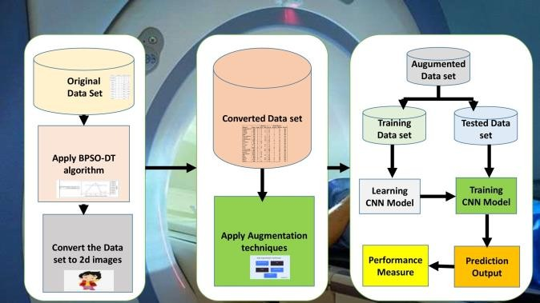

Fig.2. Architecture of the proposed scheme

As shown in Fig.2.This can be done in a variety of phases and methodologies. To begin, the RNA sequence should be converted to 2D images using the best technique during pre- processing.

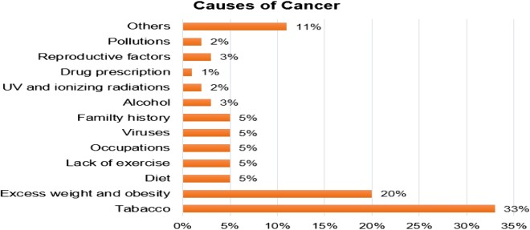

Fig.3. The Causes of Cancer

` Fig.3. focusses on various causes of cancer. Furthermore, the following step is data augmentation in the proposed scheme. The dataset volume is increased to 5 times the original volume in this case, withthe goal of having less impact on manipulating the features of obtained images in

the initial phase. Label-preserving transformations can be used to accomplish this. Finally, a deep learning approach, convolutional neural network (CNN) architecture, can be implemented using a software package (MATLAB) in which convolutional layers and connected layers are used for feature extraction and to identify different types of cancer based on the images available.

1. *Multi-Modial Fusion Method for Automatic Prediction of TP 53 Mutation*

TP53 mutation is also known as Li-Fraumeni syndrome. It is a genetic condition that can increase the risk of certain types of cancers [3].

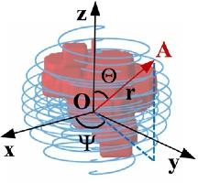

Fig.4. Spiral-transform Coordinate System The midpoint of the spiral transformation is the coordinate origin O. And the spiral line was computed using, and r. Adapted from [3]

Fig.4. shows the spiral-transform coordinate system. The multi-Modal deep learning fusion method can be used for the automatic prediction of TP53 mutation. One such strategy is spiral transformation. A spiral transformation algorithm can be used on 3D images to obtain 2D images from the available data and to effectively augment the data. Later, A bilinear module Algorithm can be used for fine-grained prediction.

1. *AI system of cancer rehabilitaion using IOT*

The nutrition consumed can influence one's risk of developing certain types of cancer [5]. The BAS algorithm can be integrated into the intelligent recommendation system of cancer rehabilitation medical plan using the IoT framework.

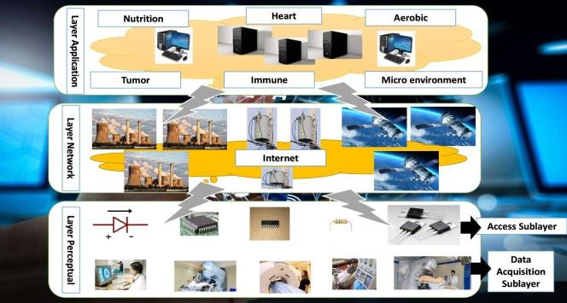

Fig.5. Basic Framework of medical Internet of things

Fig.5. Basic framework of medical IOT. CT images of cancer can be learned using an artificial intelligence algorithm, and a deep neural network model that detects cancer cells is trained; this is also useful for staged detection and treatment.

1. *AI-Based Diagnosis For Cervical Lymph*

Thyroid cancer, lymphoma, and esophageal cancer are some of the most common head and neck cancers that cause cervical lymphadenopathy [7]. An AI architecture for CEUS feature extraction and categorization was created using the point-wise gated Boltzmann machine (PGBM).

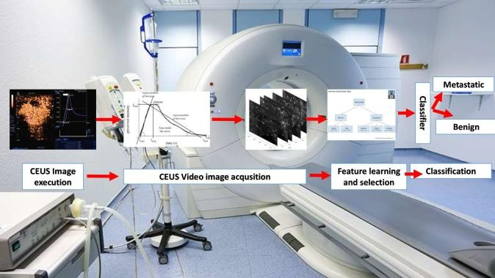

Fig.6. Architecture of the proposed system

Fig.6. shows the architecture of the proposed network. The PGBM used task-relevant and task-irrelevant hidden units for feature learning and feature selection, with the task- relevant units coupled to the support vector machine (SVM) to provide the likelihood for classification. The synthetic minority over-sampling technique is used to improve the classification performance of an unbalanced data set.

1. *Prostate Cancer Detection Using Deep Learning Technique*

Fig.7. shows deep learning analysis in cancer detection. The prostate is a walnut-sized male reproductive gland that produces and secretes an alkaline fluid. The gland is located in the pelvis, between the rectum and the bladder on the posterior side, and is surrounded on the top side by sections of the urethra. Skeletal muscles run inside the body from the diaphragm to the apex. The part of the gland that is closest to the urethral sphincter. [8] The part closest to the bladder is referred to as the apex, while the rest is referred to as the base.

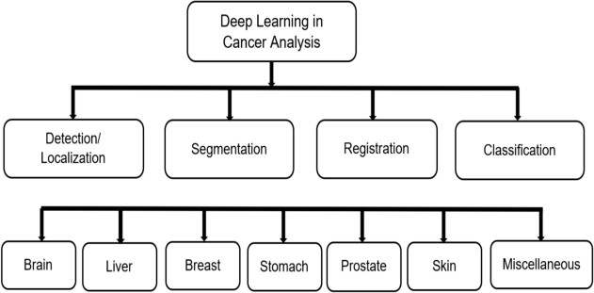

Fig.7. Deep Learning in Cancer Analysis

The four anatomical lobes of the prostate are the peripheral zone (PZ), transition zone (TZ), central zone (CZ), and anterior fibromuscular trauma, with the first three containing 70%, 5%, and 25% tissue, respectively. The latte contains no glandular tissue. According to research, the higher the count of glandular tissue, the greater the risk. Cancer is a global health issue that affects patients clinically and administratively.

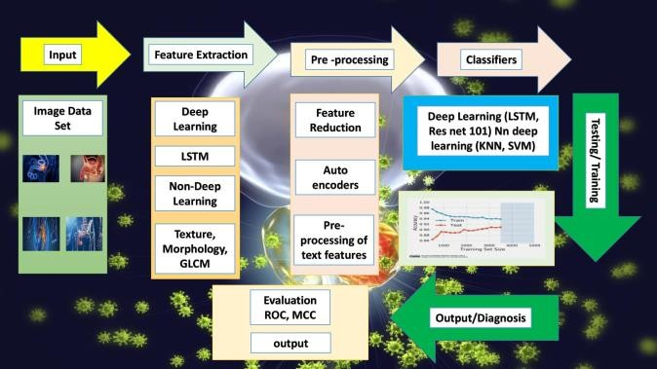

Fig.8. Graphical representation of detection of cancer using deep learning and traditional techniques

Fig.8. shows the graphical representation of cancer using deep learning techniques. Cancer is more common in older adults who do not participate in physical activity. There are a variety of methods for diagnosing prostate cancer, including screening tests for urinary symptoms, which most men dislike because they cause persistent irritation. In contrast, many men go their entire lives without ever being diagnosed with prostate cancer. The digital rectal exam (DRE) was first used to screen for prostate cancer in the early 1990s. A significant reduction has been documented as a result of its implications. A significant reduction has been documented as a result of its implications. This screening test can also distinguish between cancerous and non-cancerous cells. The DRE can only detect cancers in the prostate's posterior section and cannot detect tumours in other areas or regions of the prostate. PSA (prostate-specific antigen) is a prostate cancer screening test.

1. *Breast Cancer detection using Neural Networks*

Breast cancer is a type of cancer that develops in the breast cells and is a relatively common cancer in women. Breast cancer, like lung cancer, is a fatal disease for women [11].

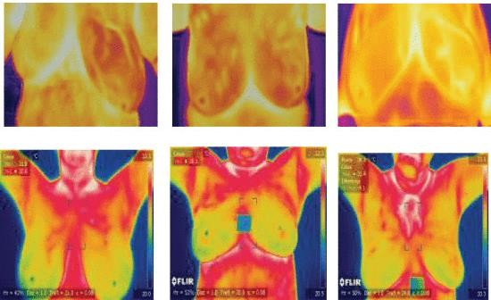

Fig.9. Data set images for breast cancer analysis

Fig.9. shows the data set images of the breast cancer analysis. A convolutional neural network (CNN) method for assessing hostile ductal carcinoma tissue zones in whole-slide images (WSIs) is proposed to improve the automatic detection of breast cancer. It looks at a proposed system for automatically detecting breast cancer that uses several convolutional neural network (CNN) designs and compares the results to those obtained using machine learning (ML) algorithms. Image processing techniques are used in mammography analysis to generate imaging biomarkers based on artificial intelligence technology to detect breast cancer in its early stages, assisting in the diagnosis and prioritisation of high-risk patients. With an accuracy of 95.83 percent, a generalised regression artificial neural network was trained and tested to differentiate malignant and benign tumours on mammograms. Using the biomarker and trained neural net, a computer-aided diagnosis method is being developed. According to the findings, a generalised regression artificial neural network is a viable and reliable technique for detecting breast cancer.

1. RESULTS

We have used 700 samples of Cells and have tested various ML Algorithms on it. Here we first process the data and then extract the features. Adding to that we then test the various ML algorithms on the data set.

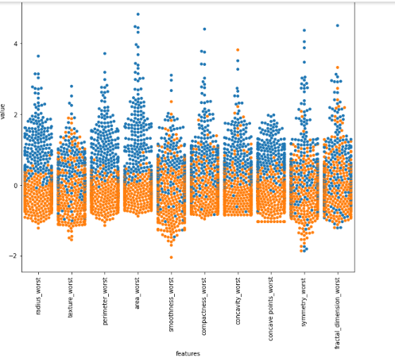The Code can be found [here](../../Downloads/Breast_Cancer_Detection.ipynb)

Fig.10. Graph of the extracted Features

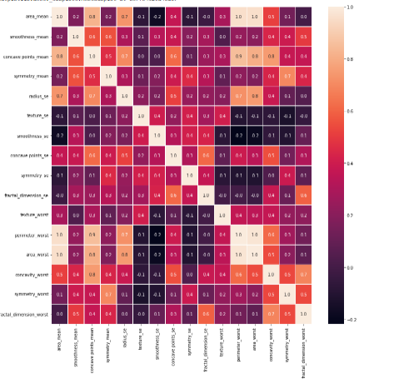

Fig.11. HeatMap of the extracted Features

**According to our results as per Fig.10 and Fig.11**

1.KNN gives us accuracy of 95.9%

2.Random Forest gives us accuracy of 96.25%

3.Logistic Regression gives us accuracy of 96.875%

4.XG Boost gives us accuracy of 98.75%

5.XG Boost is best

1. CONCLUSION

This review study attempts to summarize the various research directions for AI-based cancer prediction models. AI has marked its significance in the area of healthcare, especially cancer prediction. A critical and analytical examination of current state-of-the-art cancer diagnostic and detection analysis approaches is done and—a thorough examination of the machine and deep learning models used in cancer early detection using medical imaging. AI techniques play an important role in early cancer prognosis and detection by extracting and classifying disease features using machine and deep learning techniques. Our research found that the majority of previous literature works used deep learning techniques, particularly Convolutional Neural Networks. Another significant finding in our study is that the majority of studies have focused on breast cancer data. When deep learning models are applied to pre-processed and segmented medical images, classification metrics such as AUC, Sensitivity, Dice-coefficient, and Accuracy are improved. Because less research has been done on both types of cancer, there is room for advancement in early detection. The federated learning model can also be used to detect cancer using distributed datasets. This study focuses on the difficulties that researchers encountered while developing AI-based prediction models. Despite the fact that numerous studies have yielded significant results, there is still a need to address the challenges in cancer research in the future.

REFERENCES

1. N. E. M. Khalifa, M. H. N. Taha, D. Ezzat Ali, A. Slowik and A. E. Hassanien, "Artificial Intelligence Technique for Gene Expression by Tumor RNA-Seq Data: A Novel Optimized Deep Learning Approach," in IEEE Access, vol. 8, pp. 22874-22883, 2020, doi: 10.1109/ACCESS.2020.2970210.
2. N. Yukinawa, S. Oba, K. Kato and S. Ishii, "Optimal Aggregation of Binary Classifiers for Multiclass Cancer Diagnosis Using Gene Expression Profiles," in IEEE/ACM Transactions on Computational Biology and Bioinformatics, vol. 6, no. 2, pp. 333-343, April-June Biology and Bioinformatics, vol. 6, no. 2, pp. 333-343, April-June

2009, doi: 10.1109/TCBB.2007.70239.

1. X. Chen, X. Lin, Q. Shen and X. Qian, "Combined Spiral Transformation and Model-Driven MultiModal Deep Learning Scheme for Automatic Prediction of TP53 Mutation in Pancreatic Cancer," in IEEE Transactions on Medical Imaging, vol. 40, no. 2, pp. 735-747, Feb. 2021, doi: 10.1109/TMI.2020.3035789.
2. M. Kokuer, R. N. G. Naguib, P. Janclovic, H. B. Younghusband and

R. C. Green, "Cancer Risk Analysis in Families With Hereditary Nonpolyposis Colorectal Cancer," in IEEE Transactions on Information Technology in Biomedicine, vol. 10, no. 3, pp. 581-587, July 2006, doi: 10.1109/TITB.2006.872054.

1. Y. Han et al., "Artificial Intelligence Recommendation System of Cancer Rehabilitation Scheme Based on IoT Technology," in IEEE Access, vol. 8, pp. 44924-44935, 2020, doi: 10.1109/ACCESS.2020.2978078.
2. M. Alawad et al., "Privacy-Preserving Deep Learning NLP Models for Cancer Registries," in IEEE Transactions on Emerging Topics in Computing, vol. 9, no. 3, pp. 1219-1230, 1 July-Sept. 2021, doi: 10.1109/TETC.2020.2983404.
3. Q. Zhang, Y. Liu, H. Han, J. Shi and W. Wang, "Artificial Intelligence Based Diagnosis for Cervical Lymph Node Malignancy Using the Point-Wise Gated Boltzmann Machine," in IEEE Access, vol. 6, pp. 60605-60612, 2018, doi: 10.1109/ACCESS.2018.2873043.
4. S. Iqbal et al., "Prostate Cancer Detection Using Deep Learning and Traditional Techniques," in IEEE Access, vol. 9, pp. 27085-27100, 2021, doi: 10.1109/ACCESS.2021.3057654.
5. J. T. Kwak and S. M. Hewitt, "Nuclear Architecture Analysis of Prostate Cancer via Convolutional Neural Networks," in IEEE Access, vol. 5, pp. 18526-18533, 2017, doi: 10.1109/ACCESS.2017.2747838.
6. J. X. Qiu, H. -J. Yoon, P. A. Fearn and G. D. Tourassi, "Deep Learning for Automated Extraction of Primary Sites From Cancer Pathology Reports," in IEEE Journal of Biomedical and Health Informatics, vol. 22, no. 1, pp. 244-251, Jan. 2018, doi: 10.1109/JBHI.2017.2700722.
7. M. A. S. A. Husaini, M. H. Habaebi, S. A. Hameed, M. R. Islam and

T. S. Gunawan, "A Systematic Review of Breast Cancer Detection Using Thermography and Neural Networks," in IEEE Access, vol. 8, pp. 208922-208937, 2020, doi: 10.1109/ACCESS.2020.3038817.

Y. Li et al., "Computer-Aided Cervical Cancer Diagnosis Using Time-Lapsed Colposcopic Images," in IEEE Transactions on Medical Imaging, vol. 39, no. 11, pp. 3403-3415, Nov. 2020, doi: 10.1109/TMI.2020.2994778.

1. S. H. Hawkins et al., "Predicting Outcomes of Nonsmall Cell Lung Cancer Using CT Image Features," in IEEE Access, vol. 2, pp. 1418- 1426, 2014, doi: 10.1109/ACCESS.2014.2373335.
2. R. Hajjo, "The Ethical Challenges of Applying Machine Learning and Artificial Intelligence in Cancer Care," 2018 1st International Conference on Cancer Care Informatics (CCI), 2018, pp. 231- 231, doi: 10.1109/CANCERCARE.2018.8618186.
3. J. Al-Enezi, M. F. Abbod and S. Al-Sharhan, "Artificial Immune Systems Applications in Cancer Research," 2011 Developments in E- systems Engineering, 2011, pp. 168-171, doi: 10.1109/DeSE.2011.36.
4. Mohsen H, El-dahshan EA, El-horbaty EM, Salem AM (2018) Classification using deep learning neural networks for brain tumors. Future Comput Inform J 3(1):68– 71. <https://doi.org/10.1016/j.fcij.2017.12.001>
5. Eleyan A, Saliha O, Ikram G, Tolga E (2018) Breast cancer classification using machine learning. 2018 Electric Electronics, Computer Science, Biomedical Engineerings’ Meeting (EBBT),

Istanbul, Turkey

1. Gupta R, Sarwar A, Sharma V (2017) Screening of cervical cancer by artificial intelligence based analysis of digitized papanicolaou-smear

images. Int J Contemp Med Res 4(5):1–6

1. Hoerter N, Gross SA, Liang PS (2020) Artificial intelligence and polyp detection. Current Treatment Options Gastroenterol 18(1):120– 136. <https://doi.org/10.1007/s11938-020-00274-2>
2. Han S, Hwang SI, Lee HJ (2019) The classification of renal cancer in 3-phase ct images using a deep learning method. J Digit Imaging 32(4):638–643. <https://doi.org/10.1007/s10278-019-00230-2>Raj

A, Jayasree M (2016) Automated liver tumor detection using markov random field segmentation. Procedia Technol 24:1305–

1310. <https://doi.org/10.1016/j.protcy.2016.05.126>

Liu S, Zheng H, Feng Y, Li W (2017) Prostate cancer diagnosis using deep learning with 3D multiparametric MRI. Medical imaging 2017: Comput Aid Diagn

10134:1013428. <https://doi.org/10.1117/12.2277121>

1. Kumar, Y., Gupta, S., Singla, R. *et al.* A Systematic Review

Artificial Intelligence Techniques in Cancer Prediction and Diagnosis. *Arch Computat Methods Eng* (2021). https://doi.org/10.1007/s11831-021-09648-