Artificial Intelligence Based Face Masks Detection Techniques For Prevention of COVID-19

Palak Singh1

Dept.of EIE2

VNR VJIET3

Hyderabad, Telangana4

Themoonsul@gmail.com5

***Abstract***— Since the contagious coronavirus disease (COVID-19) had first been published in Wuhan, this has become a public health issue in China and even worldwide. This pandemic is wreaking havoc on economies and societies all over the world. The increased number of COVID-19 tests provides more information about the spread of the epidemic, which may improve the chances of neighbouring it to prevent further infections. Wearing a face mask that inhibits the transmission of droplets released into the air, as well as maintaining an appropriate external distance between people and reducing close contact, can still be beneficial in combating this pandemic. As a result, the objective of this paper is to provide a comprehensive analysis of artificially intelligent models that were used to discover face masks. It is deduced that the majority of the datasets used to detect face masks are artificially generated and do not represent real-world environments, which affects the highly precise model accuracy when deployed in the real world. On the contrary, real-world COVID-19 mask images are shared to model deep learning techniques. Additionally, in a real- time scenario, the usability and efficiency of these techniques are tracked down. It is further estimated that these technologies in conjunction with the existing embedded camera infrastructure can be used in a variety of verticals and can contribute to communal health.

***Keywords— COVID-19, Face Mask, Artificial Intelligence, Deep Learning Models, Machine Learning***

1. INTRODUCTION (*HEADING 1*)

The emergency of a novel coronavirus (COVID- 19) poses an enormous challenge in many healthcare systems around the world. The World Health Organization (WHO) declared a public health emergency in March 2020, as the global epidemic continues to spread and decimate the population, particularly in vulnerable countries. To combat the pandemic, countries strengthened infection and preventive measures such as imposing travel restrictions, nationwide lockdown, solitude, quarantine of suspected and positive cases, sanitizing regular hand washing and temperature verifying, wearing face masks, and social distancing.

Furthermore, some countries declared COVID-19 limitations such as nationwide lockdown, curfews, travel restrictions, closing public places, physical separation, and border closures. [1] These constraints posed significant challenges in developing countries, where weakened infrastructure, overburdened health systems, insufficient funding, and limited public health surveillance undermined their potential efficacy. Large-scale restrictions are difficult to implement, adhere to, and thus practice and maintain, resulting in flawed public compliance, especially when there is a big difference in social and political norms, the economy, and the psychological well-being of the victims. [2] Following the successful development of vaccines, the focus has shifted to population vaccination. [3] However, emerging COVID-19 variants, porous borders, the regular movement of informal traders, and the sale of forged vaccination certificates continue to jeopardize some countries' progress toward virus containment. Notably, respiratory protective equipment, such as facemasks, protects against infection. [4] Face masks are reasonably priced, easier to use, and, despite ongoing research into their efficacy. [5] Despite the successful production of vaccines, wearing face masks remains critical for reducing transmission chains. [6] Regulatory authorities have mandated the use of face masks in public places where there is frequent and inevitable contact between people, such as public transportation, sports arenas, shopping malls, and workplaces. This is done to prevent re-infection and the spread of COVID-19 as countries reopen in the new normal. [7] Face mask guidelines, as well as penalties for violating face mask guidelines, have been implemented in countries such as the United States, South Africa, France, Brazil, India, China, Kenya, Uzbekistan, Lebanon, Spain, and Qatar, among others. Law enforcement and social groups have been tasked with monitoring and observing people's compliance and adherence to face mask guidelines. [8] When worn correctly, the face mask reduces the momentum of coughing droplets and prevents the virus from spreading through talking, coughing, or sneezing. However, compliance and adherence to wearing face masks have been difficult, due to a variety of factors such as

underlying health conditions that make breathing difficult, poor sanitation, informal settlements, social unrest, socioeconomic factors, ignorance, and a lack of face masks, among others.

Prominently, innovative technologies have been used in various domains to combat COVID-19. [16] The Internet of Things, Blockchain, 5G technology, geographical information systems, big data, and artificial intelligence are among these technologies (AI). For example, scientists, researchers, and technologists have used artificial intelligence models to scale up the pandemic screening process, detect and map hotspots and migration patterns in real-time, thermal imaging, predicting, modeling, screening, monitoring, and diagnosing COVID-19 suspected cases. Since the pandemic's outbreak, artificial intelligence techniques have also been used to create contact tracing apps, social distancing tools, smart wearable devices, and subsequent remote monitoring of patients in isolation and quarantine facilities A systematic review of all the discussed technologies for covid-19 prognosis is further reviewed.

1. THE MAIN EMPHASIS OF THE STUDY

The third and fourth waves are unavoidable due to a lack of technology-based face mask monitoring tools, as well as compliance and adherence policies. Face mask detection has also been a difficult task, particularly in image processing, due to a variety of mask types, camera pixels, different degrees of obstruction, various variations (such as the angle of view, illumination, resolution, and rotation), balancing various model detection accuracy or errors and real-time requirements, deployment of detection models on computers with limited processing power, and the storage space required to manage image data. Face mask detection has received little attention in the context of the pandemic, although it is critical to identify masked faces in static images, videos, and closed- circuit television (CCTV) to reduce secondary virus transmission. This is supported by a few published studies on the use of artificial intelligence models to detect face masks. Because artificial intelligence techniques are improving, it is critical to use artificial intelligence models to detect COVID-19 face masks. Image classification and object detection using artificial intelligence models yielded promising results. As a result, these models must be used to detect face masks. As a result, the purpose of this study was to provide a comprehensive review of artificial intelligence techniques used to detect face masks to ensure compliance and adherence to COVID-19 face masking. The following are the major contributions of this paper:

* Identifying and systematically reviewing cutting-edge artificial intelligence (deep learning and machine learning) models used to detect COVID-19 face masks.
* To assess and discuss the prediction accuracy and limitations of AI models used to detect face masks.
* To investigate COVID-19 face mask image datasets that are used to predict face masks.

Based on the findings, the study presents future research directions for the further development of efficient and reliable AI models to detect face masks in real environments.

1. AI- BASED ALGORITHMS THAT HAVE BEEN USED TO DETECT FACE MASKS

Various AI-based algorithms that have been used to detect face masks were identified.

TABLE.1. Artificial Models applied to detect Covid-19 mask

|  |  |  |  |  |
| --- | --- | --- | --- | --- |
| AI  Models | Description of the  model | Accuracy | Limitations | Image Data set source |
| SRC NET [17] | The model distinguishe s faces with and without mask using image resolution and classificatio n networks | 98.70% | 1. The data set was very small and limited. 2. Could not dynamic facial conditions | Celeb A face mask dataset availab le publicl y |
| Hybrid deep transfer learning Model [18] | The model consists of SVM  algorithm, Decision Trees, and enable methods to detect Face masks | 99.64% | 1) Uses images from Real- world Masked Face Data set. 2)  Consists of 5000  masked faces and 90000  unmasked faces.  3) Could not include face mask detection in real-life video streaming. | The data set used are RMFD  and SMFD |
| Face Mask net Model  [19] | It uses deep Learning algorithm | 98.6 % | Limited to only a few cases | Uses data sets from MFDD RWFC D |

TABLE.2. Artificial Intelligence models to detect COVID- 19

|  |  |  |  |  |
| --- | --- | --- | --- | --- |
| AI  Models | Descripti on of the model | Accur acy | Limitatio ns | Image Data Sourc e |
| Inceptio n V3 convolu tion network  [20] | Inception v3 is a Googlene t module with 22  layers to improve accuracy.  It detects a person who isn’t wearing a mask | 99.9% | Tested with small data set. | Used simula ted maske d face data set |
| Light weight neural network [21] | To detect face masks, the neural network used MobileNe tV2 and Single Shot Detector (SSD). | 85% | Could use large data sets | Uses custo m data sets of image s |
| A  Novel Deep learning model [ 22] | The CNN model recognise s people who are not wearing a face mask and collects their informati on for future effects. | 91.2% | The model doesn’t detect a person wearing a mask | Datas et source not menti oned |

TABLE.1 and TABLE.2. shows the results of various technologies in detecting COVID-19 masks. According to the available literature, artificial intelligence techniques produced promising results in detecting COVID-19 face masks. The abbreviation’s are RMFD means Real-World Masked face data set, SMFD (Simulated Masked Face data

set), MFDD (Masked Face detection data set), and SMFRD (Simulated Masked face Recognition Data set).

Various other models that have been used to detect face masks were identified and are discussed further.

1. *Face Mask Detection using OPEN CV*

Open CV is a free and open-source library for computer vision applications. This includes a variety of functions and algorithms for motion tracking, facial recognition, object detection, segmentation and recognition, and a variety of other applications.

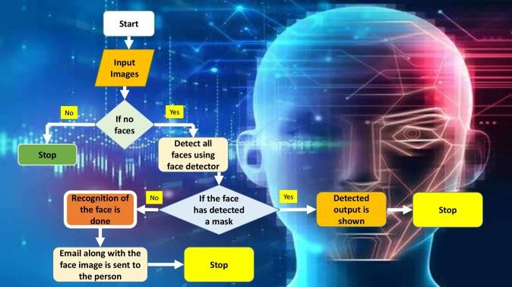

Fig.1. Flow chart of the proposed Idea

The Fig.1. shows the flowchart of the proposed idea. Using this library, images and real-time video streams can be manipulated to meet a variety of requirements. For the detection of human face masks, this project employs Open CV, a Caffe-based face detector, Keras, Tensor Flow, and MobileNetV2. The dataset being used contains 3835 images, with people wearing masks in 1916 and without masks in 1919. [9] To begin, a base model is created. This is accomplished through the use of Keras and MobileNetV2. A base model is created first, and then a head model is created on top of that. The head model is made up of a network with 128 layers, a "Relu" activation function, and a dropout of 0.5, followed by a network with

2 layers and a "softmax" activation function. All three layers combined will result in a model that can be trained.

1. *Mask Identification by edge computing techniques*

Edge computing, as an emerging field of research.

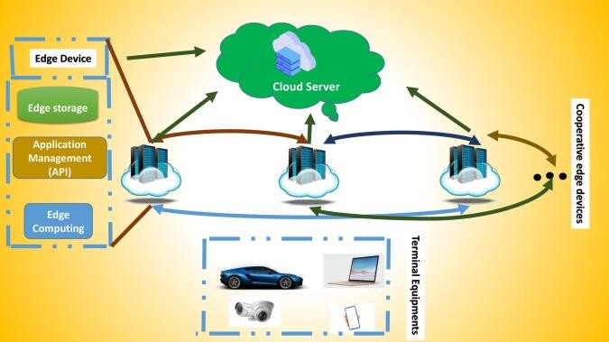

Fig.2. Basic flow chart of cooperative edge computing in IOT.

As shown in Fig.2. cooperative edge computing plays a significant role in IoMT due to its benefits such as faster

data processing, lower costs, offloading network traffic, improving application efficiency, and security and privacy protection. BodyEdge, an IoMT system architecture is designed to support various healthcare scenarios such as factory workers, athletes, and hospital patients. [10] With a focus on sustainability and energy utilization, a clustering model for medical applications (CMMA) was introduced for cluster head selection that took into account additional factors specific to the IoMT network, such as medical device capacity and queue. An edge computing- based healthcare system in IoMT is introduced and further develops a non-cooperative game-based decentralized method to minimize the costs beyond WBANs. Besides, the deep learning model is combined with edge computing in it. An effective deep learning neural network (ETS- DNN) training scheme in edge computing enabled IoMT systems that incorporated a Hybrid Modified Water Wave Optimization technique to improve healthcare system efficiency is further discussed.

1. *Deep Learning Neural Architecture for Face Mask Detection*

A machine learning prediction framework for forecasting future COVID-19 epidemic risk is presented. The module analyses the dataset, which contains actual day-to-day past results, and employs machine learning methodologies to forecast the next few days. The findings demonstrated that, in terms of the complexity and size of the dataset, ES performed better in comparison to the current forecasting environment. [11] To some extent, LR and LASSO are also useful for forecasting in terms of estimating the death rate and validating events. According to the effects of these two approaches, death rates will rise shortly, while recovery rates will be greatly reduced. SVM performs poorly in all situations due to the extreme ups and downs in database calculated points. A complex model is further presented that detects face masks using deep and classic learning algorithms. The scheme was created in two stages. The first phase involved extracting features with Resnet50. The second phase, on the other hand, used traditional machine learning methods to detect face masks. As traditional machine learning approaches to analysis, Support Vector Machine (SVM), Decision Trees, and Ensemble Algorithms have been chosen. The proposed finding confirmed that the SVM classifier obtained the highest possible accuracy with the least amount of time spent during training. In RMFD, the SVM classifier achieved 99.64 percent test accuracy. In SMFD, 99.49% of the test accuracy was achieved, whereas, in LFW, 100% of the test accuracy was achieved.

1. *Face mask detection using Mobile Net V2*

The collection of data is the first step in the development of the Face Mask Recognition model. [12] The dataset is used to train data on people who use masks and those who do not. The model will distinguish between people who are wearing masks and those who are not. This study builds the model using 1.916 data with a mask and 1.930 data without a mask. At this point, the image is cropped so that the only visible object is the object's face. As shown in Fig.4. The following step is to label the data.

The collected data was labeled into two groups: with and without a mask. The pre-processing phase comes before the data training and testing. Pre-processing consists of four steps: resizing image size, converting the image to an array, pre-processing input using MobileNetV2, and performing hot encoding on labels. The following step is to convert all of the images in the dataset into an array. The image is converted into an array so that the loop function can call it.

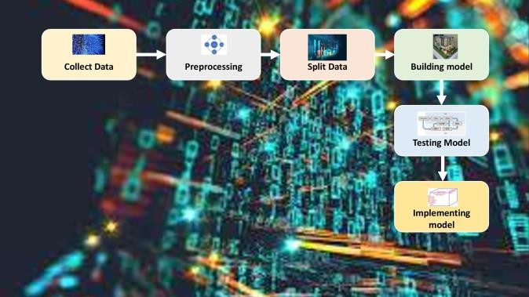

Fig.3. Flow chart of the proposed idea

The image will then be used to pre-process input using MobileNetV2. Following the pre-processing phase, the data is divided into two batches: training data (75 percent) and testing data (the remaining 25 percent). Each batch includes both with-mask and without-mask images. Pre-processing consists of four steps: resizing image size, converting the image to an array, pre-processing input using MobileNetV2, and performing hot encoding on labels. The following step is to convert all of the images in the dataset into an array. The image is converted into an array so that the loop function can call it. The image will then be used to pre-process input using MobileNetV2. Following the pre- processing phase, the data is divided into two batches: training data (75 percent) and testing data (the remaining 25 percent). Each batch includes both with-mask and without- mask images. The final data is later analyzed and monitored.

1. *Face Mask Detector using YOLO V3 Algorithm*

The proposed face mask detection algorithm consists of two steps: preprocessing and face detection. The preprocessing step improves the quality of the input image by using auto white balance and edge enhancement with the unsharp filter.

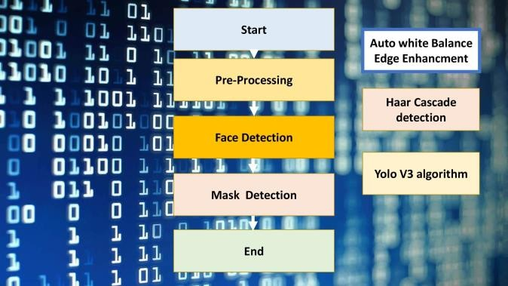

Fig.4. The flowchart of the proposed algorithm

According to Fig.4. The auto white balance function ensures that the color consistency of the input image frames is maintained across a wide range of color temperatures. The unsharp filter is then applied to the input images to enhance the edges. Some researchers have demonstrated that image enhancement can improve object detection accuracy by 2-5%. [13] The face region is detected in the face detection step. Viola-Jones proposes the Haar cascade classifier to detect the face region. This classifier extracts features using the Haar Wavelet technique with a 24x24 window size, uses AdaBoost to remove redundant features, and detects objects using cascade classifiers. The Haar cascade classifier detects face regions, which are then fed into the YOLOv3 algorithm, which detects face mask regions.

1. *Transfer Learning system for Mask Detection*

Some data sets were created to detect an occluded face or a facial mask. Ge et al. obtained an occluded face detection data set from the Internet by conducting a keyword search for "face mask occlusion cover." There are 25 876 train images and 4935 test images in total.

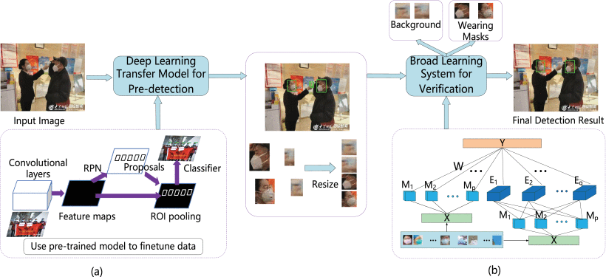

Fig.5. Block diagram of the proposed approach

Fig.5. shows the Block diagram of the proposed approach. It is cited from [14] Face location, eye location, face direction, occlusion degree, and occlusion type are all labeled on each masked face. [14] Wang et al. proposed a data set of Real World Masked Faces. It contains 4342 images, which are divided into three groups based on image size: smaller than 256 256; a fixed size of 256 256 with most of the images distorted; and different sizes of images without distortion. The data set, however, does not include label information.

1. *3D Face Reconstruction based masked Face synthesis*

Furthermore, in light of the COVID-19 pandemic, certain methods for general masked face recognition have been proposed. Geng et al. present a GAN-based method for the synthesis of masked faces, as well as a domain constrained loss to bring the masked faces close to the corresponding full face in the feature space. Furthermore, a latent part detection model is proposed to locate the facial region that is resistant to mask wear and can be used to extract discriminate features.[15] The methods described above primarily investigate general homogeneous masked face recognition, but the large domain gap between masked NIR faces and full VIR faces is a more difficult task.

1. CODE AND RESULTS.

The Coronavirus pandemic has left traces of

tragedy in many families, companies and countries.

This would not differ in the financial market, where

expectations influence decision making.

Political changes, global catastrophes, pandemics

can change investors' expectations about the future

of some financial assets, exchanges and companies.

The objective of this project is to analyze the asset

behavior of some companies that are in the race

for the Covid-19 vaccine. [Project Link](../../Downloads/Covid_Vaccines_Stocks.ipynb)

1. CONCLUSION

Aside from the successful execution of AI models in those other domains of image processing and computer vision, its implementation in detecting COVID-19 face masks in the actual world is still in its early stages. Face mask detection has been a difficult task in the domain of image processing, particularly during the COVID-19 pandemic, due to diversified mask types, various camera pixels, various degrees of obstructions, various variations (such as mall sizes, pose variation, shadows, illumination, the field of view, and rotation), attempting to balance various model detection accuracy or errors and real-time requirements, and deployment of detection model on computers with limited processing power. Furthermore, we concluded from the analysis that the majority of these datasets do not represent the real world because they were artificially created, which affects the precision accuracy of the model when deployed in the real world. This is due to the scarcity of publicly available face mask datasets for training deep learning and machine learning models to detect COVID-19 face masks. This has an impact on the performance of data mining and machine learning models, particularly when utilized in real-world, changing environments and under varying facemask-wearing conditions. Datasets are used by DL and machine learning models for training, accuracy, and extracting meaningful insights. According to the study, the majority of the datasets used to detect face masks are created artificially and do not represent real-world environments, which affects the precision accuracy of the model when installed in the real world. This has an impact on the performance of deep learning and machine learning models, particularly when deployed in real-world, dynamic environments and under varying facemask-wearing conditions. Because the emergence of infectious pandemics such as COVID-19 is unavoidable in the future, there is a need for the sharing of real-world COVID-19 mask images for simulating deep learning techniques. Future work can maybe concentrate on strategies for sharing real-world COVID-19 face mask images for modeling deep learning techniques, which will aid in the development of high-precision real-time automatic face mask detection systems. Such systems could be used in a variety of dynamic environments and facemask-wearing conditions. Furthermore, future work may employ deeper and wider deep learning architectures with increased training parameters, such as inception-v4, inception5h, Mask R-CNN, Faster R-CNN, YOLOv4, Xception, and DenseNet, which have not yet been implemented to detect face masks.

1. REFERENCES
2. M. I. Amin, M. Adeel Hafeez, R. Touseef and Q. Awais, "Person Identification with Masked Face and Thumb Images under Pandemic of COVID-19," 2021 7th International Conference on Control, Instrumentation and Automation (ICCIA), 2021, pp. 1-4, doi: 10.1109/ICCIA52082.2021.9403577.
3. X. Fan, M. Jiang and H. Yan, "A Deep Learning Based Light-Weight Face Mask Detector With Residual Context Attention and Gaussian Heatmap to Fight Against COVID-19," in IEEE Access, vol. 9, pp. 96964-96974, 2021, doi: 10.1109/ACCESS.2021.3095191.
4. A. Nowrin, S. Afroz, M. S. Rahman, I. Mahmud and Y. -Z. Cho, "Comprehensive Review on Facemask Detection Techniques in the

Context of Covid-19," in IEEE Access, vol. 9, pp. 106839-106864, 2021, doi: 10.1109/ACCESS.2021.3100070.

1. S. Srinivasan, R. Rujula Singh, R. R. Biradar and S. Revathi, "COVID-19 Monitoring System using Social Distancing and Face Mask Detection on Surveillance video datasets," 2021 International Conference on Emerging Smart Computing and Informatics (ESCI), 2021, pp. 449-455, doi: 10.1109/ESCI50559.2021.9396783.
2. S. Susanto, F. A. Putra, R. Analia and I. K. L. N. Suciningtyas, "The Face Mask Detection For Preventing the Spread of COVID-19 at Politeknik Negeri Batam," 2020 3rd International Conference on Applied Engineering (ICAE), 2020, pp. 1-5, doi: 10.1109/ICAE50557.2020.9350556.
3. I. B. Venkateswarlu, J. Kakarla and S. Prakash, "Face mask detection using MobileNet and Global Pooling Block," 2020 IEEE 4th Conference on Information & Communication Technology (CICT), 2020, pp. 1-5, doi: 10.1109/CICT51604.2020.9312083.
4. R. I. Yocupicio-Gaxiola et al., "Prospects for Further Development of Face Masks to Minimize Pandemics Functionalization of Textile Materials with Biocide Inorganic Nanoparticles: A Review," in IEEE Latin America Transactions, vol. 19, no. 6, pp. 1010-1023, June 2021, doi: 10.1109/TLA.2021.9451247.
5. J. Zhang, F. Han, Y. Chun and W. Chen, "A Novel Detection Framework About Conditions of Wearing Face Mask for Helping Control the Spread of COVID-19," in IEEE Access, vol. 9, pp. 42975- 42984, 2021, doi: 10.1109/ACCESS.2021.3066538.
6. H. Adusumalli, D. Kalyani, R. K. Sri, M. Pratapteja and P. V. R. D. P. Rao, "Face Mask Detection Using OpenCV," 2021 Third International Conference on Intelligent Communication Technologies and Virtual Mobile Networks (ICICV), 2021, pp. 1304-1309, doi: 10.1109/ICICV50876.2021.9388375.
7. X. Kong et al., "Real-Time Mask Identification for COVID-19: An Edge-Computing-Based Deep Learning Framework," in IEEE Internet of Things Journal, vol. 8, no. 21, pp. 15929-15938, 1 Nov.1, 2021, doi: 10.1109/JIOT.2021.3051844.
8. A. Negi, K. Kumar, P. Chauhan and R. S. Rajput, "Deep Neural Architecture for Face mask Detection on Simulated Masked Face Dataset against Covid-19 Pandemic," 2021 International Conference on Computing, Communication, and Intelligent Systems (ICCCIS), 2021, pp. 595-600, doi: 10.1109/ICCCIS51004.2021.9397196.
9. S. A. Sanjaya and S. Adi Rakhmawan, "Face Mask Detection Using MobileNetV2 in The Era of COVID-19 Pandemic," 2020

International Conference on Data Analytics for Business and Industry: Way Towards a Sustainable Economy (ICDABI), 2020, pp. 1-5, doi: 10.1109/ICDABI51230.2020.9325631.

1. T. Q. Vinh and N. T. N. Anh, "Real-Time Face Mask Detector Using YOLOv3 Algorithm and Haar Cascade Classifier," 2020 International Conference on Advanced Computing and Applications (ACOMP), 2020, pp. 146-149, doi: 10.1109/ACOMP50827.2020.00029.
2. B. Wang, Y. Zhao and C. L. P. Chen, "Hybrid Transfer Learning and Broad Learning System for Wearing Mask Detection in the COVID- 19 Era," in IEEE Transactions on Instrumentation and Measurement, vol. 70, pp. 1-12, 2021, Art no. 5009612, doi: 10.1109/TIM.2021.3069844.
3. H. Du, H. Shi, Y. Liu, D. Zeng and T. Mei, "Towards NIR-VIS Masked Face Recognition," in IEEE Signal Processing Letters, vol. 28, pp. 768-772, 2021, doi: 10.1109/LSP.2021.3071663.
4. Y. Chen et al., "Face Mask Assistant: Detection of Face Mask Service Stage Based on Mobile Phone," in IEEE Sensors Journal, vol. 21, no. 9, pp. 11084-11093, 1 May1, 2021, doi: 10.1109/JSEN.2021.3061178.
5. B. Qin, D. Li, Identifying facemask-wearing condition using image super-resolution with classification network to prevent COVID-19 Sensors (Switzerland) (2020), [10.3390/s20185236](https://doi.org/10.3390/s20185236)
6. M. Loey, G. Manogaran, MHN. Taha, NEM. Khalifa A hybrid deep transfer learning model with machine learning methods for face mask detection in the era of the COVID-19 pandemic, Meas J. Int. Meas.

Confed. (2021), [10.1016/j.measurement.2020.108288](https://doi.org/10.1016/j.measurement.2020.108288)

1. M. Inamdar, N. Mehendale, Real-time face mask identification using facemasknet deep learning network, SSRN Electron.

J. (2020), [10.2139/ssrn.3663305](https://doi.org/10.2139/ssrn.3663305)

1. GJ. Chowdary, NS. Punn, SK. Sonbhadra, S. Agarwal, Face mask detection using transfer learning of inceptionV3,

ArXiv (2020), [10.1007/978-3-030-66665-1_6](https://doi.org/10.1007/978-3-030-66665-1_6)

1. S. Yadav, Deep learning based safe social distancing and face mask detection in public areas for COVID-19 safety guidelines adherence, Int. J. Res. Appl. Sci. Eng.

Technol. (2020), [10.22214/ijraset.2020.30560](https://doi.org/10.22214/ijraset.2020.30560)

1. T. Subhamastan Rao, S. Anjali Devi, P. Dileep, M. Sitha Ram, A novel approach to detect face mask to control covid using deep learning, Eur. J. Mol. Clin. Med. (2020)