D214 – Capstone Task 2
Linear Regression Model for Determining Factors
that are Correlated with Depression in College Students

Lynh Le Casidy
November 30, 2025
Dr. Daniel Smith, Ph.D., MBA
Western Governors University

Table of Contents
Research Question 3
Research Question 3
Hypothesis 3
Summary of Research Question 3
Data Collection 5
Advantage 5
Challenges 6
Data Extraction and Preparation 8
Advantages: 8
Disadvantages: 8
Data Preparation Process 9
Analysis 16
Advantage 16
Disadvantage 16
Start of the Analysis 17
Data Summary & Implications 25
PDF, JPYNB, PY 25
Summary of Data Analysis 25
Limitation 25
Recommendations 26
F. Works Cited 27

Research Question

Research Question
To what extent do the variables, gender, age, profession, academic pressure, work pressure, study satisfaction, job satisfaction, sleep duration, dietary habits, degree, work/study hours, financial stress, and familial history affect depression among college students?

Hypothesis
Null Hypothesis: The variables gender, age, profession, academic pressure, work pressure, study satisfaction, job satisfaction, sleep duration, dietary habits, degree, work/study hours, financial stress, and familial history are not statistically significant to depression among college students.
Alternate Hypothesis: The variables gender, age, profession, academic pressure, work pressure, study satisfaction, job satisfaction, sleep duration, dietary habits, degree, work/study hours, financial stress, and familial history are statistically significant to depression among college students.

Summary of Research Question
I have been to many universities within the last ten years, and at almost every university, there has been at least one suicide attempt. Unfortunately, many of those attempts resulted in fatality. The fatalities caused the universities to send a mass email offering counseling to students, but after a week, the suicide attempts were never talked about again. I was curious as to why this happens at universities.
According to Abbot (2021), nearly 42% of students felt depressed to the point where they were unable to function. Additionally, a student’s support system may have difficulty recognizing symptoms of depression and understanding the “Why?” As a college student, I have been diagnosed with depression, and things have gotten worse related to schooling, but also other outside factors. I chose to research what variables affect depression among college students because of the suicide experiences on campus and my own depression diagnosis. I was curious as to what other factors can affect students' feelings of depression.

Data Collection
To find relevant data for my research, I searched “Student Depression” with the filter “Highly Voted for Research” on Kaggle.com, and it was the first result out of three datasets. I decided to go with this due to its positive reviews and large collection of records.
The Student Depression Dataset consists of 18 columns (id, gender, age, city, profession, academic pressure, work pressure, CGPA, study satisfaction, job satisfaction, sleep duration, dietary habits, degree, suicidal thoughts, work/study hours, financial stress, family history of mental illness, and whether a student is experiencing depression). Per the “Provenance” section on Kaggle, it states that data cleaning, anonymization, normalization, and feature selection have already been completed. More about the dataset explained by the owner of the data: “This dataset was compiled from multiple sources to provide a comprehensive view of mental health trends among students. The data was originally gathered through anonymized, self-reported surveys distributed across various educational institutions. Participants provided information on demographics, academic performance, lifestyle habits, and mental health indicators using standardized instruments and depression scales (Student Depression Dataset, 2025).”

Advantage
An advantage of using this dataset is that it has already undergone extensive preprocessing, including cleaning, anonymization, normalization, and feature selection. This ensures that the dataset was ready for modeling without major adjustments. Additionally, the large sample size provides the dataset with a wide variety of student mental health factors.
Disadvantage
A disadvantage of the dataset is that it was compiled from self-reported surveys, which introduces potential bias and inaccuracies in the responses. Students may underreport or overreport sensitive information such as suicidal thoughts or financial stress, which can affect the reliability of the data. Furthermore, because the dataset was gathered from multiple sources, there may be inconsistencies in how questions were asked or interpreted.

Challenges
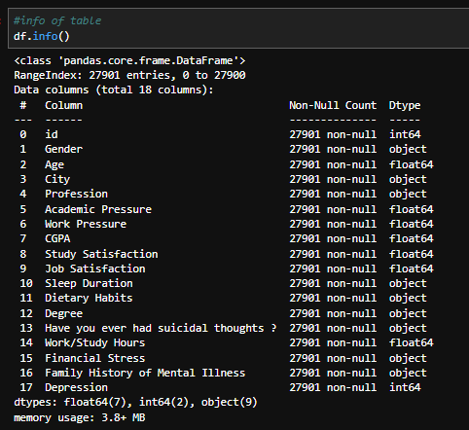
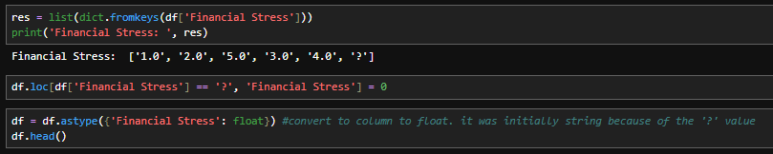
One challenge I encountered was the data type for the “Financial Stress” column. I had problems with my code working and reading the error code in Jupyter Notebook, I realized that the data type for “Financial Stress” was a string. The reason is that there was a “?” as one of the answers for the list, with the rest of the responses written as if they were the float data type. Once realized, I performed another step to encode the “?” to return a 0 and converted the data type of the column to a float.
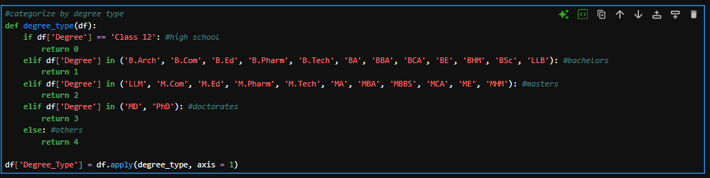
Another challenge is that the categorical variables “Age” and “Degree Type” could have been grouped by age ranges and degree types. I decided to group them into ordinal categories because there is an order of age and degree earned. For “Degree Type,” I categorized high school diploma as 0, bachelor's as 1, master's as 2, doctorate’s as 3, and others as 4.

For “Age”, I categorized the age ranges 18-29 as 0, 30-39 as 1, 40-49 as 2, and 50+ as 3.
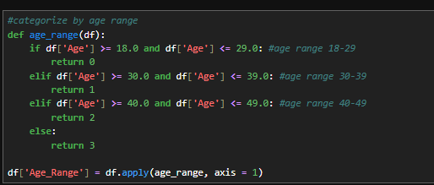

Data Extraction and Preparation
I used Jupyter Notebook and Python to analyze my data because I have familiarity with these tools and have used them throughout my educational and professional development.

Advantages:
According to Delony (2025), Jupyter Notebook doesn’t allow a complete wipe or alteration of spreadsheets because it keeps data separate from operations being performed with Python. Python also scales larger datasets, such as the data I am using for research, and can handle them with ease when performing any operation during my analysis (Delony, 2025). Additionally, Jupyter Notebook allows me to execute single operations, which is useful for debugging.

Disadvantages:
Although I can execute each isolated operation in Jupyter Notebook, executing lines after debugging may result in incorrect output or not execute at all. Therefore, this requires a complete restart of the whole kernel. With Python it is not the fastest language for data analysis and may cause a lag when running the kernel without stopping. I have a desktop computer built for gaming, and it can handle the load and performance well, but for others, it may not be the case.

Data Preparation Process
The following screenshots explain the data preparation process. Firstly, I downloaded the CSV file of the dataset from the Kaggle webpage.
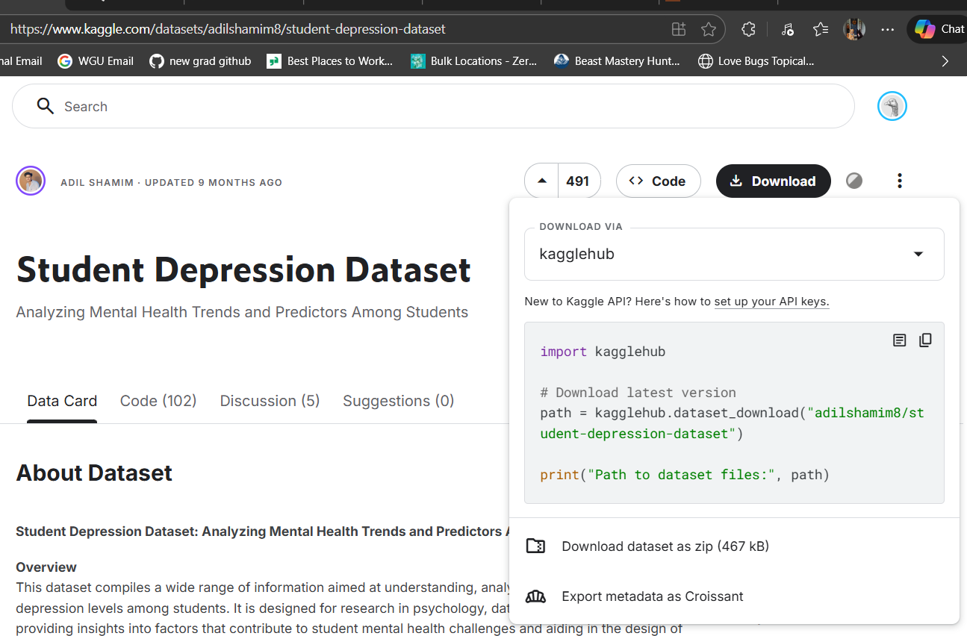

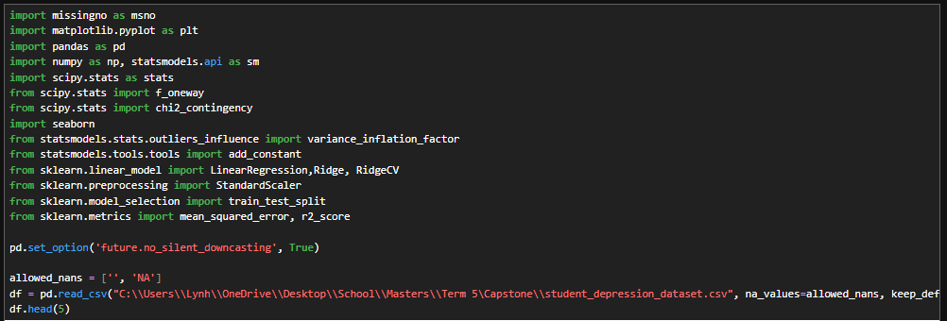
Then, I imported all packages and libraries and used pd.read_csv() to import the data.

Once imported, I checked the shape of the dataset to confirm the number of records aligned with what was shown on Kaggle.
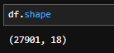
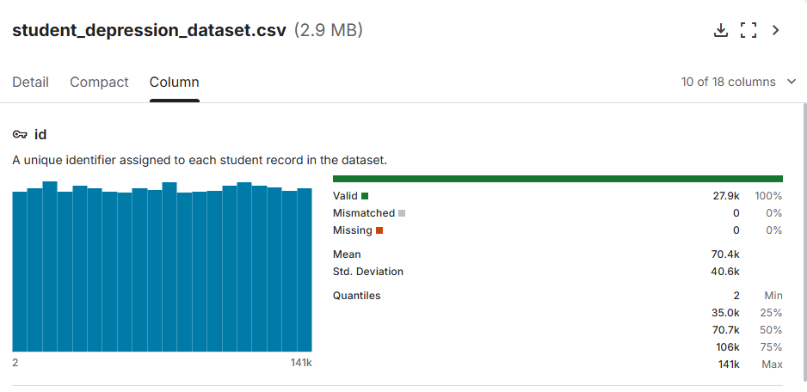

Next, I checked for duplicates. The output displays “False” for 27901, which means no duplicates were found in the dataset.
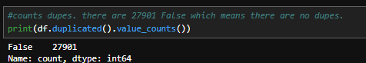

Next, I checked for nulls. The output displays 0 null values for all columns.
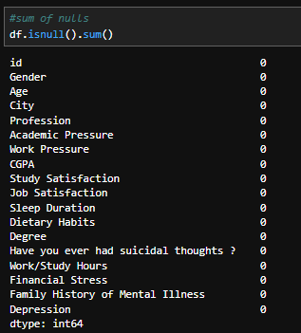

Then, I gathered a list of all answers for each column that I am using for research. This is to ensure I understand the possibility of answers for each column. I addressed the issue and process with the “Financial Stress” in the Challenges of the Data Collection header.
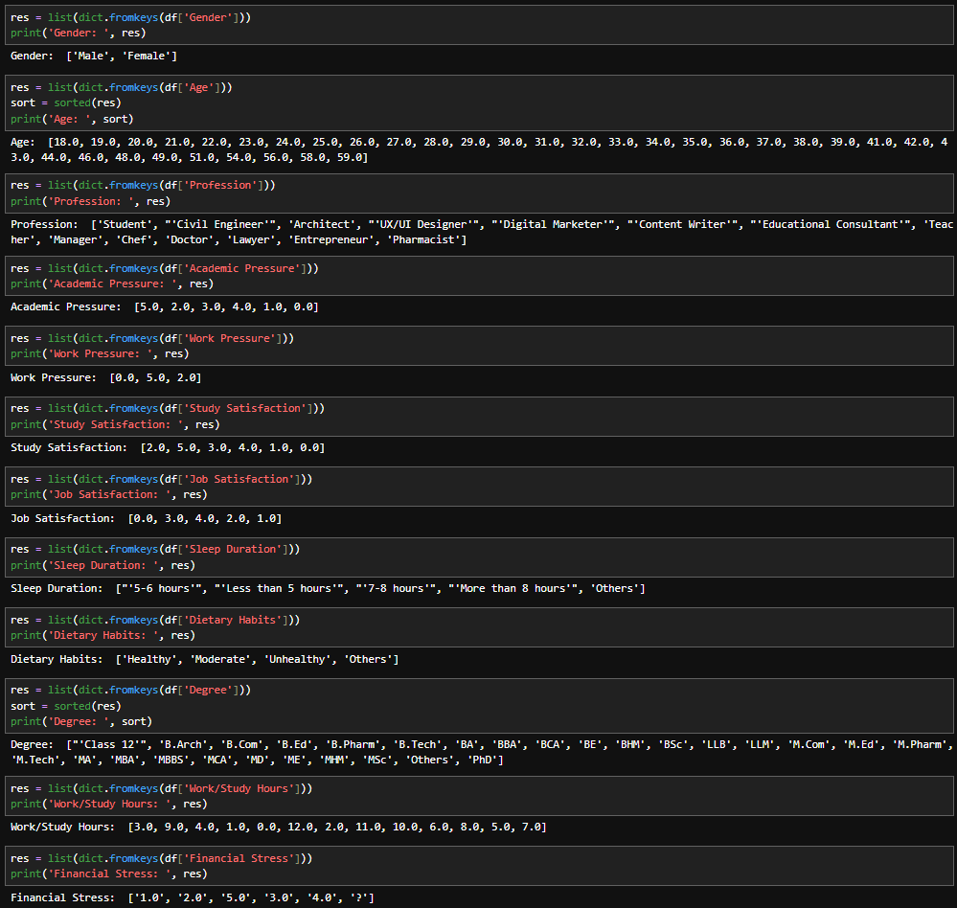

C. Describe your data-extraction and -preparation process and provide screenshots to illustrate each step. Explain the tools and techniques you used for data extraction and data preparation, including how these tools and techniques were used on the data. Justify why you used these particular tools and techniques, including one advantage and one disadvantage when they are used with your data-extraction and -preparation methods.
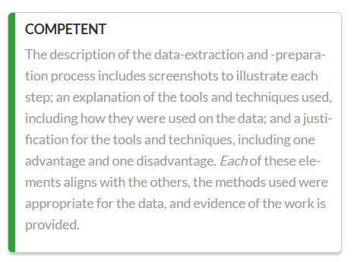
Next, I dropped variables that are not a part of the research question.
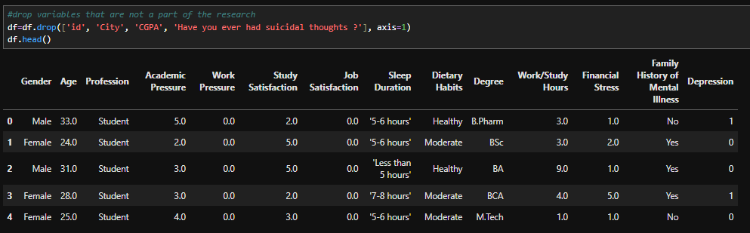

Next, I perform categorical binary encoding for “Family History of Mental Illness” and “Gender,” since it is necessary to have numerical values for data analysis.
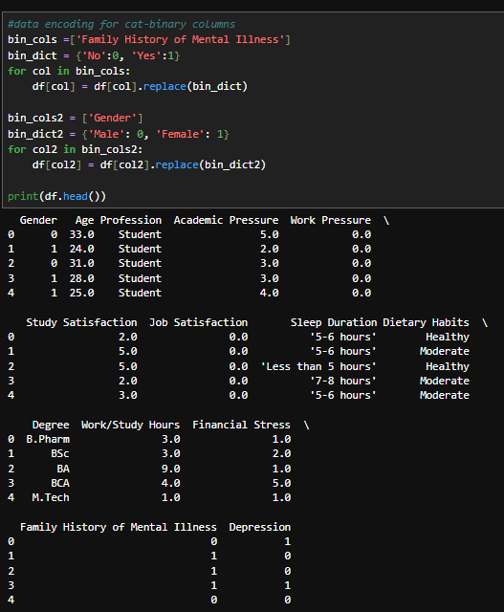
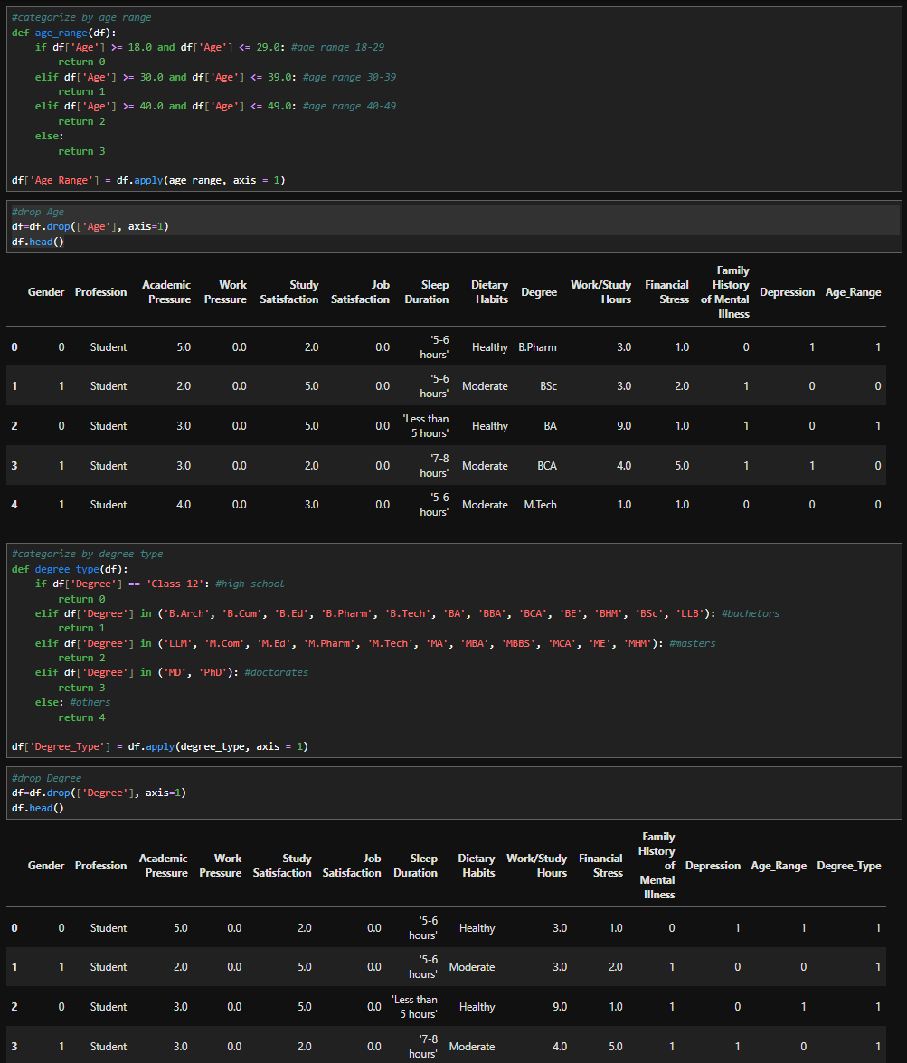
Please refer to the Challenges of the Data Collection header to see the reasoning as to why I decided to categorize “Age” and “Degree”. Once categorized, I dropped the original columns because they are redundant.
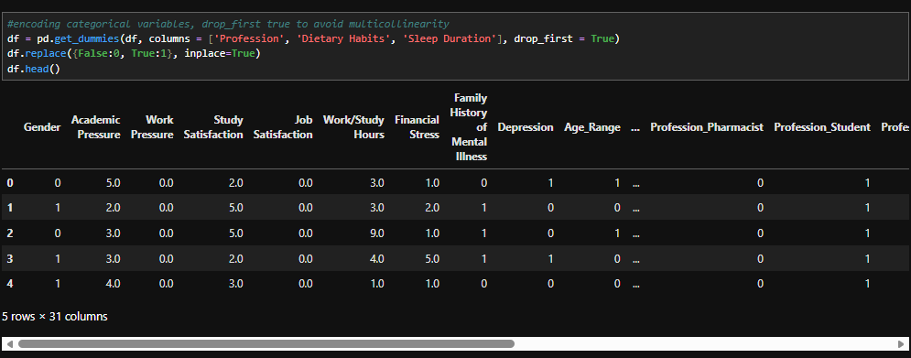
Next, I encoded categorical variables and set “drop_first” to True, because I wanted to avoid multicollinearity.

Analysis
For the data analysis, I will be using multiple linear regressions. Multiple linear regressions are based on assumptions. One assumption is that there’s a linear relationship between the dependent and independent variables. Another assumption is that the independent variables are not directly correlated with one another. Additionally, there’s an assumption that observations are chosen randomly and that residuals are normally distributed.

Advantage
An advantage of linear regression is that it is straightforward, the coefficients are easy to interpret, and the relationship between independent and dependent variables is expected to be linear. This method is effective due to its low complexity compared to more advanced algorithms. Although linear regression can be prone to overfitting, this risk can be mitigated through techniques such as dimensionality reduction, regularization methods (L1 and L2), and cross‑validation (ML - Advantages and Disadvantages of Linear Regression, 2025).

Disadvantage
A disadvantage is its sensitivity to outliers, which can influence the model’s coefficients and overall fit. The technique also relies on the assumption of a strictly linear relationship between independent and dependent variables, meaning it may perform poorly when the true relationship is non-linear (ML - Advantages and Disadvantages of Linear Regression, 2025).

Start of the Analysis
Once the data is prepared, I printed the names of the columns so I could input the calculation for the Variance Inflation Factor (VIF) analysis to assess multicollinearity, if any. VIFs exceeding 5 or 10 are indicative of high multicollinearity between independent variables (Bhandari, 2020). Most variables exhibited low VIF values (< 5), except for Profession_Student (VIF = 29.527407), Academic Press (8.009824), Study Satisfaction (5.883014), and Financial Stress (6.665752). VIF values greater than 5 indicate moderate collinearity.
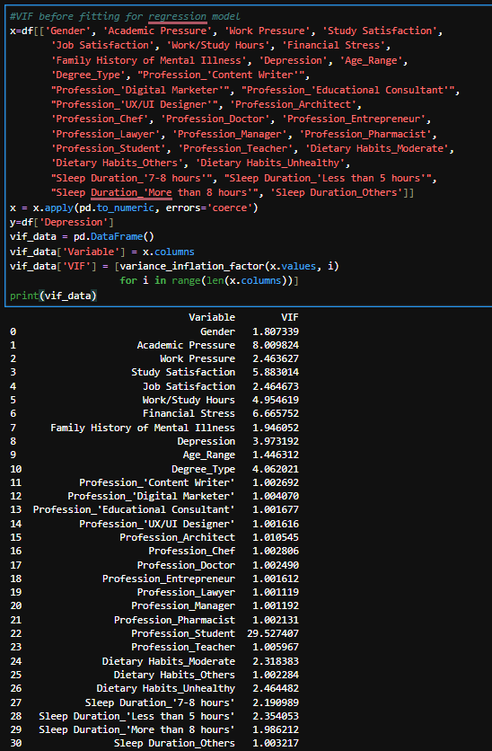
To address multicollinearity, I applied a regularization technique called ridge regression, which shrinks the coefficients of correlated variables, mitigating the effects of multicollinearity (Multicollinearity in Regression: How to See and Fix Issues, 2025). I decided to use ridge regression because all predictors used should contribute to the outcome, a “student” is considered a profession, and shouldn’t be excluded from the model (Ridge Regression vs Lasso Regression, 2025). The code used was inspired by the Lasso and Ridge Regression in Python Tutorial (2025). Comparing the training and testing scores of a linear regression model and a ridge regression model, there does not seem to be a significant difference in whether I handle the multicollinearity or not. Additionally, I plotted the graph to provide a visualization of the differences, but there weren’t any significant differences.
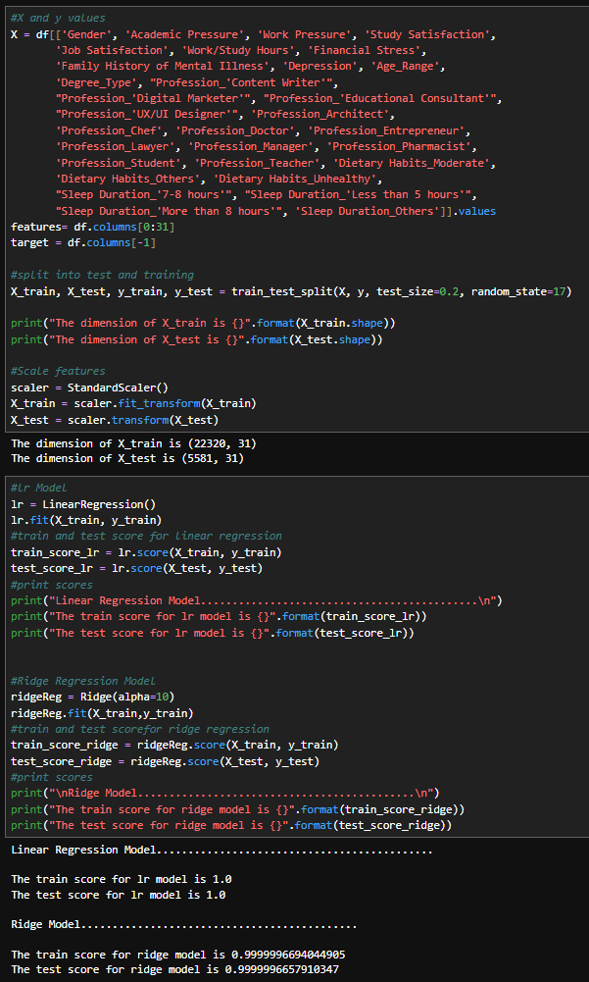
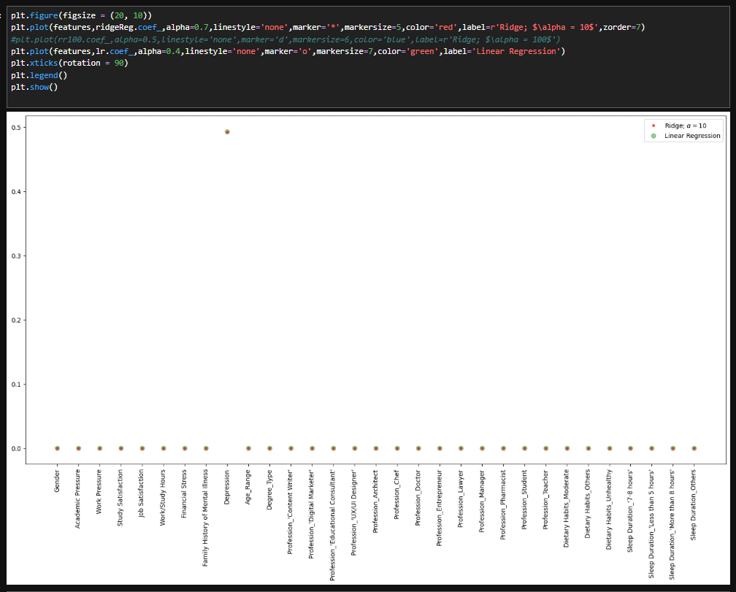

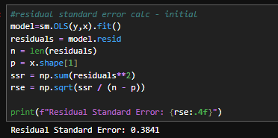
Moving forward, I performed the initial linear regression, as the ridge regression didn’t provide a significant change in the dataset. I also calculated the residual standard error, which measures the standard deviation of residuals and determines errors associated with the prediction.
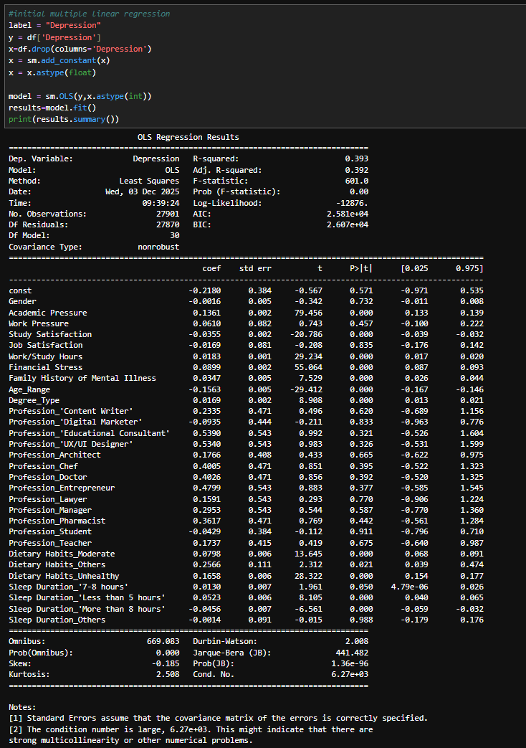
Then, I reduced linear regression and calculated the reduced residual standard error. Comparing the initial and reduced results, the residual standard error calculation remains the same, which means that there is no better regression than the other. Comparing the initial and reduced model results, the residual standard error calculation remains the same, and there is no better regression than the other.
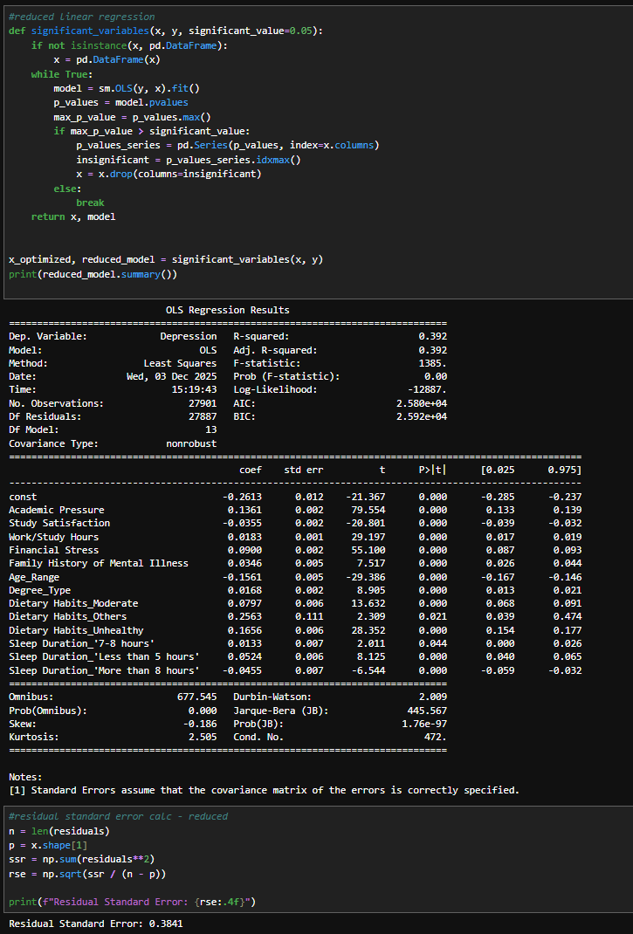
Then, I checked the residual structure by plotting a residual scatterplot. Since there are two distinct patterns, this suggests that the model may be missing nonlinear relationships, and the model does not provide a good residual structure. Heteroscedasticity is seen, meaning that there is an unequal scatter of residuals. Therefore, this indicates that the linear regression model may not be the best fit for the data. (Bobbitt, 2023).
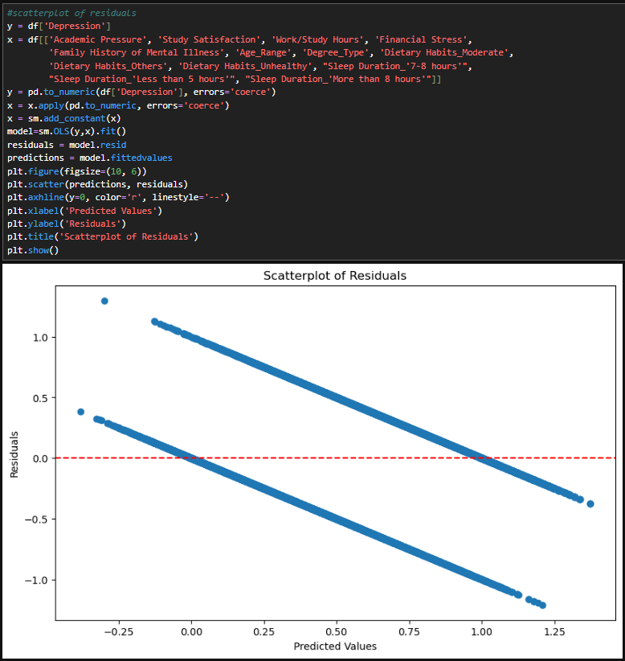
Next, I create a Quantile-Quantile (Q-Q) plot of residuals to determine if the dataset follows a particular distribution. The plot shows that the residuals are normally distributed, and the model fits the data well in terms of the normality assumption (The Q-Q Plot: What It Means and How to Interpret It, 2025).
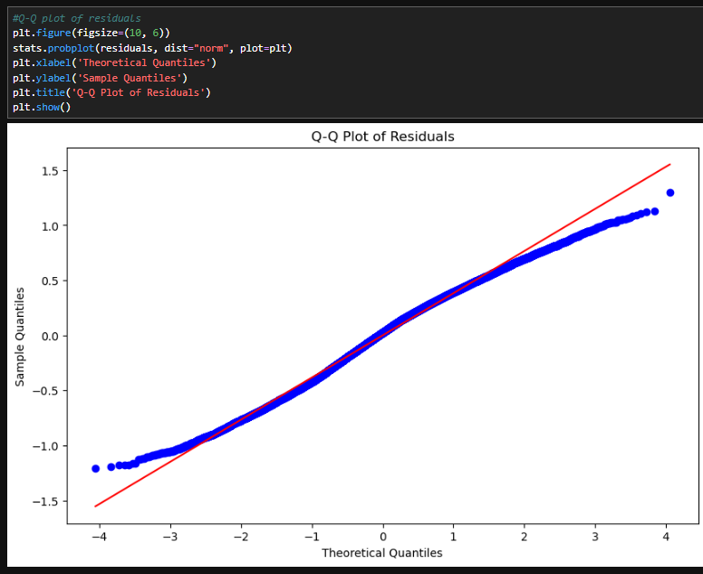

Data Summary & Implications

PDF, JPYNB, PY
lynhCasidy_Capstone_Task2.pdf
lynhCasidy_Capstone_Task2.jpynb
lynhCasidy_Capstone_Task2.py

Summary of Data Analysis
The analysis revealed that academic pressure, study satisfaction, work/study hours, financial stress, family history of mental illness, age, degree type, dietary habits, and sleep duration were significant predictors of students who reported experiencing depression. The regression model explained a meaningful portion of the variance in depression outcomes, suggesting that these variables are strongly associated with student mental health. The Q-Q plot indicates that the normality assumption was satisfied; however, the residual scatterplot displayed a structured pattern, violating linearity and homoscedasticity. This discrepancy implies that the model satisfies the normality assumption but may be missing key interactions or non-linear relationships (Bobbitt, 2023). These findings suggest that both lifestyle and demographic factors contribute meaningfully to mental health outcomes.

Limitation
A limitation of this analysis is that the dataset only asked students in India. It doesn’t provide a diverse range of students who come from different cultures. Collecting data across diverse cultures may reveal meaningful differences in certain influencing factors. For example, some cultures place a strong emphasis on professional achievement and educational success, which can shape students’ career choices and stress levels.

Recommendations
- I recommend that further model refinement, such as using a non-linear regression, be considered because they can capture interactions between variables that the linear regression missed and are flexible to handle patterns in data (The Difference between Linear Regression and Nonlinear Regression Models, 2025). This would help address the structured residual patterns observed in the scatterplot.
- I recommend expanding data collection to include students from multiple continents and cultural backgrounds. As noted in the Limitations section, cultural values surrounding education and professional success vary widely. Incorporating perspectives from different regions would enhance diversity in the dataset.

F. Works Cited
Abbott, G. (2021, September 13). What are the warning signs of depression in college students? National Alliance on Mental Illness. https://www.nami.org/Blogs/NAMI-Blog/September-2021/What-Are-the-Warning-Signs-of-Depression-in-College-Students
Bhandari, A. (2020, March 19). What is Multicollinearity? | Causes, Effects and Detection Using VIF. Analytics Vidhya. https://www.analyticsvidhya.com/blog/2020/03/what-is-multicollinearity/
Bobbitt, Z. (2023, February 17). What is Considered a Good vs. Bad Residual Plot? Statology. https://www.statology.org/good-vs-bad-residual-plot/
Delony, D. (2025, October 30). 5 Reasons Jupyter Notebooks With Python Are Better Than Excel for Data Analysis. How-To Geek. https://www.howtogeek.com/jupyter-notebooks-with-python-are-better-than-excel-for-data-analysis/
Lasso and Ridge Regression in Python Tutorial. (n.d.). Retrieved December 3, 2025, from https://www.datacamp.com/tutorial/tutorial-lasso-ridge-regression
ML - Advantages and Disadvantages of Linear Regression. (08:51:32+00:00). GeeksforGeeks. https://www.geeksforgeeks.org/machine-learning/ml-advantages-and-disadvantages-of-linear-regression/
Multicollinearity in Regression: How to See and Fix Issues. (n.d.). Retrieved December 3, 2025, from https://www.datacamp.com/tutorial/multicollinearity
Ridge Regression vs Lasso Regression. (18:55:50+00:00). GeeksforGeeks. https://www.geeksforgeeks.org/machine-learning/ridge-regression-vs-lasso-regression/
Student Depression Dataset. (n.d.). Retrieved November 26, 2025, from https://www.kaggle.com/datasets/adilshamim8/student-depression-dataset/data
The Difference between Linear Regression and Nonlinear Regression Models. (18:44:06+00:00). GeeksforGeeks. https://www.geeksforgeeks.org/machine-learning/the-difference-between-linear-regression-and-nonlinear-regression-models/
The Q-Q Plot: What It Means and How to Interpret It. (n.d.). Retrieved December 3, 2025, from https://www.datacamp.com/tutorial/qq-plot

