**Lab Practical #01:**

Study of basic networking commands and IP configuration.

**Practical Assignment #01:**

1. Perform and explain various networking commands listed below:
   1. ipconfig
   2. ping
   3. getmac
   4. systeminfo
   5. traceroute / tracert
   6. netstat
   7. nslookup
   8. hostname
   9. pathping
   10. arp

## ipconfig

### Description:

It displays the current network configuration details of the system, including IP address, subnet mask, and default gateway. It can also be used to refresh DHCP and DNS settings with options like /release and /renew.

|  |  |  |
| --- | --- | --- |
| No. | Option | Description |
| 1 | Link-local IPv6 Address | Display Ip version 6 address of wireless LAN Adapter |
| 2 | IPv4 Address | Display Ip version 4 address of wireless LAN Adapter |
| 3 | Subnet Mask | Display Address number of Subnet Mask of wireless adapter |
| 4 | Default Gateway | Display Address number of Gateway of wireless adapter |
| 5 | Ethernet adapter Bluetooth Network Connection | Display Details Of ethernet adapter and bluethooth Connection. |

### Implementation:

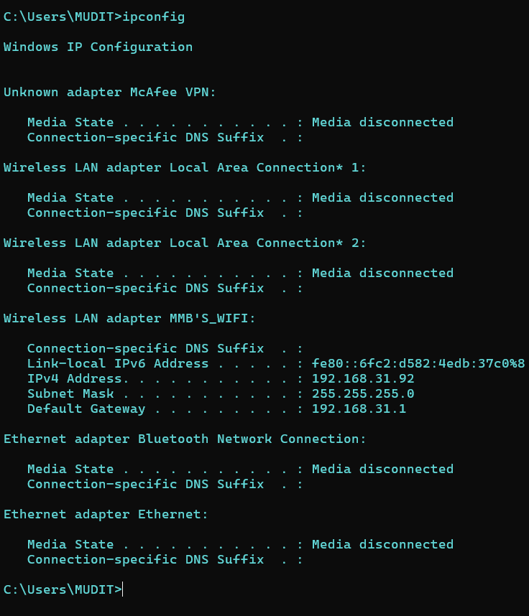

## ping

### Description:

The ping command in Windows tests the connectivity between your computer and another device by sending Internet Control Message Protocol (ICMP) echo request packets and measuring the time it takes to receive a response. It's used to diagnose network issues and ensure a device is reachable.

|  |  |  |
| --- | --- | --- |
| No. | Option | Description |
| 1 | -a | Resolve addresses to hostnames. |
| 2 | -n count | Number of echo requests to send. |
| 3 | -S srcaddr | Source address to use. |
| 4 | -c compartment | Routing compartment identifier |
| 5 | -p | Ping a Hyper-V Network Virtualization provider address. |

### Implementation:

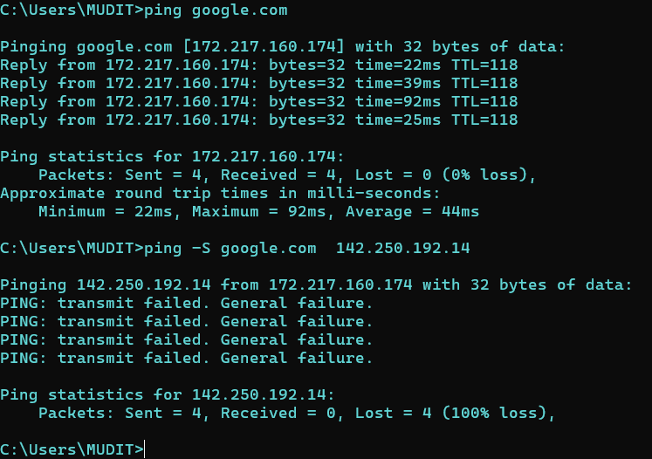

## 3. GETMAC

### Description:

The getmac command in Windows displays the MAC addresses for network adapters on a system, along with their associated transport names. It is useful for identifying network hardware and troubleshooting network-related issues.

|  |  |  |
| --- | --- | --- |
| No. | Option | Description |
| 1 | /S | Specifies the remote system to connect to. |
| 2 | /U | Specifies the user context under which the command should execute. |
| 3 | /P | Specifies the password for the given user context. Prompts for input if omitted. |
| 4 | /FO | Specifies the format in which the output is to be displayed. Valid values: "TABLE", "LIST", "CSV". |
| 5 | /V | Specifies that verbose output is displayed. |

### Implementation:

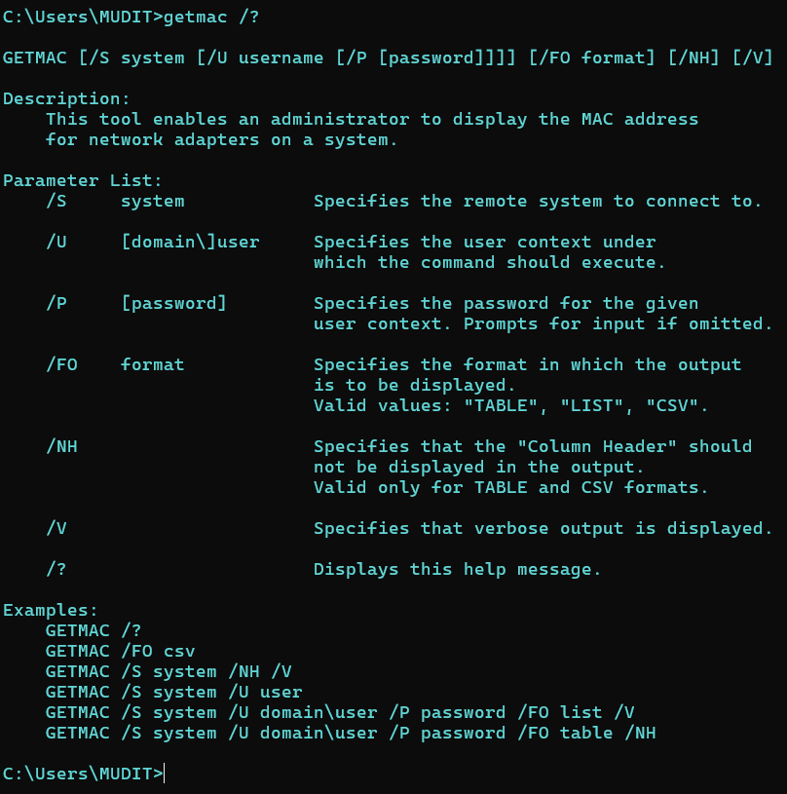

## 4. Systeminfo

### Description:

The systeminfo command in Windows displays detailed information about the system configuration. It provides data such as the OS version, hardware specifications, network configurations, and system uptime. This command is useful for diagnosing system issues and gathering essential system details for troubleshooting and maintenance.

|  |  |  |
| --- | --- | --- |
| No. | Option | Description |
| 1 | Logon Server | Specifies Local Pc or Server name. |
| 2 | Host Name | Specifies The host name of your local pc. |
| 3 | Registered Owner | Specifies Owner name of local pc. |
| 4 | BIOS Version | Specifies the Bios Company and version name. |
| 5 | OS Manufacturer | Specifies the local pc’s Manufacturer company name. |

### Implementation:

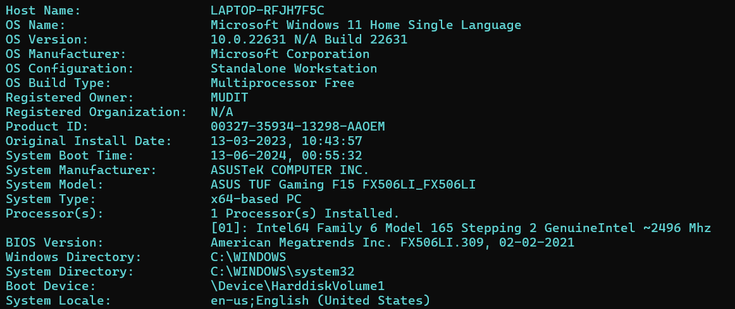

## 5. tracert

### Description:

The tracert (short for "trace route") command in Windows is used to determine the path packets take to reach a destination network address. It sends a sequence of ICMP echo requests and displays each hop along the route, including the time taken for each hop. This helps diagnose network connectivity issues by identifying where delays or failures occur.

|  |  |  |
| --- | --- | --- |
| No. | Option | Description |
| 1 | -d | Do not resolve addresses to hostnames. |
| 2 | -R | Trace round-trip path (IPv6-only). |
| 3 | -4 | Trace round-trip path (IPv4-only). |
| 4 | -S srcaddr | Source address to use (IPv6-only). |
| 5 | -j host-list | Loose source route along host-list (IPv4-only). |

### Implementation:

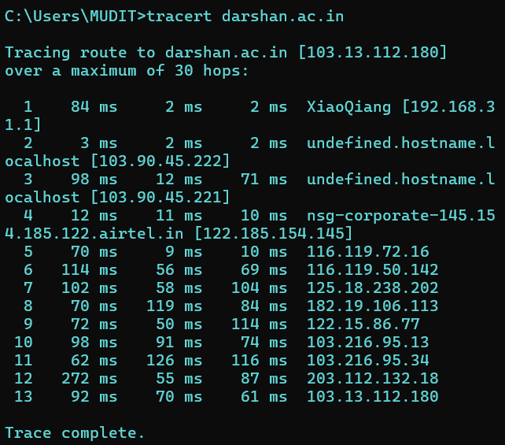

## 6. netstat

### Description:

The netstat command in Windows is used to display network statistics and information about active TCP connections, routing tables, network interfaces, and protocol usage. It helps diagnose network issues and monitor network performance by providing details such as local and foreign addresses, connection states, and port numbers. Running netstat with various options can yield more specific data, like netstat -a for all connections and listening ports or netstat -n for numerical addresses.

|  |  |  |
| --- | --- | --- |
| No. | Option | Description |
| 1 | -q | Displays all connections, listening ports, and bound non-listening TCP ports. |
| 2 | -r | Displays the routing table. |
| 3 | -t | Displays the current connection offload state. |
| 4 | -x | Displays Network Direct connections, listeners, and shared endpoints. |
| 5 | -y | Displays the TCP connection template for all connections. Cannot be combined with the other options. |

### Implementation:

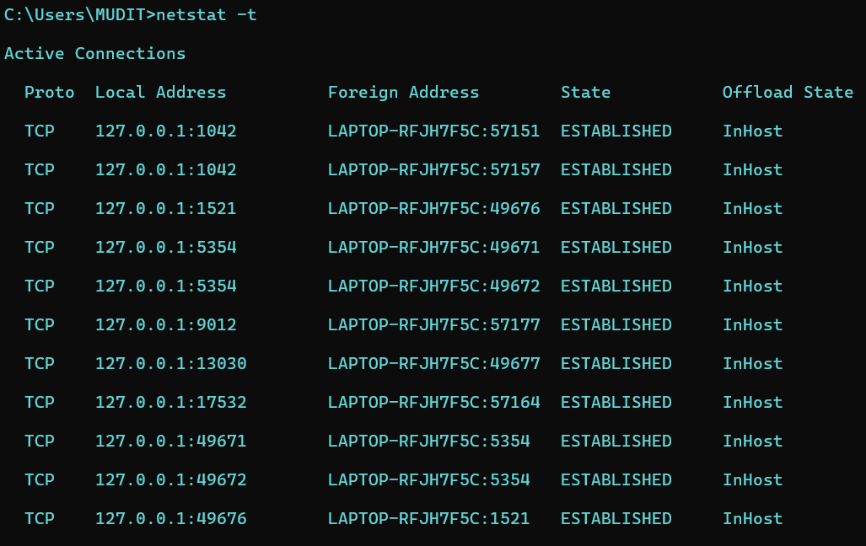

## 7. nslookup

### Description:

The nslookup command in Windows is a network utility used to query Domain Name System (DNS) servers to obtain domain name or IP address mapping information. It helps diagnose DNS issues by retrieving detailed DNS records for specified domains. Users can look up information such as IP addresses, MX records, and other DNS-related data.

|  |  |  |
| --- | --- | --- |
| No. | Option | Description |
| 1 | nslookup [-opt ...] | interactive mode using default server |
| 2 | Server | Specifies The Server Name. |
| 3 | Address(server) | Specifies Address of local pc. |
| 4 | Name | Specifies the name of Website which are you look up. |
| 5 | Address(web site) | Specifies the Web Site address. |

### Implementation:

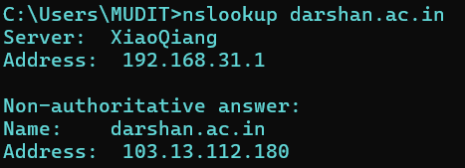

## 8. Hostname

### Description:

The hostname command in Windows is used to display the name of the current computer or host. This command, when executed in the Command Prompt, outputs the NetBIOS name of the local machine, which can be useful for network identification and troubleshooting. Simply typing hostname and pressing Enter will reveal the system's name.

|  |  |  |
| --- | --- | --- |
| No. | Option | Description |
| 1 | hostname | Display the host name of your local computer. |

### Implementation:

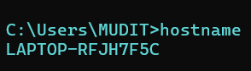

## 9. pathping

### Description:

The pathping command in Windows is a network utility that combines the functions of ping and tracert to test and diagnose network connectivity issues. It sends packets to each router on the way to a final destination and computes results over a period of time, providing detailed information on packet loss and latency at each hop. This helps in identifying network bottlenecks and potential points of failure.

|  |  |  |
| --- | --- | --- |
| No. | Option | Description |
| 1 | -g host-list | Loose source route along host-list. |
| 2 | -h Maximum_hops | Maximum number of hops to search for target. |
| 3 | -I address | Use the specified source address. |
| 4 | -n | Do not resolve addresses to hostnames. |
| 5 | -w timeout | Wait timeout milliseconds for each reply. |

### Implementation:

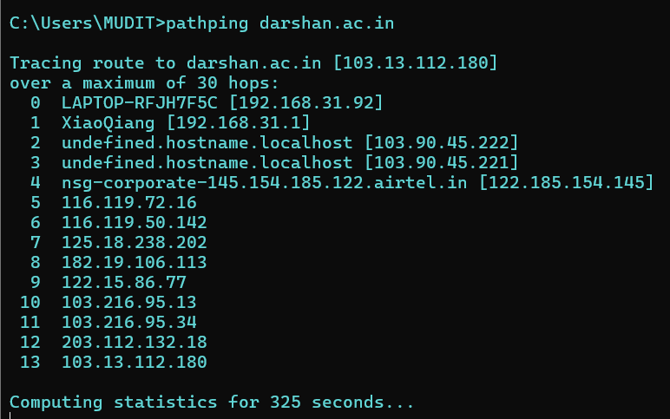

## 10. arp

### Description:

The arp command in Windows is used to display and modify the Address Resolution Protocol (ARP) cache, which maps IP addresses to physical MAC addresses on a local network. This command helps in troubleshooting network issues by showing the current ARP entries and allows users to add or delete specific entries. Key options include arp -a to view the ARP table and arp -d to delete an entry.

|  |  |  |
| --- | --- | --- |
| No. | Option | Description |
| 1 | -a | Displays current ARP entries by interrogating the current protocol data. |
| 2 | -v | Displays current ARP entries in verbose mode. All invalid entries and entries on the loop-back interface will be shown |
| 3 | Inet_addr | Specifies an internet Address of. |
| 4 | -d | Deletes the host specified by inet_addr. inet_addr may be wildcarded with * to delete all hosts. |
| 5 | If_addr | If present, this specifies the Internet address of the interface whose address translation table should be modified. If not present, the first applicable interface will be used. |

### Implementation:

