**Lab Practical #03:**

Study of different network devices in detail.

**Practical Assignment #03:**

1. Give difference between below network devices.

* Hub and Switch
* Switch and Router
* Router and Gateway

1. Working of below network devices:
   * Switch
   * Router
   * Gateway

# Hub and Switch

|  |  |  |
| --- | --- | --- |
| No. | Hub | Switch |
| 1 | Broadcasts data to all devices on the network. | Sends data only to the specific device it is intended for. |
| 2 | Operates at the physical layer (Layer 1) of the OSI model. | Operates at the data link layer (Layer 2) and sometimes the network layer (Layer 3). |
| 3 | No intelligence; simply repeats incoming signals to all ports. | Intelligent; can learn MAC addresses and make forwarding decisions. |
| 4 | Slower due to repeated broadcasting. | Faster due to direct data paths. |
| 5 | Generally cheaper. | More expensive but offers better performance. |
| 6 | Less efficient due to data collisions. | More efficient with minimal data collisions. |
| 7 | Shared bandwidth among all ports. | Dedicated bandwidth per port. |

# 

# 

# Switch and Router

|  |  |  |
| --- | --- | --- |
| No. | Switch | Router |
| 1 | Connects devices within a single network, creating a local area network (LAN). | Connects different networks together, directing data between them. |
| 2 | Operates at Layer 2 (Data Link Layer) of the OSI model. | Operates at Layer 3 (Network Layer) of the OSI model. |
| 3 | Uses MAC addresses to forward data to the correct device within the same network. | Uses IP addresses to route data between different networks. |
| 4 | Generally faster for data transfer within a network. | Slightly slower as it processes and directs data between networks. |
| 5 | Manages traffic based on MAC addresses and uses a switching table. | Manages traffic based on IP addresses and uses a routing table. |
| 6 | Typically keeps all connected devices in the same broadcast domain. | Breaks up broadcast domains, creating separate broadcast domains for each connected network. |
| 7 | Used within a single network (LAN). | Used to connect different networks (LAN to WAN). |

# Router and Gateway

|  |  |  |
| --- | --- | --- |
| No. | Router | Gateway |
| 1 | Connects multiple networks and directs data packets between them. | Acts as a bridge between different network protocols or architectures |
| 2 | Operates primarily at the network layer (Layer 3) of the OSI model. | Can operate at any layer of the OSI model, depending on its function. |
| 3 | Commonly used to connect local area networks (LANs) to wide area networks (WANs). | Used to connect networks with different protocols, such as a LAN to the internet. |
| 4 | Typically performs IP address routing and forwarding. | Often performs protocol translation, such as converting IP addresses to other network protocols. |
| 5 | Configured with routing tables and protocols like OSPF, BGP, or RIP. | Configured to handle protocol conversion and specific network tasks. |

# Working of below network devices:

1. Switch:

* A network switch is a crucial device in computer networking that connects multiple devices within a local area network (LAN) and uses packet switching to forward data to its destination. Unlike a hub, which broadcasts data to all connected devices, a switch intelligently directs incoming data packets to the specific device based on its Media Access Control (MAC) address. This targeted communication reduces network congestion and enhances overall performance. Switches operate at the data link layer (Layer 2) of the OSI model, although some advanced switches also have Layer 3 capabilities, enabling basic routing functions. They come in various configurations, from simple unmanaged switches suitable for home networks to complex managed switches used in enterprise environments, offering features such as VLAN support, Quality of Service (QoS), and port mirroring. By improving the efficiency and speed of data transmission within a network, switches play a vital role in maintaining the smooth operation of modern digital communication.
* Image:



1. Router

* A router is a critical device in a computer network that directs data packets between different networks, ensuring efficient and accurate data transmission. Operating at the network layer (Layer 3) of the OSI model, a router uses IP addresses to determine the best path for forwarding each data packet. This process is facilitated by routing tables and protocols such as OSPF, BGP, and RIP, which help the router make informed decisions about packet routes. Routers can connect local area networks (LANs) to wide area networks (WANs), enabling devices in different geographical locations to communicate with each other. They also provide basic security functions like Network Address Translation (NAT) and firewall rules to protect the network from unauthorized access and to manage traffic. In essence, routers are the backbone of data routing on the internet and within private networks, ensuring that information travels smoothly from its source to its intended destination.
* Image:

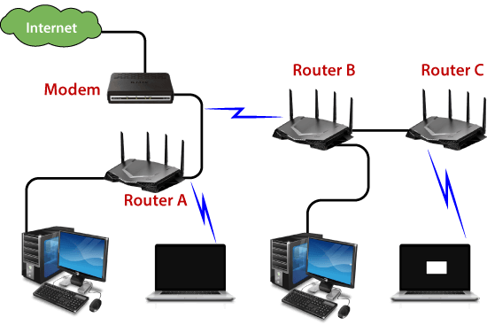

1. Gateway

* A gateway in networking serves as a critical intermediary that connects two different networks, often operating with distinct protocols or architectures. It acts as a translator, enabling seamless communication between heterogeneous systems by converting data from one protocol to another. For instance, a gateway can bridge a local area network (LAN) to the broader internet, facilitating the exchange of data between devices that use different communication protocols. This translation capability makes gateways essential for integrating legacy systems with modern network infrastructures or connecting different types of networks, such as a VoIP network with a traditional PSTN. Besides protocol conversion, gateways can also provide additional functionalities like security enhancements, traffic management, and data compression. They ensure that data packets reach their intended destination accurately, regardless of the underlying network differences, thus playing a pivotal role in maintaining interoperability and connectivity in complex network environments.
* Image:

