
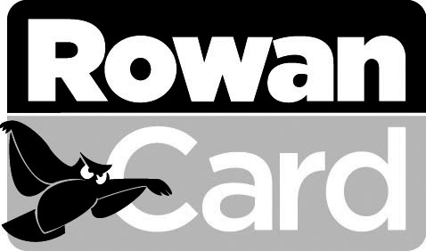
ROWANCARD
CLOSE ACCOUNT REQUEST

NAME________________________________ ROWAN ID #___________________________
Last, First (please print)

Yes! I would like to close my Dining and/or Debit account(s) at the end of the
academic school year. I authorize the University to credit my University account
for any unused funds remaining in those accounts. I understand that only
balances of $10.00 or greater are eligible for refunding. Checks will be mailed to
the students permanent address listed in the system.
Office use only
[ ] [ ]
SIS Bb

____________________________________________
Student signature Date

