We’ll use the following frameworks to fix this website:
- WCAG 2.0 Compliance: Perceivable, Operable, Understandable, Robust
- Jacob Nielsen’s 10 Usability Heuristics:
https://www.nngroup.com/articles/ten-usability-heuristics/
- Aesthetic --> must be cinematic, tell a story rather than showcase a random website.
Personas:
- Her professional website may be a signal to potential partners, recruiters, and academic/educational institutions. But exactly what does she teach?
  - Poetry but why poetry? What’s her major motivation to teach poetry to people? Is it to inspire them to value the underlying
Persona:
- Academic Institutions
- General Public
- Haters from Elementary School
- Researchers
Improvements: Home Page
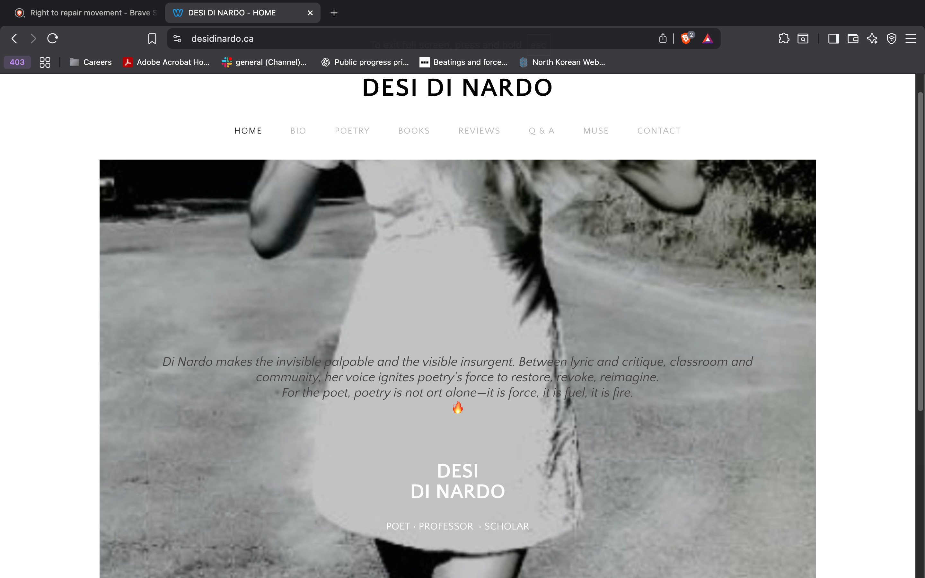
- Grey on grey, hard for the reader to read.
- Certain aspects of the hero can be more operable.
- As a user, I would love to immediately access, based on the hero, where and how she is a poet, professor, or scholar. Add anchors that link to her work as a poet, her work as a professor, and her work as a scholar.
Tagline:
Di Nardo makes the invisible palpable and the visible insurgent. Between lyric and critique, classroom and community, her voice ignites poetry’s force to restore, revoke, reimagine.
​For the poet, poetry is not art alone—it is force, it is fuel, it is fire.
🔥​
As a user, personally…
- Too semantic. On the first load up of the home page, I want to get to know exactly who she is immediately. I want to know what kind of work she does, where she brings value, and how I, as a potential partner, can connect with and contact her.


- Header could improve operability.
  - Right now, as I’m hovering on the header items, there’s a timing mismatch between the color fade-in and me hovering on the item, which makes the website less sleek.
Improvements: Bio:
- First paragraph should be in the home page, in her hero.
- Links so that users know exactly what her organizations are, and what they support. E.g. (Habitat for Women, CAMH, SickKids, June Callwood Centre, Poetry Parade)
Find a way to consolidate, brandify, and immersify all her poems.
- We’ll work with things like html frames (nested websites as part of her carousel. Different views, and Blender action.
Books & Bio: Mix of Three.js, React, and potentially Blender.
Q&A Dropdowns, stabilize information architecture into cohesiveness

Decorations:
- Sunflowers “the sun is my emblem”.
- Daisies
- Cicadas & The Sun
HTML/CSS/JavaScript:

Idea:
- The Bad Game create as much disinformation to get followers using online tricks to see who can get the most followers.
- Goal: Understanding how disinformation gets passed around.
  - Zero sum interaction posting and
  - Cyber security Phishing scams, DDoS,
  - Scammers MLMs, Fake Gurus,
- Sifting: Stop, investigate, find other sources, traceback to your original source.

Wednesday 5-7pm

