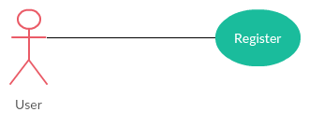

|  |  |
| --- | --- |
| Use Case ID | UC-MH001 |
| Name | Register on App |
| Objective | To register user on application |
| Entry conditions | This use case will initiate when a new user register itself |
| Success end condition | User is registered and his/her details is added to the database |
| Fail end condition | User is unable to sign-up because the required information is not provided or user already exists in database |
| Actors | User |
| Main scenario | * User can download the *Musician Hub* application from play store and after opening the app, he/she can sign up using the sign up form * The details of user will be stored to database |

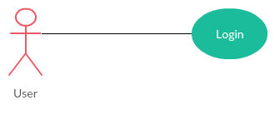

|  |  |
| --- | --- |
| Use Case ID | UC-MH002 |
| Name | Login |
| Objective | To search other members and events on Application |
| Entry conditions | This use case will initiate when user requests to login in to the app |
| Success end condition | User is logged in to the app |
| Fail end condition | Username and password of user does not match to the database so user is unable to login to the system |
| Actors | User |
| Main scenario | * The login process required *username* and *password* of a user which he/she created at the time of registration * The application will compare the required info of the user with the one in database * If the information matches user will login successfully and if it does not, user will be prompted to enter correct info |

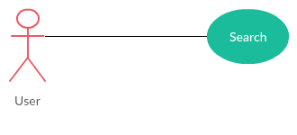

|  |  |
| --- | --- |
| Use Case ID | UC-MH003 |
| Name | Search other users |
| Objective | To search other members and events on Application |
| Entry conditions | This use case will initiate when a user is logged in to the app and type the name of member or event in search bar |
| Success end condition | User is able to search desired member or event |
| Fail end condition | The search result is not available into the system |
| Actors | User |
| Main scenario | * The user enters the name of desired event or musician in the search bar * He/She can use the filters eg: City, Expertise, Ratings, etc. * The app will show all the available results from the database according to the filter |

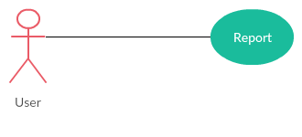

|  |  |
| --- | --- |
| Use Case ID | UC-MH004 |
| Name | Report Fake Content |
| Objective | To report fake content or ID in the application |
| Entry conditions | This use case will initiate when a user is logged in the app and report the ID as fake or SPAM |
| Success end condition | The report case is filed successfully |
| Fail end condition | User is unable to report some ID which is spamming or is fake |
| Actors | User |
| Main scenario | * The user is logged in the app and opens the profile of other member * The user can report the ID of other member by pressing report button if he/she thinks that the particular ID is fake or is spamming |

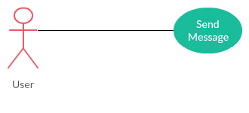

|  |  |
| --- | --- |
| Use Case ID | UC-MH005 |
| Name | Send Messages |
| Objective | To send messages to other users |
| Entry conditions | This use case will initiate when a user is logged in the app and tries to send message to other member |
| Success end condition | Message from sender is sent to the receiver |
| Fail end condition | Message is not delivered or delivered partially |
| Actors | User |
| Main scenario | * The user is logged in the app and opens the profile of other member * The user can send message to the other member by clicking a send message button * A new window/panel will popup in which user can write a message to the user |

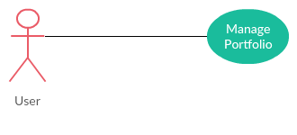

|  |  |
| --- | --- |
| Use Case ID | UC-MH006 |
| Name | Portfolio Management |
| Objective | To manager portfolio of Bands or Individuals |
| Entry conditions | This use case will initiate when a user is logged in the app and edit his/her own profile |
| Success end condition | The portfolio of user will be updated |
| Fail end condition | The user is unable to perform updates on his/her portfolio |
| Actors | Individuals, Bands |
| Main scenario | * The band or individual is logged in the app * He/She can customize profile using the settings icon on home screen * There will be an option to edit portfolio through which band or musician will be able to update portfolio including:  1. Upcoming Events 2. Previous Events 3. Video Links (Youtube) &Social Profile 4. Profile Picture 5. Band Name (For Bands Only) 6. Pricing |

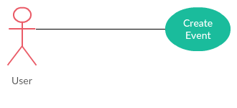

|  |  |
| --- | --- |
| Use Case ID | UC-MH007 |
| Name | Create Events |
| Objective | Create and Manage Upcoming Events |
| Entry conditions | This use case will initiate when a band or individual is logged in the app and tried to create an event on his profile |
| Success end condition | The event is created successfully |
| Fail end condition | Event is not created. Either user cancels or not enough information is provided |
| Actors | Individuals, Bands |
| Main scenario | * The band or individual is logged in the app * Band or individual tries to create event on his/her profile * The event will be created after filling out event registration form * If the required fields in the form are filled, event will be registered otherwise user will be notified that not all information is provided |

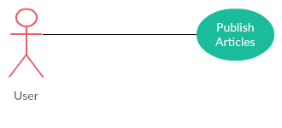

|  |  |
| --- | --- |
| Use Case ID | UC-MH008 |
| Name | Publish Articles |
| Objective | To publish Articles on App’s Blog Section |
| Entry conditions | This use case will initiate when a band or individual is logged in the app and tries to publish or edit article in application’s blog section |
| Success end condition | The article is published or edited successfully |
| Fail end condition | The article is not published |
| Actors | Band, Individual |
| Main scenario | * The band or individual is logged in the app * Band or individual tries to publish an article on Application’s Blog Page * The new window/panel will appear in which user can write an article and will press submit button * Upon submission article will be published in application’s blog page |

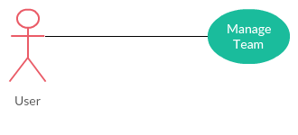

|  |  |
| --- | --- |
| Use Case ID | UC-MH009 |
| Name | Team Profile |
| Objective | Manage Band’s Team Members and their Details |
| Entry conditions | This use case will initiate when a band tried to create or edit its team profile |
| Success end condition | The team profile is create or modified successfully |
| Fail end condition | Team profile is not created because user cancels it or not enough data is provided |
| Actors | Bands |
| Main scenario | * The band is logged in the app & tries to create or modify team profile using settings button * After inserting details the band will publish team profile which will be displayed on their profile page |

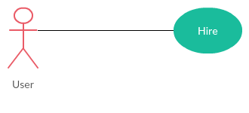

|  |  |
| --- | --- |
| Use Case ID | UC-MH010 |
| Name | Hiring Bands or Individuals |
| Objective | To hire individual artists or bands |
| Entry conditions | This use case will initiate when a band or customer tried to hire an individual or band |
| Success end condition | The band or individual is hired for an event |
| Fail end condition | The band or individual is not hired |
| Actors | Band, Customers |
| Main scenario | * The band or customer is logged in the app and tries to hire a particular band or individual artists by using hire button on his/her profile * The notification will be sent to the band or individual that a particular person or band wants to hire them * If he/she accepts the invitation, hiring process will be completed |

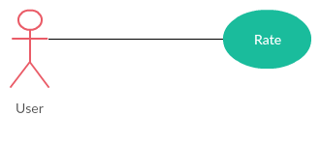

|  |  |
| --- | --- |
| Use Case ID | UC-MH011 |
| Name | Rating |
| Objective | Giving Ratings to Bands or Individuals |
| Entry conditions | This use case will initiate when a band or customer tries to rate a band or individual and they must have been hired |
| Success end condition | The band or individual has been rated |
| Fail end condition | The band or individual is not hired because they were not hired |
| Actors | Bands, Customers |
| Main scenario | * The band or customer is logged in the app & tries to rate another band or individual which they hired before * In the profile page of band or individual there will be an option to rate that band or individual based on their previous performance * The rating will not be approved if Customer or band did not hired that band or individual |