the NHS2 CORPUS VALIDATION PROTOCOL

✨Hello and welcome! Thank you for helping us to finish assembling and validating the NHS2 Corpus! ✨

Objectives: (1) confirm the authenticity and usability of the field recordings, and if available, extract a single representative image to use in our online experiments; and (2) randomly select and extract a 10-second clip of audio from each recording, which will be used in the corpus itself.

To do this work, you will need:
- the NHS2_corpusValidation google sheet
- a copy of Adobe Audition on your computer
- access to musiclabnas via https://quickconnect.to/themusiclab (log in, enter the File Station, and navigate to /nhs2/stim/corpus); You should have your own username & password to log onto musiclabnas; if you don't have one, ask a lab manager for help.

Pick a track to work on and do the following:

PART A. Validate the metadata (and get an image if one is available)
For the first two items, you need access to the audio file of the song. Copy it from musiclabnas (in /nhs2/stim/corpus) to your computer to work locally.
- Confirm that the track is NOT SKETCHY (e.g., overproduced, operatic, etc).
Download the track to your computer and listen to 20-30 seconds of audio to ensure that the song was authentically recorded in the field and not in a studio setting.
Red flags: sounds produced or is a reproduction or re-performance, orchestral instruments, operatic, reverb, electronic instruments, sounds very modern, etc.
- Confirm that there is an AUDIBLE SINGER. This one is self-explanatory :)

For the next few steps, you'll need the liner notes associated with the song. These are in the same spot as the audio files (musiclabnas in /nhs2/stim/corpus). Copy them to your computer to work locally on the next few items.
- Are there any problems with the TYPE classification?
Refer to the song type definitions at the bottom of this protocol, the song_reason, song_label, and song_info fields in NHS2_corpusValidation, and the liner notes.
Not problematic means the original type classification is clear and accurate.
Maybe problematic might be that a song is categorized as DANCE, but from your reading, it looks like it could be considered primarily for HEALING (but also involves dancing).
Definitely problematic might be that a song is categorized as DANCE, but the liner notes clearly state that it’s a LULLABY.
- Are there any problems with the REGION classification?
Use the name of the culture, any geographic information available in the liner notes, and the reference region maps at the bottom of this protocol.
Not problematic means the original region classification is clear and accurate.
Maybe problematic might be that a song is categorized as being from the Maya Area, but from your reading, it looks to be from Central America instead.
Definitely problematic might be that a song is categorized from the Maya Area, but the liner notes clearly state that it’s from the Amazon.

- Are there any problems with the GLOTTOCODE classification?
Compare the information from the liner notes with the summary information about the language on Glottolog that is associated with the specified glottocode (click the glottolog_url in NHS2_corpusValidation). If the language is not listed in the liner notes, use the culture name you already validated, and/or any other information in the liner notes that can point you to an accurate glottocode.
Not problematic means the original glottocode classification is clear and accurate.
Maybe problematic might be that a song is listed as corresponding with a particular glottocode, but you suspect that it should actually correspond with a different but closely related language.
Definitely problematic might be that a song is listed as corresponding with English, but it’s clear it should be a completely different language, like Danish or Punjabi or even Hopi.

Last, you'll get an image from the liner notes, if one is available.
- If the liner notes include images, screenshot at highest possible resolution (⌘⇧4 and highlight the area you would like to save) the most interesting, most relevant photo to pair with the audio recording. Name the image with the same text as the audio file (e.g., NHS2-1234.png) and put it on musiclabnas in /nhs2/corpusValidated.
Please take extra care to ensure that the people, tribe, or cultural images indicated in the photo are accurately represented. If unsure, it is better to not choose a photo at all. If the quality of the scan is very low, or the image looks horrible or whatever, don't choose an image. Please do not use an album cover for the image!!

In NHS2_corpusValidation, for each step, enter your responses in the columns corresponding to each step, and check the checkbox to indicate if you have added a photo to musiclabnas in /nhs2/corpusValidated.
If you specified "Maybe problematic" or "Definitely problematic" for ANY field, provide a brief explanation in the classify_issue field!

PART B. Prepare the audio (check out screenshots here).
Complete part B for all tracks, EXCEPT if the track is sketchy and/or lacks an audible singer.
- Open the full-length .wav file from musiclabnas in /nhs2/stim/corpus in Audition.
- In the “Selection/View” box located in the bottom right-hand corner of the application, enter the randomly selected startTime from NHS2_corpusValidation (e.g., if startTime is 30, this will display as 0:30.000).
- Set the Duration to 10 seconds (this displays as 0:10.000), to highlight the 10-second snippet.
- Right-click the selection and choose "Copy to New..." (⌥⇧C), to create a new file with just the 10-second snippet (the snippet will open separately from the full song)
- Listen to the snippet and confirm that it contains singing but does not include speaking (e.g., when the anthropologist or the singer describes the song) or other weirdness (e.g., substantial non-music sounds).
  - If the snippet is OK, continue. If not, close the snippet without saving it (⌘W) to return to the full song; then go to https://random.org and use the True Random Number Generator to randomly select a new start time and try a new snippet. Repeat until you've got a usable 10-second snippet. Enter the new startTime in Column T and make any relevant notes in Column S.
- Once the snippet is confirmed, save it (⌘⇧S) as MP3 audio in 44100 Hz Stereo, 16-bit, 192Kbps CBR (these are not necessarily the default settings!) using exactly the same track number (e.g., NHS2-1234.mp3).
  - Audition will probably warn you that you are saving the snippet to a compressed/lossy format. If so, then click Yes.
- Upload the snippet to musiclabnas in /nhs2/corpusValidated
Be very careful to not overwrite any other files!! If you get a warning, you or someone else labeled a track incorrectly: STOP and make sure the filenames are correct and in the corpusValidated directory.

In NHS2_corpusValidation, check the checkbox to indicate that you have added the .mp3 to musiclabnas in /nhs2/corpusValidated. If you run into an issue extracting the audio, describe the issue in Column S.

PART C. Confirm that everything is done!
- Check that there is ONE and ONLY ONE MP3 file uploaded to musiclabnas in /nhs2/corpusValidated, and that its filename is correct!
- If you found a suitable image to accompany the file, check that there is ONE and ONLY ONE PNG file uploaded to musiclabnas in /nhs2/corpusValidated, and that its filename is correct!

Last (if you like) delete local copies of these files from your computer so that they don't take up extra space.

Now you're all done and ready to move onto the next track!

SONG TYPE DEFINITIONS

DANCE
Inclusion criteria: Sung with the goal of a person or persons dancing along to it.
Exclusion criteria: Songs that happen to be accompanied by dancing but are used for other goals.

HEALING
Inclusion criteria: Sung in a healing ceremony with the goal of curing sickness.
Exclusion criteria: Songs describing sick people or a past epidemic.

LOVE
Inclusion criteria: Sung to express love directly to another person or to describe currently felt love.
Exclusion criteria: Songs about unrequited love, deceased loved ones, or love for animals or property.

LULLABY
Inclusion criteria: Sung to an infant or child with the goal of soothing, calming, or putting to sleep.
Exclusion criteria: Songs designed to excite the listener (e.g., "play songs"); singing games.

PLAY
Inclusion criteria: A song that excites a child or infant and engages them in play. This can include singing games.
Exclusion criteria: Children's songs for soothing, calming, or putting to sleep.

PROCESSION
Inclusion criteria: sung to accompany a formalized march, entrance, or parade, such as during a wedding, funeral or the introduction of a leader [*note*: please specify in 'secondary function' the type of event that the procession is associated with, e.g., "wedding"].
Exclusion criteria: Processions of dancing.

MOURNING
Inclusion criteria: sung to express grief or sadness about the death of a person, in the present or past.
Exclusion criteria: Songs for sick or dying people (these are more likely to be healing songs), or laments about events other than the death of a person.

WORK
Inclusion criteria: sung to accompany work activities, including planting, grinding, harvesting, processing, tool-making.
Exclusion criteria: Hunting songs (esp. songs sung to celebrate successful hunts, songs sung to prepare for hunts).

STORY
Inclusion criteria: sung to recount historical or mythological events, narrate a sequence of activities by one or more persons, etc. (e.g., a ballad).
Exclusion criteria: Lullabies that include stories.

PRAISE
Inclusion criteria: sung to express admiration for the traits or accomplishments of a person, animal, location, or item of property.
Exclusion criteria: A song expressing love for another person or explicitly religious songs (like devotionals).

REGION INFORMATION
The subregions are roughly defined. Don't worry if there is ambiguity about the local area where a track is from. Just confirm that the region classification is not crazy wrong!
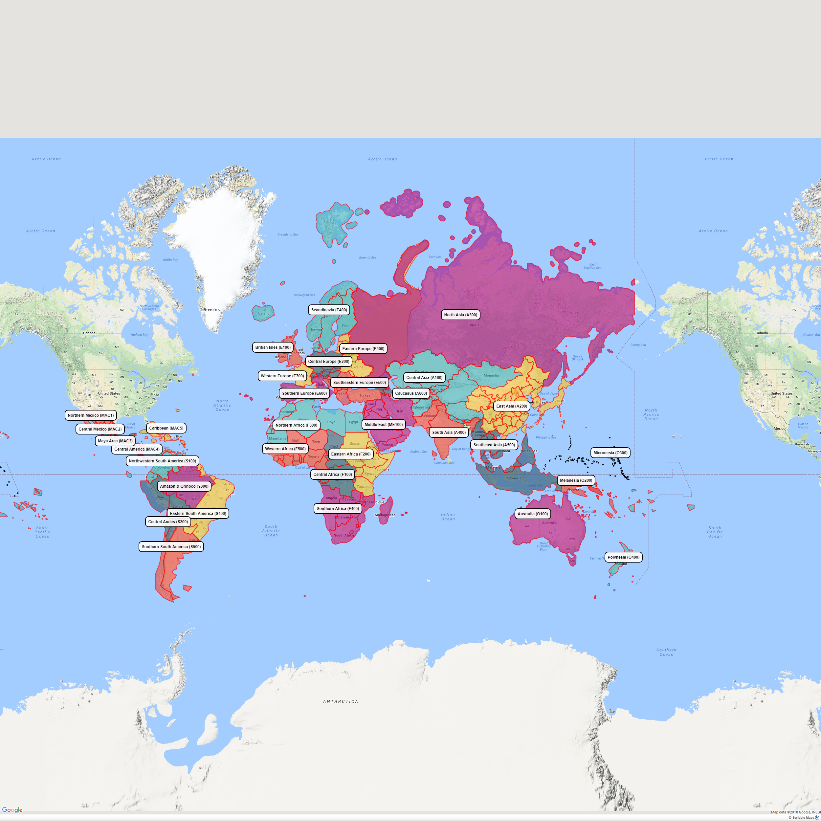
Larger version of this map is at https://drive.google.com/file/d/14FTizVakM3LuYnCDuO8Mph_VTZb70mY4/view?usp=sharing
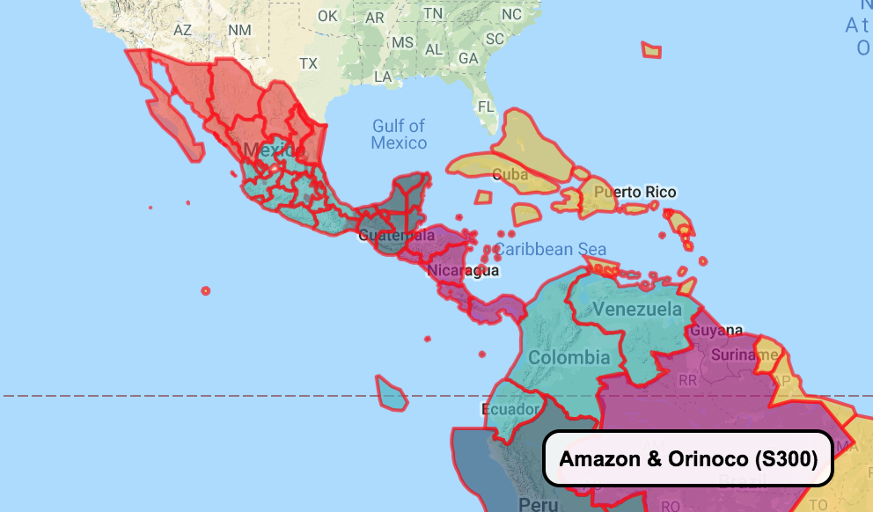
Larger version of this map is at https://drive.google.com/file/d/14FTizVakM3LuYnCDuO8Mph_VTZb70mY4/view?usp=sharing

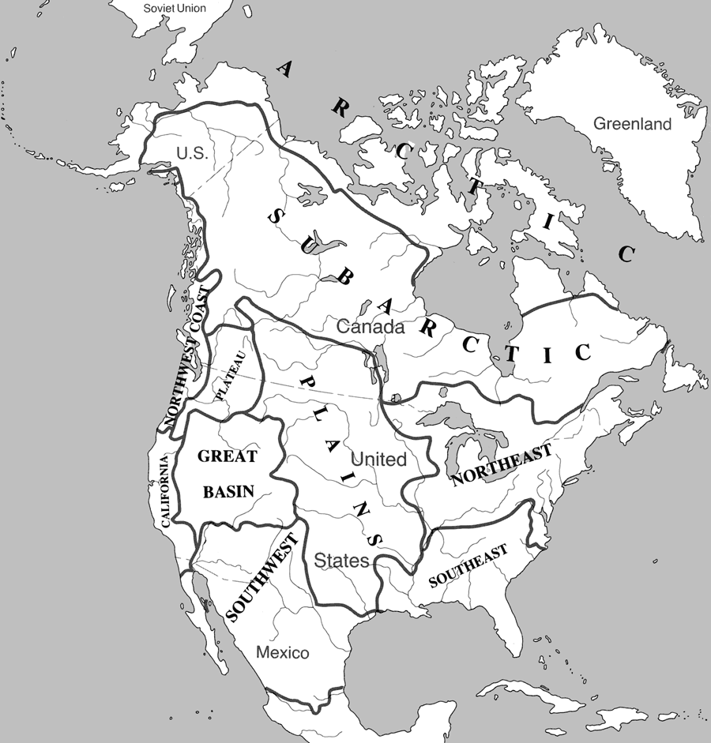

ADOBE AUDITION SCREENSHOTS

