Links You Will Need:
- Glottolog Sheet:
  - Nivi
  - Mona & TJ
- Glottolog Language Search: https://glottolog.org/glottolog
- D-Place Society Search: https://d-place.org/societysets#1/30/153
- EHRAF World Cultures Search: https://tinyurl.com/browseHRAF
- Global Jukebox Metadata: https://tinyurl.com/GJMetadata

For every item in the NHS2 Corpus:
- Visit the page with associated ethnographic source material (generally in column G or S) and search for language information.
n.b. #1 Sometimes there are multiple languages represented within a single collection of audio files; be sure to double-check to make sure the language information you find is associated with the specific track cataloged.
n.b. #2 If the link in column G leads to an .mp3 file, use additional information found in column S to access written ethnographic information. When relevant, use Global Jukebox Metadata to find relevant track information.
  - If language information is not listed in ethnographic information proceed to section 2 below.
  - If there is language information associated with the cataloged track, use the Glottolog Language Search to find the Glottocode.
  - Copy and paste the glottocode (format: xxxx####) into the "glottocode" field.
[if the glottocode is formatted incorrectly, the cell will not turn green!]
    - If there is not an exact match (e.g. there are multiple languages listed; you are unable to find a specific language listed), then work your way up the Glottolog the Classification Tree to find the most common subfamily and list this in column D of the associated track in the NHS2 Corpus
[see exhibit a & b on the next page for examples of this]
  - Use the Classification Type dropdown menu to specify whether your glottocode entry is:
    - exact language match
    - the most common subfamily between multiple languages
    - unknown
[if it's unknown, type 'unknown' in the glottocode field]
  - Use the Are you sure? dropdown menu to indicate whether or not you're sure that your classification is accurate.
- If there is no language information listed, look for culture information associated with the cataloged track.
n.b. Sometimes there are multiple cultures represented within a single collection of audio files; be sure to double-check to make sure the culture information you find is associated with the specific track cataloged.
  - Use the D-Place Society Search to find the Glottolog Code associated with the culture.
    - Search the glottolog code found in D-place on Glottolog Language Search to to confirm classification type.
  - If the culture is not available on D-Place, find the culture up on eHRAF database and use the “Linguistic Affiliation” section of the “Culture Summary” to find the affiliated language.
    - If culture is not listed on eHRAF database, leave columns D and F blank, and select “unknown” in column E.
  - Follow the steps listed above to enter the glottocode, classification type, and your confidence in the classification.

Exhibit A:
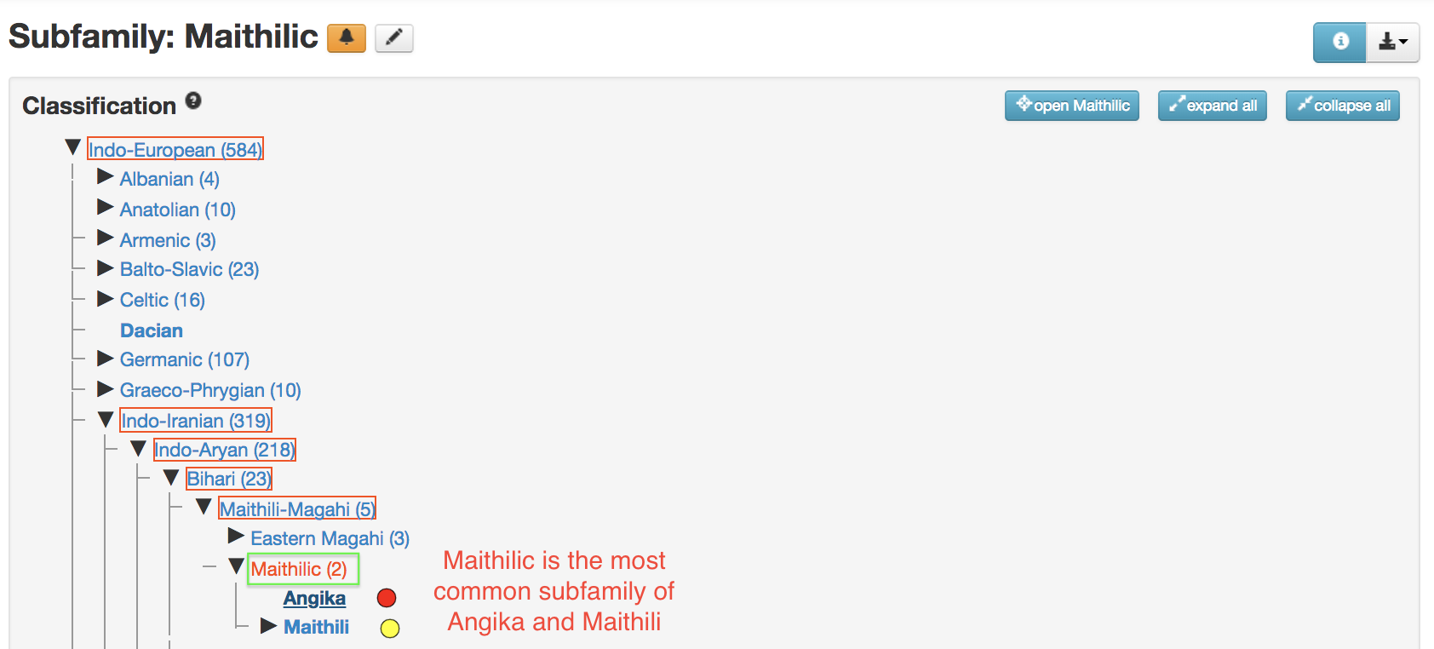

Exhibit B:
