ASSIGNMENT-1

DBMS LAB-1

***Ct2022503003:***

**1. Create the table with the constraint specified**

create table employee_2022503003

(emp_no number(5) primary key,

first_name char(30) not null,

last_name varchar(30) not null,

hire_date date default current_timestamp,

projid varchar(5),

language varchar(15) check(language in('VB','Java','C++','Python','Ruby')),

taskno number(2) check( taskno >=11 and taskno <=99),

privilage char(25));

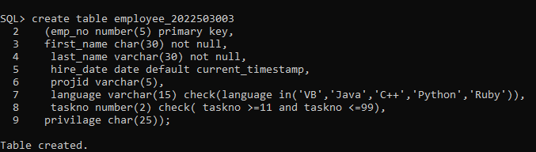

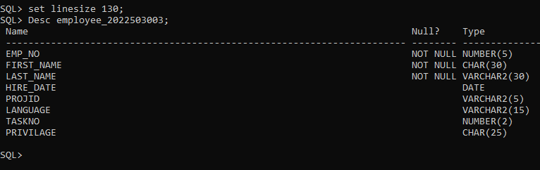

**2. Insert the values using static and dynamic method.**

Static:

insert into employee_2022503003 values(201,'gupta','surav',to_date('01/01/95','mm/dd/yy'),'NPR','VB',52,'secret');

insert into employee_2022503003 values(390,'ghosh','pinky',to_date('01/05/93','mm/dd/yy'),'kcw','Java',12,'Top secret');

insert into employee_2022503003 values(789,'agarwal','praveen',to_date('08/11/98','mm/dd/yy'),'RNC','VB',12,'secret');

insert into employee_2022503003 values(134,'chaudary','supriyo',to_date('07/15/95','mm/dd/yy'),'TIPPS','C++',52,'secret');

insert into employee_2022503003 values(789,'jha','ranjit',to_date('06/15/97','mm/dd/yy'),KCW','Java',11,'Top secret');

insert into employee_2022503003 values(345,'anderson','peter',to_date('11/15/99','mm/dd/yy'),'TIPPS','Java',52,);

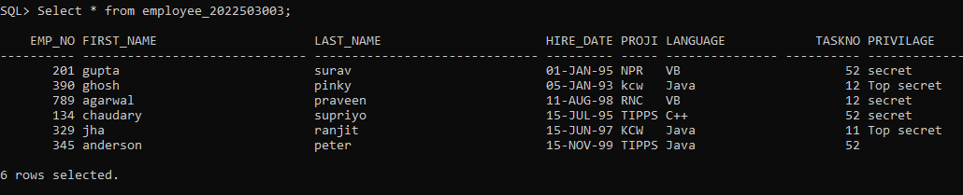

Dunamic: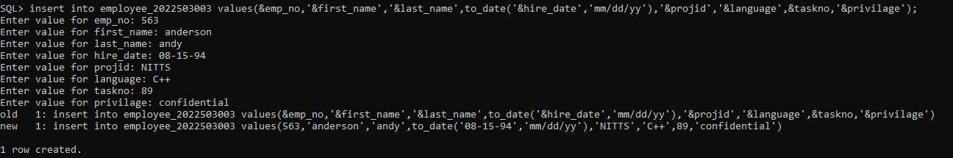

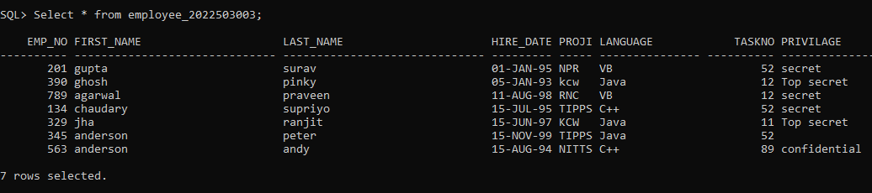

**3. Insert an employee with**

**EmpNo 896, Last Name=’Dilip’ FirstName=’Kumar’ HireDate=’08-**

**JAN-1997’**

**projid=’Rnc’**

**Language=Python**

**TaskNo=12**

**Privilige=secret.**

**Check the integrity constraint violation and report the same.**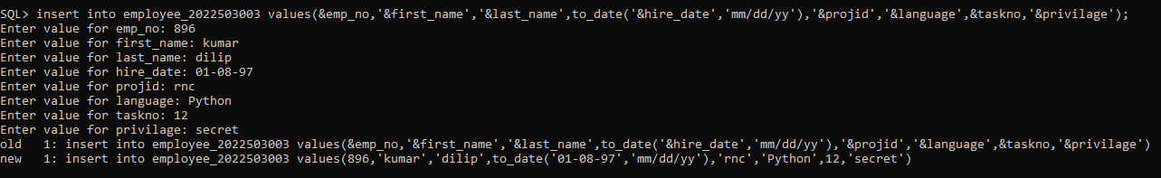

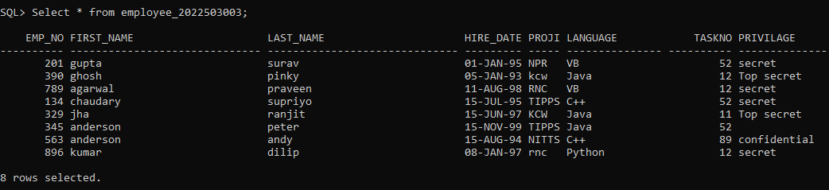

**4. Add the column salary. Max size 10 and 4 places of decimal**

Alter table employee_2022503003 add salary number(10,4);

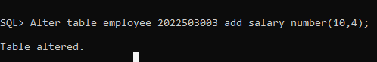

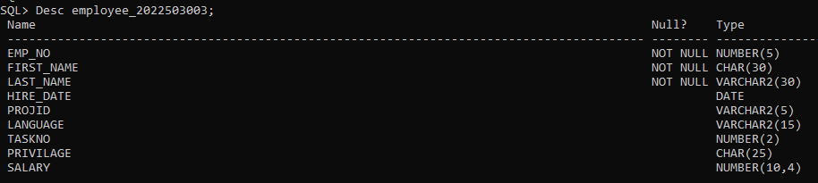

**5. Modify the column salary. Max size is 12 and 4 places of decimal**

Alter table employee_2022503003 modify salary number(12,4);

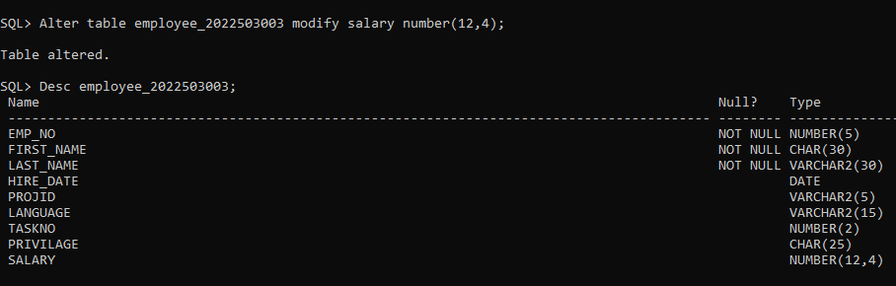

**6.update column slaary based on privilage**

Update employee_2022503003 set salary=15000.1234 where privilage=’secret’;

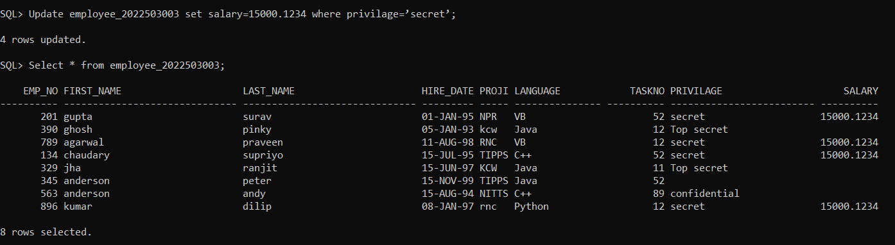

Update employee_2022503003 set salary=25000.9998 where privilage=’Top secret’;

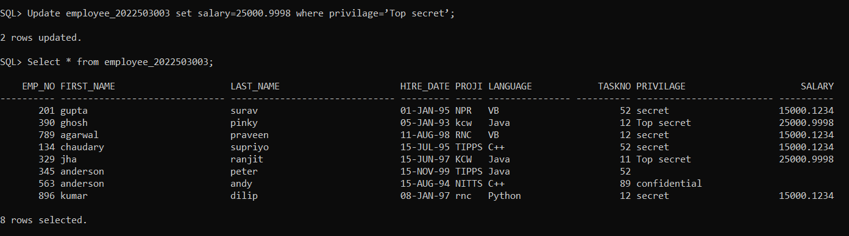

Update employee_2022503003 set salary=5000.9678 where privilage=’confidential’;

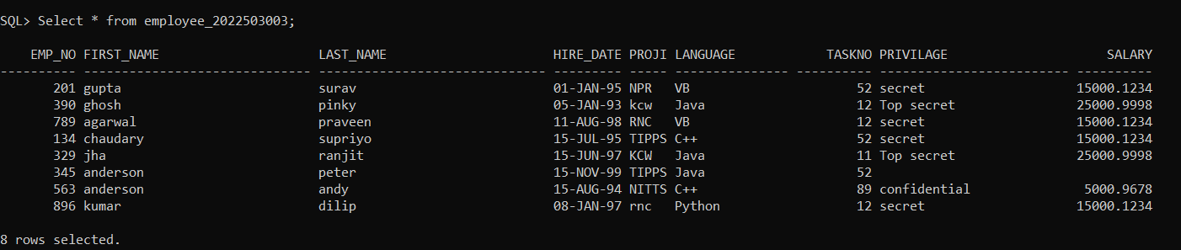

**7. Modify the column EmpNo. Change the maximum size to 10. Report if**

**any error occurs.**

Alter table employee_2022503003 modify emp_no number(10);

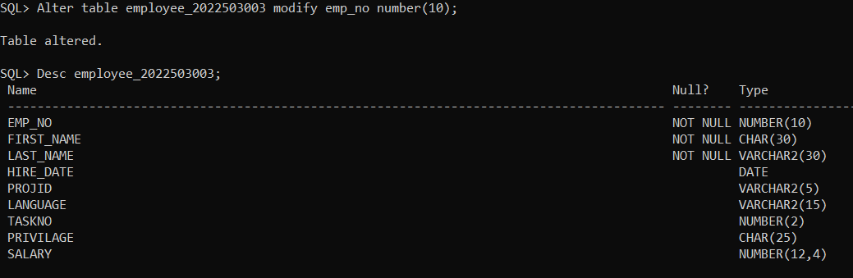

**8. Modify the column Privilege. Set the constraint as NOT NULL. Report**

**if any error occurs.**

Alter table employee_2022503003 modify privilage char(25) not null;

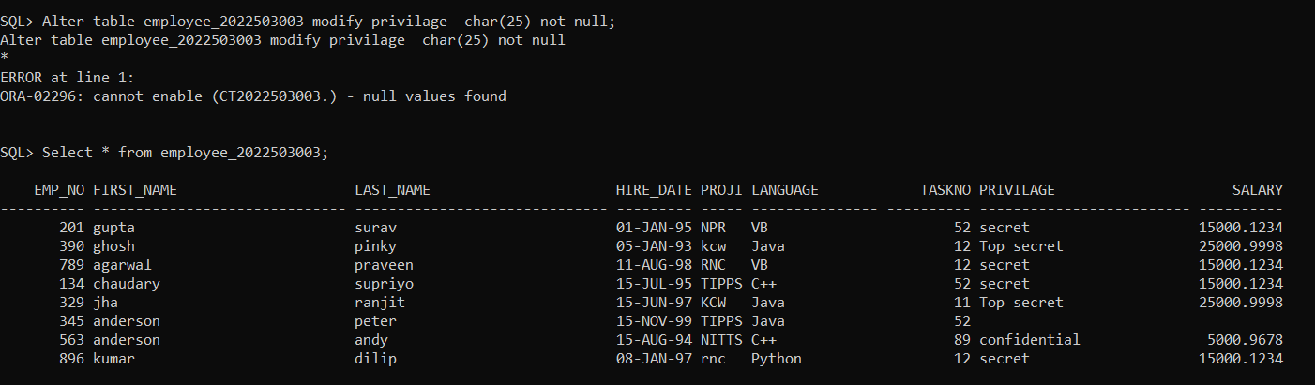

**9.Rename the column Language to Prog_language.**

Alter table employee_2022503003 rename Language to Prog_language;

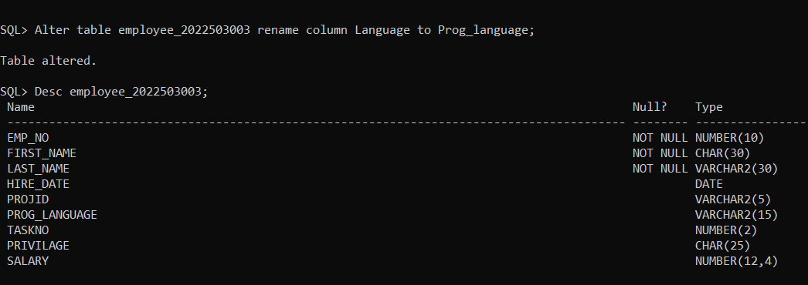

**10.Update the language for an employee with EmpNo 896 to "Python"**

Update employee_2022503003 set prog_language =’Python’ where emp_no=’896’;

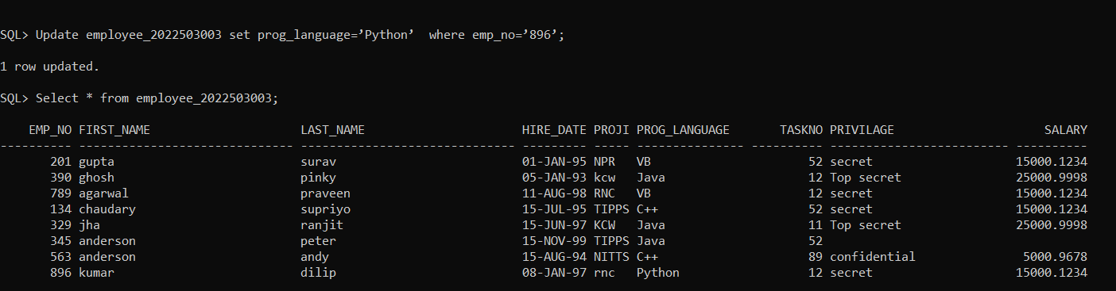

**11. Increase the salary of all employees by 10%**

Update employee_2022503003 set salary=salary+0.1*salary;

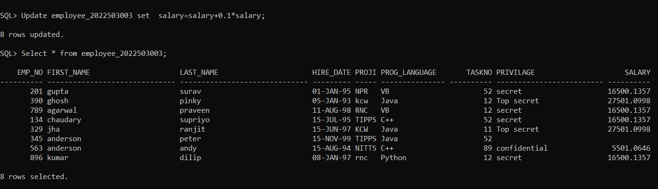

**12. Set the hire date to the current date for all employees hired after**

**08/30/98**

Update employee_2022503003 set hire_date=current_date where hire_date> to_date(‘08/30/98’,’mm/dd/yy’);

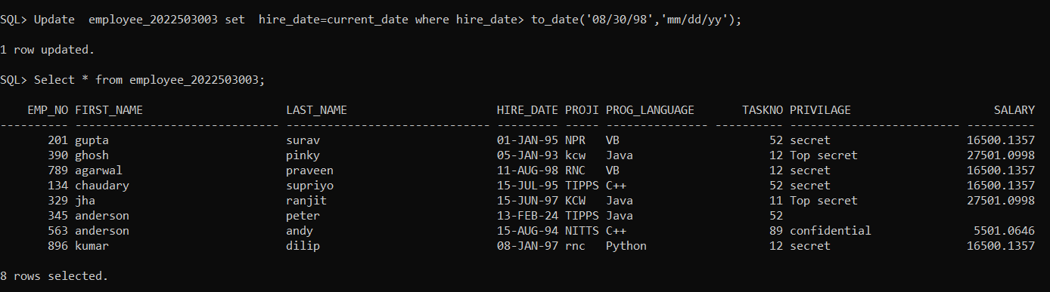

**13. Update the Privilege to Top Secret for employees hired between**

**1/1/98 to 1/1/2000**

Update employee_2022503003 set Privilege =’Top Secret’ where hire_date between to_date(‘1/1/98,’mm/dd/yy’) and to_date(‘1/1/2000,’mm/dd/yy’) ;



**14.Update the Language for employees whose last names contains vowels**

**to "Go":**

Update employee_2022503003 set prog_language ='go' where last_name like '%a' or last_name like '%e' or last_name like '%i' or last_name like '%o' or last_name like '%u' ;



**15.update the Language column to "Swift" for rows where the**

**LastName column has a length of exactly 5 characters.**

Update employee_2022503003 set prog_language ='swift' where last_name like '-----' ;

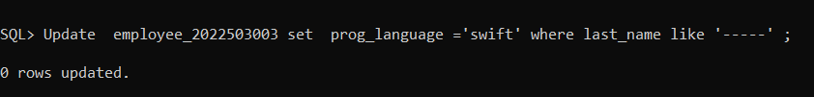

**16.Drop the column EmpNo. Check the integrity constraint violation and**

**report the same.**

ALTER TABLE employee_2022503003 DROP COLUMN emp_id;

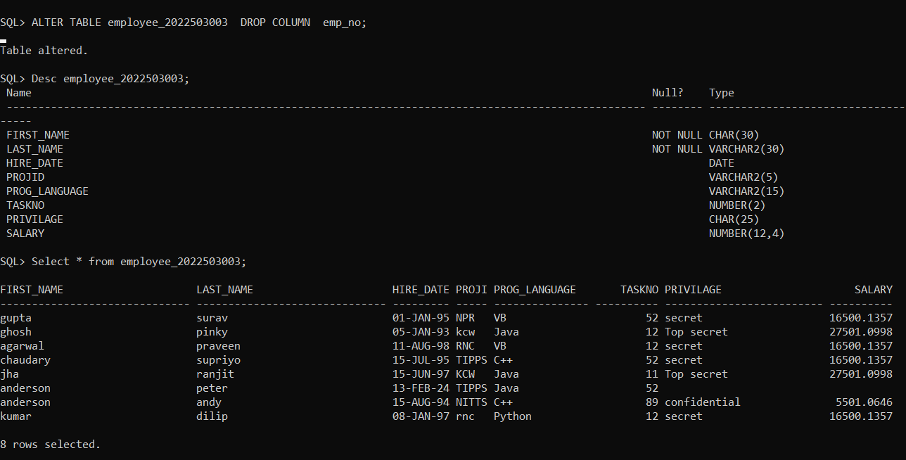

**17.The column salary in the PROGRAMMER Table is no longer needed.**

**Delete the column.**

ALTER TABLE employee_2022503003 DROP COLUMN salary;

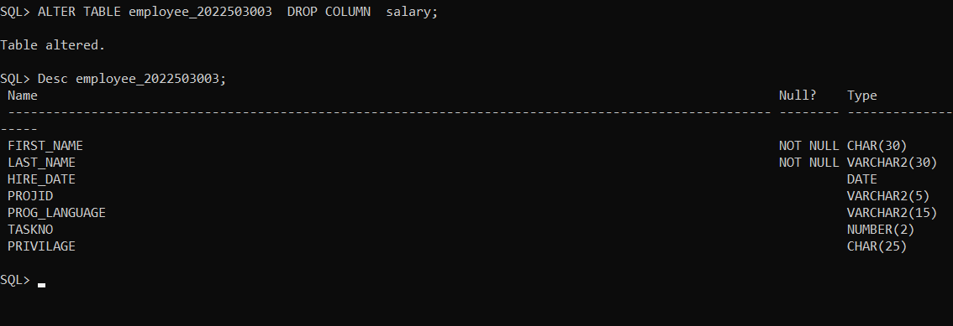

**18. Create a table Department with Dno(character type), dname**

**(character of 25) , location (character of 25)**

Create table department_2022503003(dno char(25), dname char(25),location char(25));

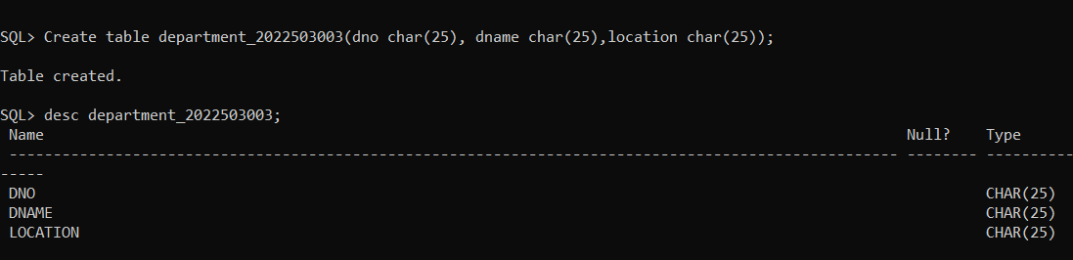

**19. Insert three rows with dno D101, D102, D103 and include other field**

**values as your choice.**

Dynamic:

Insert into department_2022503003 values('&DNO','&DNAME','&LOCATION');

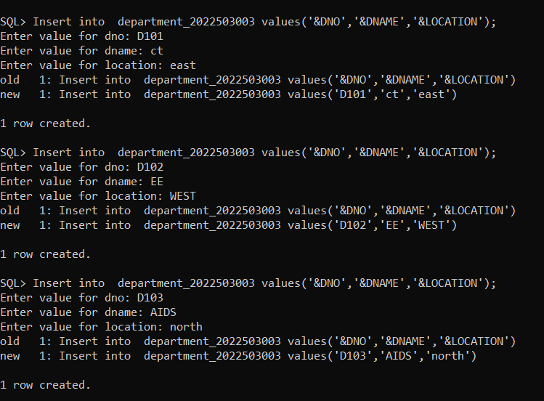

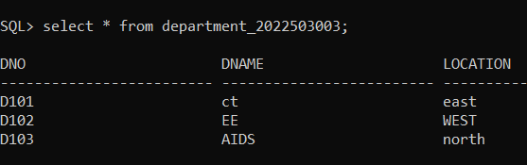

**20. Add a column deptid in the programmer table as foreign key.**

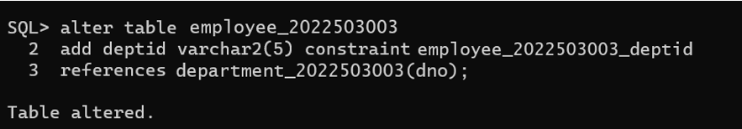

**22. Create a duplicate table with the same structure and data**

**Hint: create table new_table as select * from existing_table;**

Create table duplicate as select * department_2022503003;

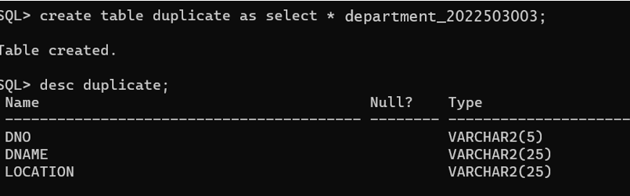

**23. Delete all the entries in the table but retain the structure of**

**the table.**

Truncate table duplicate;

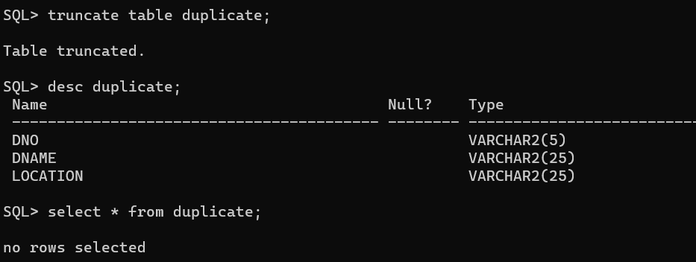

**24.Drop the table Department as it not needed. Report if any constraint violation occurs.**

Drop table department_2022503003;

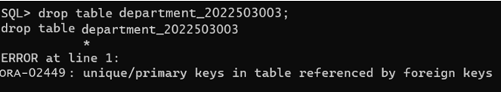

**25.Drop the table programmer as it not needed. Report if any constraint violation occurs**

drop table employee_2022503003;

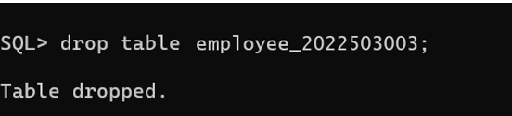

x.SELECT:

Desc employee_2022503003;

Select * from employee_2022503003;